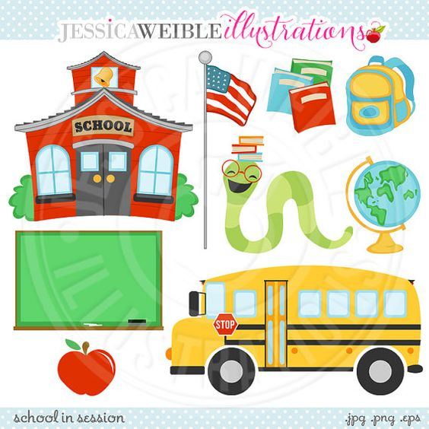
Tuckahoe Elementary Supply List 2022-2023
Below is a list of supplies for each grade level. In September your child’s teacher may ask for some additional supplies. We ask that you label items with a permanent marker and to please bring these supplies to
Open House in August.
REMINDER: Supplies will need to be replenished throughout the school year.
Kindergarten | First Grade | Second Grade
Please Label:  - Backpack –large enough to hold a folder, library books, and lunch box. (No wheels please!)  - 1 over-sized T-shirt for art - Please label and put in a 1-gallon ziploc bag.  - 1 set of headphones  - 1 pair of blunt end scissors  - 9 large glue sticks  - 2 4oz bottles of washable white school glue  - 5 packs of 24 classic color regular size crayons  - 1 pack of 8 broad-tip classic color washable markers (for class use)  - 1 large pink eraser  - 2 two-pocket folders with pockets on the bottom.  - 2 wide ruled marble composition notebooks  - 1 plastic (no zippers) school supply box – 8”x 5”  Please DO NOT label:  - 1 large box of tissues  - 1 box low odor dry erase markers  - 1 box gallon size Ziploc bags  GIRLS:  1 box sandwich or snack-size Ziploc bags  1 additional pack of 8 broad-tip Classic Color washable markers  BOYS:  1 box quart size Ziploc bags  1 additional pack thin tip classic markers | Please Label:  - Backpack - (No wheels please!)  - 1 old T-shirt for art  - 2 pair of scissors  - 1 box of crayons  - 1 9”x 11” dry erase board  - 1 plastic school supply box - 8”x 5”  - 1 pack of 8 broad-tip washable markers  - 1 two-pocket folder without  three brads  - 1 9” x 12” wooden clipboard  - 2 marble composition journals  Please DO NOT label:  - 4 dozen sharpened wooden #2 pencils  - 2 large pink erasers  - 9 large glue sticks  - 4 broad-tip dry erase markers (low-odor) with erasers  - 1 yellow highlighter  - 2 boxes of baby wipes  - 1 box of tissues  - 1 bottle of liquid soap  GIRLS  1 box sandwich size Ziploc bags  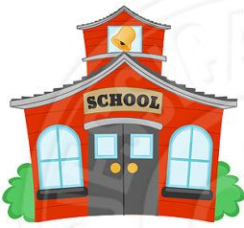  1 box band aids  BOYS  1 bottle liquid glue  1 box gallon size  Ziploc bags | Please Label:  - Backpack - (No wheels please!)  - 1 old T-shirt for art-Please label with name  - 1 pair of scissors  - 1 box of crayons (24 count ONLY)  - 1 pack of 8 washable markers  - 2 highlighters  - 1 marble composition notebooks (not spiral, wide-ruled)  - 1 plastic school supply box -8”x 5”  - 1 9” x 11” dry erase board  - 1 9” x 12” clipboard  - 1 personal set of headphones  - 2 dozen sharpened wooden #2 pencils  - 4 large glue sticks  - 8 broad-tip dry erase markers (low-odor)  - 1 whiteboard eraser or old sock  - 1 two-pocket folder with three brads (solid colors, NO PLASTIC)  - 1 box of band-aids  - 1 large box of tissues  - 1 4oz bottle white glue  - 2 packages baby wipes  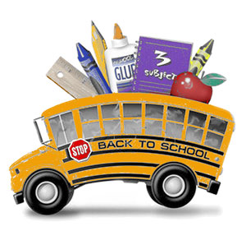
Third Grade | Fourth Grade | Fifth Grade
Please Label:  - 1 pair of scissors  - 1 plastic school supply box - 8”x 5”  - 4 single-subject spiral notebooks  - 1 marble composition notebook  - 2 plastic two–pocket folders (no brads)  - 1 art smock or oversized t-shirt  - 1 set of headphones OR earbuds  Please DO NOT label:  - 2 dozen sharpened #2 pencils  - 2 large pink erasers  - 1 box 24 crayons  - 1 pack colored pencils  - 4 black broad-tip dry erase markers  - 2 blue ball-point pens  - 2 yellow highlighters  - 12 large glue stick  - 2 boxes of tissues  - 2 boxes baby wipes  - 1 box sandwich size Ziploc bags  - Wordly Wise  Book 2 THIRD EDITION  ISBN-13: 978-0838876022  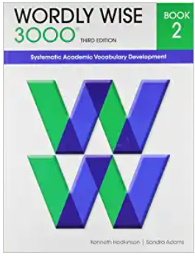  GIRLS:  1 box gallon size Ziploc bags  BOYS:  1 box Band-Aids | Please Label:  - 1 standard pencil box or zippered pouch  - 1 24 count box sharpened colored pencils  - 1 small pencil sharpener (that holds shavings)  - 3 2-pocket folders w/holes  - 4 wide ruled 100 page marble composition notebooks with margins  - 2 pairs of scissors  - 1 5-subject spiral notebooks with pocket dividers (Mead 5-Star brand)  - 1 1 ½” binder-no larger (Genazia, Malechek, Randolph and Williams)  - 1 3-subject spiral notebooks with pocket dividers  - 1 plastic or wooden clipboard  - 1 oversized t-shirt for ART (labeled w/child’s name in plastic bag)  - 2 art boxes (Roberts only)  - 1 set of earbuds or headphones (in a baggie or case)  - 1 external mouse-wireless or wired (Roberts only)  - 2 dozen sharpened #2 pencils  - 2 large pink erasers  - 1 pack of 8 broad-tip markers (Roberts only)  - 1 boxes of tissues  - 6 Elmer’s glue sticks JUMBO  - 2 pens (black or blue)  - 2 red pens  - 2 black Sharpies  - 2 highlighters  Please DO NOT label  - 4 black low odor broad-tip dry erase markers  - 1 box of tissues  - 1 box gallon size Ziploc bags  - 1 box quart size Ziploc bags  - Wordly Wise  Book 3 THIRD EDITION  ISBN-13: 978-0838876039  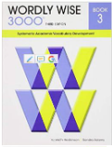  OR  For students identified gifted in language arts or both language arts and math-  Book 4 THIRD EDITION  ISBN-13: 978-0838876046  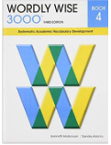 | Please Label:  - Backpack - (No wheels please!)  - 1 box of colored pencils  - 2 dozen #2 wooden pencils  - 2 red pens  - 2 yellow highlighters  - 1 black sharpie  - 1 box of washable markers  - 1 clear protractor without swing arm  - 4 dry erase markers  - 1 dry erase board  - 1 oversized t-shirt for ART(labeled w/ name in plastic bag)  - 1 ruler with inches and centimeters  - 1 pair of scissors  - 4 large glue sticks  - 2 three-subject notebooks  - 2 plastic two-pocket folders  - 1 pencil pouch or box  - 1 set of earbuds or headphones  - 1 marble composition notebook  - Wordly Wise  Book 4 THIRD EDITION  ISBN-13: 978-0838876046  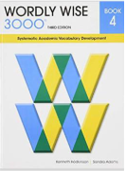  OR  For students identified gifted in language arts or both language arts and math-  Book 5 THIRD EDITION  ISBN-13: 978-0838876053  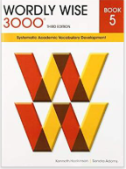  Please DO NOT label:  - 2 large boxes of tissues  - 1 pack of baby wipes  - Last names A-M: 1 box band aids  - Last names N-Z: 1 gallon size Ziploc bags

