AP BIOLOGY EXAM ESSAY (FREE RESPONSE) QUESTIONS
General directions:
Answers must be in essay form. Labeled diagrams may be used to supplement discussion, but in no case will a diagram alone suffice. It is important that you read each question completely, and answer each section of the question. When giving examples, the first ones you give will be the ones graded. (if two examples are asked for, and you write about 4, make sure the first two are the best ones; they are the only ones counted!)

UNIT 1 BIOCHEMISTRY, WATER, ENZYMES

#1 (1996)
The unique properties of water make life possible on earth. Select three properties of water and
a. for each property, identify and define the property and explain it in terms of the physical/chemical nature of water.
b. for each property, describe one example of how the property affects the functioning of living organisms.

#2 (1994)
Enzymes are biological catalysts.
a. Relate the chemical structure of an enzyme to its specificity and catalytic activity.
b. Design a quantitative experiment to investigate the influence of pH OR temperature on the activity of the enzyme.
c. Describe what information concerning the structure of an enzyme could be inferred from your experiment.

#3 (2001)
Proteins – large complex molecules – are major building blocks of all living organisms . Discuss the following in relation to proteins.
a. the chemical composition and levels of structure of proteins.
b. the roles of DNA and RNA in protein synthesis.
c. the roles of proteins in membrane structure and transport of molecules across the membrane.

#4
Water is important for all living organisms. The functions of water are directly related to its physical properties.
a. Describe how the properties of water contribute to TWO of the following:
- transpiration
- thermoregulation in endotherms
- plasma membrane structure
b. water serves as a reactant and a product in the carbon cycle. Discuss the role of water in the carbon cycle.
c. Discuss the impact of one human activity on the water cycle.

#5 (2005)
Yeast cells are placed in an apparatus with a solution of sugar ( a major nutrient for yeast metabolism). The apparatus detects bubbles of gas released by the yeast cells. The rate of respiration varies with the surrounding temperatures as indicated by the data below.

Temp (C ) | 0 | 10 | 20 | 30 | 40 | 50 | 60 | 70
Number of bubbles of gas produced per minute | 0 | 3 | 7 | 12 | 7 | 4 | 1 | 0

a. Graph the results on the axes provided. Determine the optimum temperature for respiration in the yeast.
b. Respiration is a series of enzyme-catalyzed reactions . Using your knowledge of enzymes and the data above, analyze and explain the results of the experiment.
c. Design an experiment to test the effect of varying the pH of the sugar solution on the rate of respiration. Include a prediction of the expected results.

#5 B (also genetics)

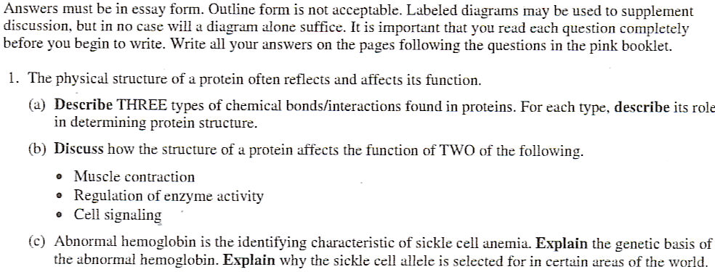

UNIT 2 CELLS, TRANSPORT, KINGDOMS

#6
Cells transport substances across their membranes. Choose THREE of the following four types of cellular transport.

Osmosis
Active transport
Facilitated diffusion
Endocytosis/ Exocytosis

For each of the three types of transport you choose,
a. describe the transport process and explain how the organization of cell membranes functions in the movement of specific molecules across membranes, and

b. explain the significance of each type of transport to a specific cell (you may use different cell types as examples)

#7 (2004)
Organisms differ from one another and yet share common characteristics.
a. Select two kingdoms and briefly describe three characteristics used to distinguish between members of one kingdom and members of the other.
b. Describe 3 characteristics (at least one cellular and one molecular) that members of these two kingdoms share.
c. Propose an explanation for the existence of similarities and differences between the two kingdoms.

#8 (1993) (also photo and resp)
Membranes are important structural features of cells.
a. Describe how membrane structure is related to the transport of materials across a membrane.
b. Describe the roles of membranes in the synthesis of ATP in either cellular respiration or photosynthesis.

#9 (2007) - also body systems and biochemistry
Membranes are essential components of all cells.
a. Identify THREE macromolecules that are components of the plasma membrane in a eukaryotic cell and discuss the structure and function of each.
b. Explain how membranes participate in THREE of the following biological processes .
- muscle contraction
- fertilization of an egg
- chemiosmotic production of ATP
- Intercellular signaling

#10 (2006) – (can use the student answer for this one and make corrections )
A major distinction between prokaryotes and eukaryotes is the presence of membrane-bound organelles in eukaryotes.
a. Describe the structure and function of TWO eukaryotic membrane-bound organelles other than the nucleus.
b. Prokaryotic and eukaryotic cells have some non-membrane bound components in common. Describe the function of TWO of the following and discuss how each differs in prokaryotes and eukaryotes.
- DNA
- cell wall
- ribosomes
c. Explain the endosymbiotic theory of the origin of eukaryotic cells and discuss an example of evidence supporting this theory.

#10 B (2002)

#10C

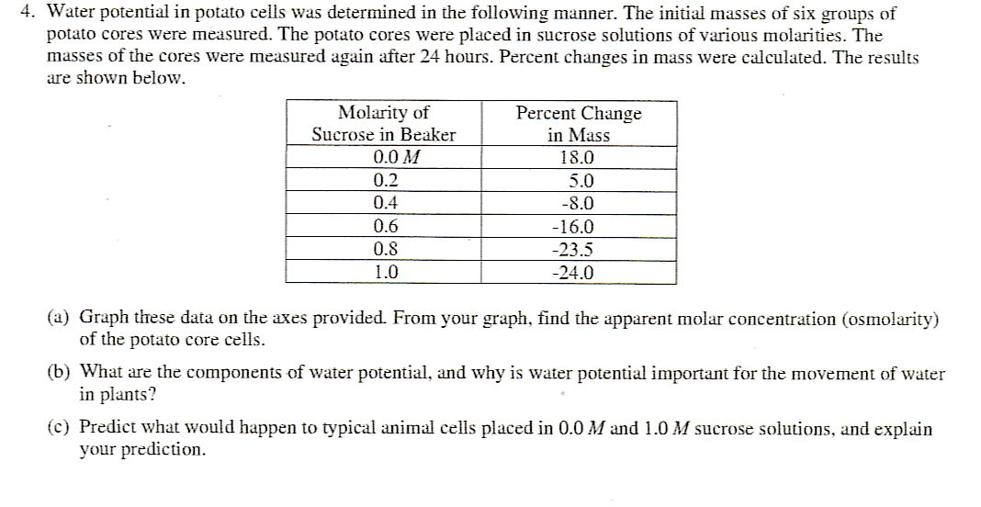

PHOTOSYNTHESIS, RESPIRATION, PRODUCTIVITY of an ECOSYSTEM, ENERGY TRANSFER
#11 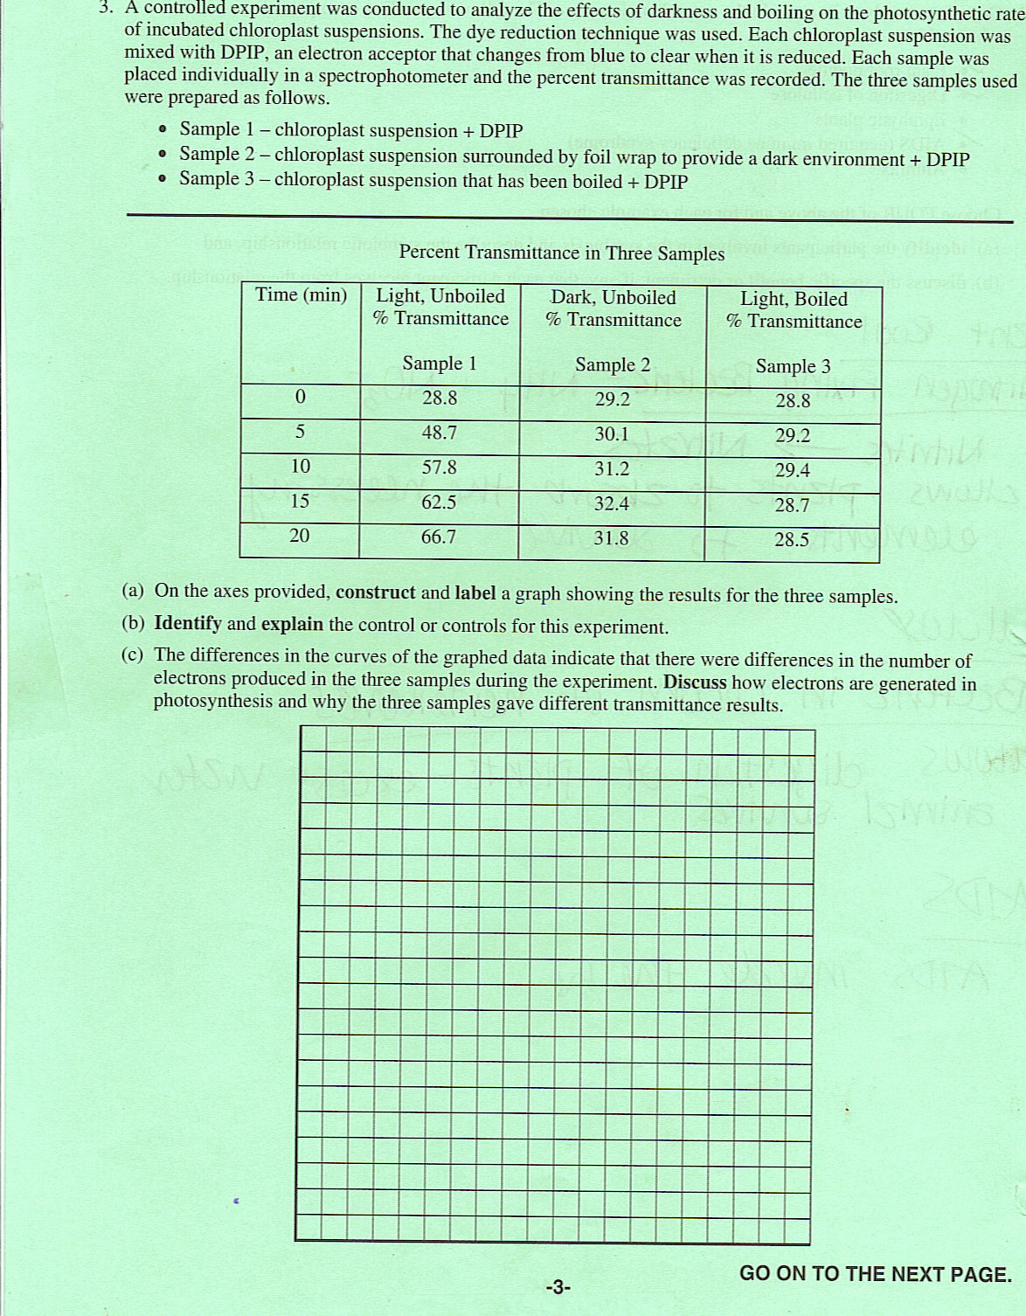
#12
Photosynthesis and cellular respiration recycle oxygen in ecosystems. Respond to TWO (and only two) of the following:
a. Explain how the metabolic processes of cellular respiration and photosynthesis recycle oxygen.
b. Discuss the structural adaptations that function in oxygen exchange between each of the following organisms and its envrironment : a plant, an insect, a fish.
c. Trace a molecule of O₂ from the environment to a muscle cell in a vertebrate of your choice.

#13 (1995)
Energy transfer occurs in all cellular activities. For 3 of the following 5 processes involving energy transfer, explain how each functions in the cell and give an example. Explain how ATP is involved in each example you choose.
- cellular movement
- active transport
- synthesis of molecules
- chemiosmosis
- fermentation

#14
The rate of photosynthesis may vary with change that occur in environmental temperature, wavelength of light, and light intensity. Using a photosynthetic organism of your choice, choose only ONE of the three variables (temperature, wavelength, , or light intensity) and for this variable
- design a scientific experiment to determine the effect of the variable on the rate of photosynthesis for the organism
- explain how you would measure the rate of photosynthesis in your experiment
- describe the results you would expect. Explain why you would expect these results.

#15
Energy is neither created nor destroyed, but it is changed from one form to another. Energy transfer is an important concept in cellular biology. In most eukaryotic cells, chemical bond energy in glucose is eventually converted to the chemical bond energy in ATP molecules in the process of aerobic cellular respiration.
a. The majority of ATP molecules are produced in the process of oxidative phosphorylation. Describe this process including the names and locations of the structures involved and the formation of the electrochemical gradient.
b. For 3 of the following situations, discuss the role of ATP in completing these examples of cellular work.
- active transport
-Glucose production in the dark reaction
- cytokinesis in an animal cell
- movement of a flagellum
- Contraction of a muscle
- control of the stages in mitosis

#16 (2004)
In most aquatic environments, primary production is affected by the light available to the community of organisms.
Using measurements of dissolved oxygen concentration to determine primary productivity, design a controlled experiment to test the hypothesis that primary productivity is affected by either the intensity or the wavelength of light. In your answer, be sure to include the following.
- a statement of the hypothesis that you are testing
- a description of your experimental design (be sure to include a description of what data you would collect and how you would present and analyze the data using a graph)
- a description of results that would support your hypothesis

#16B
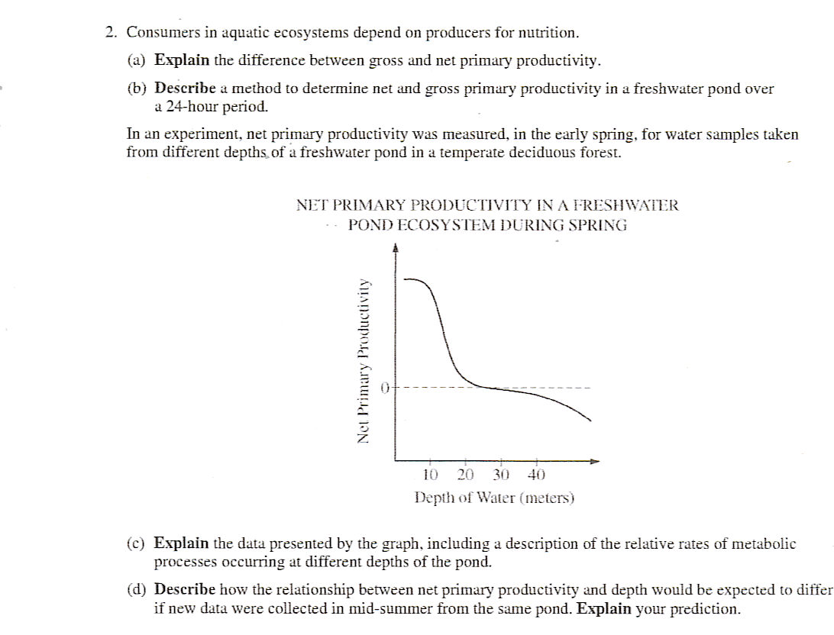
#17 (2007)- also ecology
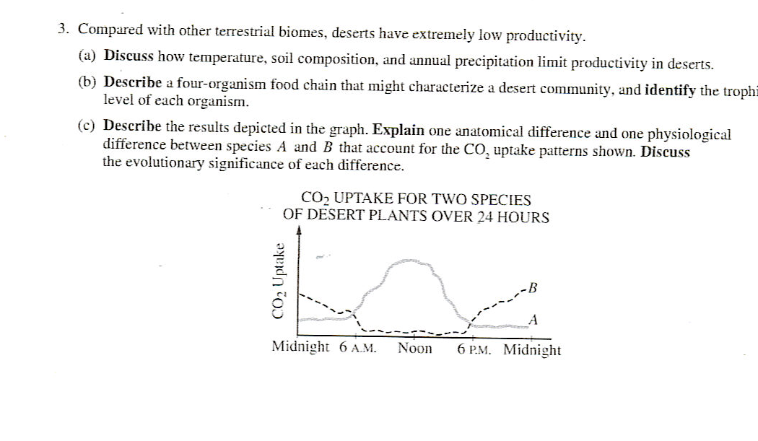
#18

The results below are measurements of cumulative oxygen consumption by germinating and dry seeds. Gas volume measurements were corrected for changes in temperature and pressure.
Cumulative Oxygen Consumed (mL)
Time (min)
0 10 20 30 40
22C germinating seeds | 0.0 | 8.8 | 16.0 | 23.7 | 32.0
22C dry seeds | 0.0 | 0.2 | 0.1 | 0.0 | 0.1
10C germinating seeds | 0.0 | 2.9 | 6.2 | 9.4 | 12.5
10 C dry seeds | 0.0 | 0.0 | 0.2 | 0.1 | 0.2

a. Using the graph paper provided, plot the results for the germinating seeds at 22C and at 10C.
b. Calculate the rate of oxygen consumption for the germinating seeds at 22C using the time interval between 10 and 20 minutes.
c. Account for the differences in oxygen consumption observed between:
- germinating seeds at 22C and 10 C
- germinating and dry seeds
d. Describe the essential features of an experimental apparatus that could be used to measure oxygen consumption by a small organism. Explain why each of these features is necessary.

#19 (2001)
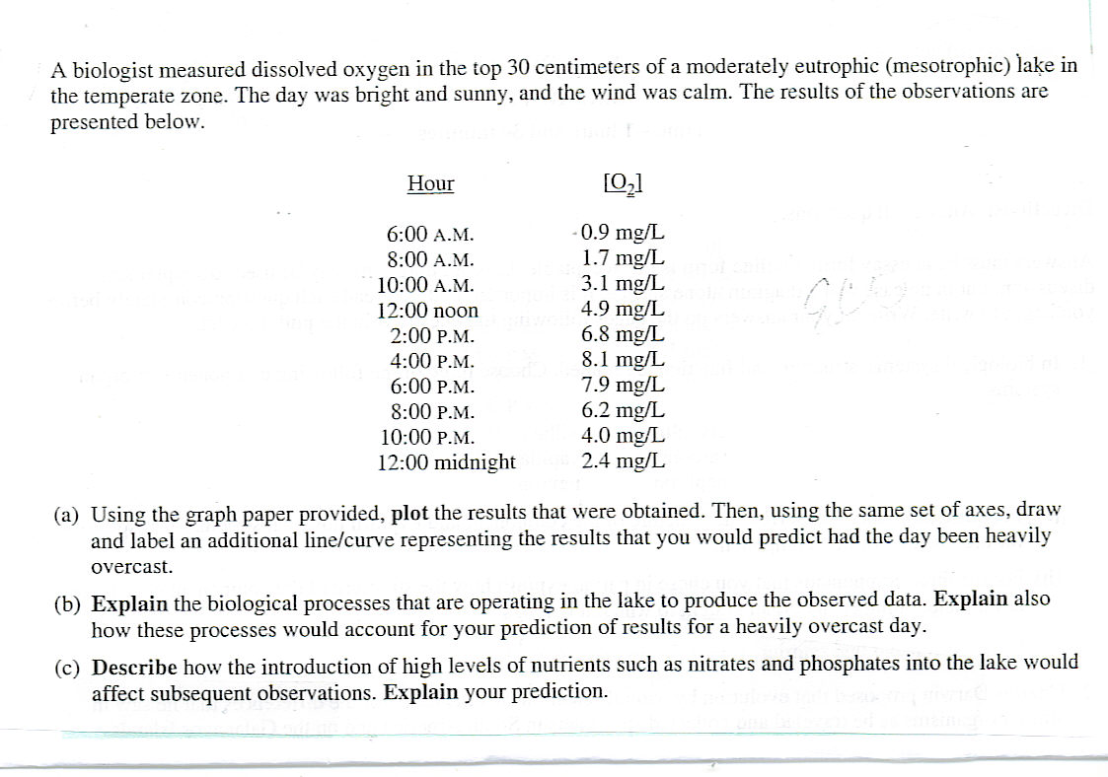

#19B
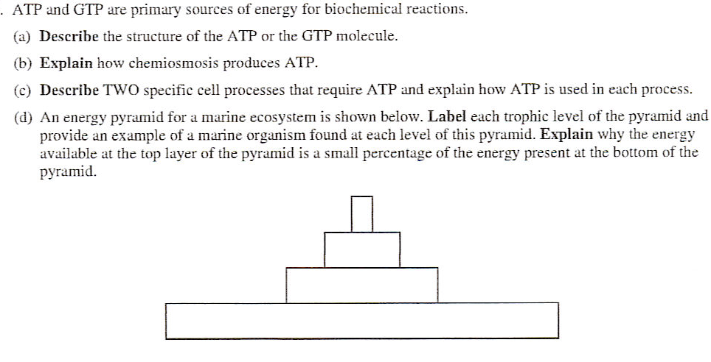

DNA, RNA and PROTEIN SYNTHESIS, GENETIC ENGINEERING

#20
By using the techniques of genetic engineering, scientists are able to modify genetic material so that a particular gene of interest from one cell can be incorporated into a different cell.

a. Describe a procedure by which this can be done.

b. Explain the purpose of each step of your procedure.

c. Describe how you could determine whether the gene was successfully incorporated.

d. Describe an example of how gene transfer and incorporation have been used in a biomedical or commercial application.

#21 (1995)
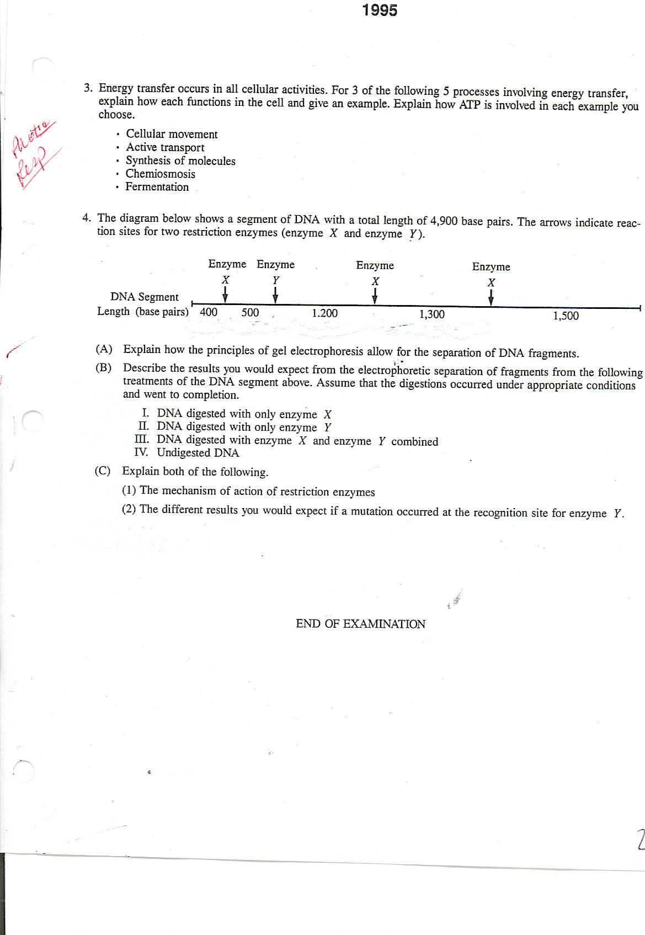
#22
The unit of genetic organization in all living organisms is the chromosome.
a. Describe the structure and function of the parts of a eukaryotic chromosome. You may wish to include a diagram as part of your description.
b. Describe the adaptive (evolutionary) significance of organizing genes into chromosomes.

c. How does the function and structure of the chromosome differ in prokaryotes
#23 (1999)
Scientists seeking to determine which molecule is responsible for the transmission of characteristics from one generation to the next knew that the molecules must (1) copy itself precisely (2) be stable but able to be changed and (3) be complex enough to determine the organism’s phenotype.
- Explain how DNA meets each of the three criteria stated above.
- Select one of the criteria stated above and describe experimental evidence used to determine that DNA is the hereditary material.

#24 (2007)
A molecule of messenger RNA (mRNA) has just been synthesized in the nucleus of a human cell.
a. What types of modifications may occur to this RNA before it leaves the nucleus.
b. Once in the cytoplasm how is the mRNA translated to a protein ?
c. If the cell is a secretory cell, how is the protein form part (b) eventually targeted, packaged and secreted to the exterior of the cell?

#68 (2005)
Protein synthesis is vital for cell growth and metabolism.
a. Describe transcription and translation.
b. Identify similarities between transcription and translation.
c. Identify differences between transcription and translation.
d. Describe structural changes that can occur in a protein after translation to make it function properly.

#71 (2003)
A difference between prokaryotes and eukaryotes is seen in the organization of heir genetic material.
a. Discuss the organization of the genetic material in prokaryotes and eukaryotes.
b. Contrast all of the following activities in prokaryotes and eukaryotes:
- DNA replication
- transcription OR translation
- gene regulation
- cell division

#25 (2007)
Next page
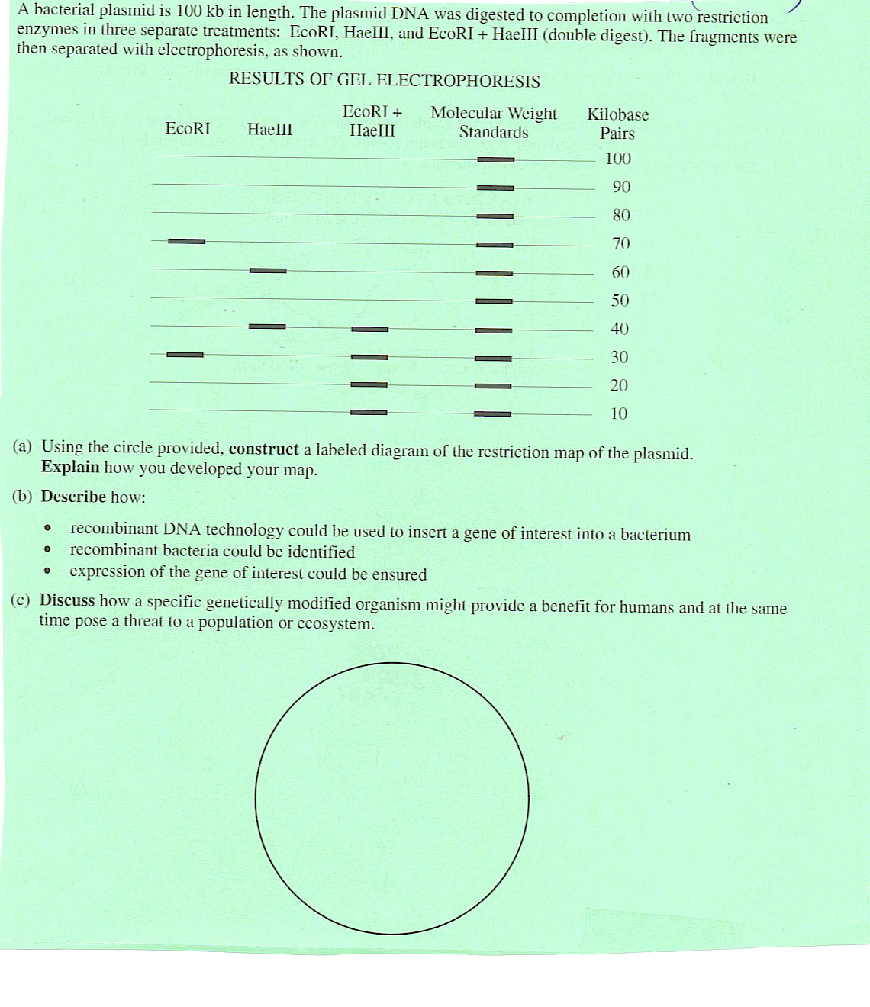
#74 (2002)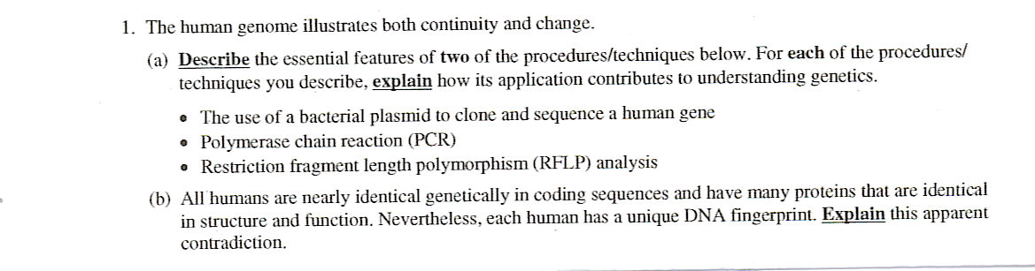

#75 (2000)
The physical form of cells and organisms is often influenced by special structural polymers. Choose ONE form EACH of the following pairs of polymers.
Pair 1 : tubulin …myosin
Pair 2: cellulose….chitin
Pair 3 : messenger RNA….transfer RNA

For each of the three polymers you have chosen,
a. describe its structure
b. describe its role in a cell or organism

#75B

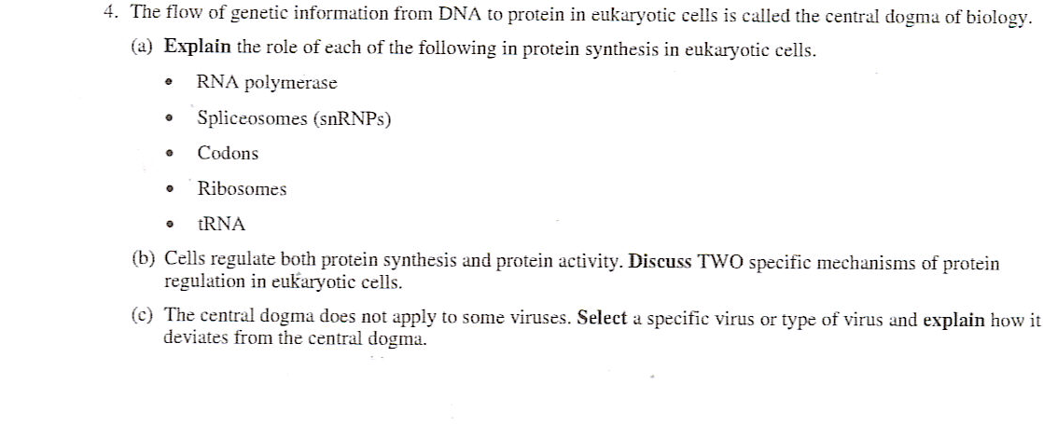
MITOSIS, MEIOSIS

#26 (2004)

Meiosis reduces chromosome number and rearranges genetic information.

a. Explain how the reduction and rearrangement are accomplished in meiosis.

b. Several human disorders occur as a result of defects in the meiotic process. Identify ONE such chromosomal abnormality ; what effects does it have on the phenotype of people with the disorder? Describe how this abnormality could result from a defect in meiosis.

c. Production of offspring by parthenogenesis or cloning bypasses the typical meiotic process. Describe either parthenogenesis or cloning and compare the genomes of the offspring with those of the parents.

#27 (1996)

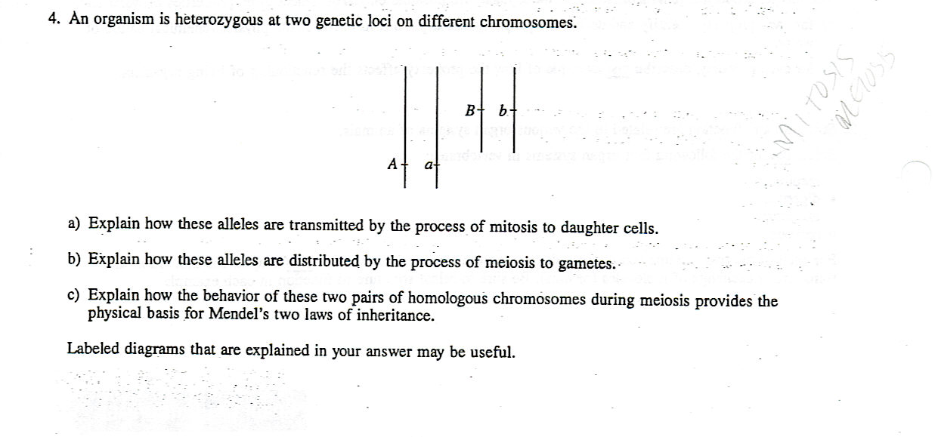

#28 (2006)

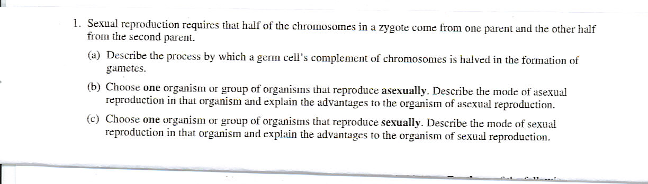

GENETICS

#29 (2003)

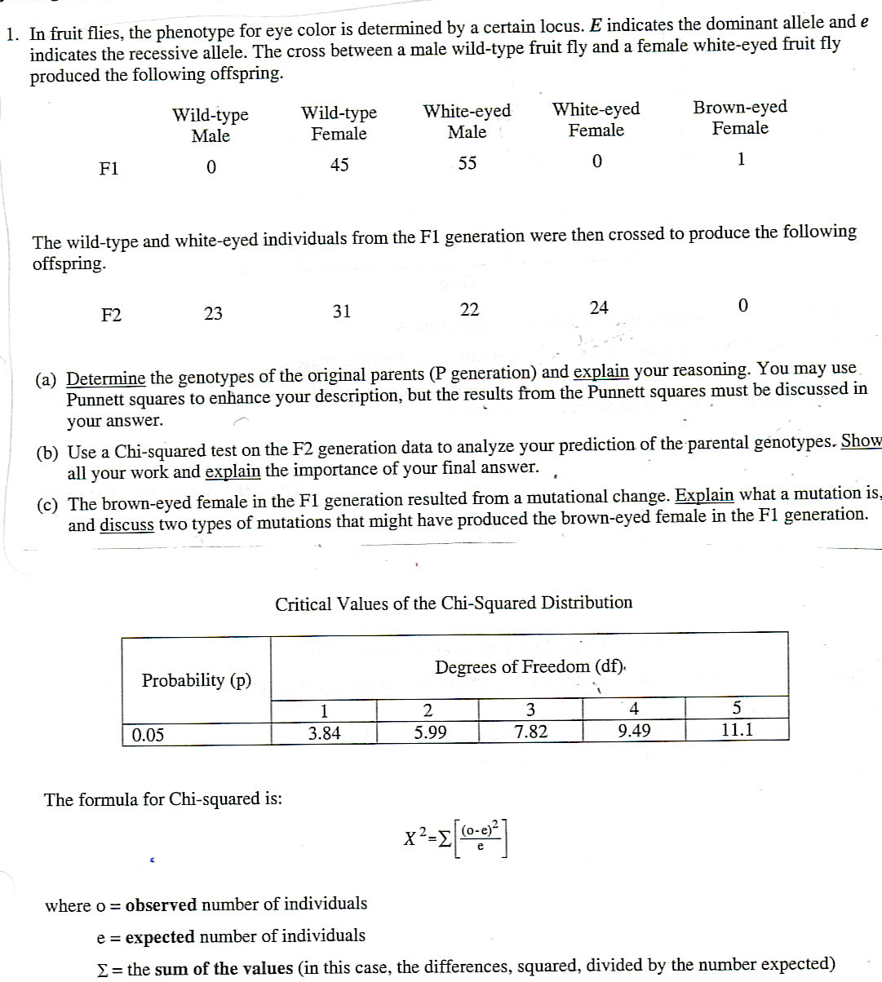

#30 (1993)

Assume that a particular genetic condition in a mammalian species causes an inability to digest starch. This disorder occurs with equal frequency in males and females. In most cases, neither parent of affected offspring has the condition.
a. Describe the most probable pattern of inheritance for this condition. Explain your reasoning. Include in your discussion a sample cross(es) sufficient to verify your proposed pattern.
b. Explain how a mutation could cause this inability to digest starch.
c. Describe how modern techniques of molecular biology could be used to determine whether the mutant allele is present in a given individual.

NATURAL SELECTION and EVOLUTION

#72 (1990)
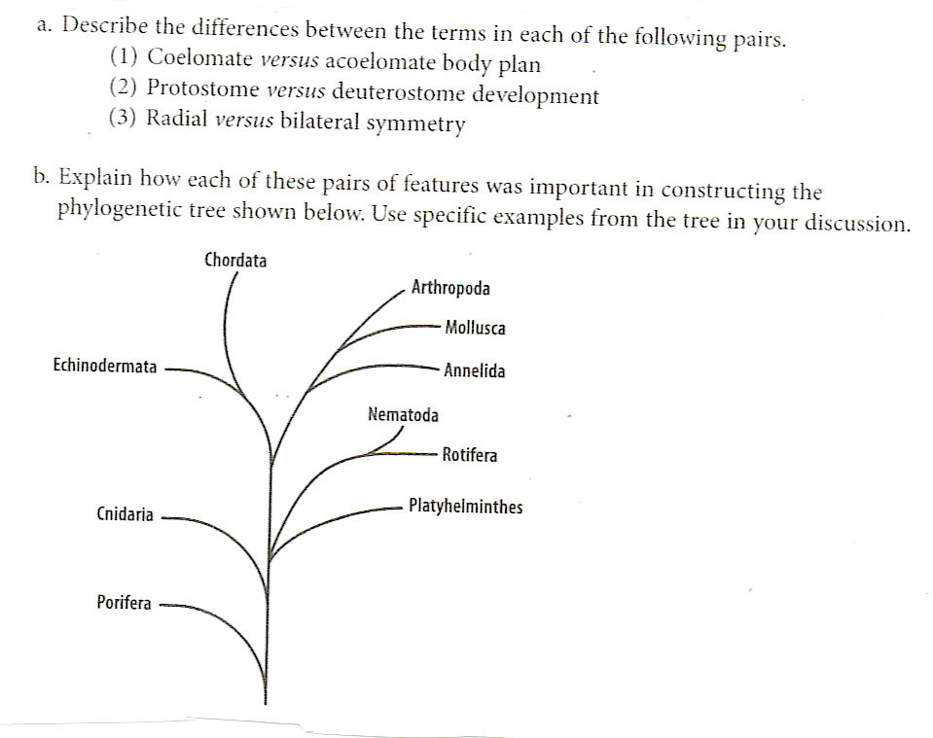

#31 (2004)

Darwin is considered the “father of evolutionary biology”. Four of his contributions to the field of evolutionary biology are listed below.

The nonconstancy of species
Branching evolution, which implies the common descent of all species
Occurrence of gradual changes in species
Natural selection as the mechanism of evolution

a. For EACH of the four contributions listed above, discuss one example of supporting evidence.

b. Darwin’s ideas have been enhanced and modified as new knowledge and technologies have become available. Discuss how TWO of the following have modified biologists’ interpretation of Darwin’s original contributions.
Hardy Weinberg equilibrium
Punctuated equilibrium
Genetic engineering

#32
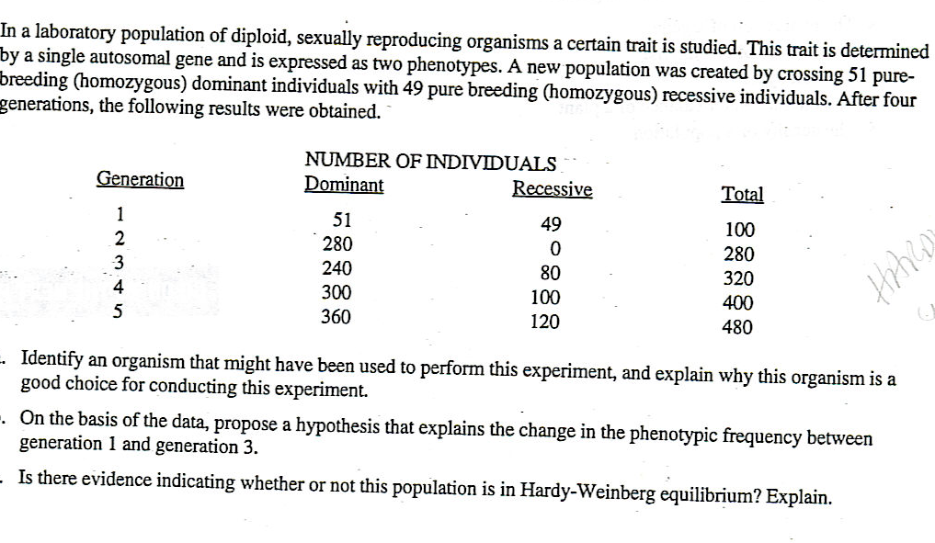

#33 (1999)

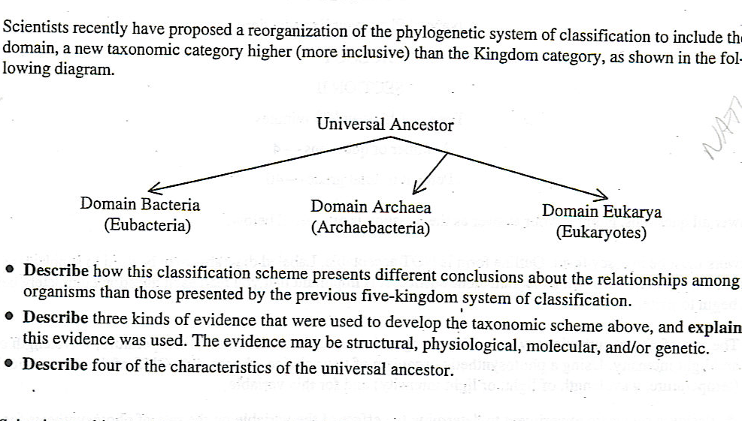
#34 (2001)

Charles Darwin proposed that evolution by natural selection was the basis for the difference that he saw in similar organisms as he traveled and collected specimens in South America and on the Galapagos Islands.

a. Explain the theory of evolution by natural selection as presented by Darwin.

b. Each of the following relates to an aspect of evolution by natural selection. Explain three of the following.
i. Convergent evolution and the similarities among species (ecological equivalents) in a particular biome ( for example, tundra, taiga, etc)
ii. Natural selection and the formation of insecticide resistant insects or antibiotic resistant bacteria.
iii. speciation and isolation
iv. natural selection and behavior such as kinesis, fixed action pattern, dominace hierarchy, etc.
v. natural selection and heterozygote advantage

#35 (2004)

Darwin is considered the “father of evolutionary biology”. Four of his contributions to the field of evolutionary biology are listed below.

The nonconstancy of species
Branching evolution, which implies the common descent of all species
Occurrence of gradual changes in species
Natural selection as the mechanism of evolution

a. For EACH of the four contributions listed above, discuss one example of supporting evidence.

b. Darwin’s ideas have been enhanced and modified as new knowledge and technologies have become available. Discuss how TWO of the following have modified biologists’ interpretation of Darwin’s original contributions.
Hardy Weinberg equilibrium
Punctuated equilibrium
Genetic engineering

#36 (2003)
Biologists are interested in preserving the diversity of living organisms on the planet.
a. Explain THREE of the following processes or phenomena, using an appropriate example for each.
- mutation
- adaptive radiation
- polyploidy
- population bottlenecks
- growth of human populations

b. For each process or phenomenon you selected in a.., discuss its impact on the diversity of life on Earth.

#37 (1994)
Genetic variation is the raw material for evolution.
a. Explain three cellular and /or molecular mechanisms that introduce variation into the gene pool of a plant or animal population.
b. Explain the evolutionary mechanism that can change the composition of the gene pool.

#38
Select TWO of the following three pairs and discuss the evolutionary relationships between the two members of EACH pair you have chosen. In your discussion, include structural adaptations and their functional significance.
PAIR A : green algae and vascular plants

PAIR B: prokaryotes and eukaryotes

PAIR C: amphibians and reptiles

#39
The evolutionary success of organisms depends on reproduction. Some groups of organisms reproduce sexually, some reproduce asexually, and some reproduce both asexually and sexually.
a. Using THREE different organisms, give an example of one organism that reproduces sexually, one that reproduces asexually, and one that reproduces in both ways. For each example, describe two reproductive adaptations . The adaptations may be behavioral, structural and /or functional.

b. What environmental conditions would favor sexual reproduction? Explain. What environmental conditions would favor asexual reproduction? Explain.

#39 B

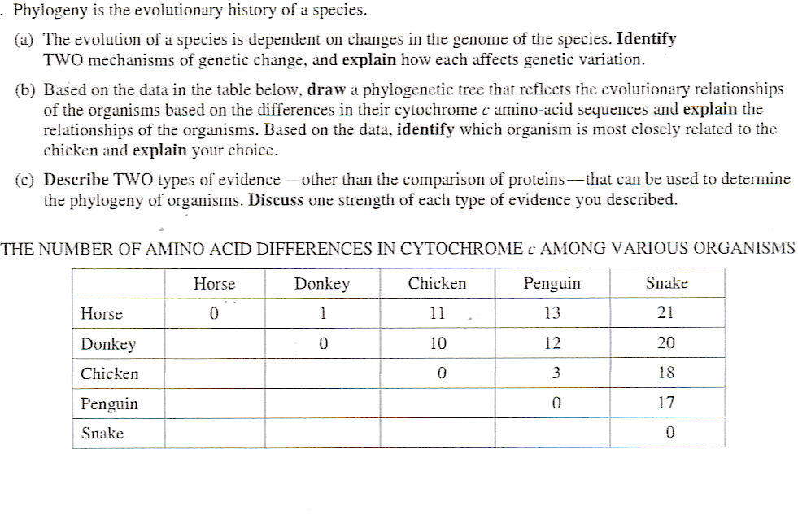

#40 (2005) – includes body system, embryology and/or plant info

In the evolution of organisms, major adaptations arose in certain groups, opening new evolutionary possibilities. For TWO of the following types of organisms, discuss the evolutionary significance of the features listed.
a. Flowering plants: flowers, fruits and seeds, broad leaves
b. Flatworms: three germ layers, bilateral symmetry, and cephalization
c. Segmented worms: segmentation, coelom, digestive system
d. Reptiles: amniotic egg, waterproof skin, and well-developed lungs

#41 (1995) – also body systems

The problems of survival of animals on land are very different from survival of animals in an aquatic environment . Describe 4 problems associated with animal survival in terrestrial environments but not in aquatic environments. For each problem, explain an evolutionary solution.

#42 ( 2004)

Prokaryotes are found throughout the biosphere. Answer two of the following.
a. Provide 3 examples of adaptations found in various prokaryotes. Explain how these three adaptations have ensured the success of prokaryotes.
b. Discuss how prokaryotes early in Earth’s history altered environments on Earth.

ECOLOGY

#43 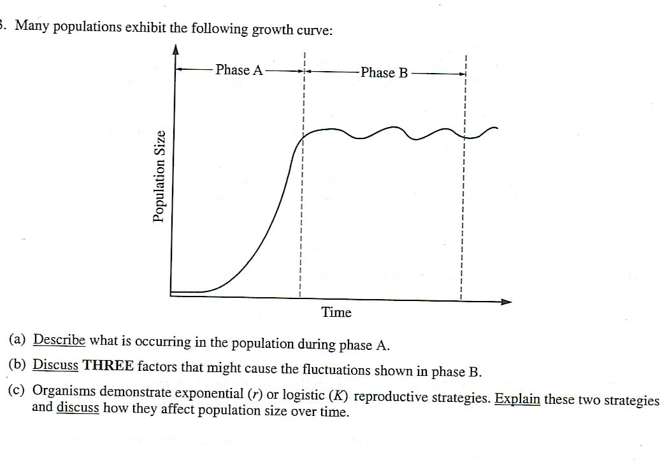

#44 (2005)
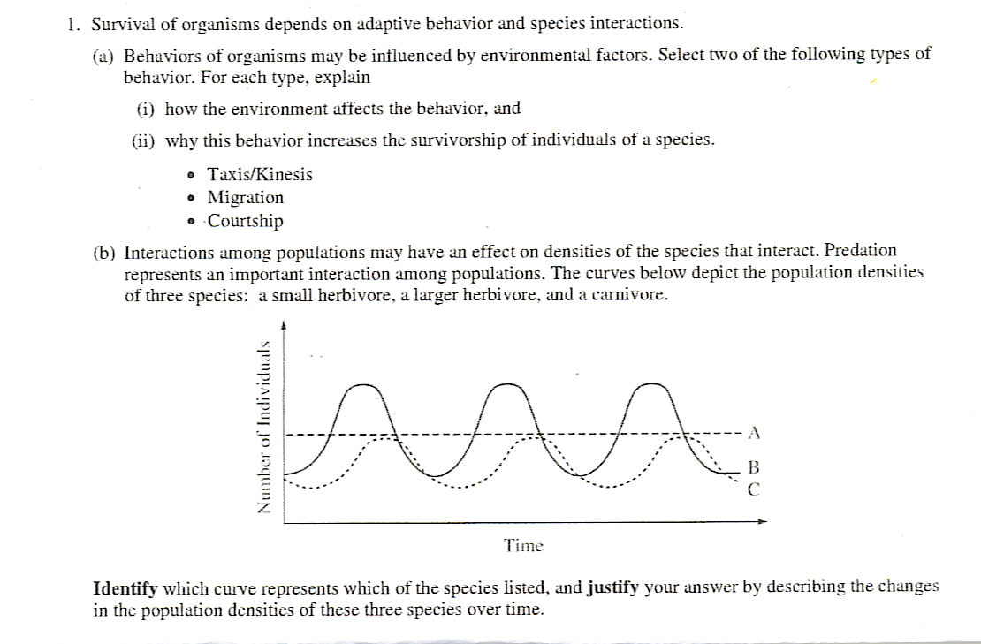

#45 (2007)
The energy flow in ecosystems is based on the primary productivity of autotrophs.
a. Discuss the energy flow through an ecosystem and relative efficiency with which it occurs.
b. Discuss the impact of the following on energy flow on a global scale.
- deforestation
- global climate change

#69 (2006)
In many ways, all organism in a food web can be said to be solar-powered. The producer level of the food web is responsible for the transformation of the solar energy into a form that can be used by other living organisms.
a. Discuss the role of green plants in transforming the Sun’s energy into a form that can be ultimately used by heterotrophs.
b. Discuss the flow of energy from producers through top carnivores in a food web in terms of the laws of thermodynamics .

#46 (2006)
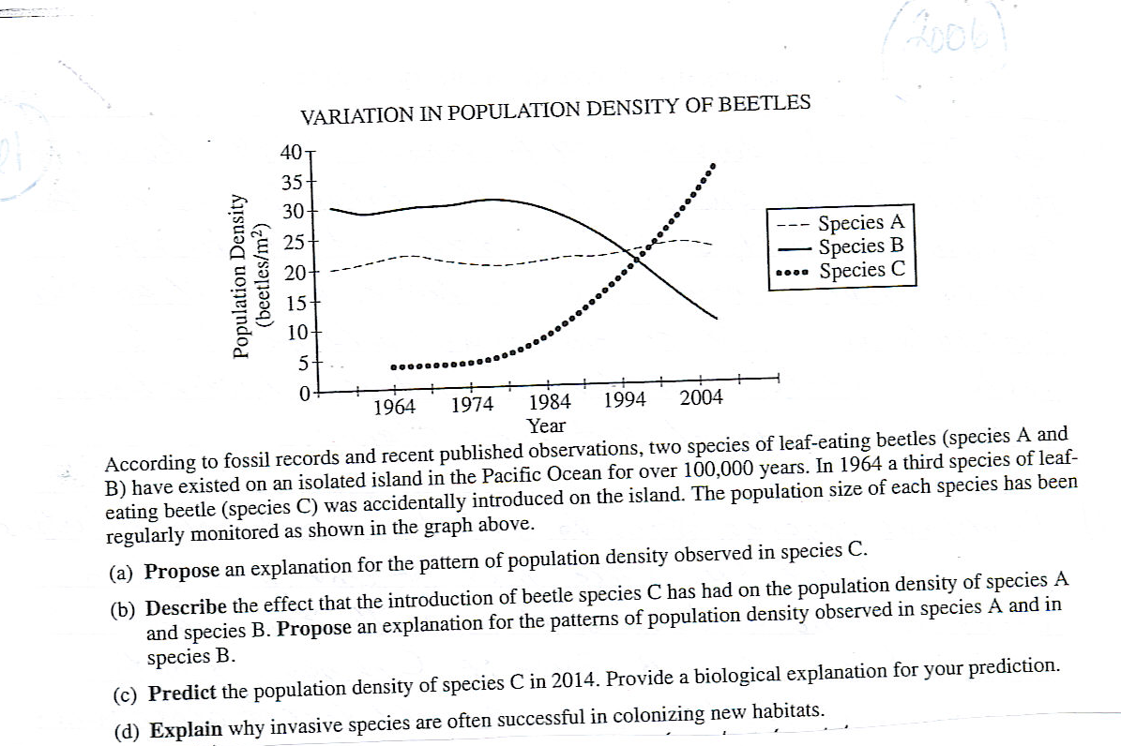

#47
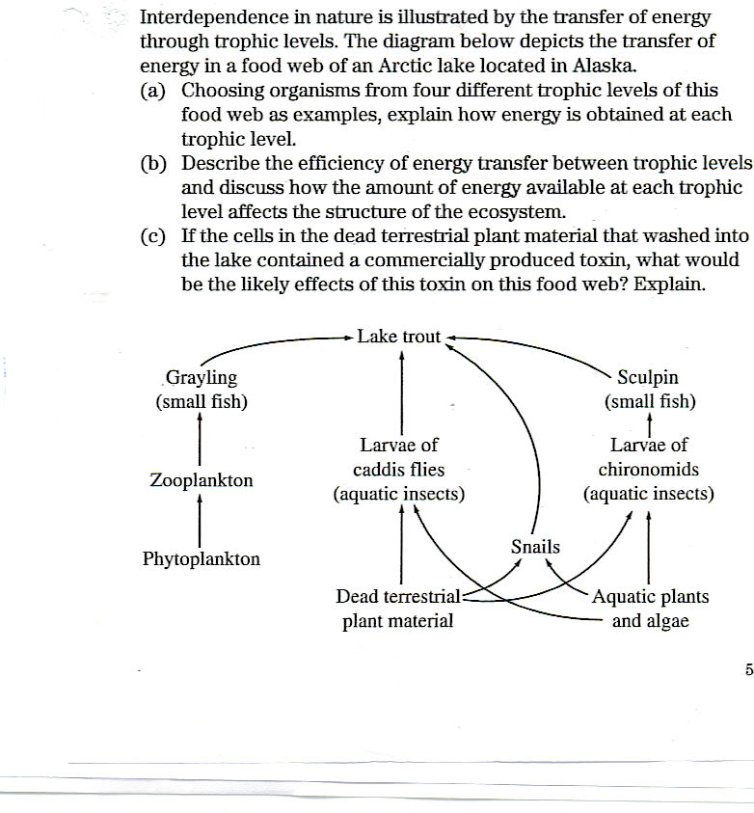
BODY SYSYEMS, STRUCTURE and FUNCTION, REGULATION, HOMEOSTASIS

#48 (2005)
An important defense against diseases in vertebrate animals is the ability to eliminate, inactivate, or destroy foreign substances and organisms. EXPLAIN how the immune system achieves THREE of the following:

- provides an immediate nonspecific immune response
- activates T and B cells in response to an infection
- responds to a later exposure to the same infectious agent
- distinguishes self from non-self

#49
The survival of organisms depends on regulatory mechanisms at various levels. Choose three from the following examples. Explain how each is regulated.
- the expression of a gene
- the activity of a gene
- The cell cycle
- The internal water balance of a plant
- The density of a population

#50 (2001)

In biological systems , structure and function are related. Choose three of the following components of organ systems.
Alveolus
Sarcomere
Nephron
Villus
Capillary
Neuron

a, For each component , describe the structure of the component and explain how that structure is responsible for the function of that component.

b. for the three components you chose in part a, explain how the structure of the component contributes to the functioning of the organ system to which it belongs.

#51 (2007)
Cephalization and the development of a brain were important steps in animal evolution
a. Duscuss the evolutionary origin and adaptive significance of cephalization in animal phyla
b. Describe the development of the nervous system in the vertebrate embryo.
c. At the sound of shattering glass, people quickly turn their heads. Discuss how the human nervous system functions to produce this type of response to an external
stimulus.

#52 (1993)
Many physiological changes occur during exercise.
a. Design a controlled experiment to test the hypothesis that an exercise session causes short-term increases in heart rate and breathing rat in humans. .
b. Explain how at least three organ systems are affected by the increased physical activity and discuss interactions among these organisms.

#53 (2003)
Regulatory (control) mechanisms in organisms are necessary for survival. Choose THREE of the following examples and explain how each is regulated .

- flowering in plants
- water balance in plants
- water balance in terrestrial vertebrates
- body temperature in terrestrial vertebrates

#54 (1996)
Structure and function are related in various organ systems of animals.
Select TWO of the following four organ systems in vertebrates:
- respiratory
- digestive
- excretory
- nervous

For each of the two systems you choose, discuss the structure and function of TWO adaptations that aid in the transport and exchange of molecules (or ions). Be sure to relate structure to function in each example.

#55 (2006)
The evolution of circulatory systems allowed more complex and larger animals to arise.
a. describe the respiratory and digestive systems’ specialized structures that facilitate the movement of oxygen and glucose into the circulatory system of mammals.
b. Explain how oxygen and glucose are transported within the circulatory system of mammals.
c. Explain the transfer of oxygen and glucose from the blood and into the active cells of mammals.

#56
The survival of organisms depends on regulatory mechanisms at various levels. Choose THREE from the following examples. Explain how each is regulated.
- the expression of a gene
- the activity of a gene
- the cell cycle
- the internal water balance of a plant
- the density of a population

#57 (1995)
Homeostasis, maintaining a steady-state internal environment, is a characteristic of all living organisms. Choose THREE of the following physiological parameters and for EACH, describe how homeostasis is maintained in an organism of your choice. Be sure to indicate which animal you have chose for each parameter. You may use the same animal or different animals for your three descriptions.
- blood glucose levels
- body temperature
- pH of the blood
- osmotic concentration of the blood
- neuron resting –membrane potential

#58 (2003)
Hormones play important roles in regulating the lives of many living organisms.
a. For TWO of the following physiological responses, EXPLAIN how hormones cause the response in plants.
- increase in height
- Adjustment to change in light
- adjustment to lack of water

b. For TWO of the following physiological response, EXPLAIN how hormones cause the responses in animals.
- increase in height
- adjustment to change in light
- adjustment to lack of water

# 59 (2007)
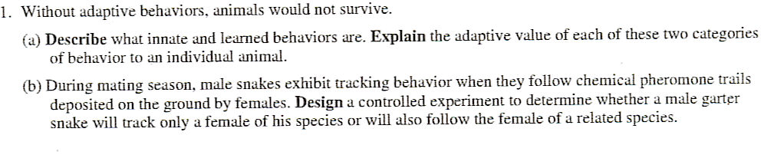

#60 (2007)
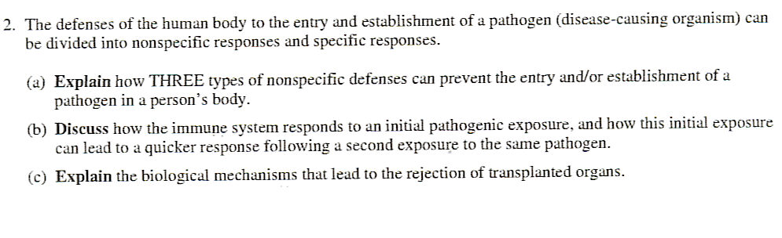

#61
Death is a natural and necessary part of life cycles at all levels of organization.
a. Discuss TWO examples of how cell death affects the development and functioning of a multicellular organism .
b. Discuss ONE example of how substances are degraded and reused in cells.
c. Discuss the evolutionary significance of death.

#61 B

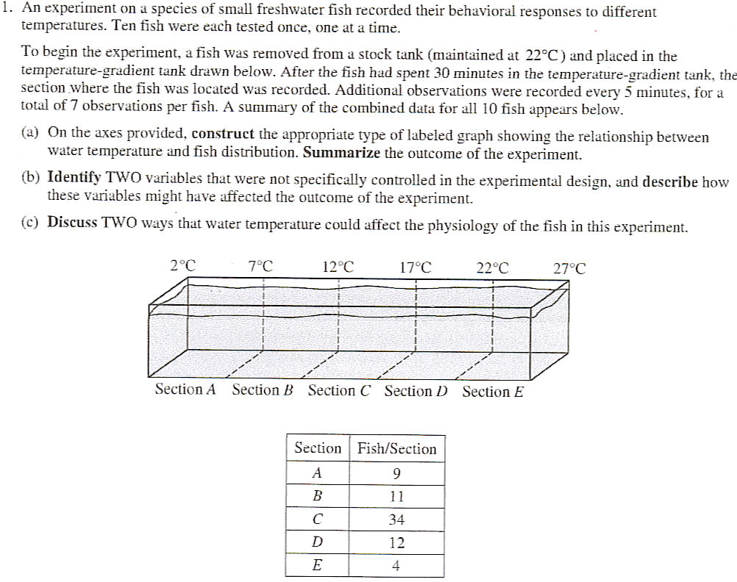
#75 (2002)
Bacteria were cultured in a system that allowed for the continual addition of fresh nutrients and the removal of waste products.
Bacteriophage (virus) were added at the time shown and the following population changes were observed.

#76 A triploblastic animal is one in which three germ layers form during embryonic development. Triploblastic animals include acoelomate, pseudocoelomate, and coelomate (eucoelomate) animals.
a. Identify the three germ layers of a triploblastic embryo and discuss the fates of these germ layers in embryonic development.
b. Describe acoelomate, pseodocoelomate, and coelomate body plans. Identify an animal that is representative of each of these types of body plans.
c. Compare and contrast the idgest vie systems of an acoelomate and a coelomate animal.

#77 To survive , organisms must be capable of avoiding , and or defending against various types of environmental threats. Respond to each of the following.
a. Describe how adaptive coloration, mimicry, or behavior function as animal defenses against predation. Include two examples in your answer.
b. Describe how bacteria or plants protect themselves against environmental threats. Include two examples in your answer.
c. Compare the human primary immune response with the secondary immune response to the same antigen.

#77B
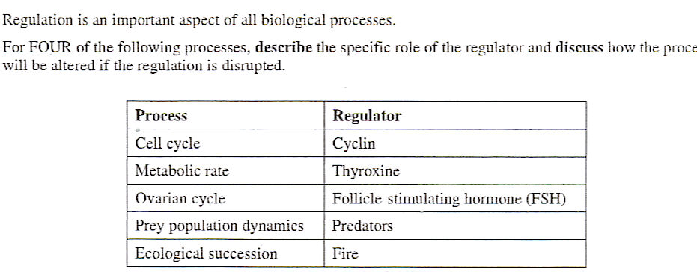

PLANTS, SYMBIOSIS

#62 (2005)
Angiosperms have wide distribution in the biosphere and the largest number of species in the plant kingdom.

a. Discuss the function of FOUR structures for reproduction found in angiosperms and the adaptive (evolutionary) significance of each.

b. Mosses (bryophytes) have not achieved the widespread terrestrial success of angiosperms . Discuss how the anatomy and reproductive strategies of mosses limit their distribution.

c. Explain alternation of generations in either angiosperms or mosses.

#63 (2006)

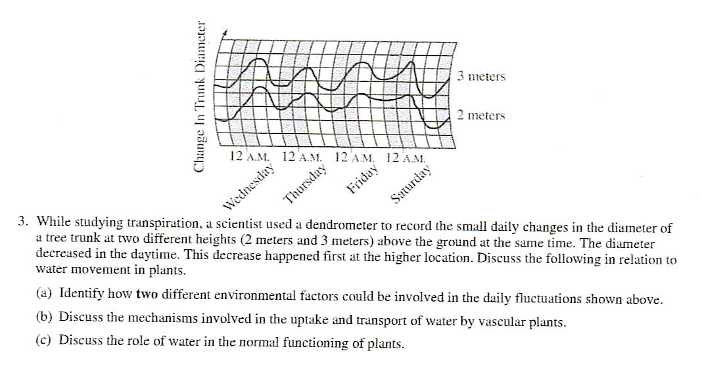

#64 (1995)

Angiosperms (flowering plants) and vertebrates obtain nutrients from their environments in different ways.
a. DISCUSS the type of nutrition and the nutritional requirements of angiosperms and vertebrates.
b. DESCRIBE TWO structural adaptations in angiosperms for obtaining nutrients from the environment. Relate structure to function.
c. Interdependence is evident in many species. EXPLAIN two symbiotic relationships that aid in nutrient uptake, using examples from angiosperms and /or vertebrates. (Both examples may be angiosperms, both may be vertebrates, or you may use one from each group).

#65 (2006)
The movement of water through plants is important to their survival.
a. EXPLAIN the mechanism of water movement through vascular plants during transpiration. Include a discussion of how the anatomy of vascular plants and the properties of water contribute to this process.
b. EXPLAIN how gas exchange affects transpiration.
c. DESCRIBE two adaptations that affect the rate of transpiration in desert plants.

#66
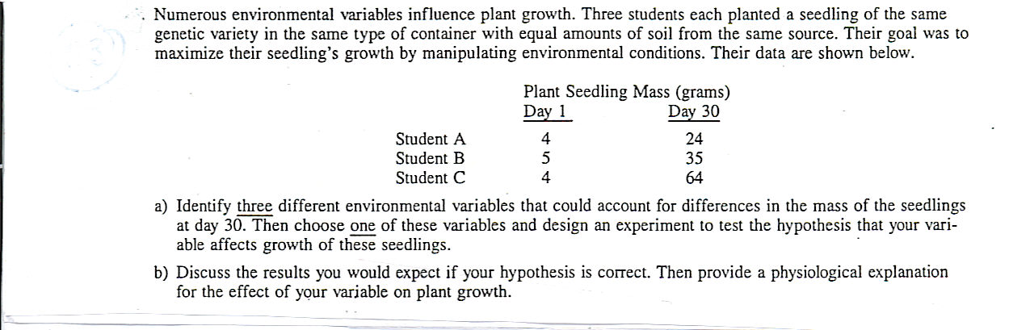

#67

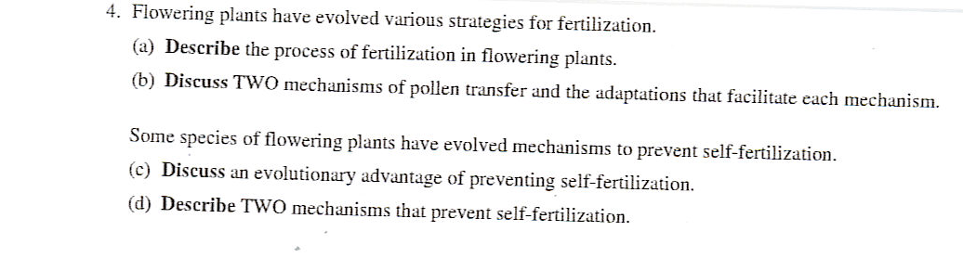

#70 (2004)
