Colony HS AJROTC
Cadet Handbook
& Standard Operating Procedures

“To Motivate Young people to be better citizens.”

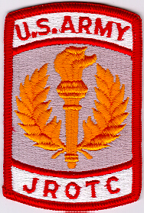

9550 E Colony Schools Drive
Palmer, AK 99645
http://www.matsuk12.us/page/10523

Updated: 22 Aug, 2013
Summary. This Standard Operating Procedure (SOP) Manual provides guidance for all JROTC cadets. This SOP supplements information in Army Regulation (AR) 145-2 Cadet Command Regulation (CCR) 145-2 and CCR 145-8-3.

Applicability. This SOP applies to all JROTC cadets at Colony High School. It covers the necessary information that is needed for all JROTC cadets to be successful in their positions.

Word Use. Will/Must - Indicates mandatory actions, formats or requirements. Should/Can - Indicates recommended procedures. May- Indicates it is at the discretion of the individual to choose whatever method best fits the given situation.

Suggested improvements. Send comments and suggested improvements to the Battalion XO.

Cadet Supplements. Cadet Reference Manual Third Edition

Contents
Memorandum for all cadets

Chapter 1
Introduction Paragraph Page

Purpose 1-1 7
Enrollment 1-2 7
Mission 1-3 7
JROTC Room Rules 1-4 7
Course Curriculum 1-5 7
Policies 1-6 8
Discipline 1-7 8
Withdrawal 1-8 8
Military Service and College Opportunities 1-9 9

Chapter 2
Duties and Responsibilities Paragraph Page

Cadet Battalion Commander 2-1 10
Cadet Executive Officer 2-2 11
Cadet Sergeant Major 2-3 11
Cadet Battalion S1 2-4 12
Cadet Battalion S2 2-5 12
Cadet Battalion S3 2-6 13
Cadet Battalion S4 2-7 13
Cadet Battalion S5 2-8 14
Cadet Battalion S6 2-9 14
Cadet Battalion CE 2-10 15
Cadet Company Commander 2-11 15
Cadet First Sergeant 2-12 16
Platoon Leadership 2-13 16
“Floaters” or Battalion Staff Within a Platoon 2-14 17

All Knights Cadets
2-15
17

Cadet in Charge (CIC)
2-16
17

Positional Reassessment
2-17
18

When Necessary Parts Are Not Met 18

2-18

Chapter 3
Extra-Curricular Teams Paragraph Page

Color Guards 3-1 19
Flag Detail 3-2 19
Honor Cordon/Saber Team 3-3 20
Bowling Tournament 3-4 20
JROTC Cadet Challenge 3-5 21
WACKO Decathlon 3-6 21
Drill Teams 3-7 22
Recondo 3-8 23
ASAA Rules 3-9 23

Chapter 4
Promotions/Demotions Paragraph Page

Philosophy of Promotions 4-1 24
Possible Rank per position 4-2 24
Recommendations 4-3 24
Board 4-4 24
Promotion 4-5 25
Merit/Performance Promotions 4-6 25
Exceptions 4-7 25
Demotions 4-8 26

Chapter 5
Cadet of the Month/Year Paragraph Page

Cadet of the Month 5-1 27
Recommendation 5-2 27
Procedure 5-3 27
Determining Cadet of the Month 5-4 27
Cadet of the Year 5-5 27
Awards of Cadet of the Month/Year 5-6 27

Chapter 6
Awards Paragraph Page

Ribbons 6-1 28
Unit 6-2 29
Medals 6-3 29
Cords 6-4 29
Arcs 6-5 30
Berets 6-6 31
Boots 6-7 31

Chapter 7
Merit / Demerit System Paragraph Page

Purpose 7-1 32
Recommendations 7-2 32
Procedure 7-3 32
Actions for Merits/Demerits 7-4 32
Use of Merits/Demerits 7-5 32
Exceptions 7-6 32

Chapter 8
Selection for Leadership Positions Paragraph Page

General Philosophy 8-1 33
Normal Progression (“In a perfect world”) 8-2 33
Factors Impacting Normal Progression 8-3 34
The Bottom Line 8-4 34

Chapter 9
JROTC Cadet Leadership Challenge (JCLC) Paragraph Page

Description 9-1 35
Attendance Requirements 9-2 35
Positions Within The “Company” 9-3 35
FAQ’s about JCLC 9-4 35

Chapter 10
Frequently Asked Questions (FAQ) Paragraph Page

Purpose 10-1 36
Questions 10-2 36

Chapter 11
Uniform Wear Paragraph Page

Rules for Uniform Wear 11-1 37
No wear of uniform 11-2 37
Upkeep, Maintenance, Exchange of Uniforms 11-3 37
Awards 11-4 37
Willful Disobedience and Neglect of the Uniform 11-5 37

Chapter 12
Physical Training/Cadet Challenge Paragraph Page

Basic information 12-1 38
Cadet Challenge 12-2 38
Cadet Challenge Awards 12-3 38
Rules for Physical Training 12-4 38

Chapter 13
Honor Board Paragraph Page

The Honor Board 13-1 39
Function and Procedure 13-2 39
Justification 13-3 39
Consequences 13-4 39

Annexes Page

Annex A: Supply Operations 40
Annex B Normal Cadet Career Progression 51
Annex C: Useful Web Sites 53
Annex D: Cadet Career Progression Sheet 54
Annex E: Saluting 55
Annex F: Colony JROTC Lettering Policy 56
Annex G: Uniform Wear and Appearance Policy 58
Annex H: Weapon Safety 66
Annex I: The Balance of Power in the Big Three 67
Annex J: Cadet Creed 68

Memorandum for all cadets, parents, and guardians

Welcome to Colony High School’s Army Junior ROTC. The high caliber of students who join our Battalion, the instructor cadre, and the support of the school administration, faculty, and military community are what makes us the best in the Far North. Our mission is to make better citizens out of our cadets. Army JROTC is NOT a recruiting effort for military service.

This is a 4 year program for which elective credits are awarded toward graduation. It is not necessary that a student take all 4 years AND the program may be entered starting in the 9th grade and beyond.
One of the reasons we are the best, is because the Cadet Chain of Command (from the squad leader all the way up to the Battalion Commander) is given the freedom and responsibility to run the Battalion. Cadet leaders do everything from instructing drill to teaching some classes. Through this, cadets will learn the value of teamwork as well as the satisfaction of individual accomplishments.

While in the classroom, cadets will receive training in citizenship, leadership, first aid, map reading, marksmanship, communicating, and many other subjects. Outside the formal classroom environment, cadets will learn about and practice leadership, responsibility, self-discipline, decision making, and time management. The cadet’s attitude will be THE determining factor in how enjoyable and beneficial your JROTC time will be. The uniform is worn every Monday.

The Corps of cadets is scheduled to do many things during the school year. As a member of the Knight Battalion, cadets will be expected to contribute some of their valuable time for the good of the entire battalion. Cadets will also work for the good of the community by helping in such things as highway clean-ups and community sponsored events. Our Color Guard performs at civic and school functions, parades, athletic events, and many other activities. Cadets may attend formal events such as the Military Ball, Dining out Awards Banquet, WACKO, Drill team, Recondo, and Summer Camp.

It will take a lot of hard work and dedication by the corps of cadets to maintain our “Honor Unit with distinction” status. With your ability and active participation, and the quality of the returning Cadet Leaders, we are confident that our Battalion will continue to be the BEST.

GERALD R. DIOTTE DEREK S. HEAVENER
LTC USA (Ret) 1SG USA (Ret)
Senior Army Instructor Army Instructor
Colony High School Colony High School

Chapter 1 – Introduction

1-1. Purpose
This SOP sets policy, assigns responsibilities and provides guidance for the JROTC cadets of the Knight Battalion. This document will answer any and all questions that a cadet or a parent may have about the JROTC program at CHS. This is a living document and it is not set in stone. Turn in any requests for changes to the Executive Officer

1-2. Enrollment
a. Participation in the JROTC program is voluntary and open to all students, male and female. In addition, students must be in the 9th grade or above, of good moral character, physically fit, and citizens of the United States (Waivers may be obtained on citizenship). Uniforms and all course material are issued by the JROTC Department.

b. For participation in any extra-curricular activities in JROTC the cadet must meet the minimum ASAA requirements for extra-curricular activities. Please see 3-10. ASAA Rules for the requirements. The SAI and AI may assist with further questions.

1-3. Mission
Knight Cadets are required to help the JROTC instructors meet the Cadet Command JROTC mission “To motivate young people to become better citizens.” Cadets will continually strive to meet or exceed all expectations and/or requirements set forth in Cadet Command Regulations and Policies. The Knight Battalion is a strong supporter of the school and community through various support activities.

1-4. JROTC Room Rules
a. No electronic equipment is to be seen during class (including ear buds)
b. No sitting on desks or feet on desks
c. No horseplay
d. No Gum during any JROTC function including during class and in uniform
e. No Hats/Hoods
f. School Rules Apply
g. No spinning of rifles in the class rooms
h. No spinning of regulation or color guard rifles
i. When moving down the hallway with a rifle, the bearer must be at the position of port arms
j. No carrying of more than two rifles in the hall (see Annex H)
k. The cadet staff area is for cadet staff only
l. The cadet staff area is to be kept clean at all times and sanitary (I.E. no perishable food left overnight)
m. The uniform locker located near Colonel’s door is for UNIFORM ITEMS ONLY (I.E. no shoes, no ACUs, no personal items, etc.).
n. No items are to be left overnight in either classroom unless previous authorized by the SGM or the SAI/AI regardless of rank or position
o. The battalion staff closet is for personal items and drill shoes (as long as they remain sanitary)

1-5. Course Curriculum
The course curriculum of the Knight Battalion contains many subjects and is subject to change.

a. LET 1 course curriculum may include

- Rank Identification
- Corps of cadet structure
- Flag Etiquette
- Followership
- Communications

b. LET 2, 3, 4 course curriculum may include

- Map reading
- Financial Planning
- Military History
- U.S. Government

c. All LET levels course curriculum may include

- First Aid/CPR/AED
- Marksmanship
- Physical Fitness
- Drill and Ceremonies
- Uniform Wear
- Leadership
- Citizenship
- Communication Styles
- Decision Making
- Time Management

1-6. Policies
See Cadet Command Program of Instruction

1-7. Discipline
- Discipline is best defined as those conditions and attitudes of people which contribute to orderliness among one another. Obedience by subordinates to superior ranking cadets or cadets in positions of higher authority and responsibility is that degree of self control exercised by each individual.
- Discipline, as is the case with courtesy, is the hallmark of any effective, proud and efficient unit. Discipline is a two way process: that is superiors have a responsibility to exercise mature judgment, courtesy, and patience with the subordinates. Their need to exercise self control applies in controlling the emotions and to maintain a calm, deliberate and temperate manner in their personal official relationships with subordinates. Subordinate cadets have the need to be restrained in their manner so as to assure courteous attitudes at all times in their relationships with their superiors.

1-8. Withdrawal
a. Removal – In accordance with CCR 145-2, and the discretion of the SAI, cadets will be removed from the program if applicable.

b. Dropping of JROTC – To drop JROTC you must see your guidance counselor to drop the class. This may occur in the middle of a semester by Instructor approval or at the end of semester by parent and guardian approval. To drop JROTC you MUST turn in your uniform before you drop the program. If you fail to turn in your uniform you will have a block on your transcripts until the uniform is turned in or paid for.

1-9. Military Service and College Opportunities
a. Enrollment in the Junior ROTC program in NO way obligates a student for military service. Our mission is to help cadets to be better citizens: we are not here to recruit for any service. However, it is possible for the student to be recommended for advanced rank at enlistment, and/or credit for a position in the Senior ROTC program offered by colleges and universities, or for appointment to one of the service academies. In accordance with CCR 145-2 graduating cadets completing two, three, or four years of JROTC may be recommended for advanced rank in the regular components of the US Army, Air Force, Navy, or Coast Guard.
COMPLETION OF GRADE STATUS
2 years Private (E2)
3-4 years Private First Class (E3) SAI Recommended

b. Those cadets completing four years of the JROTC program may be recommended for placement credit toward completion of the Senior ROTC program. Army four year scholarships or one of a lesser number are available for application. Winners of these scholarships receive $250 per month plus payment for tuition, books, lab fees, and other authorized expenses.

c. Academies – Outstanding Army JROTC cadets may be nominated by the SAI for competitive appointment to one of more of the Service Academies, i.e., US Military Academy, US Navy Academy, US Air Force Academy, that are available for Honor Unit Awardees. Appointments are also available to the US Merchant Marine Academy.

Chapter 2 - Duties and Responsibilities
a. The JROTC program is unique in that much of the day to day running of the battalion is accomplished through the work of cadet leadership. The cadet leadership has the key responsibility to develop cadets into better citizens. The commitment, time and work put into the JROTC program may lead to the gain of a leadership position.
b. The purpose and function of the battalion organization is to provide cadets with practical experience and knowledge of the leadership and managerial skills in life. Cadets at each level of the chain of command will be expected to accept the responsibilities of their positions. All cadets are eligible for any position in the battalion. Certain positions may require certain stipulations. You can see the normal progression for a cadet within the Corps in Annex A. The authority to exercise command within the corps of cadets is vested primarily in the cadet officers. The responsibility of command, maintenance, and discipline normally rests with the senior cadet present but other cadets may be designated as temporary commanders for the purposes of instruction. The proper functioning of the cadet battalion, like any organization, is dependent on a few basic fundamentals. Each member must know his job and its location within the organization. He/she must be aware of the necessity of producing quality results and maintaining the battalion. The following paragraphs describe the key leadership positions within the corps of cadets.

2-1. Battalion Commander (Rank Base = C/LTC)
a. Duties and responsibilities include, but are not limited to the following:
- Command the Battalion, by taking responsibility for everything the Battalion accomplishes or fails to accomplish and making use of the subordinate chain of command (delegation) to conduct all operations.
- Organize, train the battalion to accomplish the JROTC mission Statement and instill the JROTC core abilities
- Lead by example; the primary role model for appearance, behavior, and attitude for the entire Battalion.
- Develop the battalion leadership team with the BN XO and SGM
- Provide input and be present at weekly Staff and Headquarters meeting
- Coordinate with the JROTC instructors and provide guidance to the JROTC executive officer, sergeant major, and leadership for the planning and execution of all JROTC events.
- Develop goals for the Battalion, and oversee the progress towards those goals.
- Coordinate with the JROTC instructors to be the final decision authority for JROTC staff actions, promotion boards, and JROTC cadet issues.

b. Requirements
- Maintain at least a 3.0 Cumulative GPA
- Be passing All classes
- Have the commitment and after school time required to command the battalion.
- Meet requirements as stated in chapter 9 – selection for leadership positions The BC can always be distracted with bubbles.

c. Restrictions
- Can not take control of the staff
- Can not pull rank with the other Big Three Members
- Can not take over company and classroom affairs
- Can not authorize personal items to be left over night
- Can not make solitary decisions that affect the rest of the corps, the rest of the Big Three must be informed and consulted
2-2. Battalion Executive Officer (Rank Base = C/MAJ)
a. Duties and responsibilities include, but are not limited to the following:
  - Take command of the Battalion in the Battalion Commander’s absence.
  - Supervise the JROTC staff.
  - Directs and runs the weekly staff meetings
  - Coordinate with the JROTC instructors and the Battalion Commander to prioritize staff actions.
  - Be prepared to brief and escort VIP’s to the JROTC program.
  - Voice the staffs concern at the weekly Command and Staff meetings as well as provide direction to staff members
  - Help develop the battalion leadership team with the BN CDR and SGM
  - Maintain and edit the SOP as necessary

b. Requirements
- Maintain at least a 3.0 Cumulative GPA
- Be passing all classes
- Have the commitment and after school time required to command the battalion.
- Meet requirements as stated in chapter 9 – selection for leadership positions

c. Restrictions
- Can not take over company or classroom affairs
- Can not order the company leadership around, they must go through the SGM or BC
- Can not be excessively absent in the work with the staff
- Can not postpone staff meetings indefinitely
- Can not make solitary decisions that affect the rest of the corps, the rest of the Big Three must be informed and consulted

2-3. Battalion Sergeant Major (Rank Base = C/SGM)
a. Duties and responsibilities include, but are not limited to the following:
- Responsible for planning and manning the proper execution of ALL color guards
- Be the Battalion expert on Drill and Ceremony.
- Spot check cadets before/during/after school compliance of uniform SOP on uniform wear day
- Advise the Battalion Commander on issues pertaining to enlisted cadets.
- Attend JROTC staff and headquarters meetings and provide input as necessary to insure that the interests of enlisted cadets are represented.
- Plan, establish, and maintain the Battalion’s merit / demerit system, promotion and Cadet of the Month policies.
- Provide input and guidance at weekly staff meetings
- Schedule and provide oversight of the daily flag detail and community color guards
- Be prepared to brief and escort VIP’s to the JROTC program.
- Establish, schedule, plan and develop Promotion and Cadet of the Month/Year boards
- Direct NCO calls
- Help develop battalion leadership team with BN CDR and XO
- Enforce the SOP at all times

b. Requirements
- Maintain at least a 3.0 Cumulative GPA
- Be passing all classes
- Maintain current Color Guard commander’s cord (in a perfect world)
- Have the commitment and after school time required to command the battalion
- Meet requirements as stated in chapter 9 – selection for leadership positions

c. Restrictions
- Can not mandate cadets to sign up for a color guard without just cause
- Can not boss around the staff without going through the XO
- Can not take control of the company or classroom affairs
- Can not make solitary decisions that affect the rest of the corps, the rest of the Big Three must be informed and consulted

2-4. Battalion S1 (Rank Base = 1LT)
a. Duties and responsibilities include, but are not limited to the following:
- Ensure that all requirements on the S1 section of the Cadet Formal Inspection checklist are met at all times.
- Maintain active cadet records in the JUMS program.
- Maintain inactive cadet records in JUMS, or paper copies for cadets not entered in JUMS as required.
- Produce JUMS generated orders for all promotions, demotions, merits, demerits and cadet awards.
- Produce and publish the reports (e.g. enrollment, intentions of grads)
- Maintain cadet administrative records, and ensure they contain all required documents.
- Coordinate with the Company Commanders to ensure cadet portfolios are being checked against the current Cadet Command standards.
- Attend cadet staff meetings, and be prepared to discuss any JROTC issues from the S1 perspective.
- Coordinate with the S4 for award orders and promotions

b. Requirements
- Maintain at least a 2.5 Cumulative GPA
- Be passing all classes
- Dedication and time commitment to the Corps of cadets
- Meet requirements as stated in chapter 9 – selection for leadership positions

2-5. Battalion S2 (Rank Base = 2LT)
a. Duties and responsibilities include, but are not limited to the following:
- Attend cadet staff meetings, and be prepared to discuss any JROTC issues from the S2 perspective.
- Produce and maintain the JROTC upcoming events calendar
- Coordinate with the S4 to conduct monthly sensitive item inventories.
- Community/school service hours upkeep and posting
- Coordinate with organization heads requesting JROTC assistance
- Keep records of community service completed by cadets
- Designate CIC for community/school service events when no leadership volunteers
- Serve as the Battalion’s risk assessment officer
- Tag all government equipment to distinguish it from school property.

b. Requirements
- Maintain at least a 2.5 Cumulative GPA
- Be passing all classes
- Dedication and time commitment to the Corps of cadets
- Meet requirements as stated in chapter 9 – selection for leadership positions

2-6. Battalion S3 (Rank Base = 1LT)
a. Duties and responsibilities include, but are not limited to the following:
- Assist the S1 with maintaining paper cadet records
- Produce and publish the company, weekly and yearly training schedules.
- Maintain the training portion of the cadet file
- Ensure that all requirements on the S3 section of the Cadet Formal Inspection checklist are met at all times.
- Produce and publish planning documents for all JROTC activities, not later than two weeks prior to the activity.
- Maintain file copies of all coordination with the school and community for any support requested by the Knight Battalion.
- Update the Unit Report in the JUMS program after every Unit Report event executed by the Knight Battalion.
- Attend cadet staff meetings, and be prepared to discuss any JROTC issues from the S3 perspective.
- Update and maintain Cadet Challenge information in the JUMS program.
- Gather companies physical training input at staff meetings for training schedule
- Keep a record of staff meeting notes at all times on record.

b. Requirements
- Maintain at least a 2.5 Cumulative GPA
- Be passing all classes
- Dedication and time commitment to the Corps of cadets
- Meet requirements as stated in chapter 9 – selection for leadership positions

2-7. Battalion S4 (Rank Base = 1LT)
a. Duties and responsibilities include, but are not limited to the following:
- Planning coordinating supervising Supply operations
- Issues, turn-in, and exchanges of Uniform clothing/accouterments
- Coordinate with the S2 to conduct monthly sensitive item inventories.
- Ensure that all requirements on the S4 section of the Cadet Formal Inspection checklist are met at all times.
- Coordinate with the JROTC instructors to input all JROTC equipment and uniform information into the JUMS program.
- Produce and maintain a signed, JUMS generated, clothing record for every active cadet.
- Maintain an accurate inventory (shelf) of all JROTC uniform items. Primary system is the JUMS program; secondary system is a manual inventory maintained in the Supply Room.
- Coordinate with the JROTC instructors to ensure that the Property Book matches the number and serial numbers of the items on hand.
- Organize and maintain the Supply Room in an efficient manner; and ensure the area is free from unsafe setups and fire hazards.
- Attend cadet staff meetings, and be prepared to discuss any JROTC issues from the S4 perspective.
- Coordinate with the S1 for orders to document promotions and awards issue.
- Maintain documentation demonstrating coordination with the cadet leadership and staff for all supply matters.

b. Requirements
- Maintain at least a 2.5 Cumulative GPA
- Be passing all classes
- Dedication and time commitment to the Corps of cadets
- Meet requirements as stated in chapter 9 – selection for leadership positions

2-8. Battalion S-5 (Rank Base = 2LT)
a. Duties and responsibilities include, but are not limited to the following:
- Attend cadet staff meetings, and be prepared to discuss any JROTC issues from the S5 perspective.
- Public affairs (publicizing the corps)
- Upkeep and Maintain the Yearly Scrapbook
- Insure Room/Display case décor is up to date and appealing
- Ensure that all requirements on the S5 section of the Cadet Formal Inspection checklist are met at all times.
- Produce and publish monthly JROTC newsletters that inform cadets, students, parents, and school administrators of past, current, and future JROTC activities and accomplishments.
- Coordinate to have JROTC information published in the school and local newspapers. Maintain documentation of all requests for articles and published articles.
- Maintain the JROTC bulletin board and trophy cases throughout the school to advertise JROTC activities and promote higher enrollment.
- Coordinate with the JROTC instructors, S3 and elementary schools to conduct Feeder School visits to each Feeder School at least twice a year.

b. Requirements
- Maintain at least a 2.5 Cumulative GPA
- Be passing all classes
- Dedication and time commitment to the Corps of cadets
- Meet requirements as stated in chapter 9 – selection for leadership positions

2-9 Battalion S-6 (Rank Base = 2LT)
- Duties and responsibilities include, but are not limited to the following:
- Recruiting new cadets into the battalion
- Coordinate with the various middle school representatives (Principal, Vice-Principal, and Representatives) in the Mat-Su Valley to bring new cadets into the program
- Fundraising for the Battalion and developing plans for fundraising.
- Oversee the execution of fundraising plans and prepare an AAR for the JROTC instructors
- Recruiting with the help of drill team commanders for publicity events
- Coordinate with the CE and S5 to create videos for use of publicity
- Command a recruiting team for use of recruiting and fundraising events
- Coordinate with S5 for advertisement of the JROTC program

- Requirements
- Maintain at least a 2.5 Cumulative GPA
- Be passing all classes
- Dedication and time commitment to the Corps of cadets
- Meet requirements as stated in chapter 9 – selection for leadership position

2-10. Battalion CE (Rank Base = 2LT)
a. Duties and responsibilities include, but are not limited to the following:
- Upkeep and accountability of Computer and Electronic equipment
- Organize and Develop the CFI cadet briefing slideshow
- Coordinate, organize, develop, and publicize the Life of a Cadet video slideshow presentation
- Coordinate with the S5 establish and maintain a Knight Battalion website.
- Attend cadet staff meetings, and be prepared to discuss any JROTC issues from the CE perspective.
- Coordinate with the S6 to create recruiting videos
- Any necessary videography including drill meets and extracurricular activities
- Keep the Colony JROTC instructors’ pages and the Facebook page updated

b. Requirements
- Maintain at least a 2.5 Cumulative GPA
- Be passing all classes
- Dedication and time commitment to the Corps of cadets
- Attend cadet staff meetings, and be prepared to discuss any JROTC issues from the S3 perspective.

2-11. Company Commanders (Rank Base = 1LT)
a. Duties and responsibilities include, but are not limited to the following:
- Ensure that any “down” time is properly used to the best ability by coordinating with the platoon leader and platoon sergeant
- Command the Company, by taking responsibility for everything the Company accomplishes or fails to accomplish and making use of the subordinate chain of command to conduct all operations.
- Coordinate with the Battalion Commander and the Battalion Staff to organize and direct Company personnel to accomplish all required activities.
- Lead by example; the primary role model for appearance, behavior, and attitude for the Company.
- Attend weekly staff and headquarters meetings
- Ensure that all cadets in the Company are maintaining JROTC cadet portfolios, and they contain the minimum requirements as stated in CCR 145-2, Chapter 2.
- Inspect cadets in the Company to insure they meet appearance standards.
- Coordinate with the Knights SGM and S1 for cadets in your Company for merits and demerit updates.
- Recommend cadets for the promotion board, cadet of the Month board, and awards.
- Plan and coordinate weekly PT with S-3

b. Requirements
- Maintain at least a 2.5 Cumulative GPA
- Be passing all classes
- Dedication and time commitment to the Corps of cadets
- Meet requirements as stated in chapter 9 – selection for leadership positions

2-12. Company First Sergeants (Rank Base = SFC)
a. Duties and responsibilities include, but are not limited to the following:
- Ensure that any “down” time is properly used to the best ability by coordinating with the platoon leader and platoon sergeant
- Assist the Company Commander to oversee Company activities and tasking.
- Perform as the primary drill and ceremony instructor for the Company.
- Lead by example; the primary role model for appearance, behavior, and attitude for the Company.
- Assist Company Commander with recommending company leadership positions
- Inspect cadets in the Company to insure they meet appearance standards.
- Coordinate with the Knight SGM and S1 for cadets in your Company Commander for merits and demerit updates.
- Recommend cadets for the promotion board with the Company Commander.
- Ensure company attendance is properly recorded
- Help plan, coordinate PT; supervise execution of PT
- Coordinate with the Company Commander on the issues and achievements of the other platoon
- Attend weekly staff and headquarters meetings

b. Requirements
- Maintain at least a 2.5 Cumulative GPA
- Be passing all classes
- Dedication and time commitment to the Corps of cadets

2-13. Platoon Leadership (PL and PS)
a. Duties and responsibilities include, but are not limited to the following:
- Ensure that any “down” time is properly used to the best ability
- Lead by example; the primary role model for appearance, behavior, and attitude for the Platoon
- Attend weekly staff and headquarters meetings (not required, highly recommended)
- Inspect cadets in the Platoon to insure they meet appearance standards.
- Coordinate with the Company First Sergeant for cadets in your Platoon for merits and demerit
- Plan and coordinate weekly PT with the Company First Sergeant and Company Commander
- Recommend cadets for the promotion board and Cadet of the Month Board.
- Ensure Platoon attendance is properly recorded
- Help plan, coordinate PT; supervise execution of PT
- The Platoon Leader is to function as the S1 and S4 representative for each hour

b. Requirements
- Maintain at least a 2.0 Cumulative GPA
- Be passing all classes
- Dedication and time commitment to the Corps of cadets
- Ensure that any “Down” time is properly used to the best ability
- Be prepared

2-14. “Floaters” and Battalion Staff within Company Leadership
a. Duties and responsibilities include, but are not limited to the following:
- Floaters shall not interfere in the affairs and issues of the company and/or platoon unless specifically asked by company leadership.
- Lead by example; the primary role model for appearance, behavior, and attitude for the hour
- Full participation within the class is required and staff work is not to be conducted during instruction or required activities (I.E. PT, Drill and Ceremony, First-Aid) regardless of rank or position within the Battalion
- When requested to perform a task by company leadership, if within reason, it must be performed regardless of rank or position.
- Upper leadership that is not part of primary company leadership need to function as a TA as necessary and to do tasks appointed by the SAI and AI.
- Regardless of previous position, thou shalt not interfere with the platoon leadership and allow them to perform their designated duties without interference

b. Requirements
- To maintain a senior NCO or officer rank, they must maintain a 2.5 GPA
- Must maintain good moral standing with the corps of cadets

2-15. All Knight Cadets including ALL Leadership –
a. Duties and responsibilities include, but are not limited to the following:
- Follow the instructions of the JROTC instructors and cadet chain of command.
- YOU ARE NOT ALLOWED TO DROP CADETS UNDER ANY CIRCUMSTANCES.
- Strive to improve as a student and a citizen by fully participating in, and applying the lessons learned in JROTC.
- Wear the JROTC uniform on all uniform days and for designated JROTC activities; in accordance with the standards in the Cadet Reference Guide and Annex: Uniform SOP.
- Know and memorize the entire Cadet Creed and do your best to live by the JROTC Creed and Core Abilities.
- Remember that the Knight Battalion is a team and that your actions reflect on the entire Battalion inside and outside of the school at all functions.

b. Requirements
- Maintain good physical fitness
- Maintain good grades, a 2.0 is required to participate in ANY JROTC function except community service events.
- Follow the SOP at all times

2-16. Cadet-in-Charge (CIC)
a. Duties and responsibilities include, but are not limited to the following:
- No cadet is to sign up as CIC if they have never attended the event prior, unless this is the first time the event has been conducted
- Cadets participating in an event requiring a CIC are under the command of the CIC and are required to follow the commands of the CIC regardless of rank or position
- Paperwork/AAR’s are required to be completed and submitted within 2 school days of completion of the event. Not following this procedure will lead to the CIC’s community service hours for the event being cut in half. Not submitting an AAR within 5 school days of an event will result in the total community service hours of the cadet being cut in half and also a possibility of loss of privilege.
- Maintain accurate attendance and accountability of cadets at all times including contact numbers
- The Cadet in Charge is not allowed to leave the event until EVERYONE has left
- Participate in the event in some way, period
- Leaving the event or unprofessional attitudes or actions is not acceptable
- Must have the sign-up sheet with them at the event and be prepared to add on additional cadets and no-shows

b. Requirements
- Must be an LET 2, 3, or 4
- Must be an E4 at minimum
- Must be able to provide accurate and precise directions on how to get to the destination
- Must arrive least 15 minutes prior to the event fully prepared
- Must be in good moral standing within the corps
- Must maintain a minimum GPA of 2.0

2-17. Positional Reassessment
a. Events that may prompt an evaluation of a leadership positions
- Insubordination
- Grades
- Merits/Demerits
- Time Spent in the Position
- Attendance
- Misconduct
- Leaders transfer or drop JROTC

b. Procedure to evaluate a leadership position
- First conflict - Cadet to cadet, oral, no instructor, informal
- Second conflict - Cadet to cadet, oral, instructor
- Third conflict – Written conflict submitted SAI, See SAI for format
- Fourth conflict - Written conflict submitted to SAI, Evaluation by SAI on position evaluation
- Direct loss of leadership position may result by discretion of SAI.

2-18. When Duties, Responsibilities and Requirements Are Not Met
- Extra-curricular (I.E. Drill Team, Recondo, CIC Privileges) are taken away when the minimum GPA requirements are not met
- Possibility of demerits depending on repetition and severity of issue and possible demotion or expulsion from the program in extreme cases
- Probationary Period of ONE (1) quarter is granted to those to regain and maintain required GPA
- Any rank above SSG is revoked to SSG or previous enlisted rank if the cadets GPA requirement after probationary period is lower than a 2.0 (possible exceptions at the discretion of the SAI and/or the AI)
- Risk of loss of ability to command activities or participate in future activities
Chapter 3 – Extra Curricular Activities

3-1. Color Guard – Community/School
a. How to participate
- Normal participants – inform SGM about interest in color guard, become color guard trained at color guard practice and become Color Guard Certified.
- Commander participants – become color guard commander certified, sign up for a commander slot on a color guard team

b. Requirements to participate
- 2.0 grade point average
- Passing all classes
- Color Guard Certified
- Follow all rules set by the Cadet SOP
- Outstanding appearance and uniform wear grades
- Must be in exemplary cadet in the corps
- All color guard members must be rifle certified

- Duties
- Perform color guards in the community and school when needed in a highly professional manner.

d. Special Information
- Shined boots are allowed to be worn with the class A uniform if you have been awarded the Color Guard cord (awarded after participating in three color guards)
- Cadets who participate in off campus color guards will receive 2 hours of community service for each color guard
- Cadets who participate in on campus color guards will receive 1 hour of school service
- Alternates are required for off-campus color guards, and alternates which show up will receive half the amount of community service hours for the event if their services are not needed

e. Possible Awards (ONLY AVAILABLE AFTER PARTICIPATING IN THREE COLOR GUARDS)
- Color/Honor Guard Ribbon – N-3-6
- Color Guard Cord (3rd Class) after three color guards
- Color Guard Cord (2nd Class) after five color guards
- Color Guard Cord (1st Class) after commanding three color guards
- Color Guard Arc

3-2. Flag Detail
a. How to participate
- Normal participants – talk to cadet SGM for training and how to join detail
- Commander candidates – participate in flag detail and know the whole routine, designated by SGM

b. Requirements to participate
- 2.5 grade point average
- Passing all classes
- Follow all rules set by the Cadet SOP

c. Duties
- Raise/Lower the flags at the beginning/end of the school day IAW Established procedures

d. Special Information
- The maximum consecutive term to be on flag detail is one semester.
- The Battalion Commander, XO, SGM, Alpha Company Leadership in the morning and Charlie Company Leadership in the afternoon are not allowed to participate in flag detail.

e. Possible Awards (AFTER PARTICIPATING IN FOURTY (40) FLAG DETAILS)
- Flag Detail Ribbon N-3-12
- Flag Detail Arc

3-3. Honor Cordon/Saber Team
a. How to participate
- Normal participants – sign up and come to practice on a first come, first serve basis
- Commander candidates – sign up and come to practice. Selection by C/SGM and AI

b. Requirements to participate
- Follow all rules set by AI and commanders

c. Practice
- Practice is three days, Tuesday, Wednesday, Thursday 1400-1600 the week of homecoming or whenever required for alternate events

d. Special Information
- This event conflicts with the homecoming football game. Members of the Honor Cordon/Saber team will be in uniform and participate at the half time of homecoming game, band and football students may NOT participate unless previously authorized

e. Possible Awards
- Honor Cordon Ribbon N-3-6
- Honor Cordon/Saber Team Cord
- Honor Guard Arc

3-4. Bowling Tournament
a. How to participate
- Normal participants – sign up and come to practice
- Commander candidates – sign up and come to practice. Selected by SAI/AI

b. Requirements to participate
- Follow all rules set by SAI/AI and commanders

c. Practice
- Corps Tournament is in October, qualification is mandatory to participate

d. Meets
- JROTC Bowling Tournament – a Bowling lane in Anchorage to be determined at a later date. This is an annual competitive event between JROTC schools from south-central Alaska

e. Possible Awards
- Merit Ribbon – N-3-5

3-5. JROTC Cadet Challenge
a. How to participate
- Normal participants – sign up and come to practice
- Team selection will be based on desire to participate and the cadet’s score on the cadet challenge

b. Requirements to participate
- Follow all rules set by SAI/AI and commanders

c. Practice
- Practice is to be determined at a later date but will leisurely involve two weeks of practice before the competition

d. Meets
- Cadet Challenge – Bartlett High in October. This is an annual competitive event between JROTC schools from south-central Alaska

e. Possible Awards
- Merit Ribbon – N-3-5
- PT Team arc
- Rifle team – Rifle Team Ribbon N-3-7, Rifle team cord, Rifle Team Arc
- Orienteering team – Orienteering ribbon N-3-5, Orienteering cord, Orienteering Team Arc

3-6. WACKO Decathlon
a. Teams – Graveyard Relay, Sponge Relay, Egg Drop, Peach-Eating Contest, Cadet Bowling, Bat-Spin Relay, Picnic Table Relay. Events generally change over the years

b. How to participate
- Normal participants – sign up and come to practice
- CIC candidates – sign up and come to practice

c. Requirements to participate
- Follow all rules set by SAI and commanders

d. Meets
- Wacko Decathlon – East High in October/November. This is an annual competitive event between JROTC schools from south-central Alaska

e. Special Information
- This event is annually in the fall.

g. Possible Awards
- Merit Ribbon – N-3-5

3-7. Drill Teams
a. Teams

- Color Guard (CG)
- LET 1 Color Guard (L1 CG)
- Regulation Unarmed (RU)
- Regulation Armed (RA)
- LET 1 Regulation Unarmed (1 RU)
- Exhibition Unarmed (EU)
- Exhibition Armed (EA)

b. How to participate
- Normal participants - sign up and come to practice
- Exhibition Candidates – practice during preseason after school
- Regulation Commander Candidates - Turn in a resume into AI after he asks for it.
- Exhibition Commander Candidates – Turn in a resume and routine into AI after he asks for it.

c. Requirements to participate
- ASAA Requirements (mostly) (see below)
- Follow all rules set by SAI/AI and commanders.

d. Practice
- 1CG , CG, and RA practice Tuesday and Thursday 0620-0720
- RU practice Monday and Wednesday 0620-0720
- 1RU practice Monday-Thursday 0620-0720
- EU practice Monday and Wednesday 1430-1600
- EA practice Tuesday and Thursday 1430-1600
- Friday morning practices are catch up days to be fought over vigorously by the commanders

e. Meets
- Far North Drill Meet - Lathrop, North Pole, or Eielson in early December. Teams - CG, 1CG, RU, RA, 1RU, EU, EA.
- Eagle River Drill Meet – Bartlett High in Late January. Teams –CG, 1CG, RU, RA, 1RU, EU, EA.
- Josh Prins Memorial Drill Meet – Colony High in Early February. Teams – CG, 1CG, RU, RA, 1RU, EU, EA.
- Service Drill Meet – Service High in Late February. Teams – CG, 1CG, RU, RA, 1RU, EU, EA

g. Possible Awards
- Drill Team or Color Guard Commander Cord
- Drill Team or Color Guard Cord
- Drill Team or Color Guard Arc
- Drill Team Ribbon N-3-6
- Issue of the White Beret
- Boots

3-8. Recondo

a. Teams – Medical Relay, Obstacle Course, 80M Duffle Bag Shuttle Run, 20M High Crawl, One mile run

b. How to participate
- Normal participants – Come to Recondo practice, sign up for the desired team
- Commander Candidates - Turn in a resume into SAI/AI after he asks for it.

c. Requirements to participate
- Follow all rules set by SAI, AI, and Commander.

d. Practice
- Practices Mondays, Wednesdays, occasionally Fridays 1430-1600.

e. Special Information
- Commanders may designate the wear of ACUs on non-uniform wear days
- Black berets are able to be worn with the Class A and ACU uniform
- Colony HS annually hosts and runs this event

f. Meets
- Recondo Challenge – Colony High School in early May. Teams – All

g. Possible Awards
- Recondo Cord
- Recondo Arc
- Physical Fitness Participation Ribbon N-2-4
- Issue of ACUs

3-9. ASAA Rules
a. Suspension or Expulsion from the activity may result from:
- Insubordination
- Obscene gestures, swearing or profanity
- Fighting, stealing, lying
- Substance abuse
- Other inappropriate behavior of a student

b. Eligibility Rules
- Enrolled in and passing 5 classes(not including Teacher Assistant) with at least a 2.0 GPA
- In school the complete day before and day after an event, Attend the practice before the event

Chapter 4 – Promotion/Demotion

4-1. Philosophy of Promotions:
Promotions are only given to deserving cadets that work to earn them. Cadets will be recommended for promotion based on the following factors
- Demonstrated skill and motivation in current duty position
- Potential for higher level of responsibility & leadership
- Academic success in JROTC and all other subjects
- Participation in JROTC extra-curricular activities
- Commitment to the success of the corps
- Cadet of the Year award

4-2. Possible Rank per position
Position Base Rank Highest Rank
a. Squad member C/PVT C/SGT
b. Squad leader C/CPL C/SSG
c. Platoon Sergeant C/SSG C/SFC
d. Platoon Leader C/2LT C/1LT
e. Company First Sergeant C/SFC C/1SG
f. Company Commander C/1LT C/CPT
g. Battalion Non-Primary Staff C/2LT C/1LT
h. Battalion Primary Staff C/1LT C/CPT
i. Battalion Executive Officer C/MAJ C/MAJ
j. Battalion Sergeant Major C/SGM C/SGM
k. Battalion Commander C/LTC C/LTC
*Exceptions may be made by order of SAI

4-3. Recommendations
In order to go before the promotion board, a cadet must be recommended by a senior cadet within the chain of command, preferably the Platoon Sergeant. That recommendation must be seconded by another senior cadet within the chain of command, preferably the Platoon Leader. To do this the cadet must fill out a promotion recommendation sheet and turn the sheet into the inbox of the cadet’s Company Commander. If the Company Commander is in agreement s/he passes the sheet on to the Battalion Commander for final consent. Cadets who are nominated will be notified, at least one week before the board. The C/SGM will post a list on the bulletin boards of each classroom at least one week before the board of all the cadets going before the board.

4-4. Board
The promotion board is only for those cadets who are attempting to be promoted to C/CPL or higher. The board will consist of the BN CDR, XO, SGM, as well as one Company 1SG or CO. The promotion board increases in difficulty with the higher the rank attempting to obtain. During the board the cadet is graded on appearance, bearing, and answers. When the board occurs during uniform inspection the cadet reporting to the board will automatically receive a 100 on their uniform for the day. Anything covered during class, current events, enclosed in study guides, or curriculum knowledge questions are fair game. The procedure for the board is as follows:
a. The cadet will request to enter the room by knocking three times on the door that they will be entering from. If the command “ENTER!” is not given within 10 seconds of knocking, the cadet will wait for 30 seconds and knock again unless otherwise directed.
b. On the command of “ENTER!” the cadet will enter the room by marching and proceed to march and halt on the “x” that has been provided for them on the floor.
c. The cadet will halt face the board and present arms. Upon presenting arms the cadet will present in, in a confident voice, “Sergeant Major, Cadet (Rank and name) reporting to the president of the board as directed!”
d. At this time the president of the board will present arms and begin the inspection. NOTE: CADETS IN FRONT OF THE BOARD ARE NOT TO DROP THEIR SALUTE UNTIL THE PRESIDENT OF THE BOARD HAS DROPPED THEIRS.
e. After the drill evaluation the president of the board will direct the cadet to be seated.
f. The cadet will be briefed on what exactly will occur.
g. From this point on each board member, starting with the president, will ask a series of questions. NOTE: CADETS SHOULD ANSWER ALL QUESTIONS USING CORRECT ANSWERING PROCEDURE.
h. After the last board member has asked their last question the president of the board will instruct the cadet that the board is a private matter and should not be discussed with anyone. At this time the president of the board will inform the cadet that the board has concluded and that they are dismissed.
i. The cadet will rise, present arms, wait for the president of the board to present arms, and exit as in marching. NOTE: CADETS SHOULD NOT ORDER ARMS UNTIL THE PRESIDENT OF THE BOARD HAS DROPPED HIS/HER SALUTE.
j. Major infractions in the board procedure are placed solely on the responsibilities and duties of the Platoon Leadership and failure to follow these procedures will result in demerits and/or discipline of the leadership. However, company/battalion leadership within the hour may defend the leadership for properly explaining procedures, then responsibility falls solely on the cadet and any dishonesty shall be dealt with promptly.

4-5. Promotion - In order to be promoted the cadet must score at least a 70% on the board and have no serious infractions (Multiple Demerits, GPA < 2.0, etc)

4-6. Merit/Performance Promotions
One other type of promotion is a merit or performance promotion.
a. MERIT: When a cadet earns 5 merits, that cadet will automatically qualify for a promotion based upon merit. This type of promotion is NOT possible for a cadet at the highest possible rank for their position. These may not be approved by SAI/AI discretion.
b. PERFORMANCE: When a cadet performs to an extreme standard that is recognized throughout the corps, that cadet may automatically qualify for a promotion based upon their performance. This type of promotion is possible for a cadet at the highest possible rank for their position depending on the rank and position.

4-7. Exceptions
a. Beginning of semester promotions – Promotions done at the beginning of semester may occur to promote a cadet to the lowest rank possible due to a position increase. The cadet MUST start at the lowest rank possible and be promoted further. If a cadet has a rank that is within the boundaries of the position they will retain their rank.
b. LET 1 Drill team commander – The SAI/AI may allow for the automatically promoted to a Staff Sergeant.
c. Staff Member – Staff members will automatically be promoted to the rank of Second Lieutenant for Non-Primary Staff (S-2, S-5, S-6, CE) and 1st Lieutenant for Primary Staff (S-1, S-3, S-4).
d. Staff Member Assistant – If assistants are well trained, the Executive Officer or Staff Member can recommend the staff assistant for promotion to SGT for non-primary staff or SSG for primary staff.
e. 1SGs Christmas Present – Any LET 1 in good standing will be promoted from PVT to PFC or PFC to C/CPL providing they passed JROTC in the first semester and have a GPA of 2.0 or better.
f. Senior cadets who are C/MAJ or C/SGM may not be promoted to the next highest rank until the Awards dessert.

4-8. Demotions
a. Position lower than previously occupied – if a cadet is to occupy a position at a lower rank than previously issued the cadet will be demoted to a rank in the boundaries of that position unless they earned a rank within the boundaries of that position.
b. Demerits – when a cadet earns 5 demerits, that cadet will automatically be demoted to the next lower rank. This will also prompt an investigation whether that cadet should occupy the position.
c. Lack of Performance/Respect/Attitude – at the discretion of the SAI and AI a cadet may be demoted due to misconduct, or of a lack of performance in academics, leadership, attitude, or attendance, and etc.
d. Procedures for Demotion- Initiation of the Cadet Chain of Command will follow the following steps:
- Cadet leadership will council (verbal) with the cadet
- Cadet leadership will council in writing the cadet, this will include an explanation of what the cadet is doing wrong or not doing, and what the cadet needs to do to avoid being demoted.
- Before any change is made the current approved leadership structure (firing a cadet) The company/platoon leadership must inform the company and battalion leadership. The best way to receive this approval is by submitting promotion orders. Demotion orders must also be submitted if applicable. Included with demotion orders will be documentation of counseling.
- No change in key leader positions without approval form the AI/SAI.
e. Pro-Demotion – demotions from an officer position to an NCO position (I.E. Platoon Leader to Company First Sergeant)

Chapter 5 – Cadet of the Month/Year

5-1. Cadet of the Month
The cadet of the month is a title that has much prestige. When a cadet earns this title they have been recognized for their excellence above and beyond every other cadet.

- There will be boards for every school month except for August and May.
- The boards will, in a perfect world, occur on the last uniform wear day of the month that the cadet is nominated for.
- There are two levels of boards, LET 1 board and an LET 2/3/4 board
- The cadet of the month nominee should be a model cadet: have an ‘A’ average in JROTC, carry no less than a 2.5 GPA in the rest of the school. The nominee should also look outstanding in uniform, should be an all around excellent cadet and be proficient in cadet knowledge.
- Cadets may appear before the board more than one time only if they have not won Cadet of the Month for that school year.
- Cadets chosen as Cadet of the Month for previous school years may be nominated and chosen as Cadet of the Month for a new school year.
- Cadets who appear before the board will automatically receive a 100 on their uniform wear for the day of the board

5-2. Recommendation
A cadet will be recommended to appear in front of the Cadet of the Month board by their leadership. Each company can nominate one LET 1 and one LET 2, 3, or 4. The executive officer may nominate a staff member if s/he desires.

5-3. Procedure
The procedure of the board is much like the promotion board but has a higher level of excellence. Refer to 4-4. The Board, only replace any instance of “promotion” with “Cadet of the Month.”

5-4. Determining Cadet of the Month
Any cadet who reports and performs in front of the Cadet of the Month Board will be brought into consideration for the Cadet of the Month and will be graded on:
a. Board performance
b. Merits/Demerits
c. Academic Performance

5-5. Determining Cadet of the Year
A Cadet of the Year will be nominated by company commander and 1SG (One LET 1, One LET2/3/4)
cadet need to have continually exhibited outstanding characteristics and ideals of JROTC for the entire school year. This cadet will be selected based on the judgment of the Battalion Commander, SGM and XO.

5-6. Awards of Cadet of the Month/Year
Cadets who are chosen as the Cadet of the Month/Year will receive:
a. recognition of being the Cadet of the Month for a quarter and Cadet of the Year for a year
b. Framed certificate declaring this feat
c. N-4-3 Cadet of the Month/Year Ribbon and Cadet of the Month Arc
d. Possibly promoted to the next higher rank
Chapter 6 - Awards

6-1. Ribbons – Awards and Requirements
a. Academic
N-1-1 Distinguished Cadet – Awarded annually to one cadet who exhibits the highest degree of excellence in scholastics
N-1-2 Academic Excellence – Awarded annually to one cadet in each LET level for maintaining highest school academic grades.
N-1-3 Academic Achievement – Awarded annually to those cadets that maintain a grade of "A" in JROTC and a "B" in all remaining academic subjects.
N-1-4 Perfect Attendance – Awarded to cadets with no unexcused absence during each semester.
N-1-5 Student Government – Elected to a student government office.
N-1-6 Leadership Education Training Service – Awarded to cadets successfully completing first semester of training of each LET year.
N-1-7 Dining-Out Commendation – Awarded annually to those cadets recognized at the annual Dining-Out Awards but did not receive a medal/ribbon
N-1-8 – POWMIA – Awarded annually to those cadets who participate in the POWMIA climb at the end of each Recondo season
N-1-9 – Optional By Senior Army Instructor
N-1-10 – PT Team – Awarded annually to those cadets who participate in the PT Challenge at ??? High school each year

b. Military
N-3-1 DAI/SAI Instructor Leadership “Superior Cadet” – Awarded annually to one cadet per LET level who displays the highest degree of leadership.
N-3-2 Personal Appearance – Awarded annually to cadets who consistently present an outstanding appearance.
N-3-3 Proficiency – Awarded annually to those cadets who have demonstrated an exceptionally high degree of leadership, academic achievement, and performance of duty.
N-3-4 Drill Team – Awarded annually to drill team members.
N-3-5 Orienteering – Awarded annually to cadets who are members of orienteering teams or who place in the top 50% for a moderate or harder orienteering competition
N-3-6 Color/Honor Guard – Awarded annually to members of color/honor guard.
N-3-7 Rifle Team – Awarded annually to rifle team members.
N-3-8 Adventure Training – Awarded annually to cadets who are members of adventure training type units (Recondo) or completion of all phases of JCLC.
N-3-9 Commendation – Awarded to cadets whose performance of duty exceptionally exceeds the expected of a cadet of his grade and experience.
N-3-10 Good Conduct – Awarded annually to the cadets who have demonstrated outstanding conduct throughout the school.
N-3-11 JCLC Participation – Awarded to cadets for JCLC participation.
N-3-12 Flag Detail – Awarded to those cadets who have participated on flag detail of a semester.
N-3-13 Community Service – Awarded to those cadets who have accumulated 50 hours of community service.
N-3-14 CFI Participation – Awarded annually to those cadets who have participated in the CFI or equal inspections.
N-3-15 Merit Award –Awarded to those cadets who participate with merit in events.

c. Athletic
N-2-1 Varsity Athletics – Awarded annually to cadets that excel in varsity sports.
N-2-2 Physical Fitness – Awarded annually to cadets who score at or above the 85th percentile on all five fitness tests
N-2-3 JROTC Athletics – Awarded to cadets who score at or above the 50th percentile on all five fitness tests.
N-2-4 JROTC Physical Fitness Participation – Awarded to those cadets who score 350pts or higher on the cadet challenge or those who have completed all physical training phases at JCLC.
N-2-5 – Optional By Senior Army Instructor

d. Miscellaneous
N-4-1 Parade – Awarded to cadets who have participated in local community parades; i.e., Veterans' Day Parade, Memorial Day Parade, etc.
N-4-2 Recruiting – Awarded to cadets who recruit students into the JROTC program each quarter/semester.
N-4-3 Cadet of the Month/Year– Awarded to the Cadet of the Month or Cadet of the Year
N-4-4 First Aid/CPR – Awarded annually to those cadets who have completed all phases of the First Aid/CPR Unit
N-4-5 Orientation Day Participation – Awarded to those cadets who have participated in the annual Orientation Program.
N-4-6 Service Learning Participation – Awarded annually to those cadets who participate in service learning projects.
N-4-7 Staff Excellence – Awarded annually to cadet staff officers for excellent performance.

6-2. Unit - Awards and Requirements
a. Meritorious Unit Insignia (white star) – Awarded to each member of a unit designated as an Meritorious Unit
b. Honor Unit Insignia (blue star) – Awarded to each member of a unit designated as an Honor Unit
c. Honor Unit with Distinction Insignia (gold star) – Awarded to each member of a unit designated as an Honor Unit with Distinction
d. Academic Achievement Insignia (gold wreath) – Awarded to those cadets that obtain a 3.5+ semester GPA as well as an A in JROTC, Subsequent awards are indicated by a felt pad center background: second award---a red pad, third award---a silver pad, fourth award---a gold pad.

6-3. Medals - Awards and Requirements
a. Marksmanship – Medals are earned every year
Marksman Medal – Shoot a score of 56-70 out of 100 in marksmanship
Sharpshooter Medal – Shoot a score of 71-85 out of 100 in marksmanship
Expert Medal – Shoot a score of 86-100 out of 100 in marksmanship
b. Dining Out – a series of 32 national and state recognized medals are awarded by nomination at the Annual Dining Out Awards Banquet, These are permanent awards.
c. Physical Fitness – the top 5 male and top 5 female cadet challenge participants are awarded the appropriate place. Females ONLY qualify for top 5 if they execute the pull-up test. These are permanent awards.

6-4. Cords
a. Awards and Requirements
(1) Second Class
Color Guard (White) – Awarded to those cadets who participate on at least three color guards
Drill (Red) – Awarded to those cadets who march at a drill meet on a drill team
Marksmanship Team (Tan) – Awarded to those cadets who practice and compete on the Marksmanship team
Orienteering Team (Green) – Awarded to those cadets who practice and compete on the Orienteering team OR place in the top 50% in 2 intermediate or harder orienteering courses
RECONDO Team (Black) – Awarded to those cadets who participate on the RECONDO team AND place on the 50th percentile or higher on every cadet challenge event
Staff Cord (Green and Black) – Awarded to those cadets who are staff members
Honor Cordon/Saber Team (Gold and Black) – Awarded to those cadets who practice and perform on either the Honor Cordon or Saber team
Band (Blue) – Awarded to those cadets who successfully complete one year of band.

(2) First Class
Color Guard (White) – Awarded to those cadets who command at lease three color guards
Drill (Red) – Awarded to those cadets who command one of the drill teams
Marksmanship Team (Tan) – Awarded to those cadets who commands the marksmanship team
RECONDO Team (Black) – Awarded to the cadet who commands the RECONDO team OR cadets who participate on the RECONDO team AND place 85th percentile or higher on every cadet challenge event
Executive Officer Cord (Green and Black) – Awarded to the cadet who is Battalion executive officer
Honor Cordon/Saber Team (Gold and Black) – Awarded to those cadets who command the Honor Cordon and Saber Team, Honor Cordon, OR Saber Team
Band (Blue) – Awarded to those cadets who successfully complete two years of band.
Honor Organizations and Societies (Gold) – Awarded to those cadets who are inducted into Honor Organizations and Societies (e.g. National Honor Society)

b. Wearing
(1) Term limit – A cord can only be worn for ONE year after issue unless awarded again. After the one year term limit is over you must turn the cord in. EXCEPTION: The staff cord and the executive officer cord are to be turned in when the cadet is no longer on staff or the executive officer
(2) How to wear – if you only have one cord you will wear it on the left shoulder, cords are to be worn so that the braid is under the arm, the extension is towards the front and the tassel is outside the shoulder.

6-5. Arcs
a. Awards and Requirements
Color Guard (white) – Awarded to those cadets who participate on 3 or more color guards
Honor Guard (white) – Awarded to those cadets who participate on either the Honor cordon or Saber team
Drill Team (red) – Awarded to those cadets who march at a drill meet on a drill team
RECONDO (black) – Awarded to those cadets who participate on the RECONDO team AND met the RECONDO team requirements
Orienteering (green) – Awarded to those cadets who participate on the Orienteering team or complete the requirements for the orienteering cord.
Staff (blue) – Awarded to those cadets who are in good standing on staff.
Rifle Team (brown) – Awarded to those cadets who participate on the Rifle team.
P.T. Team (black) – Awarded to those cadets who participate in the cadet challenge competition at Bartlett HS.
Flag Detail (blue) – Awarded to those cadets who participate in at least one semester of flag details.
Band (blue) – Awarded to those cadets who participate in band activities for at least one year
Cadet of the Month (Blue) – Awarded to those cadets who earn the title of Cadet of the Month
JCLC (Black) – Awarded to those cadets who successfully complete all phases of JCLC
Perfect Attendance (Blue) – Awarded to those cadets who earn perfect attendance in all classes for one semester
Superior Cadet (Yellow) – Awarded to those cadets who earn the Superior Cadet award
Citizenship (Red) – Awarded to those cadets who earn the Citizenship Award

b. Wearing - Term limit – the Color Guard, Honor Guard, Drill team, and RECONDO team arcs can only be worn for ONE year after issue unless awarded again. After the one year term limit is over you must turn the arc in. No more than seven arcs may be worn at one time.

6-6. Berets
a. Awards and Requirements
White – Awarded to those cadets who participate on the Exhibition Armed Team

b. Wearing - Term Limit – A beret may only be worn while on the designated team or planning to be in the off season. As soon as you are not on the designated team, you will not wear the beret.

c. Special Information – Cadets may have the privilege of wearing the beret taken away for misconduct, illegal wear of beret, or lack of performance in grades, leadership, or the team.

6-7. Boots
a. Requirements
(1) The ability to wear boots in the Class “A” uniform is awarded to those cadets who earn and wear either the color guard cord or the RECONDO cord or awarded to those cadets who participate on a MARCHING exhibition drill team which wears boots for drill.
(2) This ability to wear boots may be revoked by order of the SAI or AI for improper wear of uniform, non-performance in academics, etc.

b. Wearing
(1) Shining – The black combat boot worn with the Class “A”/ ”B” uniform is to be shined for the whole boot as well as a “Glass” shine on the heel and toe of the boot.
(2) Look – The laces of the boot are to be tucked in so no “Snakes” are showing, also the pant leg is to be bloused either into the boot or by using blousing straps
Chapter 7 – Merit / Demerit System

7-1. Purpose
The purpose of the Merit/Demerit system is to award exemplary behavior and discipline behavior unbecoming of a cadet (I.E. Insubordination, Excessive Disrespect, Unlawful Behavior)

7-2. Recommendations
Recommendations are a major part of the Merit/Demerit system. Any senior cadet is able to recommend any other cadet for a merit or a demerit that is considered worthy, which must be brought before the SGM and for demerits, both sides of the story heard by the SGM.

7-3. Procedure
The procedure for recommending a cadet for a merit or demerit is outlined below
a. If a cadet sees another cadet commits and act worthy of a merit or a demerit that cadet can and should recommend that cadet for a merit(s) or a demerit(s).
b. After the cadet recommends the other cadet they should turn that form into the SGM, then the company commander of the cadet, then the BN CDR then the SAI.
c. If approved by the chain of command the S1 will input the merit into JUMS, make a copy and place the original into the receiving cadet’s record and will turn the copy into the chain of command to be given to the cadet.

7-4. Actions for Merits/Demerits
a. Actions for merits may include, but are not limited to the following:
      - Exceptional performance of duty
      - Outstanding achievement
      - Extra duties
      - Excessive community service
      - 3 or more color guards within one quarter

b. Actions for demerits may include, but are not limited to the following:
      - Insubordination
      - Lack or improper wear of uniform
      - Truancy
      - Public display of affection
      - Any action not becoming of a cadet
      - Repetitive

7-5. Use of Merits/Demerits
a. Merits may be used for a promotion of rank, grade improvement, and selection for higher leadership positions
b. Demerits may be used for a demotion in rank, grade reduction, and further selection for leadership positions
c. 2 merits must be earned to void a demerit

7-6. Exceptions - The only exception to the merit/demerit process is if the merit/demerit is for the cadet within the chain-of-command that cadet’s need for approval will be bypassed or if the cadet appeals the demerit for unjust reasoning, in which it must be reviewed by the SAI/AI.
Chapter 8 – Selection of Leadership Positions

8-1. General Philosophy
Cadets will be assigned to leadership and staff positions based on the following factors:
- Demonstrated skill and motivation in current duty position.
- Potential for higher level of responsibility.
- Academic success in JROTC and all other subjects.
- Demonstrated performance in front of cadet promotion boards.
- Participation in JROTC extra curricular activities.
- Dedication to the JROTC program

8-2. Normal Progression (“In a perfect world”)
a. LET 1
(1) DUTY POSITION:
- Squad member
- Squad leader
- Staff assistant

(2) RANKS: PVT, PFC, CPL, SGT, SSG
b. LET 2
(1) DUTY POSITION:
- Squad leader
- Platoon Sergeant
- Platoon Leader
- Staff assistant
- Staff Officer
(2) RANKS: CPL, SGT, SSG, SFC, 2LT, 1LT
c. LET 3
(1) DUTY POSITION:
- Company First Sergeant
- Platoon Leader
- Company commander
- Staff Officer
(2) RANKS: SFC, 1SG, 2LT, 1LT, CPT
d. LET 4
(1) DUTY POSITION:
- Company First Sergeant
- Battalion Sergeant Major
- Company Commander
- Staff Officer
- Battalion Executive officer
- Battalion Commander
(2) RANKS: SFC, 1SG, SGM, 1LT, CPT, MAJ, LTC

8-3. Factors Impacting Normal Progression (“It’s not a perfect world”)
a. “Too many chiefs, not enough Indians.” Sometimes we have too many good leaders in a class period and we must assign cadets positions lower then what they truly deserve.
b. Lack of a qualified Senior Cadet will result in premature promotion of a LET 1/2/3. The next semester/school year the individual changes into a different position of perceived lower status. Example: LET 1 a 2LT Staff Officer and the following semester/year a Platoon Leader or Sergeant.
c. Concern that we may be promoting a cadet too fast. If a cadet rises too fast in rank/responsibility the individual may lose some of their motivation to excel in their final two years in the program or decide to drop out of the program.
d. Transfers into the program. Until we get an opportunity to accurately evaluate the potential of a transfer cadet we will normally “under assign” the cadet as a staff assistant or squad leader until a more meaningful vacancy becomes available. We may misjudge the true capabilities of the cadet.
e. Being in the right spot at the right time. A cadet moves/drops out of JROTC, or changes duty position, and a vacancy occurs. This can ripple through the chain of command as series of individuals are promoted as they move into positions of higher responsibility.

8-4. The Bottom Line - Do the best job you can in any assigning of position no matter what LET level. Display initiative, display dedication, set the example, and be a positive influence on other members of the Corps of Cadets. If you believe you have been “under assigned,” prove it to the Chain of Command/SAI/AI by doing a super job. You’ll impress them, make them see the error in their ways and sooner or later, you will be rewarded. One last point, don’t neglect your other classes. If you’re not doing well and passing all your other classes, you’re not going to get elevated to key and important leadership and staff positions.

Chapter 9
JROTC Cadet Leadership Challenge (JCLC)

9-1. Description
JCLC is similar to a camp. The objectives of JCLC are to:
- Provide cadets an opportunity to practice leadership skills in an unfamiliar environment
- Allow cadets a change to participate in citizenship building exercises.
- Give cadets the opportunity to experience living and interacting with their peers in a military setting.
- Instruct leadership-type skills to JROTC cadets in a “hands on” military type environment.
- Provide an opportunity to participate in adventure training not normally available to cadets.
- Take advantage of recreational facilities available at military installations and to have fun.

9-2. Attendance Requirements
To attend JCLC a cadet must meet the following requirements:
- Good academic standing with a minimum GPA of 2.0
- Successfully complete the cadet challenge
- Completed at least one semester of JROTC
- Physically, mentally, and emotionally fit

9-3. Positions Within the “Company”
- The SGM of the upcoming school year is the 1SG for JCLC.
  - If absent, the senior ranking NCO is the 1SG.
- The XO of the upcoming school year is the XO for JCLC.
  - If absent, the senior primary staff officer is the XO
- The BC of the upcoming school year is the company commander for JCLC.
  - If absent, the XO takes over as Company Commander and XO.
- If everyone is absent, the senior ranking officer is company commander, the senior ranking primary staff officer is the XO, and the senior ranking NCO is the 1SG.

9-4. FAQ’s about JCLC

Q: Are there any fees associated with JCLC?
A: Yes, for incoming or returning cadets, the fee is variable, usually $110. For non-cadets or cadets leaving the corps, it is twice the usual amount.

Q: What events occur at JCLC/Freshman Orientation Camp?
A: We participate in the Obstacle Course on Fort Richardson, learn basic drill and ceremony, begin to learn basic map reading, Drown-Proofing, spend a day at H2Oasis, fly in a Black-Hawk helicopter, learn to repel, and face the basic fear of heights by jumping out of the Jump Tower.
Chapter 10
Frequently Asked Questions (FAQ)

10-1. Purpose
The purpose of this part is to answer or direct where to find the answers for any remaining questions you may have about the Colony HS JROTC program.

10-2. Questions

Q: Does Army JROTC recruit for the military?
A: No, however we may assist in nominating and recommending cadets to Military Academies. In addition, senior JROTC cadets who have completed 3+ years in the program may qualify for advancement in military rank should they choose to enlist in the military.

Q: How do I get promoted?
A: See Chapter 4: Promotions.

Q: What do merits/demerits mean?
A: See Chapter 7: Merits/Demerits.

Q: How are leadership positions determined?
A: See Chapter 8 Selection for leadership positions

Q: What are the requirements for each leadership position and what do they do?
A: See Chapter 2: Duties and Responsibilities

Q: What are the regulations for in Uniform?
A: See Chapter 11: Uniform Wear and Annex ??: Uniform Wear and Appearance Policy

Q: What is the eligibility for extra-curricular activities?
A: See Chapter 3 the specific team as well as 3-10. ASAA Rules

Q: How often do you have to wear the uniform?
A: Every Monday, unless there is some form of schedule change

Q: Do you have to purchase the uniform?
A: No, you are issued the uniform at the beginning of the class. You only must pay for lost or damaged uniform items.

Q: Are there any fees associated with JROTC?
A: Yes, There is a $20 upfront fee for JROTC and all participating activities

Chapter 11
Uniform Wear

11-1. Rules for Uniform Wear
- Uniforms are to be worn every Monday schedule at Colony High School
- When the Class “A” or ASU Jacket is worn the tie/tab must also be worn
- When outside your cover (beret/garrison/chrome dome) must be worn
- You are NOT allowed to wear civilian clothes when in your JROTC Uniform

11-2. No wear of uniform
a. Authorization to not wear the uniform - Cadets are only allowed to change out of uniform for classes that they would dirty or damage it otherwise. Cases include Welding, Small Engines, PE classes, Art during a project, Chemistry during a lab, Biology, and etc.

b. In school no wear – Cadets who are in school but do not wear their uniform must make up one uniform wear for a max grade of a 75%. If you are caught out of uniform during the school day you will receive a zero for your uniform grade and you must make up two uniform wears with the max grade of a 75%.

c. Out of school no wear – Cadets who are out of school on a uniform wear day must perform ONE uniform make up for the day missed.

11-3. Upkeep, Maintenance, Exchange of Uniforms
If you take care of your uniform it only needs to be dry cleaned every semester. To launder any part of your uniform you should follow the instructions on the tags fixed to the uniform. When and if a sewn button falls off of your uniform you should sew it back onto it. Uniforms are to be exchanged before or after school when it works for the S4. Uniforms are NOT to be exchanged before school on Mondays.

11-4. Awards
When awards are authorized to you to wear on the uniform you must wear all awards authorized if mandatory. Ribbons, Arcs and basic accouterments are required for any uniform wear. No more than seven arcs may be worn at one time. Ribbons must be ordered when placing them on the uniform. Cords are optional, maximum of one per shoulder. If only one is worn it is worn on the left side.

11-5. Willful Disobedience and Neglect of the Uniform
After being informed on a uniform wear day that a cadet needs to fix or exchange something pertaining to their uniform (I.E. haircuts, dirty ribbons, brass, too big/small items, etc.) willful disregard of this request will result in a warning for the first offense, a zero in that category for the second offense, a zero for the uniform wear for the third offense, demerits for the fourth and fifth offense, and the sixth offense is an automatic demotion.

Chapter 12
Physical Training/Cadet Challenge

12-1. Basic information
Your cadet challenge grade factors into your class grade
Your participation and attitude also factor into your class grade
Physical training is performed every Friday there is school and it is a Friday schedule

12-2. Cadet Challenge
a. The cadet challenge is a battery of physical fitness tests that test muscular endurance and strength. This test consists of five events: Curl-ups, Pull-ups/Flexed Arm hang, Shuttle Run, V-Sit, and the One mile run. The amount or time that you earn on these events is inputted into a score form based on the presidents’ challenge numbers. The combined score is your cadet challenge score. The maximum score is 500 points.

12-3. Cadet Challenge Awards
a. P.E. Class Credit – if you achieve 350 points on the cadet challenge for two years in a row you are able to apply for a P.E. credit waiver. This waiver waives 1 credit (2 classes) of your PE requirement. For more specific information see the SAI or the Counseling department.

b. Patches – Physical fitness patches are available to earn. If you earn 85+ points on every event and execute the pull-up test you earn the Presidential Physical Fitness Patch. If you earn 50+ points on every event but do not meet the Presidential patch requirements you receive the National Physical Fitness Patch.

c. Medals – During the final Cadet Challenge testing in early spring you compete for medals. You have a chance to compete for the top five places for each gender. Males are awarded the medals in order of score males must complete the pull-up test to be considered. Females are awarded by score but anyone who completes the pull-up test is automatically higher than anyone who completed the flexed-arm test.

d. Ribbons – Three ribbons have the possibility of being earned. To earn the N-2-2 Physical Fitness ribbon you must earn 85 points on the five cadet challenge tests. To earn the N-2-3 JROTC Athletics you must earn 50 points on the five cadet challenge tests. To earn the N-2-4 JROTC Physical Fitness Participation you must earn at least 350 points on the combined tests.

12-4. Rules for Physical Training
If you fail to dress properly, you get a “no-dress” - This goes into your grade as a zero.

a. Good things to do on Fridays
Wear the right clothing (loose fitting clothing and running shoes)
Give your best effort every time
Do not over exercise or hurt yourself

b. Bad things on Fridays
Wear tight clothing
Wear flip-flips or non running shoe
Over exercise when you are hurt
Become a recurring malingerer

Chapter 13 Honor Board

13-1 The Honor Board

Earlier disciplinary actions or other disciplinary actions will go with the normal procedure of JROTC. The Honor Boars is the final iteration of the disciplinary process. The Honor Board is a board consisting of six cadets; the Battalion Commander, the Battalion XO, the Battalion Sergeant Major, and 3 other senior cadets who are appointed to the position for each semester. If one of these cadets is to be seen by the Honor Board, the senior ranking officer or NCO will take the seat of the cadet. This is the most severe form of disciplinary action in the JROTC program. Nothing that goes before the board should be considered trivial by the aggressor or the victim, if one exists.

13-2 Function and Procedure

A. The function of the Honor Board is for a group of a cadet’s peers who feel as though the accused cadet has not followed the cadet creed and overstepped their boundaries and limitations to hear the case of the accused and decide a fair and just punishment for the cadet.

B. How to Send a Cadet before the Honor Board
- Anyone can be sent before the Honor Board, regardless of rank or position.
- Any LET 3 or 4 may nominate a cadet for an honor board by submitting the required paperwork to the SGM’s box. If the SGM deems an honor board is necessary, they will arrange an honor board at a date and time they see fit. The cadet will be informed that they are going before an honor board at least 2 weeks beforehand to prepare their case, unless the matter is time sensitive.
- The honor board will convene exactly as a regular board, except the questions will be of a professional nature regarding the issue brought before the SGM, regarding the cadet in question’s honor and morals.
- The board will remain private between those involved, the AI and SAI. No other cadets or students may be present or notified, unless at the discretion of the accused.

13-3. Justification for the Honor Board
- The Honor Board is only used for the serious offenses outlined in the CHS Student Handbook, such as: Harassment (racial, gender, ethnicity, nationality, religion, or sexual orientation), Insubordination (repeatedly), Disrespect, lack of morals effecting the unity and function of the corps, etc.

13-4. Consequences
- Loss of rank or position
- Loss of privilege to participate in JROTC functions
- Possible expulsion from the JROTC program
- Possible recommendation for legal actions if deemed necessary
- Possible recommendation for school suspension or expulsion if deemed necessary
Annex A:

Annex A – Supply Room Operations (S4 Procedures)

1. Inventories
There are two types of inventories that are mandatory for a JROTC Battalion; an annual 100% inventory and a monthly sensitive item inventory. Both inventories are dealing only with government property; School property will be accounted for separately.

a. 100% inventories.

(1) The Knights Battalion conducts a 100% inventory twice a year. Once in Spring, usually during April to be concluded in May, after JROTC uniforms and equipment has been returned to the Supply Room and once in December, this is forwarded to Brigade S4 to satisfy the annual requirement.

(2)The inventory counts all government equipment and uniforms on-hand. The inventory numbers are matched against the instructor’s Property Book. All differences in the Property Book and the number of items on hand must be accounted for by the SAI.

(3) The standard is for all JROTC equipment to be entered into JUMS. The JUMS Property Inventory Report will be exported to Excel and used to fill the 100% inventory requirement to Brigade.

(4) Coordinate the time and number of cadets needed to assist conducting the inventory with XO and the SAI.

(5) If equipment does not have a National Stock Number (NSN) and/or a Line Item Number (LIN) one will have to be created for it. All equipment must have a NSN and LIN to be entered into JUMS. Check with the SAI on creating NSN’s and LIN’s for items that do not have them. In most cases the automation equipment will not have and NSN or LIN.

b. Sensitive item inventories.

(1) Sensitive items are defined as the following items:

- Air Rifles - Fax Machine
- Drill rifles - TV’s
- Computers - White Boards
- Printers - CPS’s
- Projectors - Cameras
- VCR’s - USB drives
- DVD players - Ice Axes

(2) Sensitive items must be inventoried, by serial number, once every month. This will be accomplished using the sensitive item inventory listing.

(3) Coordinate to have a different cadet assist in the Sensitive item inventory to avoid having the same two cadets conduct the inventory two months in a row. The Sensitive item inventories are a shared responsibility between S4, S2 and instructors.

(4) If any items are missing, report it to the SAI immediately, and coordinate a search of the JROTC area to find the item.

(5) The Sensitive item inventory sheet will be checked for accuracy and updated at the time of the 100% inventories. It will also be updated whenever a new piece of sensitive equipment is received or a piece of equipment is destroyed at the end of its life cycle.

2. Inputting Equipment into JUMS
All government equipment and uniforms should be entered into JUMS. All primary uniform items must be entered into JUMS by size in order for JUMS to issue Cadet Clothing Records and to track uniform items still on the shelf in the Supply Room. Tracking uniform items on the shelf is an inspectable item on the Cadet Formal Inspection.

a. Military Clothing Items.

(1) Entering the uniform items by size is optional. At CHS we make bulk entries for clothing (i.e. All female Class A jackets could be entered as 12’s). Twice annual inventories will be conducted by size, so that needed items can be ordered for next year.

(2) In order to put the uniform items into JUMS, use the following steps:

- Log into JUMS, select supply, select clothing
- Select Adjust Shelf
- Use the 100% inventory sheet to add or remove items to make the shelf number correct (be sure to account for any uniforms that cadets have current clothing records for, the number of items on the shelf should only show the number of items in the Supply Room; JUMS will automatically remove issued items from the shelf)
- Select Save
- JUMS will have your entire inventory entered and your 100% inventories should be exported to an Excel spreadsheet

b. Property Book Items.

(1) All government property should be entered into JUMS. This is an instructor responsibility, but the SAI can not enter accurate numbers without the S-4s assistance (inventory).

(2) In order to put JROTC government equipment into JUMS, use the following steps:

- Log into JUMS, select supply, select property
- Select New
- Select Description, if item is a choice, select replicate, then input the correct data
- If the item is not a choice in description; Select Table
- Select New
- Input a basic description
- Input the NSN and LIN
- If it is a computer be sure to select track item at the bottom of the screen
- Select Save then go back to the third step

c. There are actually multiple methods for inputting data into JUMS. JUMS can also generate many different types of inventory reports. The best way to become familiar with JUMS is to experiment with the different functions. If a better method of inputting data or printing inventories that method should be added to Appendix L.

  - Cadet Clothing Records.

a. Cadet clothing records are produced using JUMS, and act as a signed hand receipt to show what uniform items each cadet has been issued. Cadet clothing records are inspect-able during the Cadet Formal Inspection.

b. The S4 is the primary assistant to the instructors for issuing uniforms. The S4 must coordinate with the XO and SAI to schedule a time when cadets are to be issued uniforms. Most uniforms are issued to new cadets within the first two weeks of school

In order to begin the process of establishing a cadet clothing record, the following steps must be taken:

(1) Uniforms will be issued by class and after school during the first two weeks of school.

(2) Coordinate to have both male and female experienced cadets to assist with fitting and issuing of uniforms.

(3) Establish fitting rooms with uniforms of all different sizes available for cadets to try on, if they do not know their sizes.

(4) After a cadet has been sized for all uniform items, they will be issued those items from the supply room. Each piece of clothing, by size, must be recorded so that it can be entered into JUMS.

(5) Do not issue out the last uniform item of any one size until all cadets have been sized.

(6) If we don’t have enough of certain sizes to put all cadets in complete uniforms, report the shortages to the instructors immediately. The instructors will either order new uniforms, or coordinate with another JROTC program to fill the shortages.

c. Inputting the clothing records into JUMS. The S1 must have completed updating JUMS with all active cadets prior to uniform issue in order for the clothing records to be created for each cadet.

(1) Log into JUMS, select cadet
(2) Select the cadet you wish to enter clothing for
(3) Select History
(4) Select Clothing
(5) Select issue/return/edit
(6) Select issue
(7) Select each item to be issued from the list, and push it down to the lower block
(8) Select save

d. Printing the cadet clothing record.

(1) Log into JUMS, select reports
(2) Select clothing
(3) Select cadet clothing record, then select run
(4) Select cadets by name, or all the cadets to be printed, and push them to the right
(5) Select continue
(6) Select “do not print returns” box, then continue
(7) Select export, to a Word document
(8) Name the file with the current date
(9) Export the file to a clothing folder that was created on the C drive

e. Every cadet must sign their Cadet Clothing Record. Parent’s signatures are not mandatory on cadet clothing records.

(1) Coordinate with the XO to use the cadet chain of command to hand out the clothing records to the cadets. The S-4 will print and sort records by class/company.

(2) Coordinate with the XO to set suspense on when all cadet clothing records must be returned.

(3) Coordinate with the instructors to have cadets return uniforms if their cadet clothing record is not on file with the S4 within 30 days of the uniform being issued.

(4) As the cadet leadership collect and turn in the cadet clothing records they are placed in the S4 Cadet Clothing Record Binder.

f. Cadet Clothing Record Binder.

(1) The binder will be a 3” or 4” three-ring binder.

(2) It will be clearly identified and secured by the S4 at all times.

(3) The binder is organized in alphabetical order, and not separated by class, LET level, or high school grade. It will however be separated by male and female cadets.

(4) This binder will be the primary tool when cadet clothing records are inspected.

g. Changes to cadet clothing records.

(1) Students drop JROTC.

- Collect the uniform items from them, unless the instructors give them permission to keep any of the items because it is at the end of its life cycle.
- Initial that the items have been returned on the cadet’s clothing record and give them a copy of the record.
- Log the cadet’s name and date of turn in on the uniform turn in log.
- Mark the S-4 copy of the hand receipt as “cleared”
- Enter the returns into JUMS
- Put the items back in the Supply Room (laundry).

(2) Cadets need to change sizes or trade-in damaged items.

- Collect the uniform items from them, unless the instructors give them permission to keep any of the items because it is at the end of its life cycle.
- Issue the new items
- Enter the changes into JUMS
- Print out a new cadet clothing record and have the cadet get it signed and returned.
- Put the returned items back in the Supply Room.

h. Awards, Cords, Berets, and Rank Insignia.

(1) Awards.

- Awards will not be added to the cadet clothing record.
- Awards will be issued based on JUMS orders produced by the S1.
- Awards will be issued to the cadet chain of command (Company Commanders) to be presented in formation.
- When the supply of any single award goes below 20 in the Supply Cabinet, notify the instructors of the need to order that type of award

(2) Cords.

- Cords will be issued based on the instructors placing a cadet in a position or on a
team that entitles the cadet to that chord.
- Cords will not be added to the cadet clothing record.
- When the supply of any single Cord goes below 5 in the Supply Room, notify the instructors of the need to order that type of Cord.

(3) Berets. Berets are not government property, so no entry in JUMS is required.

- Berets will be issued based on the instructors placing a cadet on a team or in a position that entitles the cadet to wear a beret.
- Berets will be hand written on the bottom of the cadet’s JUMS clothing record.
- When the supply of any single size of beret goes below 10 in the Supply Room, notify the instructors of the need to order that size of beret.

(4) Rank Insignia.

- Rank Insignia will not be added to the cadet clothing record.
- Rank Insignia will be issued based on JUMS orders produced by the S1.
- Rank Insignia will be issued to the cadet chain of command (Company Commanders) to be presented in formation.
- A separate minimum quality for each rank insignia will be established and annotated on the storage cabinets, notify the instructors of the need to order a specific rank insignia whenever the stock on hand falls below the minimum.

4. Supply Room Organization.

a. The JROTC Supply Room is an important part of the overall JROTC program. A neat and well organized Supply Room will help make the instructors’ and the S-4’s jobs easier, and it will be a source of pride during visits and inspections.

b. Safety. The Supply Room must be free of fire and safety hazards.

(1) Make sure no clothing or equipment is stored within six inches of a light source.

(2) Make sure that no items are stacked in such a way where they could fall and injure some one getting items out of the supply room.

(3) Insure that the overhead sprinkler system is not blocked from doing its normal function of sensing and extinguishing a fire.

(4) Insure that a fire extinguisher is available and in working order in the clothing storage area.

c. Security.

(1) The Supply Room will have controlled access. Coordinate with the XO and the instructors to determine who can have access to the Supply Room and post the list on the Supply Room door.

(2) The Supply Room will remain locked whenever some one on the access list is not in the immediate vicinity of the Supply Room.

(3) All of the items on the Sensitive Item inventory list must be given an extra level of security.

- The following items will be locked in the Supply Room, a desk, or instructor’s office at the end of each day.
  - Laptop computers
  - USB memory drives
  - Digital camera
  - CPS remotes
  - Projectors

- The following items must be locked in their proper wall locker or weapons rack in order to meet the double lock standard for these items.

  - Air Rifles
  - De-mil rifles
  - Pellets

(4) Any violation of security procedures or if there is a problem in securing any equipment must be brought to one of the instructors immediately.

d. Organization of equipment and uniforms.

(1) The Supply Room will be clean and neat at all times. The area will be swept and dusted at least once every two weeks.

(2) All female and male uniform items will be separated and clearly marked with laminated 3x5 cards. Each card will contain the information on the example in Appendix H.

(3) All uniform items will be separated by size.

(4) All shoes and boots will be stacked on the shelves and organized by size. Boots used only for JCLC will be kept in a separate wall locker and stacked as neatly as possible.

(5) The current Supply Room layout for organization of equipment and uniform items will be posted to the inside of the Supply Room door.

(6) Air Rifles that do not work properly will be marked with a red tag, and exhibition armed only rifles will be taped.

e. Murphy bag Monday I-O-U procedures:

(1) On Mondays (Uniform wear days) the S-4 will assign a cadet to man the “Murphy bag” and issue IOUs for cadets who forgot a part of their uniform. The Murphy IOU station will be manned from 0700-0740 every uniform wear day.

(2) Cadets will fill out an IOU form, sign it and hand it to the S-4 Rep. At that point the S-4 rep will hand the cadet the uniform item.

(3) Cadets who borrowed a uniform item on an IOU will return the item to the JROTC class room at the end of the school day. Instructors or S-4 cadets will give the IOU paper back to the cadet when he/she returns the uniform item.

(4) If a cadet fails to return a uniform item (per para 3 above) by the next uniform wear, the S-4 will add that uniform item to the cadet’s JUMS clothing record.

(5) The S-4 is also responsible for preparing and transporting the Murphy bag to off campus JROTC events when the uniform is worn, such as the State Fair Parade and Drill Meets.

(6) The Murphy Bag is the responsibility of the S-4 and must be kept clean and organized at all times during the school year.

f. JCLC uniform issue and turn in

(1) Uniforms for JCLC will be issued two weeks before the end of school.

(2) See annex ? for the list of items to be issued to cadets for JCLC. Recondo cadets will be issued a modified uniform set because they were previously issued one set of ACUs for Recondo.

(3) On the last night of JCLC, all JCLC uniform items will be collected by the S-4.

(a) Uniforms will be returned in the same condition they were issued with the exception of dirty clothing items. That means that canteens will be empty and there will be no trash in uniform pockets. Cadets who fail to correctly follow these procedures will receive corrective training.

(b) Cadets will separate unused (clean) uniform items and turn them in separately from dirty items.

(c) The S-4 will separate all uniform items into duffle bags. Each bag will contain only one type of uniform item, and the bag will be tagged with a shoe tags that identifies the content. Clean items will be bagged and tagged separately from dirty items.

(d) Some uniform items like ACUs will be processed for turn in at quartermaster laundry before departing Ft. Richardson. The S-4 will separate, count, and prepare a laundry ticket at the end of the uniform turn in process, so that the instructors can drop those uniform items at the laundry the next day.

(4) Upon returning to CHS on the last day of JCLC, the S-4 will direct the offloading of supplies, ensuring that all supplies and uniform items (tagged duffel bags) are placed in the correct location before departing for the summer break. Coordinate with the XO and SAI for cadet manpower to accomplish this mission.

g. Laundry procedures:

(1) At CHS JROTC we generally do large laundry runs to Ft. Richardson’s quartermaster laundry at the beginning, middle (semester), and end of the school year. Additional laundry runs will occur as needed during the school year.

(2) The S-4 will collect dirty uniform items as they are turned in. Uniform items in need of laundry will be stored in the “awaiting laundry” area of the supply room.

(3) The SAI/AI will inform the S-4, through the XO, at least one week out that it is time for a QM laundry run. The S-4 will then sort the laundry into “laundry” and “dry cleaning”, count the items, and them complete tickets for each type. After items are counted and the tickets are filled out the S-4 consolidates all laundry into black trash bags. The trash bags with laundry in them are then placed in the SAI/AI’s truck, the day before the run to Ft. Richardson. The laundry tickets are handed to the SAI/AI after the bags are placed in the truck.

(4) When the SAI/AI returns to school with returning laundry, the S-4 will supervise the transfer of uniform items from the SAI/AI’s truck to the supply room. The S-4 will count and verify that all laundry was returned matching the turn in ticket. The S-4 then has one week to place the returned uniform items to the proper rack or storage area in the supply room.

h. Ordering Name Tags for New Cadets:

(1) At the beginning of each semester the S-4 is responsible for ensuring that a name tag has been ordered for all new cadets. The S-4 coordinates with Company leadership to verify that all cadets who need a name tag are on the list, and s/he confirms that all cadet names are spelled correctly. The S-4 will coordinate with Company leadership on this task.

(2) When name tags arrive in the mail the S-4 will ensure that they are distributed to the correct cadet. Name tags will only be issued to cadets that are in uniform. The cadet will place the name tag on his/her uniform at that time. Name tags that are placed in backpacks are quickly broken.

(3) The goal of the S-4 is to see that all first year cadets will receive their name tag by their first uniform wear. All second year cadets receive a second name tag with the initial order for first year cadets. This second name tag is for the green short sleeve shirt. Any other cadet who needs a name tag (because they broke or lost theirs) will pay $2.00 for the replacement name tag.

(4) The S-4 will order additional name tags as required during the school year in order to keep all cadets in the proper uniform. There will be another smaller order of name tags at the beginning of the second semester, but other than that there will be no further orders until at least 5 name tags are needed.

5. Tagging Equipment.
Government equipment must be tagged to distinguish it from School owned property. These tags are an inspectable item on the Cadet Formal Inspection.

a. Use the tag templates in Appendix ?. for both government and school equipment.

b. Tags are not required for school owned clothing items, unless they are not clearly distinguishable as being out of standard with the basic JROTC uniform items.

c. Tags will be affixed in such a way that the information can be read without having to significantly move the equipment.

d. School owned air rifle tags will be inspected monthly to insure they stay in place.

6. Required Documentation – Staff Coordination.
The S4 is required to document that coordination with other staff officers and the chain of command is taking place to execute the S4 responsibilities. Staff coordination documentation is inspect-able on the Cadet Formal Inspection. This SOP is the primary document that spells out the procedures requiring staff coordination in our Battalion.

a. S1 orders to document issuing awards and rank insignia.

(1) The orders must be JUMS generated.

(2) Copies of the orders will be maintained in the S4 file cabinet, separated by SY and order type.

(3) Paragraph 5-3 of this SOP also clarifies the use of those orders to issue the awards and rank.

b. S3 coordination documents.

(1) The Upcoming Events Calendar – used to plan ahead to insure that we have enough awards on hand to issue the cadets who participate.

(2) OPORD’s – used to identify specific tasks to the S4 and to plan ahead for any logistical requirements that may result from the event.

(3) Tasking letters – used to identify S4 requirements and to coordinate suspense’s that affect the S4 records.

(4) Transportation request forms – used to document coordination for coordinating with the S3 for transportation needs.

c. S5 Coordination documents.

(1) Letters to parents in which the S4 may have logistical responsibilities.

(2) Coordination required for a Feeder School visit.

7. Cadet Staff Briefings (Appendix K)

a. Update the S4 portion of the Cadet Staff Briefing anytime there are significant changes to the data in the briefing.

b. Maintain data to be used in the briefing.

(1) Current Sensitive Inventory.

(2) Number of current Cadet Clothing Records.

(3) Current status of funds.

(4) Current logistical areas of concern.

c. Brief S4 responsibilities.

(1) Maintaining JUMS for cadet clothing records.

(2) Organization of the Supply Room.

(3) Sensitive Items Inventory.

(4) Issuing cadet uniforms, awards, and rank insignia.

(5) Maintaining records of staff coordination.

d. Personal information.

(1) Name, age, grade.

(2) Accomplishments in school and JROTC.

(3) How JROTC has affected your life.

(4) Future goals.

8. Historical Data.
Maintaining historical cadet data can assist in preparing briefings and provide the instructors or school administers information they may use for a variety of purposes. The types of data that should be maintained and updated annually include:

a. 100% equipment inventory

b. Sensitive Item inventory

c. Cadet uniform items not recovered when a cadet leaves the Program.

9. Cadet Staff Meetings.
Be prepared at each staff meeting to participate with information or requirements from the S4 perspective.

a. Logistical requirements for upcoming events.

b. Supply Room shortages.

c. Equipment and transportation issues to coordinate with the S3.

d. Record the staff coordination taking place.

END S-4 Annex

Annex-B
Normal Career Progression (In a perfect world)

1. Selection of cadet leadership: Colony High School cadets will be selected for leadership positions based on several criteria. Selection of key leaders for the program will depend on enrollment numbers as well as the aspirations and demonstrated leadership potential of the senior cadets. There are several things that cadets must do during their time in the program in order to be competitive for key leadership positions. Selection criteria includes but is not limited to the following:

a. Demonstrated leadership potential: How much leadership potential has each senior cadet demonstrated during their commitment to the program? Were they successful at every previous assigned duty position? Did they seek out the hard jobs? If a cadet chooses to not become a leader or staff officer because they feel it is too much work, then they are not committed to the program and they will not be assigned to key leadership positions just because they are a senior cadet.

b. Grade Point Average: Grades count in JROTC! Key leaders must maintain a minimum of a 2.5/3.0 GPA to be considered for and maintain leadership positions. The SAI/AI will review all low GPA cases on an individual basis and make the final determination as to whether or not the Cadet can hold or continue to hold a leadership position.

c. Successful fulfillment of previous key duty positions: It is expected that cadets will successfully complete specific positions of responsibility as they progress through the program. In order to compete for battalion leadership positions cadets must have excelled at their previous leadership/staff positions. For example:

- To compete for the position of Battalion Commander, cadets should have successfully served as a Staff Officer, Drill Team or Company Commander, and at least one NCO position.

- To compete for the position of Battalion XO, cadets should have successfully served as a Primary Staff Officer (S1, S3, S4) and in at least one Company Leadership position.

3) To compete for the position of Battalion Sergeant Major, cadets should have successfully served as First Sergeant, Platoon Sergeant, Squad leader, and at least one officer position.

d. Number of years in the program: Standard policy is that the most senior cadets will fill the higher duty positions. The number of senior cadets in the program will drive the process, For example:

1) LET 4s will fill the battalion leadership positions, key staff positions, and company leadership positions.

2) LET 3s will fill battalion staff positions and company leadership positions.

3) LET 2s will be squad leaders and assistant staff officers.

e. Demonstrated commitment to the program: Commitment to the program includes seeking out the hard jobs with more responsibility. This often means having the time to help the corps of cadets succeed. Cadets demonstrate commitment to the program by; participating in extra-curricular activities, doing more community service hours than are required, leading a service learning project, working on the staff or assisting staff officers, working on projects before, during (lunch/advisory), and after normal school hours.

f. Availability of key positions: There are a limited number of leadership positions. The number of senior cadets available for those positions fluctuates every year based on enrollment. Selection of key leaders for the program will depend on enrollment numbers as well as the aspirations and demonstrated leadership potential of the senior cadets.

2. Ideal cadet career progression and expected duties and responsibilities will vary depending on enrollment numbers. Cadets are strongly encouraged to become staff officers, and to not limit themselves to one staff position for one semester. The battalion S-1, S-3 and S-4 are considered the most challenging. The battalion S-2, S-5, S-6, and CE positions are considered to be less challenging.

a. LET-1: Serve as Assistant Squad Leader, and possibly assume the duties of Squad Leader.

b. LET-2: Serve as Squad Leader, assistant staff officer, and possibly assume the duties of Platoon Sergeant or Platoon Leader.

c. LET-3: Serve as a staff Officer, Company Commander, or First Sergeant.

d. LET-4: Serve as Battalion Commander, XO, SGM, Advisor, Company Commander, or First Sergeant.

3. Break in cadet enrollment: If, for any reason, a cadet drops out of the program for at least one semester s/he will not normally return to the program at the same rank or duty position as previously held. This policy applies regardless of weather the cadet chose to drop the program for academic reasons, or if the cadet was dropped from the program because of misconduct or poor performance.

In accordance with AR-142-7 and CCR 142-7, if a cadet returns to the program s/he can only do so with the approval of the SAI. Upon returning to the program the cadet will be assigned a duty position that is best for the corps of cadets. The returning cadet will be assigned to a duty position by the SAI.

Annex C Cadet Career Progression

In order to fill key leadership positions within the corps of cadets, the cadre must know what your aspirations are as you progress through the program.

Once each semester, toward the end of the semester every LET 2/3/4 will complete this appendix to express their aspirations. If you plan to become the Battalion Commander or Battalion Sergeant Major, that is fine, simply show that on this form. At the same time, if you do not have the time or desire to be committed to the program, and you see yourself as a Company Commander or First Sergeant during your LET 4 year, tell us that too.

I am currently a LET (circle) 1 2 3 4

When I was a LET 1, I held the following positions:
1.________________________________________
2.________________________________________
3.________________________________________

When I was a LET 2, I held the following positions:
When I become a LET 2, I want to be:
1. ________________________________________
2. ________________________________________

When I was a LET 3, I held the following positions:
When I become a LET 3, I want to be:
1. ________________________________________
2. ________________________________________

When I become a LET 4, the ultimate position in the battalion
That I want to become is:

1.________________________________________
2.________________________________________
Annex D: Important Web Sites
The following are websites are able to provide a cadet with any needed information.

a. Colony AJROTC – http://www.matsuk12.us/Page/10523

b. Colony High School – http://chs.matsuk12.us

c. US Army JROTC portal - https://gateway.usarmyjrotc.com/http:/portal.usarmyjrotc.com/jrotc/dt

d. Colony High School AJROTC Facebook -

Annex E: SALUTING

1. WHEN TO SALUTE
Army JROTC personnel in uniform are required to salute when they meet and recognize persons entitled (by grade) to a salute except when it is inappropriate or impractical (in public conveyances such as planes and buses, in public places such as inside theaters, or when driving a vehicle).
a. A salute is also rendered—
- When the United States National Anthem, “To the Color,” “Hail to the Chief,” or foreign national anthems are played.
- To uncase National Color outdoors.
- At reveille and retreat ceremonies, during the raising or lowering of the flag.
- During the sounding of honors.
- When the Pledge of Allegiance to the U.S. flag is being recited outdoors.
- When turning over control of formations.
- When rendering reports.
b. Salutes are not required when—
- Indoors, except when reporting to an officer
- Saluting is obviously inappropriate. In these cases, only greetings are exchanged. (Example 1: A person carrying articles with both hands, or being otherwise so occupied as to make saluting impracticable, is not required to salute a senior person or return the salute to a subordinate.)
- Either the senior or the subordinate is wearing civilian clothes.
c. In any case not covered by specific instructions, the salute is rendered.

2. REPORTING OUTDOORS
When reporting outdoors, the soldier moves rapidly toward the officer, halts approximately three steps from the officer, salutes, and reports (as when indoors). When the soldier is dismissed by the officer, salutes are again exchanged. If under arms, the soldier carries the weapon in the manner prescribed for saluting.

3. OTHER SALUTES
Other instances when saluting is an issue are discussed herein.

a. Outdoors. Whenever and wherever the United States National Anthem, “To the Color,” “Reveille,” or “Hail to the Chief’ is played, at the first note, all dismounted personnel in uniform and not in formation face the flag (or the music, if the flag is not in view), stand at Attention, and render the prescribed Salute. The position of Salute is held until the last note of the music is sounded. Military personnel not in uniform will stand at Attention (remove headdress, if any, with the right hand), and place the right hand over the heart.

b. Indoors. When the National Anthem is played indoors, officers and enlisted personnel stand at Attention and face the music, or the flag if one is present.

4. SALUTING COLORS
National and organizational flags, which are mounted on flagstaffs equipped with finials, are called Colors. JROTC cadets in uniform passing an uncased National Color salute at six steps distance and hold the Salute until they have passed six steps beyond it. Similarly, when the uncased Color passes by, they salute when it is six steps away and hold the Salute until it has passed six steps beyond them.

Annex F: JROTC Activities Lettering Policy

1. Colony H.S. JROTC Cadets will earn the CHS Activities Letter providing they meet the following criteria:

- Earn a grade of “B” or better in JROTC and maintain an academically eligible grade point average in accordance with school and district policy.

- Remain in good standing by avoiding serious disciplinary infractions to include school suspensions, excessive (more than 5) demerits, and excessive absences (more than 10.)

- Must meet the Academic Eligibility Requirements as per the ASAA Requirements.

- Earn TWO (2) MAJORS in JROTC extracurricular activities.

- Participation in two (2) MINOR JROTC extracurricular activities (see below) may replace one major JROTC extracurricular activity.

- Participation in FOUR (4) MINOR JROTC activities does NOT equal TWO (2) MAJORS. Cadets must participate in at least ONE (1) MAJOR extracurricular activity to earn a varsity letter.

2. MAJOR JROTC Extracurricular Activities include the following:

- LEADERSHIP POSITIONS – Cadets must successfully serve in a key leadership position for the school year, including the Battalion Commander, Executive Officer, Sergeant Major, S-1, S-3, S-4, or a key company leadership position (i.e. Company Commander or 1SG). These cadets must participate in at least ONE (1) other MAJOR activity to letter.

- DRILL TEAM – Cadets must perform in at least two of the three Anchorage area Drill meets, as a member of a team to include regulation armed and un-armed, first-year un-armed and color guard, exhibition armed and unarmed, and competition color guard.

- RECONDO TEAM – Cadets must earn the Recondo Tab, participate in at least two events at the Recondo Meet and meet national standards on the Cadet Challenge.

3. MINOR JROTC Extracurricular Activities include the following:

- COLOR GUARD – Cadets must perform in a four or five man Color Guard during after school hours (unless for assembly, football game, etc….). A total of FIVE (5) Color Guards are needed to count for ONE (1) MAJOR JROTC extracurricular activity. Also, two of the Color Guards need to be school related and two color guards no –school related.

- BOWLING TOURNAMENT – Cadets must compete as part of the CHS bowling team in the annual Anchorage area JROTC bowling competition to receive ONE (1) MINOR JROTC extracurricular activity.

- CADET CHALLENGE – Cadets must compete as part of the CHS cadet challenge team in the annual Anchorage area JROTC cadet challenge competition to receive ONE (1) MINOR JROTC extracurricular activity.

- FIELD DAY/WACKO – Cadets must participate in all practices and participate in the main event held in Anchorage to receive credit for ONE (1) MINOR JROTC extracurricular activity.

- MILITARY BALL AND AWARDS BANQUET – Cadets must participate in both the Military Ball and the Awards Banquet to receive credit for ONE (1) MINOR JROTC extracurricular activity.

- COMMUNITY SERVICE – Cadets are required to complete a minimum of FOUR (4) hours of community service through the Colony JROTC Program per semester. An additional FOUR (4) hours of completed community service will allow a cadet to earn ONE (1) MINOR JROTC extracurricular activity.

- OTHER EXTRACURRICULARS – Participation in other co-curricular activities, such as the State Fair Parade, Triathlon, etc., at the discretion of the SAI/AI may allow a cadet to earn ONE (1) MINOR JROTC extracurricular activity.

4. The SAI/AI is the final approval authority for Varsity Letters.

Annex G: Uniform Wear and Appearance Policy

E-1. Wear and Appearance:
- All cadets must wear the JROTC uniform all day each Monday and at all other announced times.

- Uniform shirt/blouse is to be worn tucked in, fully buttoned, and belted.

- No unauthorized items are to be exposed on the uniform. No hands are to be in pockets unless momentarily retrieving an item.

- No running, foul language, inappropriate behavior, horse play will be done in uniform.

- Covers will be worn any time outside to include transit to and from school.

- During your JROTC class you will be inspected in the Class A uniform. Class A Uniform components are:
- Shoes/Boots
- Black calf length socks
- Green slacks
- Belt with gold belt buckle
- White t-shirt
- Mint green shirt
- Neck tie/tab
- Class A jacket with accouterments (Brass, rank, awards, etc…)
- Appropriate cover (Garrison/Beret)

c. During school hours when a cadet is not in inspection he/she may wear the class B uniform. The Class B uniform components are the same as Class A uniform with the exception of the following:
- Class A jacket removed
- Neck tie/tab removed
- Shirt/blouse top button will be unfastened

- During the cold weather when outside the overcoat and/or Black gloves may be worn. Overcoat is ONLY worn to and from school, NOT during school. The overcoat is worn over the class A uniform buttoned and belted. Backpacks may NOT be worn on the shoulders of the Class A or Overcoat.

- Earrings may NOT be worn with the male uniform, females may wear one pair of earrings they must be studs no larger than 1/8 inch in diameter. Chains or necklaces must be worn out of sight and not bulging through the uniform. Cadets may wear two rings, one bracelet, and a watch.

- Military and civilian clothing will NOT be mixed except when approved by the SAI/AI.

- Personal grooming standards will be adhered to.
  - A cadet’s hair will not touch the collar or interfere with the wearing of the headgear.
  - Males will be clean shaven; a mustache is acceptable but cannot extend past the corners of his mouth. Sideburns will NOT extend below the bottom of the ear opening or be flared.
  - Hair will be kept combed and neat in appearance
  - Fingernails will be kept clean and trimmed, polish only allowed in good taste, no designs on nails
  - The body will be kept clean and inoffensive
  - Teeth will be kept clean

- Cadets are only allowed to not wear the uniform during a uniform day as follows: ONLY during PE, Science during a lab, welding, small engines, art class, or specific permission from SAI/AI.

- Hair must be natural hair color; no design may be cut into hair. Cornrows and dread locks are not appropriate types of hair styles.
    - Males – hair is NOT to be long or bulky in appearance. Hair is to be neatly kept. Hair is not to extend to the eyebrows.
    - Females – Hair is to be neatly kept, off collar. Hair ornaments are to be your hair color and inconspicuously placed. Hair will NOT extend to eyebrows or the bottom edge of the collar at any time. The only hair ornaments authorized are hair bands, bobby pins, and snap clips in the color of your hair or clear.

- Grading Policy – Cadets absent on uniform day need to make up one uniform wear graded by chain of command. Cadets who are not in uniform but in class or not wearing uniform when not allowed make up two uniform wears with a maximum score of seventy-five. Cadets with major uniform violations (such as hair being out of regulation, no brass on uniform, not in full uniform) will lose all points in the appropriate category (-18) and for every consecutive week thereafter will be an additional loss of ten points from the previous weeks loss. (e.g.: -18 first week, -28 second, -38 third, etc…)
- For rules on wearing awards see Chapter 6: Awards. Some awards are permanent (ribbons) and some awards are temporary (Cords). Check the guidelines set out in Chapter 6 for the specific regulations.

E-2. Maintenance and Upkeep:
- Clothing will be clean, property maintained, and pressed.

- Shoes will be “glass” shined for the whole shoe. Boots will have a “glass” shined toe and heel with the rest of the boot shined

- Brass accessories on the uniform will be highly shined and properly placed. Shine the dish separately when shining them. NOTE: DO NOT shine the torch, the nametag, DUI (colony emblem), star, awards. Never attempt to polish brass while it is on the uniform. Brasso or other chemicals will ruin the uniform material.

- The mint green shirt, socks, BDU’s, and brown t-shirt should be laundered. DO NOT USE BLEACH.

- The green coat, green trousers, hat and neck tie/tab must be dry cleaned. Remove the buttons from the pockets and shoulder loops so they will not be lost.

- If a piece of the uniform does not fit any more, exchange that piece of clothing with the SAI on a day other than uniform wear days. Talk to the SAI for the best possible day and time.
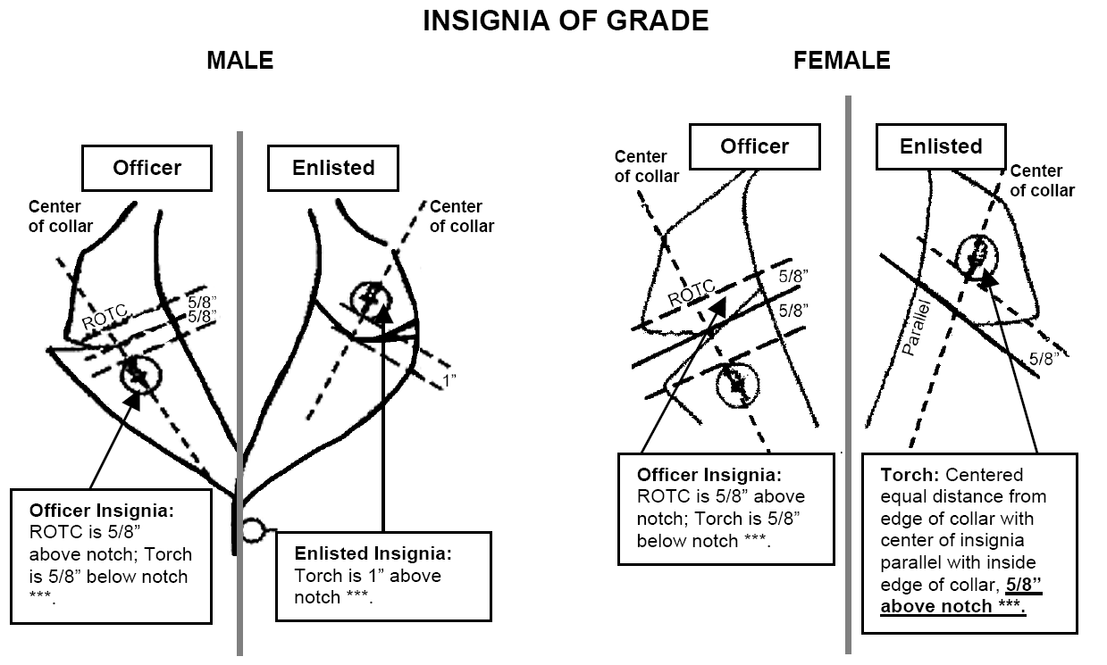

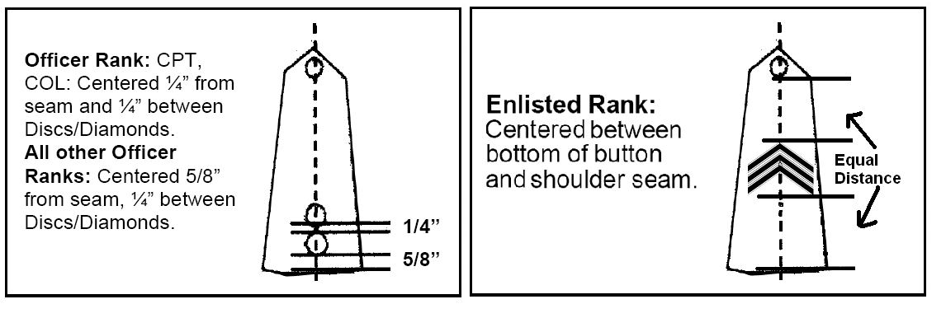
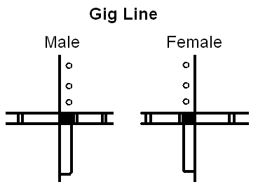
- Leadership tabs for Officers will be worn centered under the lowest rank
- Leadership tabs for Enlisted will be worn centered under the rank.

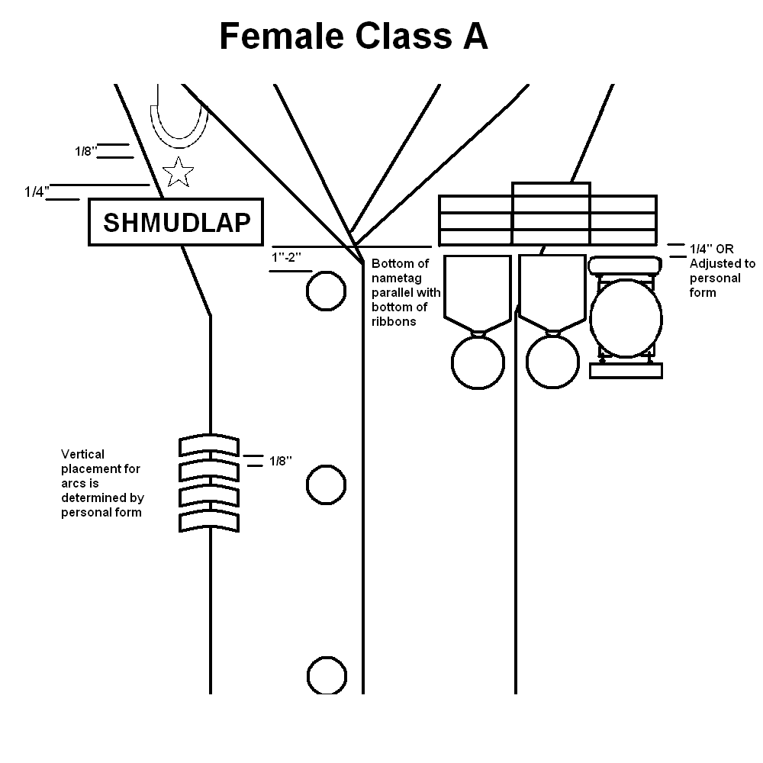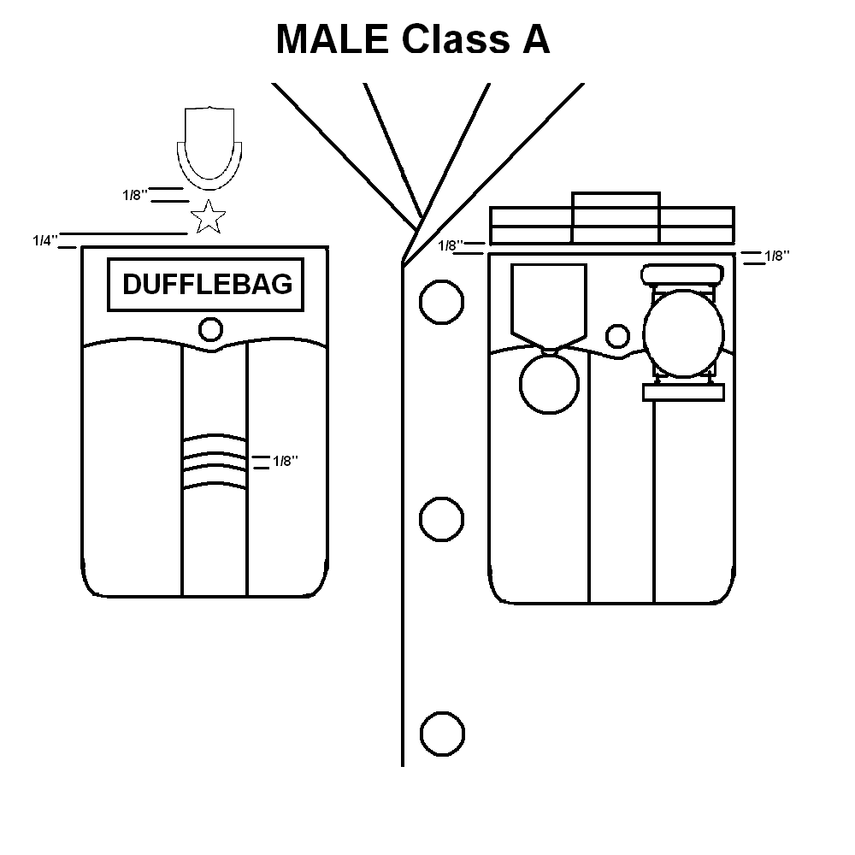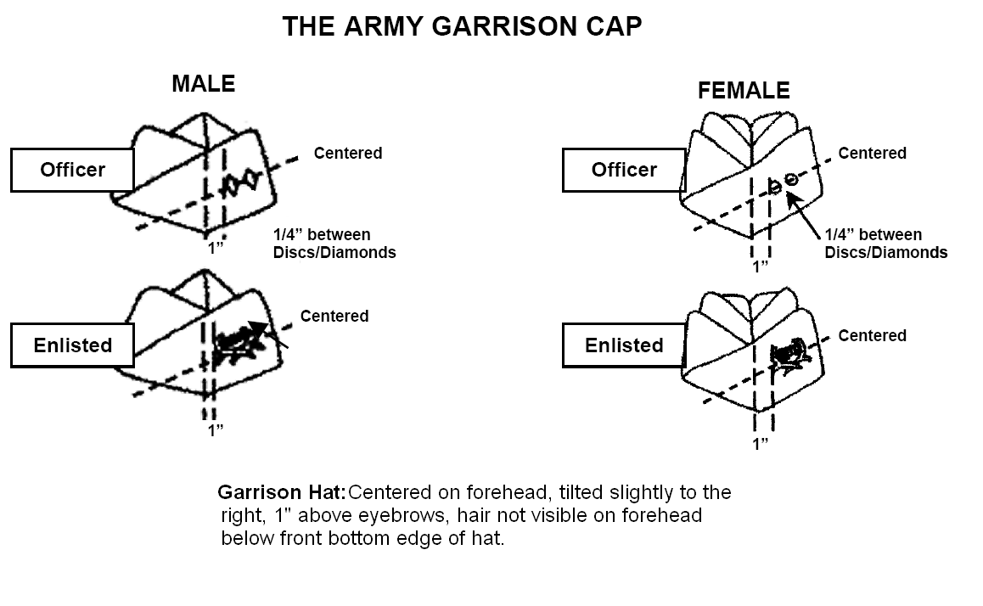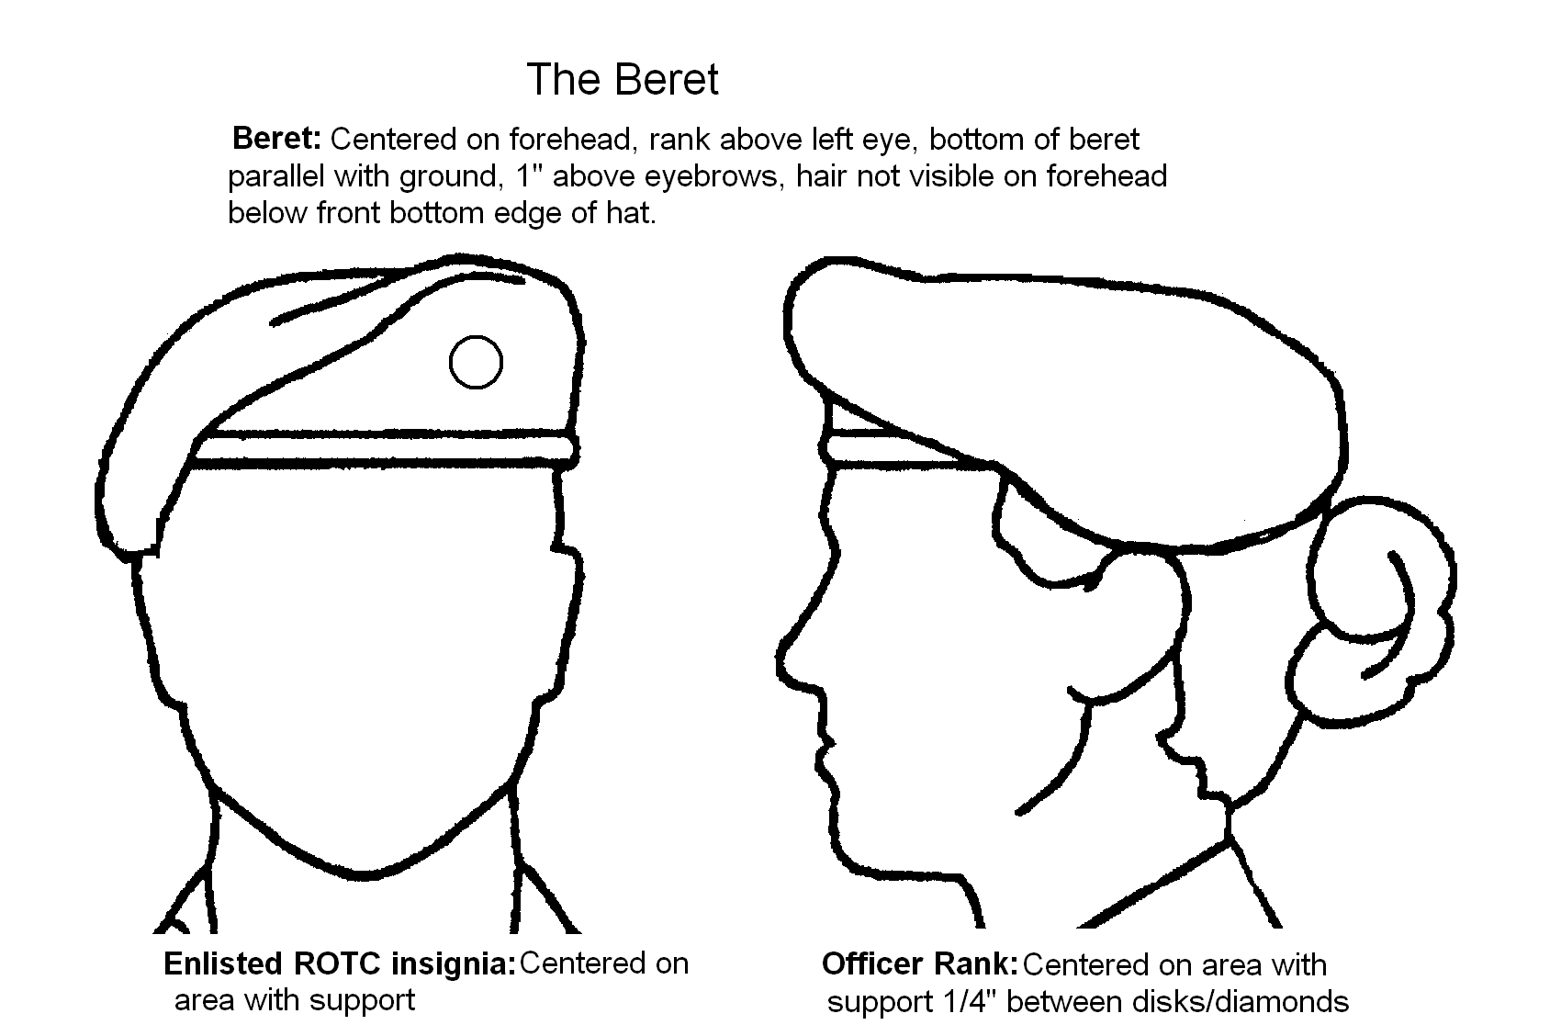
- If the academic achievement wreath is earned, the star does NOT move.

- Ribbons: Ribbons row will be touching or have 1/8” between them. Ribbons can be no more than 3 across. Ribbons can be staggered if wanted.

- Medals/Marksmanship: One medal – centered, two medals – evenly spaced apart, three medals, evenly spaced apart with the one medal centered. If more than three medals are worn the remaining medals will be worn like previous rows as close to the previous row of medals as possible.
- If the academic achievement wreath is earned, the star does NOT move.

- Ribbons: Ribbons row will be touching or have 1/8” between them. Ribbons can be no more than 3 across. Ribbons can be staggered if wanted.

- Medals/Marksmanship: One medal – centered, two medals – evenly spaced apart, three medals, evenly spaced apart with the one medal centered. If more than three medals are worn the remaining medals will be worn like previous rows as close to the previous row of medals as possible.

NECKTIE - BLACK, HALF WINDSOR
  - Correct Wear: Wear hand-tied knotted with a half Windsor knot (the Windsor or the four-in-hand knot are authorized also). Wear the top of the knot parallel to and slightly above the top of the shirt collar closure, hiding the top button. The bottom of the tie hangs within one inch of the top of the belt buckle. The tie does not cover the belt buckle

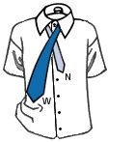 | 1) The wide end "W" should extend about 12 inches below narrow end "N". Cross wide end "W" over narrow end "N". |  | 5) Bring wide end "W" around front, over narrow end "N" from left to right.
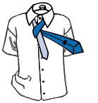 | 2) Bring wide end "W" up around and behind narrow end "N". | 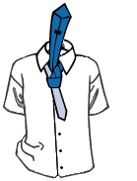 | 6) Again, bring wide end "W" up and through the loop.
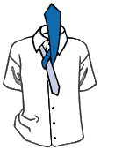 | 3) Bring wide end "W" up. | 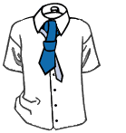 | 7) Bring wide end "W" down through the knot in front.
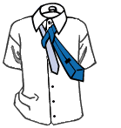 | 4) Pull wide end "W" up and through the loop. | 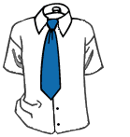 | 8) Using both hands, tighten the knot carefully and draw up to collar.

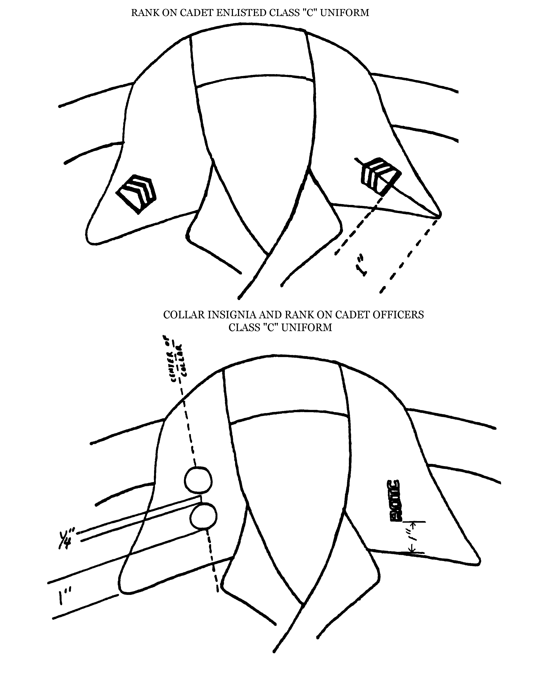

Annex H. JROTC Safety Alert; Weapons on School Campuses

Due to the recent rise in incidents involving weapons (guns) on school campuses, and the heightened awareness with regards to (WRT) gun control, our JROTC Cadets and Instructors may be at a higher degree of risk of serious injury or death.

Several recent incidents have involved Cadets practicing drill competition or conducting air rifle marksmanship training, then subsequently taking their rifles with them while going to do something else on the school campus. Transporting the rifle across or on the school campus immediately raised security and safety concerns among school administrators and their security personnel, and could have seriously endangered the Cadets carrying the rifles, their Instructors, or other students and school employees on campus.

For security personnel, particularly those who are new or have not had sufficient training to distinguish a perspective terrorist from a Cadet in uniform with a non-operational (demilitarized) rifle, this could result in a major incident or even in the serious injury or death of a Cadet or Instructor. Even the most experienced and fully trained security and law enforcement personnel have made tragic mistakes in attempting to identify whether a student with a demilitarized rifle is harmless or a potential threat.

In view of this potential danger, following are some safety and security considerations that may prove critical to your risk management concerns:
- Ensure all training, especially with drill or air rifles, is scheduled and indicated on a published training schedule.
- Ensure all changes to the training schedule, especially with regards to training involving drill or air rifles, are posted, and that all school and other authorities are notified of the changes.
- Ensure the school’s main office, security and safety offices, and school/campus police are notified and made aware that you are conducting training that will involve rifles or other items that may be considered weapons.
- Ensure the school has notified proper authorities that you will be conducting training involving rifles or other items that may be considered to be weapons.
- Ensure Cadets train in a centralized area and under the supervision of a certified Instructor.
- Ensure Cadets are not released from the training area while carryi8ng or transporting weapons. If Cadets have to go somewhere else during the training session, ensure they leave their rifle with an authorized person at the training site.
- Ensure rifles/weapons are secured and locked up in an authorized storage area with limited access, and that only Instructors have the ability to unlock the area.
- Ensure no unauthorized firearms or ammunition are stored with your drill rifles or air rifles.
- Ensure your drill rifles or air rifles are not stored or locked in either open or locked vehicles.
- Ensure all Cadets and Cadre are briefed prior to each training event, to include practices, with regards to safety and security.
- Ensure everyone is aware of the location of the nearest medical support in case of emergencies, and the procedures for local emergency plans.
- Ensure everyone is aware of and follows school guidelines and procedures WRT safety, security, and the notification process for emergencies. In the event of emergencies, use the following notification process: your school officials, then your DAI office and/or Brigade. Notification to the Army JROTC office should be through your Brigade.

Annex I. The Balance of Power Within the Big Three

- Introduction
The Battalion Commander, Executive Officer and Sergeant Major of the Colony High School Knight Battalion, are a team. All components of the Big 3 must work together for the Battalion to function as a cohesive unit. All members of the Big 3 have the same amount of power, regardless of rank, and all members of the Big 3 are equally liable for their actions and deeds.

- The Function of Each Component

  - Battalion Commander – the Battalion Commander is, in all sense of the word, the Alpha. They run the Battalion and make crucial decisions that affect the Battalion in its entirety, but they are not the only person in charge of the Battalion. The Battalion Commander is the main decision maker and makes all final decisions.
  - Executive Officer – the Executive Officer is the one in charge of the staff only. They are the second in command of the Battalion, but their primary job is control of the staff. They are in charge of paperwork and maintain the Battalion behind the scenes.
  - Sergeant Major – the Sergeant Major is the enforcer of all rules and punishments. They take the rules and decisions of the Battalion Commander and Executive Officer and actually enforce them. Also the job of the Sergeant Major is to rape the XO.

- How They Relate
The Big 3 can easily be compared to the Three Branches of Government. The Battalion Commander is the Executive Branch, the main face and decision maker of the Battalion. The Executive Officer is the Legislative Branch, in charge of paperwork and important decisions behind the scenes. The Sergeant Major is the Judicial Branch, enforcer of rules and delegator of fair and just punishments throughout the Battalion. But just as the Three Branches of Government have checks and balances, so must the Big 3. The Battalion Commander approves decisions made by the Executive Officer, the Executive Officer ensures that all punishments from the Sergeant Major are truly fair and unbiased, and the Sergeant Major ensures that the Battalion Commander does not go above and beyond what their job truly is.

Annex J. JROTC Cadet Creed
