Intro.Chemistry
Summer Review Packet

Intro. Chemistry is a rigorous course specifically designed to prepare you for a collage introductory chemistry course in the future. It will challenge you to think critically, expand your knowledge, and apply what you have learned in numerous laboratory experiments.

To get a head start for a successful year, I have created a packet with topics that you need to familiarize yourself with before the course starts. Please work on this packet through the summer and have it ready to turn in by the first Friday after the school starts. The objective is not to scare you, but to get your self at a good start.

You may use any reliable website or books to help you finish the work in the packet.

Note: be prepared to take a quiz on polyatomic ions in the second week of school.
Please feel free to contact me if necessary via my e-mail:
mkarunar@bvsd.k12.pa.us

Good luck!! Have a fantastic summer!!

Mrs. Karunaratne

Adv.Chemistry
Summer Review Packet
Safety
Print and read Flinn Scientifics’ student safety contract (search in Google); complete questions below and bring signed contract on first day of school.
- What rules exist for food and drink in the laboratory?
- What kind of safety equipment is in the laboratory?
- What is the rule as to when students should wear goggles?
- What clothing requirements exist in a laboratory setting?
- What is the procedure when a chemical splashes in your eye?
- What is the proper way for diluting acid?
- What should a student do if they don’t know how to use equipment?
- In what direction should a test tube be pointed while it is being heated?

Equipment
Provide the name and the use for each of the following items of lab equipment. Make sure to familiarize yourself with these as we will be using them throughout the year.
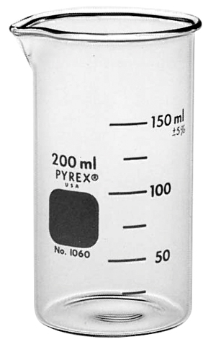 | 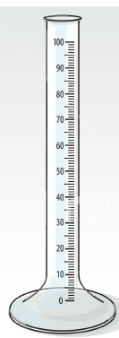 | 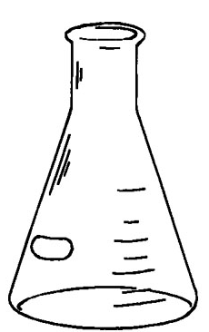 | 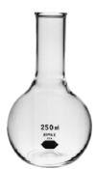
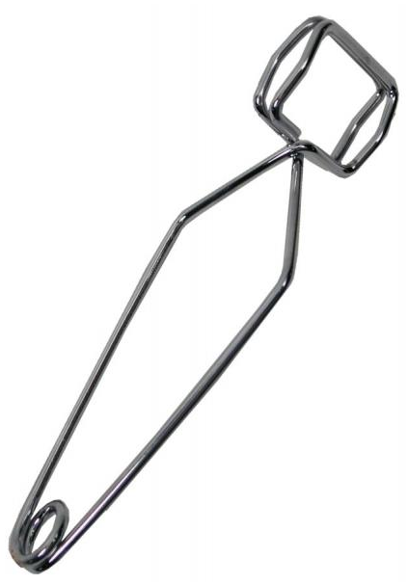 | 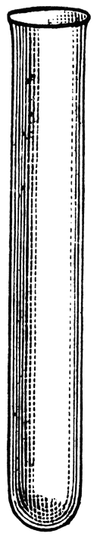 | 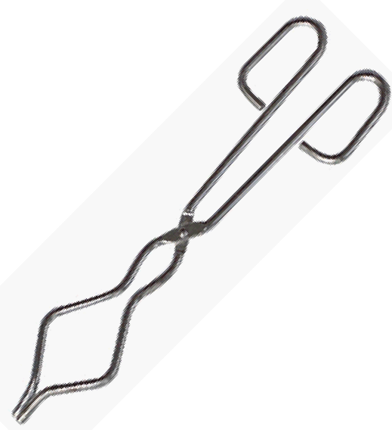 | 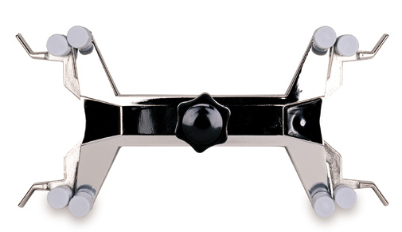
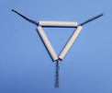 | 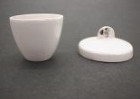 | 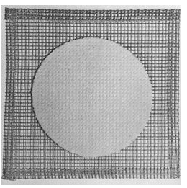 | 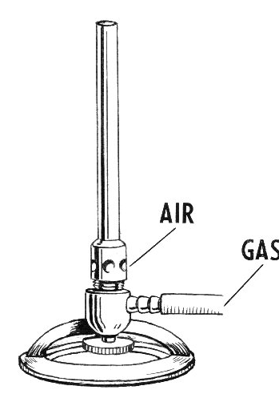
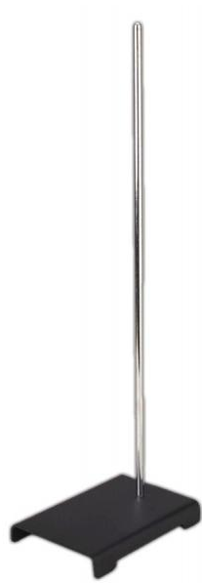 | 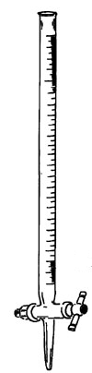 | 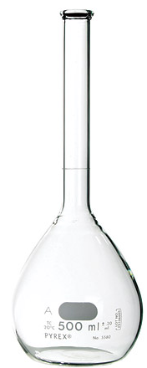 | 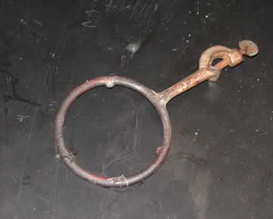
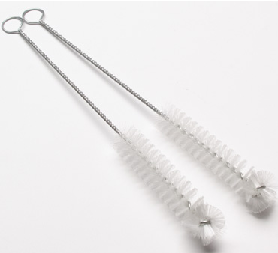 | 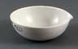 | 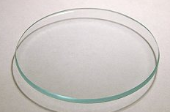 | 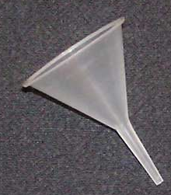

Scientific Method
- What are the basic steps of the scientific method?

Accuracy and Precision
- What is the difference between accuracy and precision?
- Can measurements be precise and not accurate? Why?
- Can measurements be accurate and not precise? Why?
- Look at the set of measurements below and determine which student accurately and precisely measured 3.65 cm.
 | Trial 1 | Trial 2 | Trial 3 | Trial 4 | Trial 5 | Trial 6
Student A | 2.63 | 3.96 | 1.85 | 2.69 | 3.65 | 6.01
Student B | 3.75 | 3.76 | 3.75 | 3.77 | 3.74 | 3.75
Student C | 3.65 | 3.67 | 3.66 | 3.65 | 3.65 | 3.69
Student D | 3.65 | 3.60 | 3.63 | 3.69 | 3.65 | 3.60

Significant Figures
- Why are significant figures important when collecting measurements?
- What is the rule for significant figures when a number is obtained by counting or when the number refers to a constant?
- What are the rules for significant figures when the number is obtained by measurement?
- Identify the number of significant figures in the following:

- 4.53
- 2.30
- 1.02
- 4500
- 3200.
- 0.002
- 1.000
- 0.070
- 0.707
- 7.070
- 7070
- 0.700
- 3.4 x 10⁴
- 1.02 x 10²

- I measured the length of my thumb and found that it is 7.50 centimeters long. When I used another ruler, I found that the length was 7.5 cm. Explain the difference between these two measurements.

- Report the following readings using the correct level of precision according to the instrument
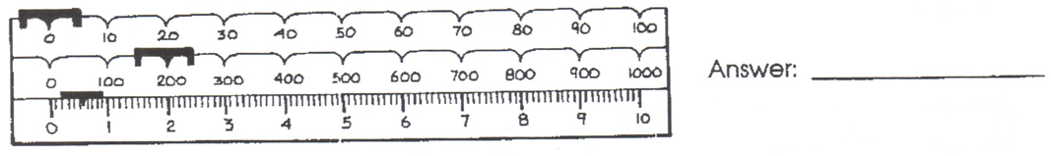
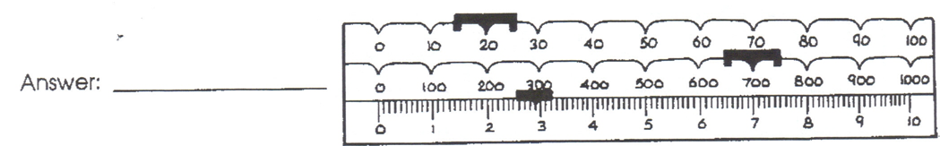

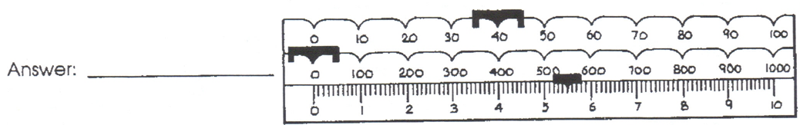

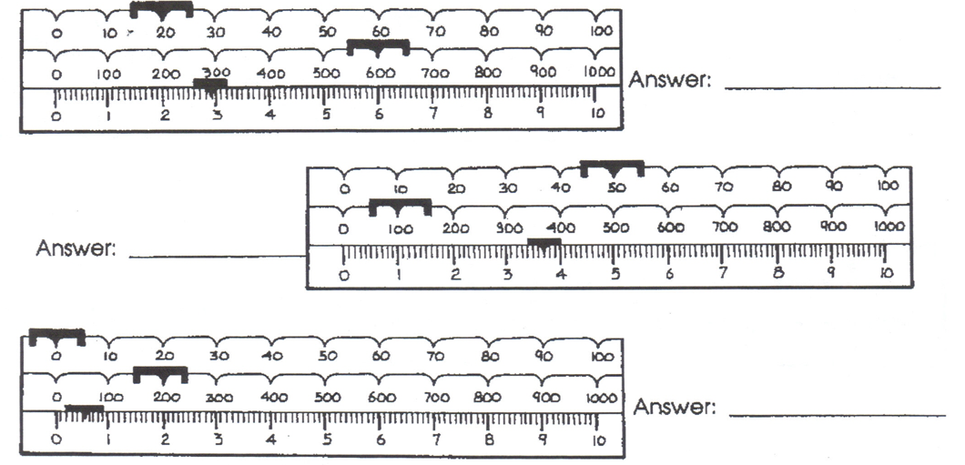

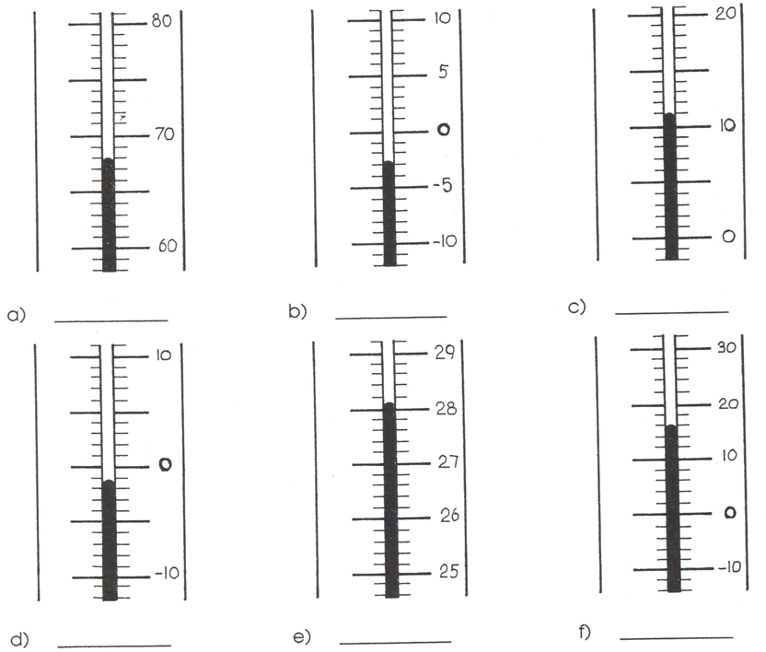

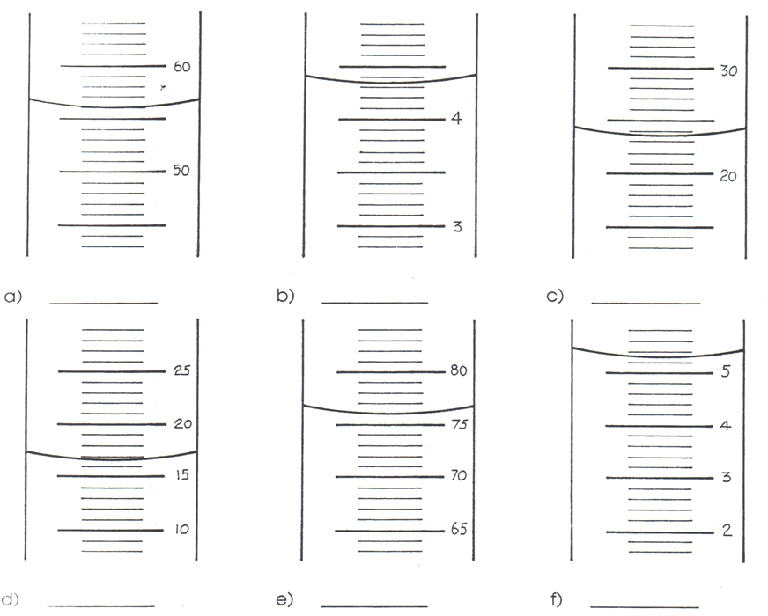
- Solve each of the following math problems and write their answers with the correct number of significant figures( assume they are measured in cm):

- 4.5 + 2.34 =
- 4.5 – 5 =
- 6.00 + 3.411 =
- 3.4 x 2.32 =
- 7.77 / 2.3 =
- 3.890 / 121 =
- 1200 x 23.4 =
- 120 x 0.0002 =
- 78.5 + 0.0021 + 0.0099 =
- (3.4 x 8.90) + (2.3 x 9.002) =
- (2.31x10³) / (3.1x10²) =
- 0.0023 + 65 =
- (3.4x10⁶) + 210,349 =
- 1.09 x 3.498 + 2.45001 – 2.123 / 0.0023=

Scientific Notation
Convert the following numbers into or out of scientific notation:

- 142.63
- 1,500,000
- 0.00336
- 1.63 x 10⁷
- 3.11 x 10⁻⁴
- 0.00125
- 86,400
- 1.01 x 10⁶
- 9.81 x 10¹
- 0.000000000000144
- 4,663,310.56

Express the following in correct scientific notation:

- 843 x 10⁵
- 0.001413 x 10⁻⁴
- 894.13
- 843.214 x 10⁻³
- 94.00 x 10⁶
- 0.00374 x 10⁷

Density (density = mass/volume)
Use the correct number of significant figures and units to report the answers to the following problems
- If an unknown solid weighs 84.0 grams and occupies 27.9 cm³ of space, what is its density?

- What is the mass of a liquid having a density of 1.40 g/mL and a volume of 3.090 L?

- What volume would a 200-gram sample of gold have if its density is known to be 19.3 g/cm³?

- A solid block of a substance is 74.0 cm by 55.0 cm by 35.0 cm and it weighs 569 Kg. Assuming that is did not chemically react with water nor dissolve in it, would it float in water?

- A gas has a volume of 7.0 liters and a mass of 8.50 x 10³ milligrams. What is its density?

Answer questions 6-10 using the following information:

Liquid Density Solid Density
A 6.7 g/mL cork 0.24 g/cm3
B 1.00 g/mL wood 0.84 g/cm3
C 13.6 g/mL iron 7.9 g/cm3
D 0.78 g/mL gold 19.3 g/cm3
- If the above liquids were put in a beaker and did not mix, in what order will they be from top to bottom? ______________________
- In which of the above liquids will wood float? __________________
- In which of the above liquids will iron float? ____________________
- Which solid will not float in any of the liquids? __________________
- Draw a picture of what you will see if all of the above liquids and solids are placed in one large graduated cylinder (assuming the liquids don’t mix). Be sure to label each of the solids and liquids in your drawing.
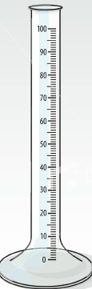
- Ann has pure gold coin that has a mass of 120.14g. What is the volume of the coin?

- Would a substance with a mass of 1.33 g and a volume of 1.38mL float in water?

Matter
- What is matter?
- What is the hierarchy/classification of matter?
Physical and Chemical Properties and Changes of Matter
- What is the difference between a physical property and a chemical property?
- Mention 3 examples of a physical property and a chemical property.
- What is the difference between a physical change and a chemical change?
- Mention 3 examples of a physical change and a chemical change.
- What is the difference between a property and a change?

Subatomic Particles
- What is a proton? Where is it located? What is its mass? What is its charge?
- What is an electron? Where is it located? What is its mass? What is its charge?
- What is a neutron? Where is it located? What is its mass? What is its charge?
- What particles constitute the mass of an atom?
- Which particle determines the identity of an atom?

Polyatomic ions
You will need to memorize/know these polyatomic ions by the second week of school.

- Ammonium NH₄⁺
- Hydronium H₃O⁺
- Acetate CH₃COO⁻ or C₂H₃O₂⁻
- Arsenate AsO₄³⁻
- Borate BO₃³⁻
- Bromate BrO₃⁻
- Carbonate CO₃²⁻
- Hydrogen Carbonate/
Bicarbonate HCO₃⁻
- Perchlorate ClO₄⁻
- Chlorate ClO₃⁻
- Chlorite ClO₂⁻
- Hypochlorite ClO⁻
- Chromate CrO₄²⁻
- Dichromate Cr₂O₇²⁻
- Cyanide CN⁻
- Hydroxide OH⁻
- Iodate IO₃⁻
- Permanganate MnO₄⁻
- Nitrate NO₃⁻
- Nitrite NO₂⁻
- Oxalate C₂O₄²⁻
- Peroxide O₂²⁻
- Phosphate PO₄³⁻
- Phosphite PO₃³⁻
- Silicate SiO₃²⁻
- Sulfate SO₄²⁻
- Hydrogen sulfate/Bisulfate HSO₄⁻
- Sulfite SO₃²⁻
- Hydrogen sulfite/Bisulfite HSO₃⁻
- Tartrate C₄H₄O₆²⁻
- Thiosulfate S₂O₃²⁻
- Thiocyanate SCN⁻

Periodic Table of Elements
You are expected to know 65 elements you have studied in pre-chemistry course.

