Chemistry
Lecture 4-0
Formulas and Nomenclature of Binary Compounds

A _________ compound is made up of only two elements. In this lecture we will learn how to write the formulas of binary compounds and how to name (nomenclature) these compounds. It is very important to be able to classify a binary compound as being either an ionic compound or a molecular (covalent) compound because the steps in writing formulas and naming these two types of compounds are different. Keep in mind that compounds containing a metal and a nonmetal are ionic compounds; molecular compounds contain only nonmetals.

Let’s start with binary ionic compounds. To write the formula of a binary ionic compound we will need to know the charges on both the cation and anion that make up the compound. The chart on the front wall of the classroom contains the names and charges of some of the more common ions. The periodic table can also be used to predict the charges on monoatomic ions. If you look at the diagram below you will see that the metals in the first column of the table (1A) form ions with a charge of ___. The metals in column 2A form ions with a charge of ___. The metals in 3A like aluminum form +3 ions. The metals in column 4A can form +4 ions. The nonmetals in 5A form _____ ions. The nonmetals in column 6A form ___ ions. The nonmetals in column 7A form __ ions.

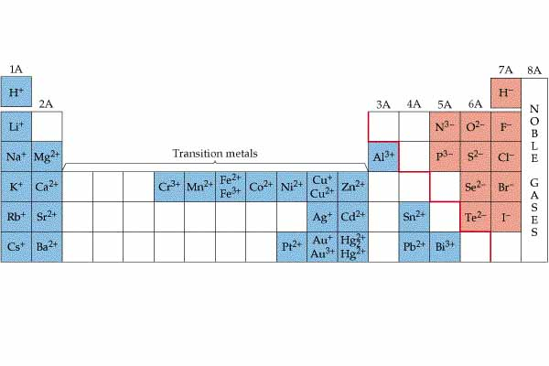
Notice that there is a pattern for predicting the charges on ions. Starting with column 1A and proceeding across the table from left to right to column 8A the pattern of charges is
+1, +2, +3, +/-4, -3, -2, -1, 0. Notice that metals in 4A can have a +4 charge and the nonmetals can have a -4 charge. The elements in 8A do not form ions so they remain neutral atoms. You should notice that metals can sometimes form different ions with different charges. This is particularly true of the transition metals. Notice in the periodic table above that iron can form a +2 ion or a +3 ion. The names of these two ions must be different. A Roman numeral following the name of the metal indicates ______________________________________________________. The
iron (II) ion indicates the ion and the iron (III) ion indicates the ion.

How do you write the formula of an ionic compound once you look up the charges on the ions? Let’s use the compound aluminum oxide as an example. The charge on the aluminum ion is +3 and the charge on the oxide ion is -2. The subscripts in the chemical formula represent the simplest ratio of ions needed to form a neutral formula unit. The simplest multiple of both 3 and 2 is 6 so we will need two aluminum ions to get a charge of +6 and three oxide ions to get a charge of -6. When we write the formula of the compound, the metal always goes first. The correct formula for aluminum oxide is. Notice that the charges are not written on the ions in the formula. A shortcut for determining the formula of an ionic compound is called the criss-cross method. Notice that we can switch the absolute values of the charges on the ions to get the subscripts!

A word of caution about using this method is important. The formula of an ionic compound is called an __________formula. This means that it shows the simplest ratio of ions needed to form a neutral formula unit. If we write the formula for magnesium sulfide using the criss-cross method, we must reduce the subscripts to the simplest ratio!

Notice that subscripts of “one” are understood and do not have to be written.

How are binary ionic compounds named? The name of the positive ion is written first followed by the name of the negative ions. Monoatomic negative ions always end in –ide. To name the compounds, we simply write the word “calcium” to describe the positive ion and the word “bromide” to identify the negative ion. Notice that the name does not include information about the subscripts.

How would you name the compound with the formula? Because the element iron can form two ions, a +2 ion and a +3 ion, we must identify the charge on the iron ion in this compound. If we look up the charge on the chloride ion, we find that each chloride ion carries a -1 charge. Since there are two chloride ions, the total negative charge would be -2. Recall that a formula unit must be neutral overall. Thus, the iron ion must have a +2 charge! The correct name of the compound would thus be iron (II) chloride. The Roman numeral indicates the charge on each metal ion. The Roman numeral is not always the same as the subscript on the nonmetal. For example, the compound is named tin (II) oxide even though no subscript of two appears in the formula. You should always check to see if a Roman numeral is needed for a particular metal ion. Only the ions formed by metals in 1A and 2A never require Roman numerals. You need to memorize the Roman numerals in the table below to be able to name ionic compounds.

number | Roman numeral
1 | I
2 | II
3 | III
4 | IV
5 | V
6 | VI
7 | VII
8 | VIII

How is the formula of a molecular compound determined? Since molecular compounds do not contain ions, the wall chart and periodic table are not needed to write the formulas of compounds containing only nonmetals. The name of the compound provides the information for writing the formula for such compounds. Carbon dioxide is a molecular compound containing the elements carbon and oxygen. The prefix “di” indicates that there are two oxygen atoms in each molecule of this compound so the formula of the compound is. The table below contains the prefixes used for subscripts one through ten. You need to memorize these prefixes!

prefix | number
mono- | 1
di- | 2
tri-
tetra- | 4
penta- | 5
hexa- | 6
hepta-
octa- | 8
nona- | 9
deca-

The prefix mono- is not used for the first element in the compound but must be used for the second element. For example, CO is carbon monoxide. The molecular formula of a compound may not be the same as the empirical formula. The molecular formula indicates the actual atomic ratios in a molecule of the compound. Recall that the empirical formula gives the simplest ratio. The molecular formula must be used to identify a compound because many compounds may have the same empirical formula.
The compound dinitrogen tetraoxide,, has an empirical formula of .

To name molecular compounds we need only write the names for the two elements and supply prefixes matching the subscripts used in the formula of the compound. For example, the name of the molecular compound with the formula would be dinitrogen trioxide. Notice that binary compounds, ionic or molecular, end in –ide.

There is a special class of molecular compounds that require some special rules for writing formulas and nomenclature. This class of compounds are called ______. Binary acids always contain the element hydrogen combined with another nonmetal. A substance is not classified as an acid until it is dissolved in water. The compound is called hydrogen chloride. When this compound is dissolved in water, an acidic solution is produced. The name of the acid produced is hydrochloric acid. The rules for naming binary acids are simple. First, the prefix “hydro-“ is always used to indicate the acid contains hydrogen. The stem of the name of the binary acid is thus determined by the nonmetal bonded to the hydrogen. The ending for binary acids is always “-ic”. The normal “-ide” ending for binary compounds is changed to “-ic” for acids.

To write the formula of an acid from the name requires that we look up the charges on ions. This may seem strange since we are working with a molecular compound which does not contain ions. When an acid is added to water, ions are formed by the interaction of the acid molecules with the water molecules! To write the formula for hydrosulfuric acid, we need to look up the charge on the hydrogen ion and the sulfide ion and then use the same procedure we used for writing the formulas of ionic compounds. The charge on a hydrogen ion is always +1. Since sulfur is in 6A of the periodic table, the charge on a sulfide ion is -2. Thus the formula for hydrosulfuric acid is.

To be able to correctly write the names and formulas of binary compounds, you must first classify the compound into one of three groups. All binary compounds are either ionic or molecular. Molecular compounds may be classified as acids if they contain hydrogen as the first element in the formula.

Chemistry Name_______________________________
HW 4-0 Period_______ Date___________________
Formulas and Nomenclature of Binary Compounds

- How are the electrical charges on ions used to write the formulas of binary ionic compounds?

Write the formulas of ionic compounds formed between the following ions.

- Ba⁺² and Cl⁻¹

- Al⁺³ and S⁻²

- Mg⁺² and N⁻³

- K⁺¹ and S⁻²

Write formulas for the following compounds.

- iron (III) sulfide

- carbon tetrachloride

- hydrosulfuric acid

- calcium fluoride

- hydrochloric acid

