AP Chemistry Name _______________________________
Period ___ Date ___/___/___
15 • Applications of Acid-Base Equ
PRACTICE TEST w/answers

1. HCN is a weak acid (K_{a} = 6.2 x 10¯¹⁰). NH₃ is a weak base (K_{b} = 1.8 x 10¯⁵). A 1.0 M solution of NH₄CN would be
(A) strongly acidic (C) neutral
(B) weakly acidic (D) weakly basic

2. How many moles of HCOONa must be added to 1.0 L of 0.10 M HCOOH to prepare a buffer solution with a pH of 3.4? (HCOOH K_{a} = 2 x 10¯⁴)
(A) 0.01 (C) 0.1
(B) 0.05 (D) 0.2

3. The acid-base indicator methyl red has a K_{a} of 1 x 10¯⁴. Its acidic form is red while its alkaline form is yellow. If methyl red is added to a colorless solution with a pH = 7, the color will be
(A) pink (C) orange
(B) red (D) yellow

4. Which mixture forms a buffer when dissolved in 1.0 L of water?
(A) 0.2 mol NaOH + 0.2 mol HBr
(B) 0.2 mol NaCl + 0.3 mol HCl
(C) 0.4 mol HNO₂ + 0.2 mol NaOH
(D) 0.5 mol NH₃ + 0.5 mol HCl

5. A buffer solution is prepared in which the concentration of NH₃ is 0.30 M and the concentration of NH₄ is 0.20 M. What is the pH of this solution? The equilibrium constant, K_{b} for NH₃ equals 1.8 x 10¯⁵.
(A) 8.73 (C) 9.43
(B) 9.08 (D) 11.72
6. For which titration would the use of phenolphthalein introduce a significant error? Answer is D
K_{indicator} for phenolphthalein = 1 x 10¯⁹
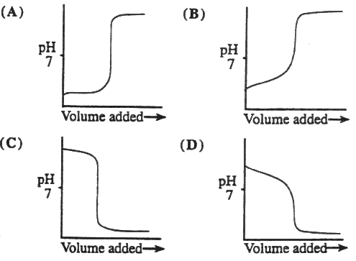

7. The titration curves labeled 1 and 2 were obtained by titrating equal volumes of two different acid samples with portions of the same sodium hydroxide solution.
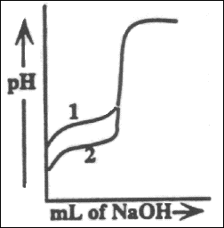
What conclusions can be drawn about the relative concentrations and strengths of acids 1 and 2 from these curves?
(A) The concentrations are the same but acid 1 is weaker than acid 2.
(B) The concentrations are the same but acid 1 is stronger than acid 2.
(C) Acid 1 is the same strength as acid 2, but it is less concentrated.
(D) Acid 1 is the same strength as acid 2, but it is more concentrated.

8. A 0.100 M solution of acetic acid (K_{a} = 1.8 x 10¯⁵) is titrated with a 0.1000 M solution of NaOH. What is the pH when 50% of the acid has been neutralized?
(A) 2.38 (C) 5.70
(B) 4.74 (D) 7.00

9. The pK_{a} values for several acid-base indicators are given in the table. Which indicator should be used in the titration of a weak base with a strong acid?
Indicator, pK_{a}
2,4-dintrophenol | 3.5
bromthymol blue | 7.0
cresol red | 8.0
alizarin yellow R | 11.0
(A) 2,4-dintrophenol
(B) bromthymol blue
(C) cresol red
(D) alizarin yellow R

10. Which one of the following is the solubility product constant for Mn(OH)₂?
a) K_{sp} = [Mn²⁺][OH⁻]²
b) K_{sp} = [Mn²⁺][2 OH⁻]²
c) K_{sp} = [Mn²⁺]²[OH⁻]²
d) K_{sp} = [Mn²⁺]²[OH⁻]
e) K_{sp} = [Mn²⁺]²[2 OH⁻]²

11. The solubility of HgS is 5.5 x 10⁻²⁷ mol/L. What is K_{sp} for HgS?
a) 4.0 x 10⁻³ d) 7.4 x 10⁻¹⁴
b) 8.2 x 10⁻⁴ e) 3.0 x 10⁻⁵³
c) 1.3 x 10⁻¹³

12. Which expression best describes the relationship between solubility product, K_{sp}, and the solubility, s, of MgF₂?
a) K_{sp} = 2s d) K_{sp} = 4s²
b) K_{sp} = s² e) K_{sp} = 4s³
c) K_{sp} = 2s³
13. Calculate the molar solubility of Fe₂S₃.
K_{sp} = 1.4 x 10⁻⁸⁸
a) 5.5 x 10⁻⁶² M d) 4.8 x 10⁻²⁴ M
b) 1.2 x 10⁻⁴⁴ M e) 1.1 x 10⁻¹⁸ M
c) 5.2 x 10⁻³⁰ M

14. What is the concentration of CrO₄²⁻ in a saturated solution of PbCrO₄?
K_{sp} = 1.8 x 10⁻¹⁴?
a) 1.3 x 10⁻⁷ M d) 1.3 x 10⁻⁴ M
b) 7.5 x 10⁻⁶ M e) 5.1 x 10⁻³ M
c) 1.8 x 10⁻⁴ M

15. Calculate the equilibrium constant for the reaction:
CuCl(s) + I⁻(aq) CuI(s) + Cl⁻(aq)
CuCl; K_{sp} = 1.9 x 10⁻⁷
CuI; K_{sp} = 5.1 x 10⁻¹²
a) 8.4 x 10⁻² d) 4.4 x 10¹⁷
b) 2.3 x 10⁻⁶ e) 9.7 x 10⁻¹⁹
c) 3.7 x 10⁴

16. For BaSO₄, K_{sp} = 1.1 x 10⁻¹⁰. If you mix 200. mL of 1.0 x 10⁻⁴ M Ba(NO₃)₂ and 500. mL of 8.0 x 10⁻² M H₂SO₄, what will be observed?
a) A precipitate forms because Q_{sp} > K_{sp}
b) A precipitate forms because Q_{sp} < K_{sp}
c) No precipitate forms because Q_{sp} = K_{sp}
d) No precipitate forms because Q_{sp} < K_{sp}
e) No precipitate forms because Q_{sp} > K_{sp}

17. A saturated solution of Ca(OH)₂, has a pH of 12.40. What is the K_{sp} for Ca(OH)₂?
a) 2.5 x 10⁻² d) 2.0 x 10⁻⁶
b) 1.3 x 10⁻² e) 4.0 x 10⁻¹³
c) 8.0 x 10⁻⁶

18. Calculate the molar solubility of AgCl in a 0.10 M solution of NaCl.
K_{sp} of AgCl is 1.8 x 10⁻¹⁰
a) 1.3 x 10⁻⁵ M d) 4.2 x 10⁻⁵ M
b) 5.5 x 10⁸ M e) 4.8 x 10⁻⁴ M
c) 1.8 x 10⁻⁹ M

10. The solubility of salts can be affected by other equilibria. Addition of all of the following will affect the solubility of FeCO₃ EXCEPT:
a) NaHCO₃ d) Na₂CO₃
b) NaCl e) HCl
c) H₂CO₃

