Regents Chemistry
Mr. Szkolar

Notes an Atomic Structure

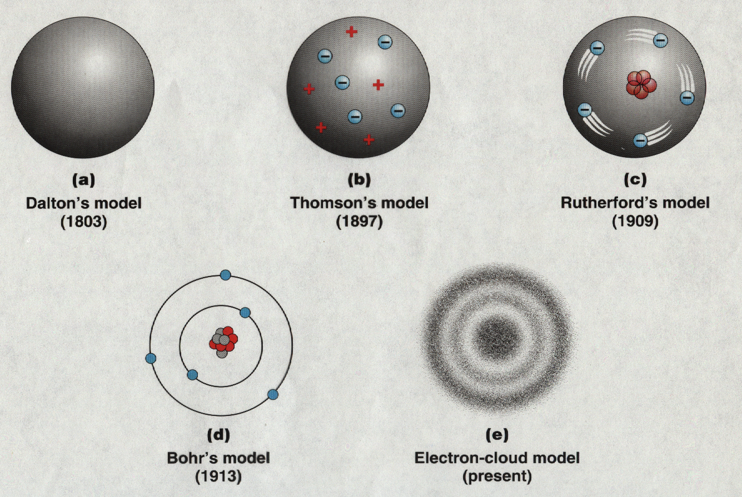

Recall the models of the atom we have discussed thus far:

- Dalton – solid neutral sphere
- Thomson –“plum-pudding” model
- Rutherford – “planetary model”

Rutherford’s” planetary model” of the atom had to be revised when it was shown that a charged particle like an electron had to radiate energy if it was accelerating. In other words a charged particle having a change in velocity or direction must emit energy. This meant that electrons must lose energy as they “orbit” around the nucleus and eventually spiral into the nucleus (because of the “pull” of the positive protons). Obviously this is not what happens! In order to revise our model of the atom it is necessary to digress for a while and discuss properties of waves. After all, recall that those electrons not only exhibit particle properties but also wave properties.

Electromagnetic Radiation

Electromagnetic radiation (EMR) is energy traveling through space in the form of alternating electric and magnetic fields or waves. WOW! The term EMR is used interchangeably with light energy. EMR consists of a spectrum of different kinds of waves that have the characteristics described below.

Wave Characteristics

1. Wavelength

- Distance from crest to crest
- Given the symbol λ (Greek letter lambda)
- Has the unit of length (m)

2. Frequency

- The number of wave crests that pass you per second
- Expressed in units called Hertz (Hz)
- Given the symbol ν (Greek letter nu)
- Has the unit of 1/sec

3. Speed

- Given the symbol c
- All electromagnetic waves travel at the speed of light, which is 3.00 X 10⁸ m/sec
- This is a universal constant
How are wavelength and frequency related?

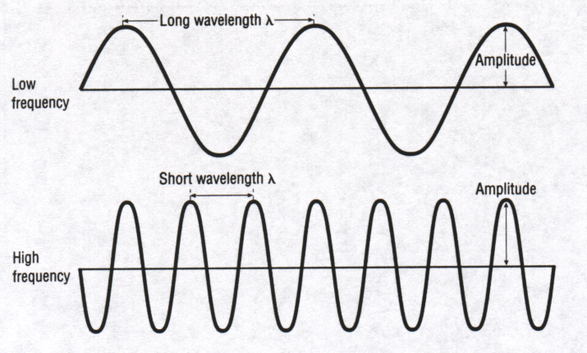

Qualitative relationship:

Quantitative relationship

Electromagnetic Spectrum – see text

Type Wavelength

radio, TV m, mm
microwave μm (micrpmeters)
infrared nm (nanometers)
visible nm
ultraviolet nm
X-ray nm
Gamma ray nm
Cosmic ray nm

Visible (white) EMR:

White light passed through a prism is bent (refracted) into its component waves:

Red 760 nm
Orange
Yellow
Green
Blue
Violet 400 nm

Problem 1

Calculate the frequency (ν) of radiation having a wavelength (λ) of 500 nm:

Problem 2.

Calculate the wavelength of radiation having a frequency of 4.2 X 10¹⁴ sec⁻¹.

Max Planck and the Quantum Theory

Planck proposed that light energy is radiated in discrete packets called quanta (quantum is singular). A quantum of light energy is termed a photon. Planck determined the energy of a photon is directly proportional to its frequency:
E = hν
E = energy (J)
h = Planck’s constant = 6.63 X 10⁻³⁴ J-sec
ν = frequency (1/sec)

Problem 3

Calculate the energy of a photon having frequency of 5.8 X 1015 sec⁻¹.

Problem 4.

Calculate the energy of a photon having a wavelength of 420 nm:

Wave-Particle Duality

Louis DeBroglie (1923) – compared Planck’s equation and Einstein’s famous equation:

E = hν E = mc²
substitute v (velocity) for c (speed of light)

E = hν E = mv²

hν = mv²
substituting v/λ for ν

and rearranging, λ =

This equation is a prediction of the wavelength (λ) of a particle with a mass (m) and a velocity (v). So what’s your wavelength? Groovy! UGH!&%$#!

Wave-particle duality shows that waves can act as particles and particles can act as waves! Hence, light (EMR) has both wave and particle properties. The wave properties of particles become evident only at the subatomic level. Hence, electrons do indeed exhibit properties of both waves and particles. What evidence is there for this?

- Particle properties – an electron has a mass (9.11 X 10⁻²⁸ g) and can impart mechanical motion
- Wave properties – a beam of electrons will show a diffraction pattern; a beam of electrons is used as a source of “light” in electron microscopes (recall we get a larger magnification with a shorter wavelength of light)

Problem 5

Calculate the wavelength of an electron moving at a velocity of 3 X 10 ⁷m/sec. The mass of an electron is 9.11 X 10⁻²⁸ g. (Note: for dimensional analysis the Joule has the units of kg-m²/sec²).

Bohr Model

Niels Bohr in 1913 proposed a model of the atom taking Planck's Quantum Theory into account. The quantum theory shook the foundations of classical physics. It showed that at the subatomic level matter does not obey the same “laws” compared to the macroscopic level. Bohr's model was based on essentially two postulates:

1. Electrons can occupy only certain specific energy levels (or shells). An electron does not emit energy when it is in one of these permitted energy levels. These energy levels are called principal energy levels and designated by the symbol n. The energy of an electron occupying a given principal energy level is said to be quantized.

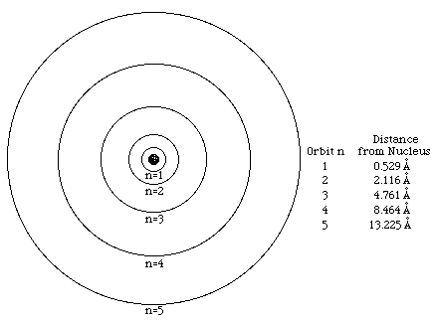

The above diagram shows that the distance between an electron and the nucleus depends on the energy of the electron. Electrons occupying energy levels further from the nucleus have greater potential energies than those occupying levels closer to the nucleus.

When electrons are in the lowest available energy levels, the atom is said to be in the ground state. This is a state of maximum stability.

2. Atoms can emit or absorb energy only in quantum amounts. The amount of energy released or absorbed is equal to the difference in energy between the two different levels:

E_{h} - E_{l} = hν where E_{h} = energy of higher level E_{l} = energy of lower level

or ΔE = hν

Let us look at this idea using simple numbers. Below is a table of the energy of the first three levels of an atom:

Energy Level (n) Energy (energy units, eu)

1 10
2 16
3 25

This means any electrons in energy level 1 must have exactly 10 eu, while those in level 2 have 16 eu, and those in level 3 exactly 25 eu.

For an electron in energy level 1 to “jump” to energy level 2, must it absorb or release energy?

How much energy is involved in this transition?

How much energy will be involved in the electron falling from n = 2 to n = 1?

How much energy is involved in the transition n = 1 to n = 3?

How much energy is involved in the transition n = 3 to n = 1?

How much energy is involved in the transition n = 2 to n = 3?

How much energy is involved in the transition n = 3 to n = 2?

Get the idea?

Energy is radiated only when an electron falls from a higher level to a lower level - the radiation emitted is of a very specific frequency - corresponding to the energy difference between the two levels.

When an electron absorbs a quantum of energy sufficient to cause it to make a "quantum jump" to a higher level, the atom is said to be in the excited state. This state is unstable and as the electron falls back to the lower level it originally occupied, it emits a quantum of radiation with an energy (and hence a frequency) corresponding to the amount it had absorbed.

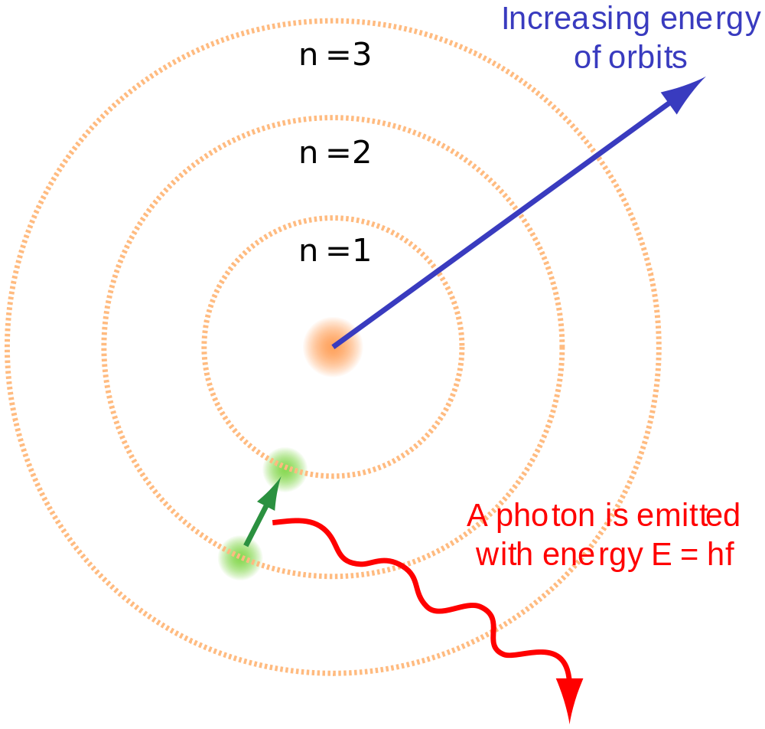

If the emitted radiation is viewed through a spectroscope (prism), characteristic spectral lines will be observed.

The spectral lines are used to identify an element (they are the "fingerprints" of the elements) and they provide evidence for the existence of energy levels within the atom.

For the hydrogen atom:

- When an electron drops from n = 7, 6, 5, 4, 3, 2 →n = 1, the radiation emitted is ultraviolet and the spectral lines produced are referred to as the Lyman series.

- When an electron drops from n = 7, 6, 5, 4, 3 → n = 2, the radiation emitted is visible and the spectral lines produced are referred to as the Balmer series.

- When an electron drops from n = 7, 6, 5, 4 → n = 3, the radiation emitted is infrared and the spectral lines produced are referred to as the Paschen series.

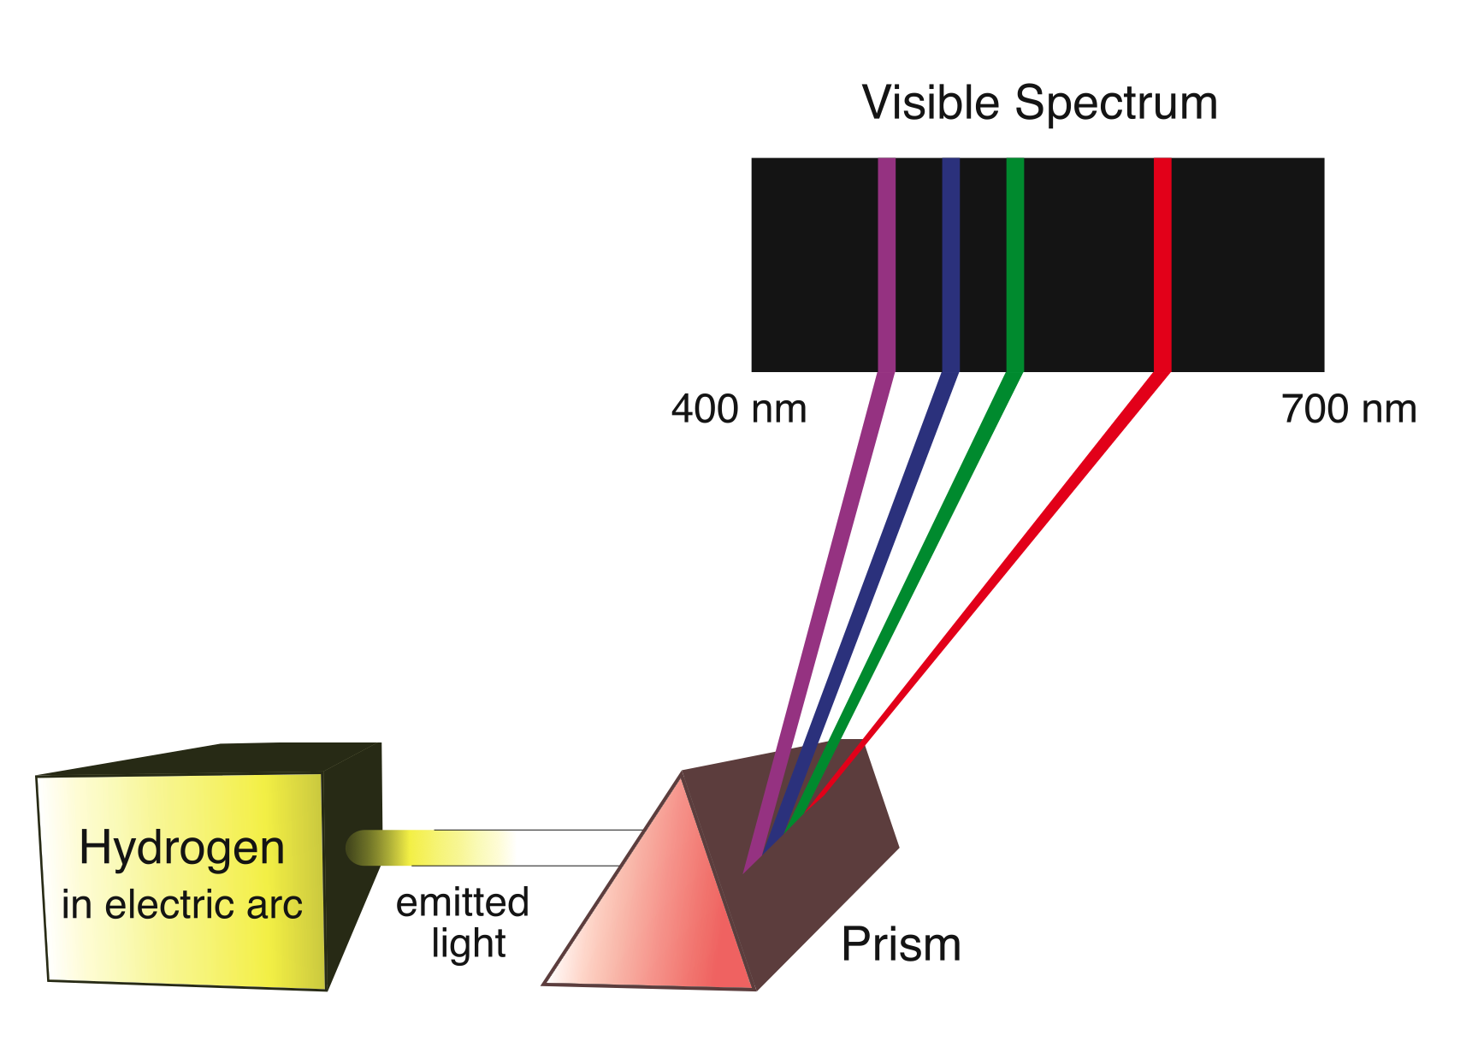

Bohr was able to calculate the energy of the electron for each energy level of the hydrogen atom. The energy is calculated by dividing the total energy of a hydrogen electron (its ionization energy) by the level squared:
E_{n} = -2.18 X 10⁻¹⁸J/n²
The negative sign indicates an increasing loss of potential energy as the electron moves to levels closer to the nucleus.

These numbers are a little ugly because they are so small and involve negative exponents but the idea is still the same. There is an equation that is allows us to calculate the energy involved in any transition in the hydrogen atom:

∆E = E_{f} - E_{i}

= -2.18 X 10⁻¹⁸J

Problem 6

An electron makes a transition from n=5 to n =1 in the hydrogen atom.

- Will energy be released or absorbed? Explain.

- Calculate the energy of the photon:

- Calculate the frequency of the photon:

- Calculate the wavelength of the photon:

- In what part of the electromagnetic spectrum is this energy? (uv, vis, ir)

Types of Spectra

- Continuous Spectrum – this occurs when an excited sample emits wavelengths of light across the entire visible region; we observe a continuous array of all colors (i.e. rainbow).

- Bright Line (Emission) Spectrum – a pattern of bright colored lines against a black background. This occurs when an excited sample emits only certain wavelengths of light in the visible region. Again, these wavelengths correspond to the electron transitions occurring when electrons fall from higher energy levels down to lower energy levels.

- Dark Line (Absorption) Spectrum – a pattern of dark lines against a continuous (rainbow) background. This occurs when a sample is exposed to white light and the light that passes through it viewed with a spectroscope. Atoms in the sample will absorb these characteristic wavelengths of light that have the exact energy needed to cause ground state electrons to jump up to higher levels. Hence, all other wavelengths will pass through (continuous background) except those that are absorbed in exciting electrons, resulting in dark lines. Stellar spectra are absorption spectra.

What is the relationship between an elements emission spectrum and its absorption spectrum?

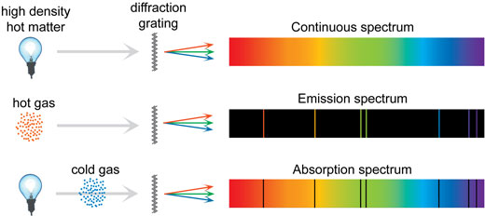

Stellar Spectra - Out of this Woooorld!

The spectra of stars are dark line or absorption type spectra. This is because EMR radiation emitted by a star’s core from nuclear fusion reactions passes through the star’s atmosphere. The elements present in the atmosphere will absorb those particular wavelengths of light that represent energy transitions from lower to higher levels. Hence those wavelengths of light will be missing (dark lines) while all other wavelengths will pass through (visible or “rainbow”). If the star is moving toward us its waves will be compressed and the lines will appear shifted toward shorter wavelengths – the “blue shift”. If a star is moving away from us the waves will be stretched out and the lines will appear shifted toward the longer wavelengths – the “red shift”.

Element A

Element B

Element C

Element D

Star A

Star B

- Identify elements present in star A. Is star A moving toward or away from us? Explain.

- Identify elements present in star B. Is star B moving toward or away from us? Explain.
The Quantum Mechanical Model of the Atom

Werner Heisenberg (1927) showed that any method that could experimentally be used for determining the position and momentum (energy) of an electron would necessarily change the momentum and alter the position of that electron in an unpredictable way. The method we could use to “see” an electron would involve shining a photon of light on the electron and seeing the reflection. At the atomic level, the photon would have enough energy to “move” the electron (i.e. change its position and momentum) in some way. Thus, it is impossible to determine the exact position and momentum of an electron at the same time. This statement is known as the Uncertainty Principle and it is an inherent property of nature. This statement showed that Bohr’s idea of definite energy levels for electrons has no real meaning and can never be demonstrated experimentally.

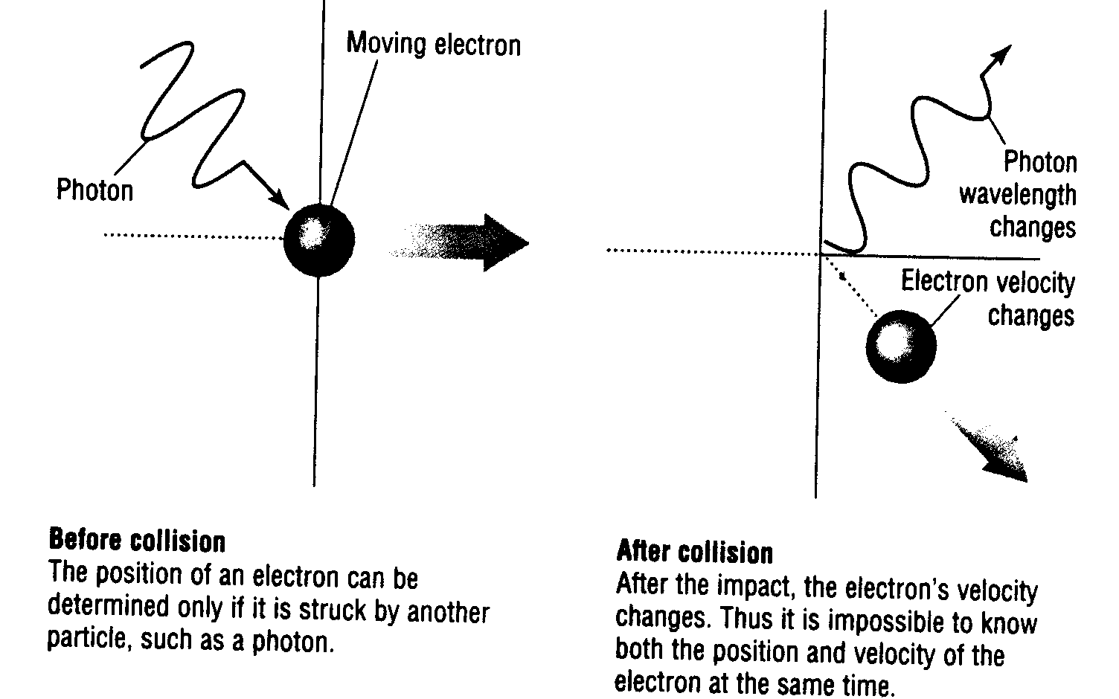

Let’s make an analogy. Suppose, for example, that you want to clock the speed of an automobile. You could set up two pylons on the side of the road a known distance apart. An observer at the first pylon will press a button that starts a clock running when the car passes; when the car passes pylon number two, a second observer will press a button stopping the clock. Dividing the distance between pylons by the time on the clock, you now have a measure of the speed of the automobile. The accuracy of the measurement depends on such things as how precisely the pylons are positioned and how quickly the observers respond. The effect of these uncertainties can be minimized by simply using a larger separation between the pylons. This will give a more accurate determination of the automobile’s speed.

But now suppose you also ask where the car was when its speed was measured. The answer is “between the pylons.” The more accurately you determine the automobile’s speed by moving the pylons apart, the less precise you can be about its position. If you want to be more precise about the position of the car, you must move the pylons closer together, making the speed measurement more uncertain.
This trade-off is the classic dilemma of measurement. Position and motion are said to be “complementary” variables. There are all sorts of complementary variables in our lives; if we look for greater security in investments, for example, we must settle for a lower rate of return. What Heisenberg postulated was that there is a fundamental limit on how accurately you can simultaneously know both the position and motion of a particle, no matter how good the measuring instrument. The limit, called the Planck constant, is a measure of the ultimate “graininess” of nature. The result, however, is to limit the possible outcomes of an experiment. A quantum transition between two states of an atom results in the emission of a photon of very specific energy. The same transition will always result in a photon of precisely that energy. Heisenberg had actually made the world more certain.

Erwin Schrodinger (1926):

Schrodinger treated the electron as a wave and developed a mathematical equation to describe its wave behavior. Schrodinger's wave equation describes the most probable position of an electron in terms of a wave function. Each wave function is associated with a set of four quantum numbers which accurately describe the energy and most probable location of any electron of an atom. The position or location of an electron is best represented by an electron cloud, which shows the probability of finding an electron in a given area around the nucleus. In keeping with Heisenberg’s uncertainty principle, a particle (electron) with a well-defined state of motion is represented by a very broad wave packet. Once the particle is detected, the wave function is said to have “collapsed” on the location of the detector. The act of observing the particle has thus caused the wave function to change everywhere. It is as if, until it was detected, the particle was everywhere at once.

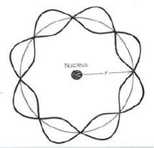

Why Doesn’t the Electron Fall Into the Nucleus?

An atom is made up of a positively charged nucleus with one or more negatively charged electrons around the nucleus. Since the nucleus and the electron are of opposite charges, naturally they attract one another and tend to come together. However, an electron is not only a particle; it also behaves as a wave. Because this is true, we can visualize the electron not as a discrete particle, but rather as a diffuse cloud of matter and electrical charge around the nucleus. As the electron and nucleus come closer together, that is, as the electron cloud is confined more and more (and the electron cloud becomes smaller and smaller), the wavelength of the electron must become shorter and shorter so that it can “fit” into the confining space. As its wavelength becomes shorter, the electron’s energy increases. Eventually, the energy possessed by the electron due to its confinement becomes sufficiently great that the electrostatic potential energy can no longer continue to draw the electron and nucleus closer together. At that point an equilibrium is established in which the atom is stable and in which the electron neither goes toward the nucleus (electron cloud becomes smaller) nor does it escape from the nucleus (electron cloud becomes larger).

The most probable location (or energy) of an electron in an atom can be determined by solving the Schrodinger wave equation, which gives four numbers, called quantum numbers. These are the numbers that describe an electron’s location (energy). The actual physical space around the nucleus in which an electron is most likely found is termed an orbital. Quantum numbers will sound a little complicated so let us start out simple and consider the location (energy) of an electron in two dimensions – like page 15.

The first quantum number (called the principal quantum number) describes the average distance of the electron (or the orbital the electron is in) from the nucleus. It is like the Bohr energy level but instead of the electron being an exact distance from the nucleus it is an average distance. The principal quantum number has the designation n, and can have values of n = 1, 2, 3, 4, 5, 6 and 7

It turns out that energy levels are made up of sublevels. The second quantum number tells us which sublevel (within the principle energy level) the electron can be found. If this sounds a little abstract you are right. Technically the second quantum number tells us the shape of the orbital. It is termed the orbital quantum number and has the designation l. The sublevels are designated by the letters s p d and f, and are given the following values:

value of l sublevel (letter code)

0 s

1 p

2 d

3 f

If this sounds a little abstract (if not confusing) do not be discouraged. The good news is that the 1st energy level is made up of only one sublevel, an s sublevel. The 2nd energy level is made up of two sublevels, an s and a p sublevel. The 3rd energy level is made up of three sublevels, an s, p, and d sublevel. The 4th energy level is made up of four sublevels, an s, p, d and f sublevel. The 5th, 6th, and 7th energy levels are like the 4th energy level, made up of s, p, d, and f sublevels.

Each sublevel in turn is made up of one or more orbitals. Again, an orbital is defined as the average region of space surrounding the nucleus through which an electron with a given energy may move. Orbitals differ from one another in three ways:

a) they may have different shapes
b) they may be oriented differently in space
c) they may have different sizes

The third quantum number, called the magnetic quantum number, describes which orbital in the sublevel the electron can be found (or technically how an orbital is oriented in space). It has the designation ml. Electrons in energy sublevels orient themselves in specific regions of space around the nucleus because of their magnetic fields. Each orbital may take a maximum of two electrons. When an orbital contains a maximum of two electrons it is said to be a filled orbital. An orbital having one electron is said to be half-filled and an orbital having no electrons is said to be empty. The allowed values for ml are -l, 0, +l

s orbital (spherical)
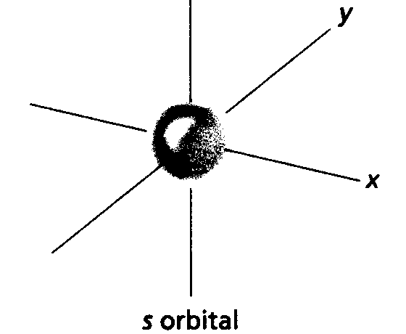

p orbitals (dumbbell shape):

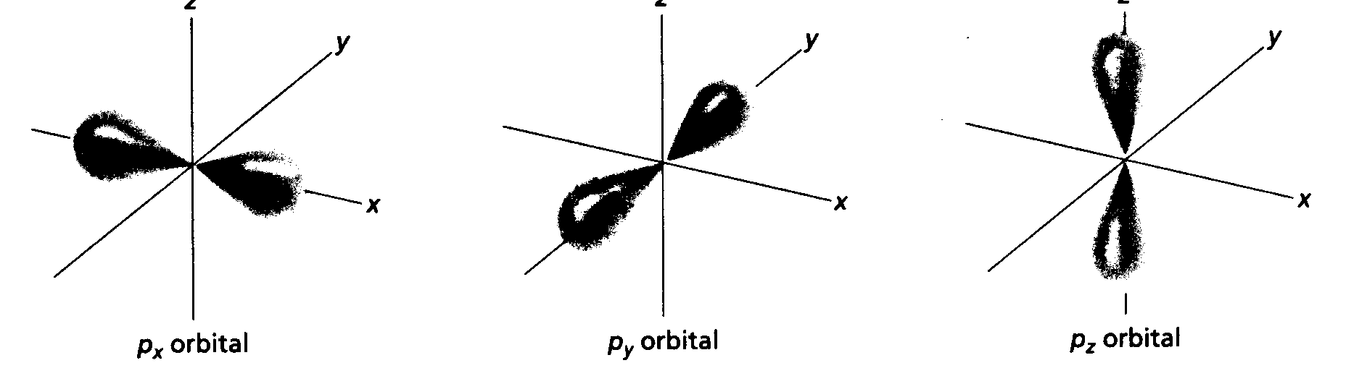

The fourth quantum number, called the spin quantum number, distinguishes between the two electrons in any orbital. It has the designation ms, and can have values of + ½. The + ½ means the electron spins clockwise (or arrow up) while the – ½ means the electron spins counterclockwise.(or arrow down). Let’s look at how energy levels (designated by n), sublevels (designated by l), and orbitals (designated by ml) are arranged in an atom considering only two dimensions:

note: energy levels 5 thru 7 have the same sublevels as level 4.

level (n) Sublevel (l) Orbitals (m_{l})
4f¹⁴

d 4d¹⁰

p 4p⁶

4 s 4s²

----------------------------------------------------------------------------------------------

d 3d¹⁰

p 3p⁶

3 s 3s²

----------------------------------------------------------------------------------------------

p 2p⁶

2 s 2s²

---------------------------------------------------------------------------------------------
1 s 1s²

level (n) Sublevel (l) Orbitals (m_{l}) electron configuration

Let’s see how this works. What are the quantum numbers for the lectron found in the 2p sublevel?

n = because

l = because

m_{l} = because

m_{s} = because

What are the quantum numbers for the electron found in the 3s sublevel?

n = because

l = because

m_{l} = because

m_{s} = because

What are the quantum numbers for the electron found in the 4f sublevel?

n = because

l = because

m_{l} = because

m_{s} = because

What are the quantum numbers for the electron found in the 3d sublevel?

n = because

l = because

m_{l} = because

m_{s} = because

Pauli Exclusion Principle:

No two electrons in an atom can have the same set of quantum numbers. Hence, every electron has a unique set of quantum numbers which describes its energy and most probable location around the nucleus. This idea showed that the periodic table of elements discovered by Mendeleev could be exactly accounted for: quantum theory explained the chemical properties of the elements.

Problem: Give the possible quantum numbers for a 3p electron:

Problem: Give the possible quantum numbers for a 2s electron:

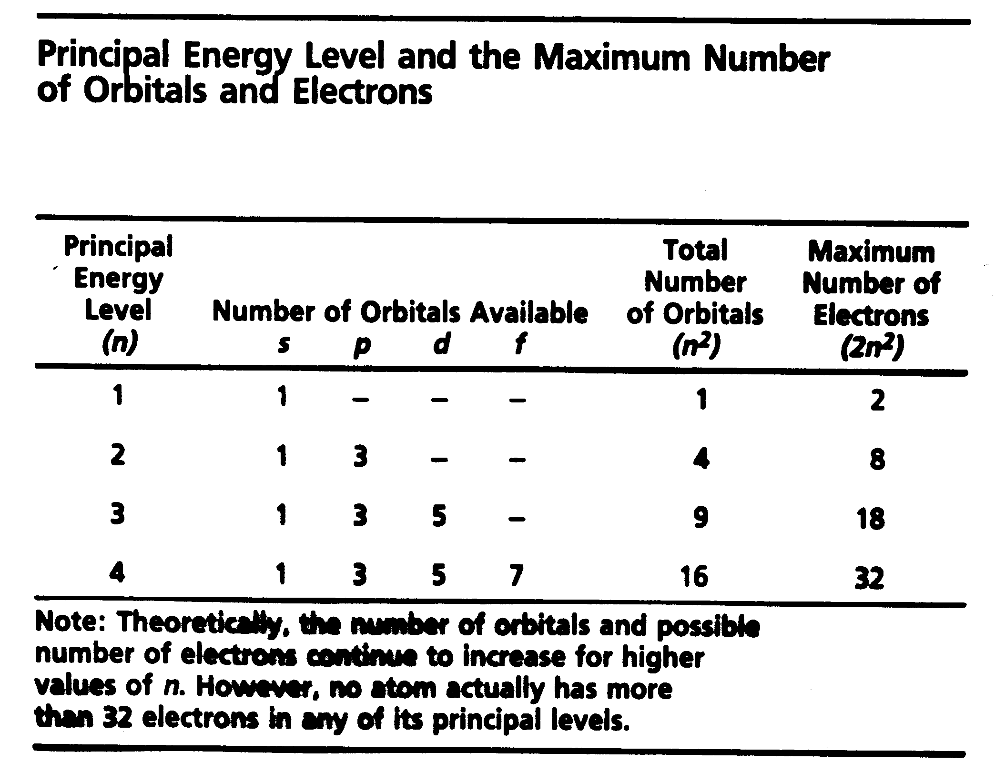

How might these orbitals look in three dimensions? Below is a diagram showing the 1s, 2s, 2p, and 3s orbitals in an atom with the quantum numbers for a 3s electron shown on the right:
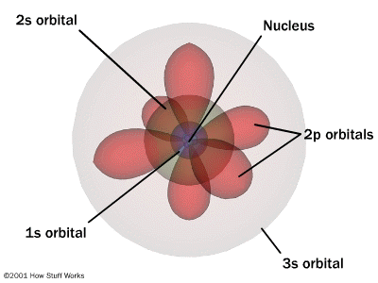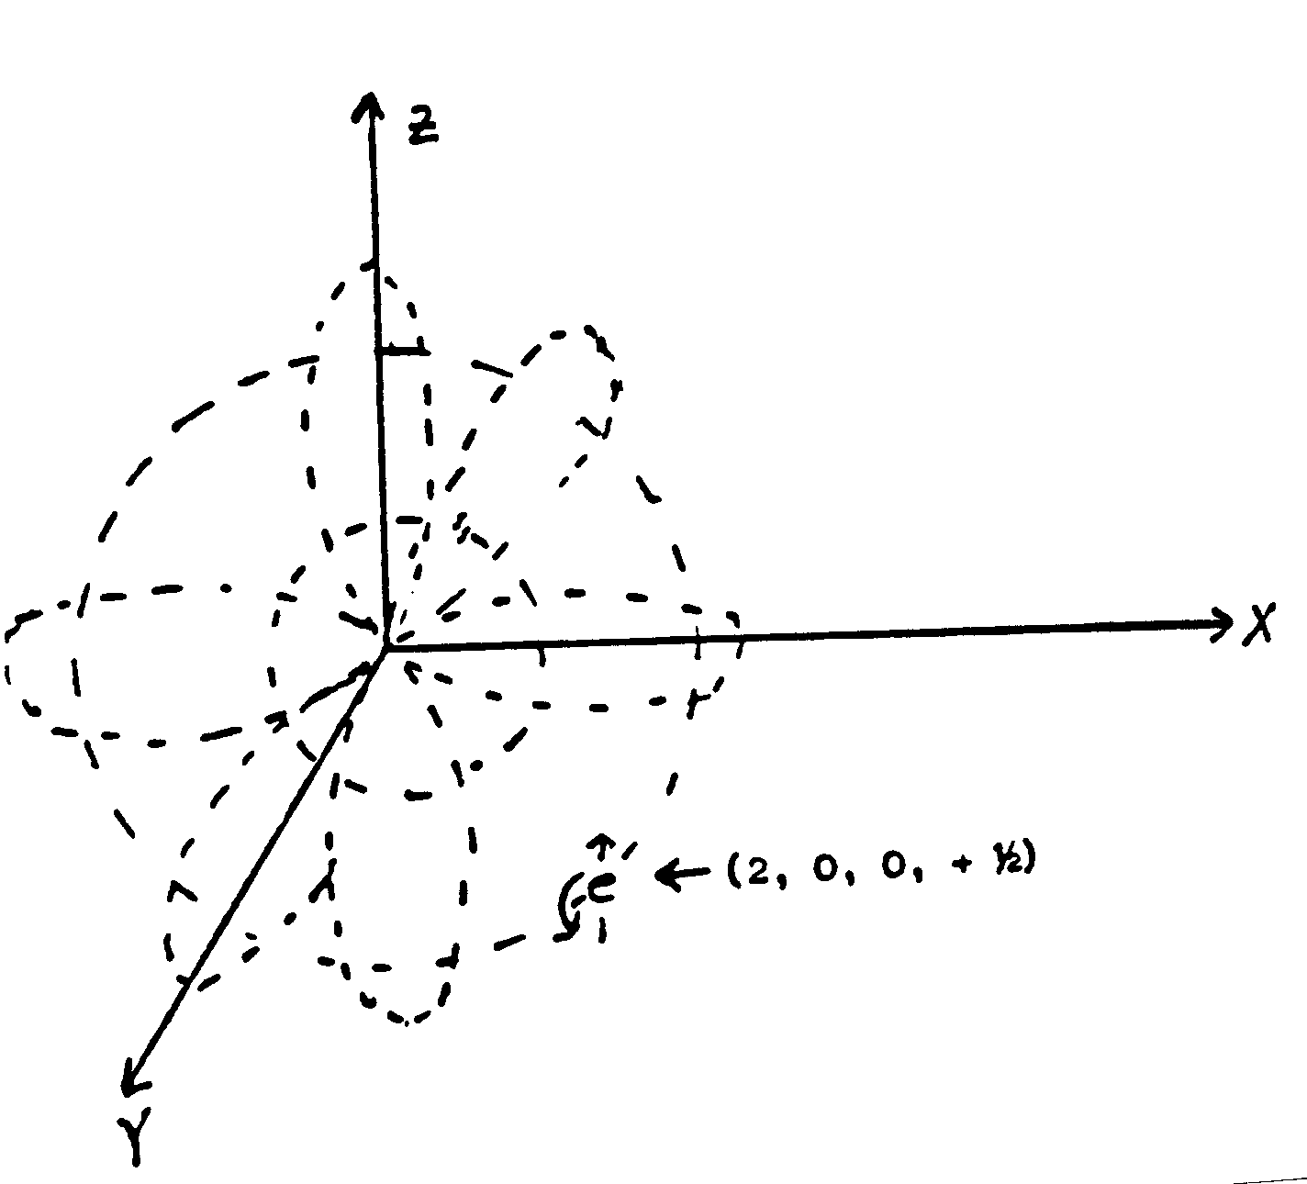

Electron Configurations

Electron configurations show the way electrons are arranged in an atom according to principal energy levels and sublevels. When writing the electron configurations of atoms, add 1 electron at a time observing the following rules:

- No more than two electrons can be accommodated in any orbital

- The added electron is placed in the unfilled orbital of the lowest energy (Aufbau Principle). Sometimes a sublevel of one energy level may have a lower energy than one of the sublevels in an energy level with a smaller value of n (e.g. 4s is lower in energy compared to 3d).

Energy order (increasing left to right):

1s2s2p3s3p4s3d4p5s4d5p6s4f5d6p7s5f6d7p

- In a given sublevel, a second electron is not added to an orbital until each orbital in the sublevel contains one electron (Hund's Rule). The most stable electron configuration is one which has the maximum number of unpaired electrons (i.e. maximum net spin or maximum number of parallel spins).

We will learn to write electron configurations by just following the atomic number on the Periodic Table because the Periodic Table is arranged in a manner that allows us to do this. Recall the Table is arranged in seven periods and the period number indicates in which energy level an atom’s valence electrons occur. For example, any element in Period 5, like silver (Ag), has its valence electrons in the fifth energy level. The Table is also arranged in 18 groups or families. The groups are arranged by sublevel blocks:

Groups 1and 2 s block elements (their configurations will end in s¹ or s²)

Groups 13 thru 18 p block elements (He is exception as it only has two electrons)

Groups 3 thru 12 d block elements

Recall that the d sublevel first appears in the 3rd energy level so that scandium (Sc) actually starts filling the 3d sublevel even though it is in period 4. Likewise yttrium (Y) starts filling the 4d sublevel.

f block elements referred to as the inner transition elements)

lanthanum (La) starts filing the 4f sublevel and actinium (Ac) starts filing the 5f sublevel. These are known as the lanthanides and actinides

Key idea – fill orbitals from lowest to highest energies. This follows the Aufbau Principle. Note that orbital “overlap” occurs; e. g. the 4s orbital is actually lower in energy compared to 3d orbitals so they fill before the 3d. The Periodic Table is arranged in sublevel blocks and the order of filling follows atomic number. You will be held responsible for the first 56 elements:
1s2s2p3s3p4s3d4p5s4d5p6s

EC valence orbital notation

H

He

Li

Be

B
EC valence orbital notation

C

N

O

F

Ne

Na

Mg

P

Cl

K

V

Fe

Ni

Ge

EC valence orbital notation

Se

Kr

Rb

Zr

Sn

Te

Ba

Exceptions in writing EC:

Chromium family:

Expected:

actual:

Copper family:

Expected:

actual:

Lewis Structures (Electron Dot Notation)

Lewis structures are a way of illustrating valence electrons – those are the outermost electrons involved in an atom’s bonding. Lewis structures specifically show s and p sublevel valence electrons. The steps in writing a Lewis notation for an element are as follows:

- write the symbol of the element – the symbol represents the kernel = the nucleus plus all but valence electrons.

- imagine a square around each symbol. In this square each side represents s, p_{x}, p_{y}, and p_{z} valence electrons.

Problems

Electron configuration valence orbital notation Lewis

O

P

K

Mo

