Name __________________________
Period ___
Earth Science Chapter 1 Study Guide

Modified True/False
Indicate whether the statement is true or false. If false, change the identified word or phrase to make the statement true.

____ 1. An inference is an activity performed to prove or disprove a hypothesis. _________________________

____ 2. The information you collect in an experiment in order to answer a question is called data. _________________________

____ 3. You marked down the time it took for each student in your class to run 100 yards. This data is an example of qualitative data. _________________________

____ 4. All five of your senses can be used for making observations. _________________________

____ 5. Scientific laws and theories are always being tested by experiments. _________________________

Completion
Complete each statement.

Select the correct term to complete each sentence. There are extra terms in the list.

hypothesis | science | observation
law | theory | inference

6. In science, an educated guess to a science question based on observations is called a(n) ________________________.

7. Plate tectonics describes how the plates move on Earth’s surface. This is an example of a scientific ___________________.

8. _________________________ is a process for answering questions.

9. A(n) ______________________________ is a statement based on your experiences.

Short Answer

10. The scientific method is used to find answers to science questions. List the five steps in this scientific process.
1. ________________________________________________
2. ________________________________________________
3. ________________________________________________
4. ________________________________________________
5. ________________________________________________

Sukie read that chlorine is added to her town’s municipal water supply to help disinfect it. She wondered how much chlorine was in the water when it came out of the tap at school. Sukie’s teacher helped her use a chlorine test kit to measure the exact amount of chlorine in the water. It turned out that the school’s tap water contained 0.20 ppm of chlorine.

11. Did Sukie collect qualitative or quantitave data in her experiment? ________________________

12. List one opinion Sukie could make about her experiment. ________________________________________________________________________________________

13. List one observation that Sukie could make about her experiment. ________________________________________________________________________________________

14. The cafeteria has served pizza every Friday for the past 5 Fridays. Tomorrow is Friday and the cafeteria will be serving pizza.

Is this statement an inference or an observation? Explain why. ________________________________________________________________________________________________________________________________________________________________________________________________________________________________________________________________________

15. Why is it important to record your observations in a science notebook? ________________________________________________________________________________________________________________________________________________________________________________________________________________________________________________________________________

16. Makayla loves science class.

Is this statement an observation or an opinion? Explain why. ________________________________________________________________________________________________________________________________________________________________________________________________________________________________________________________________________

17. 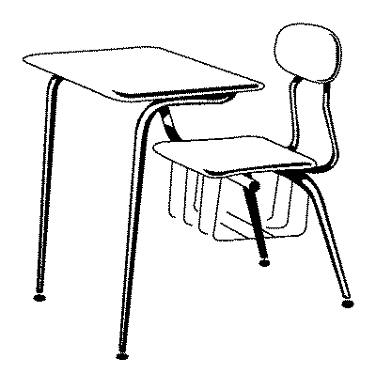
List three observations about this desk.
__________________________________________________
__________________________________________________
__________________________________________________

18. If you make a mistake in your lab notebook, what should you do? ________________________________________________________________________________________________________________________________________________________________________________________________________________________________________________________________________

19. A good hypothesis is __________________________________.

20. The leaves on a maple tree outside your school are wilting. Write a hypothesis as to why the leaves are wilting. ________________________________________________________________________________________________________________________________________________________________________________

21. For a hypothesis to be good, does it have to be correct? Explain. ________________________________________________________________________________________________________________________________________________________________________________________________________________________________________________________________________

Earth Science Chapter 1 Study Guide
Answer Section

MODIFIED TRUE/FALSE

1. F, experiment

2. T

3. F, quantitative

4. T

5. T

COMPLETION

6. hypothesis

7. theory

8. Science

9. inference

SHORT ANSWER

10. 1. Make observations.
2. Ask a question.
3. State a hypothesis.
4. Test the hypothesis with an experiment and collect data.
5. Draw conclusions based on the experiment.

11. She collected data that was a numerical measurement. This type of data is called quantitative data.

12. Answers will vary. Correct answers include:
Chlorine makes the tap water safer.
Chlorine makes the tap water taste funny.
The tap water tastes better than bottled water.

13. Answers will vary. Correct answers include:
There is 0.20 ppm of chlorine in her school’s tap water.
There is chlorine present in her school’s tap water.
You can’t see the chlorine in tap water.

14. The statement is an inference because you are making a prediction based on your experience of the cafeteria serving pizza on Fridays. It can’t be an observation because it hasn’t happened yet.

15.
If you record everything you did and observed in a science experiment, then others can repeat your experiment.

16. This statement is an opinion. It is Makayla’s personal judgement that she loves something. An observation would be an accurate description of science class, not a personal opinion.

17. Answers will vary. Correct answers include:
The desk has 4 legs
The desk has a flat top.
The desk has a seat attached to it.

18. If you make a mistake in your lab notebook, you should draw a line through it so it can still be read. You should not erase anything in your notebook. Sometimes a mistake can lead you to an answer or a discovery, so you don’t want to erase it.

19. testable

20. Answers may vary. For a hypothesis to be correct, it must be testable. Correct answers include:
The leaves are wilting because the tree does not get enough water.
The leaves are wilting because the tree does not get enough nitrogen.
The leaves are wilting because motor oil was spilled under the tree.

ESSAY

21. No, because if your hypothesis turns out to be incorrect, that still gives you valuable information about your experiment. The information can help you to modify your hypothesis. This is all part of doing science. The main requirement for a good hypothesis is that is can be tested.

