AP European History Summer Reading Assignment
Corona High School
Mrs. Menter-Hartman
Email: lmenter@cnusd.k12.ca.us
Reading: Western Civilization, Chapter 11: The Later Middle Ages, Pages 299-330

Welcome to AP European History! If you love history, if you love discovering diverse cultures, if you love Europe, if you love to travel, if you love to challenge yourself, if you love to learn, then this course is for you. In order for this course to meet the requirements of AP certification, it must be taught at the rigor of a college-level course. We will be going very fast, and covering a lot of information in a short amount of time. Therefore, in August we need to hit the ground running.

To accomplish this, I am assigning you a summer reading assignment so you are immediately ready to start AP Euro from the Renaissance the moment you walk into class in August. This reading assignment is of the first chapter in the text book and is meant to be a review of much of what you learned in 7th grade World History. Its purpose is to awaken your pre-existing knowledge. I hope it will be exhilarating and create in you an anticipation to learn more. Warning; I will NOT accept late summer assignments.

To better understand the reading, I encourage you to first complete the provided blank map of Europe with its current nations. You may refer to the map on page 929 of your textbook to help you complete the map. Then reading the provided “How to do AP European History Homework: Reading and Taking Notes.” This will give you step by step instructions of how to complete the “AP European History Summer Assignment.” This Summer Assignment is comparable to what would be a week of homework during the regular school year.

When you return to school in August you will take an open-note reading quiz on which you can use your Summer Reading Notes. You will turn your Summer Reading Notes in to me immediately following the quiz. In addition, you will also take closed-note terms quiz and a map quiz. Each component of the summer reading assessments are worth 25 points, equaling 100 homework points. You will have a grade in my class by the end of the first week of school.

So to summarize, be prepared to turn in your Summer Reading Notes and take three quizzes; a terms
quiz, a reading quiz and a map quiz. Other than that, enjoy your summer and I look forward to seeing
you in August!

AP European History Recommended Supplies:

- A 3 ring binder specifically for AP Euro
- A supply of spiral notebooks (for homework and lectures)
- 3 hole punched folders for handouts/documents

- Several highlighters of various colors
- A supply of both pens & pencils
- An AP European History test prep book

How to do AP European History Homework: Reading and Taking Notes

The point of AP European History homework is COMPREHENSION. It is not just to get the assignment done or get points. Always remember that you are taking a test in May that will assess your understanding of the subject. There is no way I can cover all the material you need to know in class, so you must be accountable for your own learning and acquire much of the information on your own.

Homework Steps:
The purpose of completing your homework in this order is to increase comprehension which is the ultimate goal of the homework.
- Terms: Define assigned terms by using the textbook glossary, a dictionary (online dictionaries are fine)
  - If there are multiple definitions for a term, first read how the term is used in the textbook and then choose the definition that most closely aligns to the academic use.

- Read: Read the assignment from start to finish WITHOUT taking notes. Instead, you should be lightly underlining important ideas with a pencil. You will take notes and erase these marks later.

- Images: Analyze all images provided by the textbook. Take notes on its importance in reference to what you have previously read.

- Documents: Read and analyze all primary documents provided by the textbook. Write a summary of each document and why it is important in reference to what you have previously read.

- Maps: Analyze all maps provided by the textbook. Write a summary of why the map/maps are important in reference to what you have previously read.

- Notes: Skim over what you have previously read by analyzing the important ideas you have underlined. Now take notes based upon the topics I have provided for you, keeping in mind the terms, images and documents.
  - Your notes should be rich, rigorous and thoughtful. They should answer the four Ws: What, Who, Why and (So) What?

- Summary Statement: Write ONE sentence that summarizes your comprehension of that night’s reading assignment.

Map of Modern Europe:

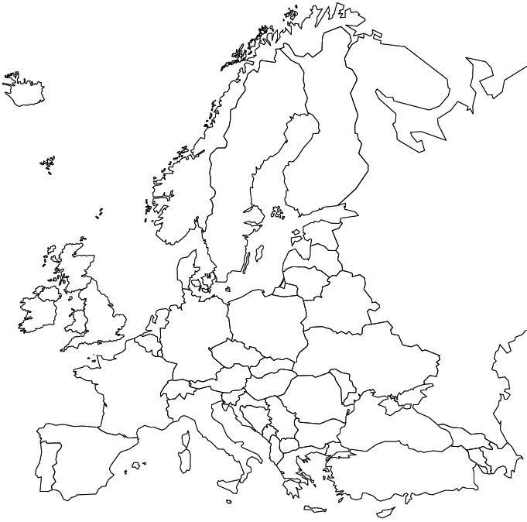

List of Modern European Nations

- Albania
- Armenia
- Austria
- Belarus
- Belgium
- Bosnia and Herzegovina
- Bulgaria
- Croatia
- Cyprus
- Czech Republic
- Denmark
- Estonia
- Finland
- France
- Georgia
- Germany
- Greece
- Hungary
- Iceland
- Ireland
- Italy
- Kosovo
- Latvia
- Lithuania
- Luxembourg
- Macedonia
- Netherlands

- Norway
- Poland
- Portugal
- Romania
- Russia
- Serbia
- Slovakia
- Slovenia
- Spain
- Sweden
- Switzerland
- Turkey
- Ukraine
- United Kingdom (England, Scotland, Wales)
- Vatican City

Bodies of Water

43 Atlantic Ocean
44 Baltic Sea
45 Black Sea
46 Bosporus Straits
47 English Channel
48 Mediterranean Sea
49 North Sea
50 Strait of Gibraltar

AP European History Summer Assignment

Chapter 11:

299-308
Terms: Black Death, flagellant (303), pogrom, Statute of Laborers (305), Jacquerie (306), English Peasants' Revolt (306), Archbishop of Canterbury (307)
Images: 5 Documents: 3 Maps: 1
Notes: 1. Famine and population
2. Cause and spread of the Black Death
3. Reactions to the Black Death
4. Economic effects of the plague
5. Peasants Revolts
Summary Statement

308-318
Terms: Valois (308), mercenary (309), Joan of Arc (310), scutage, parliaments (312), Parliament (314), Estates General (314), Third Estate, Golden Bull of Charles IV (316), despotism (316), condottieri, Patrician (317), guild (317), oligarchy (318),
Images: 4 Documents: 2 Maps: 1.
Notes: 1. Causes of the Hundred Years War
2. Major battles and treaties of the war
3. How the French finally won the war
4. How the 100 year War changes the power structure of traditional Monarchs
5. The Evolution of Monarchs
6. Weakness of the French Monarchy
7. The structure of the HRE
8. The organization and structure of Italy
Summary Statement

318-322
Terms: Doge (318), Unam Sanctan (318), College Cardinals (319), Great Schism, Conciliarism, purgatory (321), indulgences (321), mysticism, modern devotion
Images: 2 Documents: 2 Maps: 3
Notes: 1. Boniface V. Phillip
2. The Avignonese Papacy
3. The Great Schism
4. Conciliarism v. absolute Papalauthority
5. Changes in church culture and theology.
Summary Statement

322-325
Terms: vernacular (322), classical (322), realism (325)
Images: 2 Documents: 1 Maps: 0
Notes: 1. the great artists of the Later Middle
Ages:
a. Dante
b. Petrarch
c. Boccaccio
d. Chaucer
e. Christine de Pizan
f. Giotto
Summary Statement

325-330
Terms: foundlings (328)
Images: 2, Documents: 1, Maps: 0
Notes: 1. Prostitution
2. Gender Roles,
3. The Medical Profession
4. Important Inventions
a. clock
b. gunpowder
Summary Statement

