Name __________________________
Chapter 12: The Crisis of the Later Middle Ages
Complete the graphic organizer with detailed and specific information from the reading!!
I. Prelude to Disaster
How did environmental issues impact the economies of northern Europe in the early 14th century?

Why did people living at that time refer to Genesis 42 to describe their situation?
In what ways did poor nutrition lead to catastrophic loss of life?
Describe the social and economic upheavals caused by shortages, famines, and epidemics of the time.
How did the monarchs of France and England try to deal with the crises of their times? What were the results of their attempts? | French actions | Results
 | English actions | Results
Why do you think people didn’t cooperate more during this time of crisis?
What was the main source of conflicts between people and their leaders or neighboring countries at this time?

II. The Black Death (p. 381-387)
How did a technological advance lead to the plague in Italy?
Where did the plague come from?
What is the cause of the plague and when was this discovered?

How did the lifestyle of European society help in the spread of the disease?

How did the disease get its names: the bubonic plague, or the Black Death?
Describe the medical treatments of the epidemic at the time and their results?

What role did hospitals play in the epidemic? What role do they play for historians studying it?
What impacts did the plague in each region of Europe? | England:  Italian city-states:  German Empire:  Poland:  Hungary:  Russia:  The Balkans:
What changes resulted from the plague that helped lessen its effects in the future?
How did the plague influence each aspect of European society? | Respect of the clergy:  Religious authority of laypeople:  Wealth of medieval landlords:  Economic opportunities in urban regions:  Social mobility for laborers and general standard of living:  Slave trade:  Morality and religion:  Treatment of foreigners:  Educational focus:  Art and literature:
III. The Hundred Years’ War
Detail the political, economic and social causes of the Hundred Years’ War.
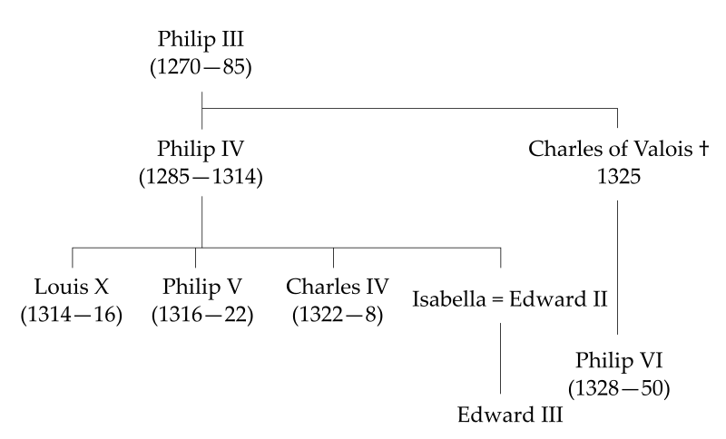
How did propaganda and royal incentives motivate support from different classes of people?
How did the code of chivalry demonstrate the social structure of the late Middle Ages?
Describe the phases of the war and the important battles of each phase.

Who was Joan of Arc and what role did she play in the war?

What were the costs and consequences of the war on the countries involved?

IV. The Decline of the Church’s Prestige
Describe the Babylonian Captivity.

Describe the Great Schism

What were the goals of the Council of Constance?

V. The Life of the People
Describe marriage patterns in the late Middle Ages.

Identify Jan Hus

Identify John Wycliff

How did economic and social roles change for people in the late Middle Ages?

What is “fur-collar crime” and why did it happen?

Describe the Jacquerie.

Describe the Peasants’ Revolt.

What caused ethnic tension and racism to increase across Europe in the late Middle Ages?

Define vernacular

Identify Dante and his significance

Identify Chaucer and his significance

AP European History Themes
The content learning objectives for the AP European History course and exam are organized under five themes, which are topics of historical inquiry to explore throughout the course. These themes will help to focus your understanding of major historical issues and development, and help you to recognize trends and processes that have emerged over the centuries.
Based on the material covered in the reading guide above, respond to the following questions.
- Interaction of Europe and the World: How did encounters between Europe and the world impact European culture, politics, and society at the end of the Medieval Period?
- Poverty and Prosperity: How was the organization of society changed as a result of or in response to the changes in the economic patterns in various parts of Europe at the end of the Medieval Period?
- Objective Knowledge and Subjective Visions: What sources were responsible for creating and transmitting knowledge through the late Middle Ages and what factors strengthened or weakened their authority?
- States and Other Institutions of Power: What type of power did institutions of authority hold in Europe and what was the source of their authority? How were these institutions strengthened or challenged by conditions in the late Middle Ages?
- Individual and Society: Describe what forms have family, class, and social groups had in Medieval Europe, and how they were changing.

