30 Book Challenge for 3rd Graders
Dear 3rd Grade Students,
Are you up for a challenge? This year, I am encouraging my 3rd graders to read at least 30 books from different genres. By reading a variety of books, students will develop and internalize independent reading habits. They will learn to appreciate different genres, understand the different elements or text features of each genre, and learn to choose “good fit” books. Students are to choose books from the genres listed below and record the number of books read in the Book Challenge Reading Log. The Book Challenge Reading Log will help your student keep track of how many books they have read from each genre.

Genre Number of Books
Poetry Anthologies 1
Traditional Literature
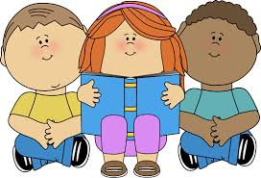
Realistic Fiction 6
Historical Fiction 1
Fantasy 3
Science Fiction 1
Mystery 2
Informational 4
Biography, Autobiography,
Memoir 1
Chapter Books 11

I understand that students have varying reading levels. For those students who read any book over 250 pages, it will count as 2 books toward the challenge total. It is my hope that all students will learn to love reading!

Sincerely,
Ms. Nunokawa

