AP BIOLOGY SOUTH GATE HIGH SCHOOL

Guided Reading:
Ch. 2 – Basic Chemistry
Answer the following questions as you read the chapter. Be prepared for a Reading Quiz on any or all of the questions.

- Your friend walks up to you and asks, “What’s the matter?” You answer, “Everything!” Explain this joke. [p.20]

- What are the six elements that are basic to life and make up 95% of the body weight of organisms? [p.20]

- Label this diagram illustrating the structure of a typical atom: [p.21]
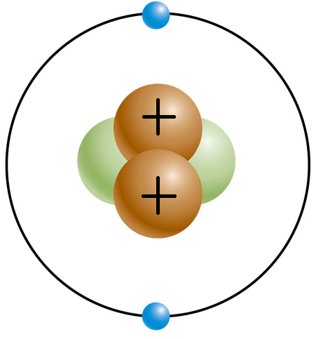
- Complete this table summarizing the characteristics of the subatomic particles: [p.21]
Particle | Electric Charge | Atomic Mass | Location
 | 0
 |  |  | Electron Shell
 | +1

- On page 21 they show you how the carbon atom is notated. In the space below, give the notation for oxygen (O):

- Explain the difference between an atomic number and an atomic mass. [p.21]

- What are isotopes and why are they biologically significant? [p.22-23]

- What is the maximum number of electrons that can be found in an orbital? [p.23]

- Why does it take energy to keep electrons in their orbitals? [p.23]

- What does the Periodic Table group number of an atom tell you? [p.23]

- What is the octet rule, and how does it predict weather or not an atom will react? [p.23]

- Explain the difference between a compound and a molecule. [p.24]

- Explain the difference between an ionic bond and a covalent bond. [p.24-25]

- Why are the shapes of molecules necessary? [p.25]

- Explain the difference between a nonpolar and polar covalent bond. [p.26]

- What are hydrogen bonds and why are they important? [p.26]

- Why do water molecules cling together? [p.27]

- Why does water absorb heat without a great change in temperature? [p.27]

- Why does water have a high heat of vaporization? [p.27]

- What is the biological significance of water’s high heat capacity and heat of vaporization? [p.27]

- Explain the difference between hydrophilic and hydrophobic. [p.28]

- Explain how cohesion and adhesion is used to transport water in plants. [p.28]

- Discuss the biological significance of water’s high surface tension. [p.28]

- Explain why water is less dense as a solid (ice) than as a liquid. [p.29]
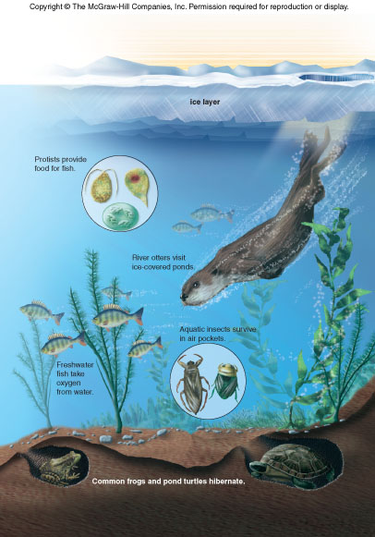
- Label this diagram illustrating the biological significance of the fact that ice floats in water: [p.29]

- What happens when water ionizes? [p.30]

- Explain the difference between an acid and a base. [p.30]

- Why is HCl considered a “strong” acid? [p.30]

- What is the pH scale used for, and discuss the difference between a pH of 3 and a pH of 9. [p.30]

- Discuss the biological significance of buffers. [p.31]

