Cells for 6th Graders
The following are lecture notes from our cell unit.

What is a Cell?
A cell is the smallest unit that can carry out the activities of life.
-must obtain nutrients and energy, remove waste products, grow, and
reproduce

Single-Celled vs. Multicellular
Single-celled organisms: most are microscopic; each part of the cell
performs a task.
Multicellular organisms: larger organisms; different cells specialize
to perform different tasks.

The Cell Theory
-took hundreds of years to develop
Robert Hooke (1635) – “coined the term ‘cell’”; used simple microscopes
Anton von Leeuwenhoek (1683) – “animacules”; bacteria; merchant who
enjoyed using microscopes.
Matthias Schleiden (1838) – concluded that all plants are made of cells.
Theodore Schwann (1839) – stated that all animals are made of cells.
Rudolf Virchow (1855) – stated that new cells come only from already
existing cells.
By 1875, microscopes similar to those used today were in common use.

*All living things are made of one or more cells.
*Cells are the basic units of living things.
*All cells come from existing cells.

For more information about the Cell Theory, check out the sites below:

http://en.wikipedia.org/wiki/Cell_theory

http://fig.cox.miami.edu/~cmallery/150/unity/cell.text.htm

Cell Parts
Organelles – structures that perform specific functions in cells

Endoplasmic reticulum (ER) – a network of folded membranes. The
cell’s transportation system. Also helps make proteins and other
substances the cell needs.
Nucleus – the “brain” of the cell. Directs the cell’s activities. Contains the
cell’s operating instructions and stores information that will be passed on
to new cells.
Vacuole – storage tank for the cell
Mitochondria – the “powerhouse” of the cell
Cell membrane – “guard” of the cell. Controls what materials enter and
exit the cell. Maintains the internal environment.
Cytoplasm – fluid portion of cell that contains the organelles.
Lysosome – the “clean-up crew” of the cell (think Lysol)
Cell wall * - found only in plant cells. Rigid, made of cellulose. Provides
support for plants.
Chloroplast * - found only in plant cells. Contains the green pigment
chlorophyll used in the process of photosynthesis.

Plant Cells vs. Animal Cells

Has chloroplasts and No chloroplasts or
chlorophyll chlorophyll

Has a cell wall No cell wall

One large vacuole Many, small
vacuoles

For more information about cells and organelles, go to the following sites:

http://www.jerichoschools.org/seaman/classrooms/grade-5/treiber/cell/The-cell/cell-intro.htm

http://biology.clc.uc.edu/courses/bio104/cells.htm

Transportation of Materials

Background information:
3 phases of matter: solid; liquid; gas
-all matter is made up of molecules
-all molecules are in constant motion
-molecules in solids are tightly packed; not as much room to move
-molecules in liquids not so tightly packed
-molecules in gases not tightly packed

To learn more about the phases of matter, check out this site:
http://www.enchantedlearning.com/physics/Phasesofmatter.shtml

Cells are 2/3 water. Substances the cell needs are dissolved in water. How does the cell get more of the substances it needs?
Diffusion = the movement of a substance from an area of high
concentration to an area of lower concentration. Diffusion
occurs because molecules are constantly moving. As they
move, they bump into one another and move apart. Over time
they spread out until they are evenly dispersed.
Cell membrane – maintains the cell’s internal environment; the
membrane is semi permeable; it allows some materials to pass
through it based on the size of the molecules.

Diffusion of Water
-this is a special type of diffusion = osmosis

For more information on diffusion and osmosis, check out the sites below:
http://biology.arizona.edu/sciconn/lessons/mccandless/reading.html
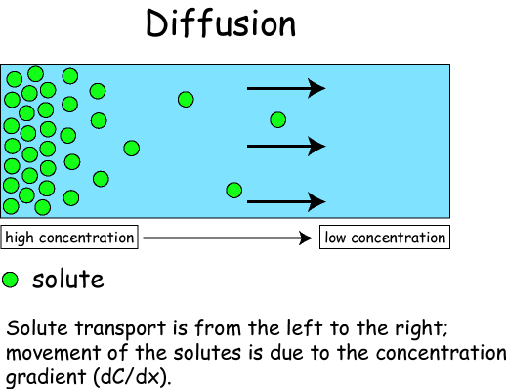
Cell Size and Growth

*as multicellular organisms grow in size, their cells increase in number
*new cells also form to replace old or damaged cells
*cells make new cell through the process of mitosis and cell division

No matter how large a living thing may be, its cells are still small.
Why are cells small?
-as a cell grows, the organelles get larger, it uses more
food and produces more waste
-the inside of the cell grows at a faster pace than the
surrounding cell membrane
-as a cell gets larger, more materials must move longer
distances into and out of the cell through a more
restricted membrane
-eventually, large cells divide into smaller cells

For more information on cell sizes, check out the link below:

http://curriculum.calstatela.edu/courses/builders/lessons/less/les9/area.html

http://users.adelphia.net/~lupold/biologybinder/notes%20pages/mitosis_tips.htm
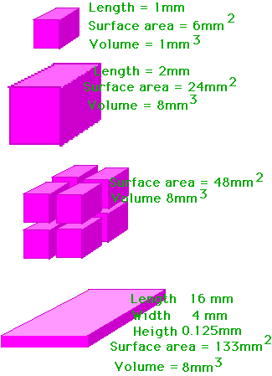
-material inside is equal (volume)

-note which configuration has the greater surface area

If a cell keeps getting bigger, sooner or later there isn’t enough cell membrane to allow the necessary amounts of materials into and out of the cell.

The bigger the cell, the more nutrients it requires, the more waste it produces, and the greater the distance these materials have to travel. The surface area of the cell (the size of the cell membrane) dictates how big the cell can get.

Cell Division and Mitosis

If cells can only get so large, how do organisms grow?

Single-celled organisms divide into two new cells when they get too large.
Multicellular organisms – as they grow, their cells must divide also.
- each cell is a copy of the old cell
- as new cells form, the organism grows larger
- new cells may form, as well as old ones and worn out get replaced

Mitosis – the process in which a cell divides
Nucleus- the nucleus contains DNA
DNA = deoxyribonucleic acid; the material that stores coded
information about how an organism will grow and
develop

*at the beginning of mitosis, DNA coils into chromosomes (visible)

Every species has a specific number of chromosomes.
Each cell must have a full set of chromosomes to operate properly.
The process of mitosis ensures that all new cells that result from
division have the proper number of chromosome pairs.

Stages of mitosis:
The cell gets ready to divide.
DNA gets copied then becomes threadlike strands called chromatin.
Mitosis begins: chromosomes become visible.
The membrane around the nucleus dissolves.
Pairs of chromosomes line up at the center of the cell.
Each pair of chromosomes separate; the two halves move to
opposite ends of the cell.
Each half is now an independent chromosome.
The chromosomes uncoil and become chromatin.
A new membrane forms around each nucleus.
Mitosis is complete.
The cytoplasm divides.
In animals, the cell membrane pinches inward forming
two identical cells.
In plants, a new cell wall divides one plant cell into two.
