I. | Course Description: | In CEA, students learn to design buildings, plan building sites, and develop commercial and residential areas. Students employ math, science, and engineering practices to complete residential and commercial projects. This is an activity-project-problem based class, so students can expect to learn through solving problems and completing projects as well as participating in learning activities. This course will also introduce students to professional architecture software used in the industry. Students will find this course requires a high level of commitment as they develop knowledge and skills that will prepare them for a future in engineering and/or architecture.
II. | Course Objectives: | Students will:  1. Understand the history, relevance, and application of civil engineering and architecture in our world.  2. Learn the basics of building, construction, and residential design.  3. Estimate costs of building materials for projects.  4. Develop an understanding of commercial building systems.  5. Engineer structural systems for commercial buildings.  6. Plan building sites  - Understanding site layout and utilities  - Considering environmental issues  7. Design a commercial building and site as a final design project.  8. Present final project proposal to a group of stakeholders.  9. Develop professional engineering and architectural skills.  10. Utilize Autodesk Revit as an architectural design tool.
III. | Virtual Learning Expectations | The graphic below states expectations for the remote learning environment. These are not necessarily strict policy, but are considered best practices and will be used as general guidelines for this class until we return to the classroom. Failure to adhere to the expectations may result in missed material or instructions that could negatively affect a student’s grades. If there are any issues, please contact me. I understand the remote learning environment presents unforeseen challenges and conflicts. I am will to work with any student who will communicate with me about any conflicts or barriers to success.  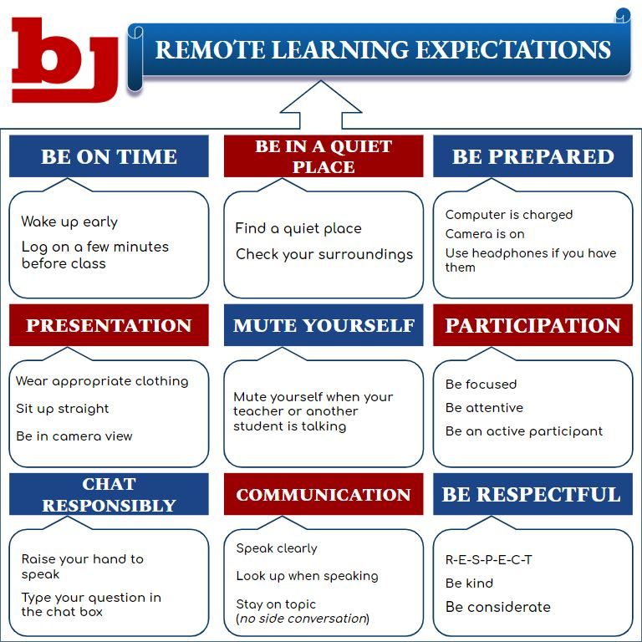
IV. | BJ Grading Policy: | Grades will be calculated according to BJHS policy: 90%-100%=A  80%-89%=B  Major tests/Projects will be 70% 70%-79%=C  Lab/Daily work/Homework/Quizzes will be 30% 65%-69%=D  64% and below= F  Grades are entered into the gradebook on a regular basis. You can check your grades at anytime using INOW which can be accessed on the Madison City Schools webpage.  Your final exam will count 20% toward your semester grade.  *All accommodations for this course or any school event are welcomed.
V. | BJ Make-up Test Policy: | Make-up tests are only allowed for excused absences. You have 2 weeks to make up a test. You can schedule a make up before or after school or during patriot path science make-ups. Students will have one week to make up their test. Students are responsible for scheduling their make-up test with the teacher.
VI. | Text and Other Required Reading: | IBC – International Building Codes (provided online)
VII. | Materials and Supplies Needed: | Pens  Pencils  Scientific Calculator  3-Ring Binder (or other organization system)

18 – WEEK PLAN
Week 1 | Unit 1.1 – History of CEA
Week 2 | Unit 1.1 – History of CEA  Special Instruction – Architectural Drafting
Week 3 | Unit 1.2 – Careers in Civil Engineering and Architecture
Week 4 | Unit 2.1 – Building and Construction
Week 5 | Unit 2.2 – Cost and Efficiency Analysis
Week 6 | Unit 2.3 – Residential Design
Week 7 | Unit 2.3 – Residential Design
Week 8 | Unit 2.3 – Residential Design
Week 9 | Unit 2.3 – Residential Design
Week 10 | Unit 3.1 – Commercial Building Systems
Week 11 | Unit 3.2 Structures
Week 12 | Unit 3.2 Structures
Week 13 | Unit 3.3 Services and Utilities
Week 14 | Unit 3.4 Site Consideration
Week 15 | Unit 3.4 Site Consideration  Special Instruction - LEED
Week 16 | Unit 4.1 Commercial Building Design Problem
Week 17 | Unit 4.1 Commercial Building Design Problem
Week  18 | Unit 4.2 Commercial Building Design Presentation

- Dates subject to change

