Pre-Calculus Name
FINAL EXAM REVIEW Period

Ch 4 Part I Review

1. Find the polynomial equation of least degree with roots –2, 4, and $±2i$.
( Expand the factors that contain i . )

2. List the possible rational roots of $4x^{3}−x^{2}−x−5$.

3. Find the value of k so that the remainder of $(x^{3}+5x^{2}−\text{kx}−8)÷(x+2)$ is 1.

4. Find the discriminant of $9x^{2}−\text{12}x+4=0$ and describe the nature of the roots of the equation.

5. Find the remainder when $x^{4}−3x^{2}+6$ is divided by $x+1$ . State whether the binomial is a factor of the polynomial.

6. Find ALL possible roots of $x^{3}−x^{2}+2x−\text{24}=0$.

7. Find ALL possible roots of $x^{3}−9x^{2}−5x+\text{45}=0$.

Ch 4 Part II Review

8. Which polynomial function best models the set of data below?
x | -3 | -2 | -1 | 0 | 1 | 2 | 3 | 4 | 5 | 6 | 7 | 8
f (x) | 40 | 15 | 0 | -8 | -5 | 0 | 4 | 9 | 3 | -5 | -18 | -40

9. Decompose $\frac{\text{12}−2x}{2x^{2}−5x−3}$ into partial fractions.

10. Solve: $x=\sqrt{x−4}+4$

11. Solve: $\sqrt[3]{4x−1}−6=−4$.

12. Solve: $\frac{1}{3n}+\frac{6n−4}{2n}=\frac{2}{n}$.

13. Solve: $\frac{1}{3x−1}−\frac{1}{x+1}=\frac{4}{3}$.

14. Solve: $\frac{x}{x+4}−\frac{1}{x−3}=\frac{\text{28}}{x^{2}+x−\text{12}}$.

15. Solve: $\frac{−5}{x−2}≤\frac{−3}{x+1}$

Ch 5 Review

16. Find the coterminal angles between -360° and 360° for the angle 585°.

17. Find the measure of the reference angle for 135º , 592°, and $\frac{\text{23}π}{6}$.

18. Find the exact value of cos (120°), tan (-150°), csc (-45°). No Calculator!

19. Suppose is an angle in standard position whose terminal side lies in Quadrant II. If $\text{sin}θ=\frac{3}{8}$, find the value of cot $q$.

20. In , A=17°38’, B=72°55’, and c = 12. Find a.

21. In , A = 53°, b = 14, and c = 6. Find a.

22. In right triangle, ABC, find $m∠A$ to three decimal places if b = 11 and c = 15.

Ch 6 Review

23. Use the unit circle to find the exact values. No Calculator!
a. sin ( – π ) b. cos $\left(\frac{π}{2}\right)$

c. sin $\left(−\frac{\text{15}π}{2}\right)$ d. tan $\left(−5π\right)$

e. sec 4π f. csc $\left(−3π\right)$

g. cos $\left(\frac{3π}{4}\right)$ h. sin $\left(\frac{7π}{6}\right)$

i. sin $\left(−\frac{π}{4}\right)$ j. tan $\left(−\frac{2π}{3}\right)$

k. cot $\left(\frac{\text{17}π}{6}\right)$ l. sec $\left(−\frac{5π}{3}\right)$

24. If, solve the equations. No Calculator!

a. $2\text{sin}x=\sqrt{3}$ for b. $\text{tan}x=\frac{\sqrt{3}}{3}$ for $0≤x≤2π$

25. Change 1200° to radian measure in terms of .

26. Change $\frac{7π}{6}$ to degree measure.

27. Determine the angular velocity if 2.25 revolutions are completed in 0.5 seconds.

Formula: $w=\frac{θ}{t}$

28. Determine the linear velocity if 2.25 revolutions are completed in 0.5 seconds for a wheel with radius of 8 inches.

Formula: $v=r ⋅ w$ or $v=r \frac{θ}{t}$

29. Find the arc length if a 24° central angle of a circle with diameter 20 inches.

Formula: $s=r ⋅ θ$

30. Find the area of the sector if a 24° central angle of a circle with diameter 20 inches.

Formula: $A=\frac{1}{2}r^{2} ⋅ θ$

31. Find the degree measure of the central angle associated with an arc that is 18 inches long in a circle with a radius of 8 inches.

No Calculator for the Remaining Problems #32 to #42!
32. Write an equation of the cosine function with period $\frac{π}{4}$, phase shift $π$ to the left, and vertical shift -5.

33. Write an equation of the tangent function with period 3π, phase shift $\frac{π}{2}$ to the right, and vertical shift 5.

34. State the amplitude, period and phase shift of the function $y=\frac{1}{5}\text{sin}\left(4x−\frac{π}{3}\right)$.

35. State the period and phase shift of the function $y=−5\text{cot}\left(\frac{1}{3}x+\frac{2π}{5}\right)$.

36. Write a Sine function to represent the of the
graph at the right.

37. Write a Cosine function to represent the of the
graph at the right.

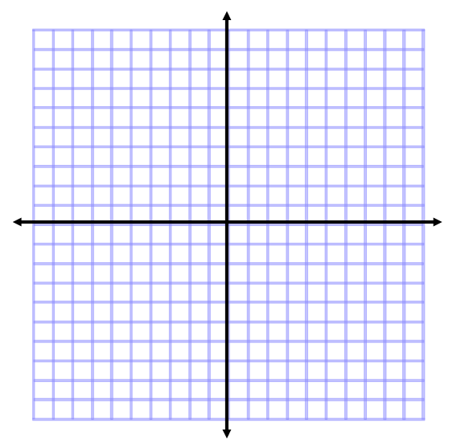
38. $y=3\text{sin}\left(4x−\frac{π}{2}\right)+1$
a) amplitude = c) phase shift =

b) period = d) vertical shift =

39. $y=−2\text{cos}\left(\frac{x}{2}+\frac{π}{3}\right)−2$
a) amplitude = c) phase shift =

b) period = d) vertical shift =

40. $y=\text{tan}\left(\frac{θ}{2}\right)$
a) amplitude = c) phase shift =

b) period = d) vertical shift =

41. $y=−\text{cot}\left(6θ\right)$
a) amplitude = c) phase shift =

b) period = d) vertical shift =

42. $y=\text{csc}\left(\frac{π}{2}θ\right)$
a) amplitude = c) phase shift =

b) period = d) vertical shift =

