Calculus AB Summer Review Packet

Welcome to AP Calculus AB!

Here are 81 problems that Mr. Meyer and Mrs. Erickson think you should know for the beginning of the 2018/2019 school year. You will be given a test on the 3rd or 4th day of school. A solution key will be posted on our websites for your reference.

***This Review Packet is MANDATORY and will be due on the first day of class, Tuesday, August 14th.***

We will be offering 3 summer workshops where you can come and get to know Mr. Meyer and Mrs. Erickson. We will be focusing on study strategies and review of your algebra 2 and pre-calculus concepts. We strongly encourage you to attend these sessions. They will be offered in the Point on the following dates:
Wednesday June 13th from 10 a.m. – 12 p.m.
Wednesday July 18th from 10 a.m. – 12 p.m.
Wednesday August 8th from 10 a.m. – 12 p.m.

Here is a list of links that may be helpful if you are having trouble with some of the material in your review packet.

http://www.brightstorm.com/

http://www.wolframalpha.com/

http://www.khanacademy.org/

Check our websites for further updates and additional resources.

Prerequisite Learning Targets for Calculus AB
Function Families:
- An understanding of all parent functions, as well as basic transformations of each.
- Determining whether a function is even, odd, or neither (graphically and algebraically).
- Determine and explain slope or rate of change in context/graphically for any non-linear function.
- Understanding key features of a graph (domain, range, end behavior, intervals of increasing and decreasing).
- Understand how to sketch and evaluate a piecewise function.
Trigonometry:
- Unit circle.
- Evaluating trig functions.
- Basic identities (Reciprocal, Pythagorean, quotient).
- Solving trig equations (using inverses).
- An understanding of functions.
- Understanding domain and range (trig and inverse trig functions).
Expressions & Equations:
- Write the equation of a line. (Point/Slope, Slope/Intercept, and Standard Form)
- Evaluate composite functions.
Simplifying –
- Creating equivalent equations and/or expressions.
- Convert back and forth between factored form and standard form.
- Simplify expressions with exponents.
- Simplify radical expressions.
- Simplifying using log properties.
- Simplifying rational expressions.
Solving –
- Using inverses as a means to solve an equation
- Exponents/logs 2. Rational exponents
- Solve equations using the zero product property and factoring.
- Apply knowledge of domain and range to identify and interpret solutions to various equations.
- Solve systems of equations (linear and non-linear)
Geometry:
- Know and apply geometric area and volume formulas.
Calculator Skills:
- Calculate min and max
- Find an intersection point
- Find zeros
- Adjust window settings
- Evaluate a function
Function Families

I . Graphing Parent Functions (No Calculator)

- Graph each of the following functions.
- Determine the domain and range for each of the following functions.
- Determine if each of the following functions are even, odd, or neither graphically.
- Determine the end behavior of the functions #1-5.

1. 2. 3.

4. 5. 6.

7. 8. 9.

10. 11. 12.

II. Graphing Transformations of Functions (No Calculator)

- Graph each of the following functions.
B. Identify the increasing and decreasing intervals of the functions in #13-16.

13. 14.
15. 16.
17. 18.
19. 20.
21.
- Sketch the graph of a continuous function defined for with all of the following properties.

- is increasing on the interval .
- is decreasing on the interval .
- is increasing on the interval .
- as .

III. Evaluating Functions (No Calculator)

- Evaluate for the following piece-wise functions:
- b)

24. Find the domain of .
25. Describe whether the function is even, odd, or neither algebraically.
a) b) c)

26. Find the average rate of change of the functions from .
a)
b)

Expressions & Equations

IV. Writing Equations (No Calculator)
- Write the equation of the vertical line that passes through the point (-1, ).
- Write the equation of the horizontal line that passes through the point (2, ).
- Write the point-slope equation of the line that passes through the point (-1, 1) and has slope m = -3.
- Write the slope-intercept equation of the line that passes through (-3, 4) and (2, 1).
- Write the equation of the line that passes through the point (-2, 2) and is parallel to the line y = -3x + 4.
- Write the equation of the line that passes through the point (-1, 3) and is perpendicular to the line 2x + y = 4.
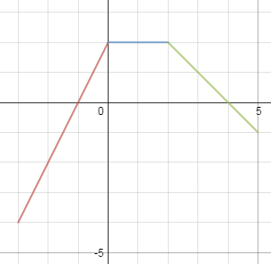
33. Write the piece-wise function for the
following graph.

V. Simplifying and Evaluating Expressions (No Calculator)

34. .
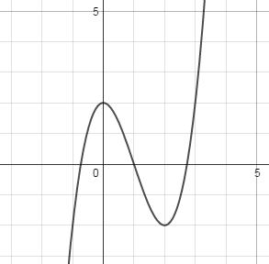
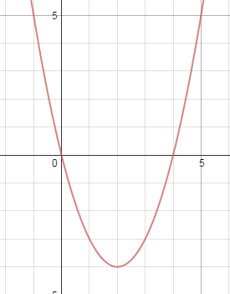

- Using the graphs above, find , and .
- Rewrite in base 2 and in base 3.
- Evaluate the following logarithmic expressions.
a) b) c)
d) e) f)
- Simplify to a single expression
- Show that .
- Show that
- Factor the following expressions.
a) b) c)
d) e) f)

44. Find the product or quotient.
a) b)
45. Evaluate thefollowing expression.
a) b) c)

VI. Solving Equations and Inequalities (No Calculator)
Solve the following equations and inequalities.
46. 47.

48. 49.

50. 51.

52. 53.

54. 55.

56. 57.

58. 59.
60.
61. Find the point(s) of intersection between the two curves.
62. Rewrite the formula for the volume of a cylinder () in terms of the height, if the radius of the cylinder is three times the height of the cylinder.

Geometry

VII. Area Problems (Calculator)
*Round all answers to three decimal places.

63. Find the area of a parallelogram with sides 12 and 8 and included angle 60.

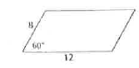

- Find the area of the shaded region.

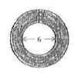
Big Diameter = 10

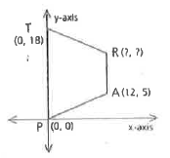
65. TRAP is an isosceles trapezoid.

- Find the coordinates of R.

- Find the area of TRAP.

- Buster Bee lives on a honeycomb like the one pictured at the right. What percent
of the honeycomb is made of wax?

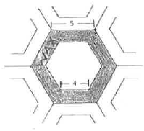

VIII. Volume and Surface Area Problems (Calculator)

- Find the volume and total surface area of each of the following.

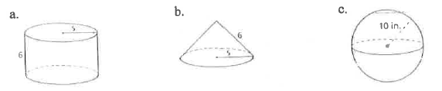

- A cylindrical glass full of water is poured into the rectangular pan. Will the pan overflow?
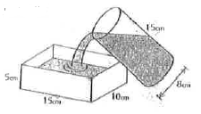

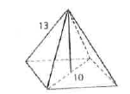
- A pyramid with a square base has a diagonal of 10. Each lateral edge measures 13. Find the volume of the pyramid.

- A cold capsule is 11 mm long and 3 mm in diameter. Find the amount of medicine it contains correct to three decimal places.
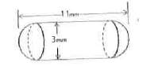

Trigonometry

IX. Evaluating Expressions/Verifying Equations (No Calculator)

- Find the values of the six trigonometric functions at angle if .
Answers must be exact.

- Evaluate the following trigonometric expressions.
a) b) c)
d) e) f)
g) h) i)
73. Use trig identities to verify the following equations.
a) b)

X. Solving Trig Equations (No Calculator)
Solve the following trig equations on the interval .
74. 75.
76. 77.
XI. Graphing Trig Functions (No Calculator)

78. Graph.
a) b) c)

Calculator Problems

XII. Using Technology to Find Key Features
*Round all answers to three decimal places.

Use your calculator to find the following.
A. The zeros of the function.
B. The maximums and minimums of the function
C.
79. 80.

81. Use your calculator to find the intersection of the following functions.

