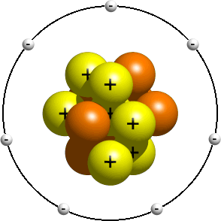

Electric Forces : Let’s get charged up!
- What are the parts of the atom?
Part of the atom | Mass (kg) | Charge (C)
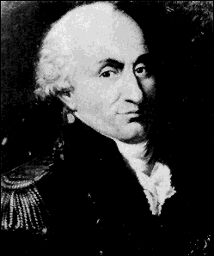
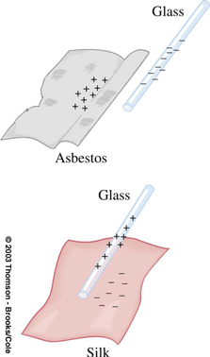
- How many excess electrons are on a drop with a –1x10⁻¹⁶C charge?

- What is the force between charged objects?
 | Gravitational force | Electrostatic Force
Name of Law
Daily Use
Equation

Constant value
Relative force value
What does r represent?

Energy associative with this conservative force
Signs

Direction of force

Force inside a shell

Finding where the net force on an object/ charge is zero

Object outside a planet/ charged object
Density

Object inside a planet/ charged object
Binary system

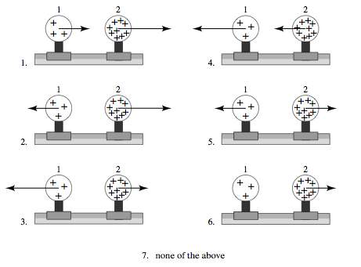
- Two uniformly charged spheres are firmly fastened to and electrically insulated from frictionless pucks on an air table. The charge on sphere 2 is three times the charge on sphere 1. Which force diagram correctly shows the magnitude and direction of the electrostatic forces?

- Two small spheres have equal charges q and are separated by a distance d. The force exerted on each sphere by the other has magnitude F. If the charge on each sphere is doubled and d is halved, the force on each sphere has magnitude
- F
- 2F
- 4F
- 8F
- 16F
+Q

+Q
+q

As shown above, two particles, each of charge +Q, are fixed at opposite corners of a square that lies in the plane of the page. A positive test charge +q is placed at a third corner.
- What is the direction of the force on the test charge due to the two other charges?
a. b. c. d. e.

- If F is the magnitude of the force on the test charge due to only one of the other charges, what is the magnitude of the net force acting on the test charge due to both of these charges?
  - Zero
  - F/
  - F
  - 2F

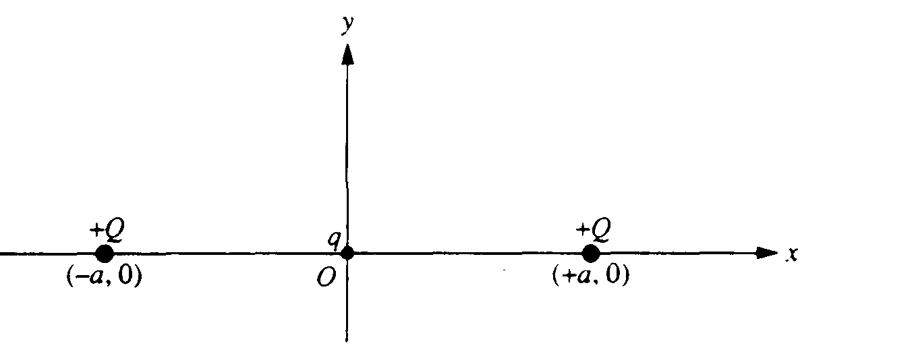
- A small particle of charge q (q << Q ) and mass m is placed at the origin, displaced slightly, and then released. Assume that the only subsequent forces acting are the electric forces from the two fixed charges Q. at x = +a and x = -a. and that the particle moves only in the xy -plane. In each of the following cases, describe briefly the motion of the charged particle after it is released. Write an expression for its speed when far away, if the resulting force pushes it away from the origin.
- q is positive and is displaced in the +x direction.

- q is positive and is displaced in the +y direction.

- q is negative and is displaced in the +y direction.

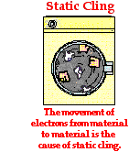
- The electrostatic force can be a torque!
  - Write the Newton’s 2nd Law equations for the seesaw pictured above

  - Write the torque equation for the seesaw pictured above

- Point charges q₁ and q₂ lie on the x axis at points x=-a and x=+a, respectively. How must the charges be related for the net electrostatic force on point charge +Q, placed at x =+a/2, to be zero?

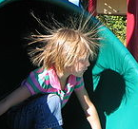
- What is the difference between conductors and insulators?

- Below a negatively charged object is placed near a conductor on the left and an insulator on the right. Fill in the charges for the conductor and insulator.
Conductor Insulator
-
-
-
-
-
-
-
-
-
-

- Two concentric conducting spherical shells with a uniform positive charge q₁ on the inner shell and a uniform negative charge –q₂ is on the outer shell. Consider the cases q₁>q₂, q₁=q₂, and q₁<q₂. use + and - signs to indicate any charge induced on the conductor.
q₁=+8C > q₂=-4C
q₁=+4C = q₂=-4C
q₁=+4C > q₂=-8C
q₁
+
- q₂
q₁
+
- q₂
q₁
+
- q₂
- q₂

+
q₁

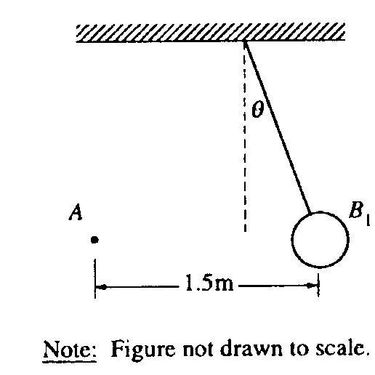
- The small sphere A in the diagram above has a charge of 120µC. The large sphere B₁ is a thin shell of nonconducting material with a net charge that is uniformly distributed over its surface. Sphere B₁ has a mass of 0.025 kg, a radius of 0.05 m, and is suspended from an uncharged, nonconducting thread. Sphere B_{I} is in equilibrium when the thread makes an angle θ=20° with the vertical. The centers of the spheres are at the same vertical height and are a horizontal distance of 1.5 m apart, as shown.
- Calculate the charge on sphere B₁.

- Suppose that sphere B₁ is replaced by a second suspended sphere B, that has the same mass, radius, and charge, but that is conducting. Equilibrium is again established when sphere A is 1.5 m from sphere B₂ and their centers are at the same vertical height. State whether the equilibrium angle θ₂ will be less than, equal to, or greater than 20°. Justify your answer.

- Types of charging:
Type of charging
What happens?

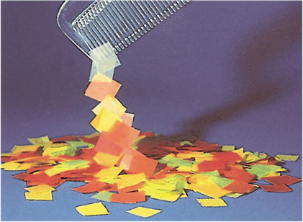
- What is grounding?

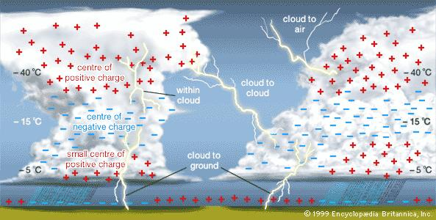

- What happens to the charges when two objects touch (if the objects are the same size/shape)? What if the objects are not the same size/shape?

d
+2Q
-Q

- Two identical conducting spheres are charged to +2Q and –Q, respectively, and are separated by a distance d (much greater than the radii of the spheres) as shown above. The magnitude of the force of attraction on the left sphere is F₁. After the two spheres are made to touch and then are reseparated by distance d, the magnitude of the force on the left sphere is F₂. Which of the following relationships is correct?
- 2F₁=F₂
- F₁=F₂
- F₁=2F₂
- F₁=4F₂
- F₁=8F₂
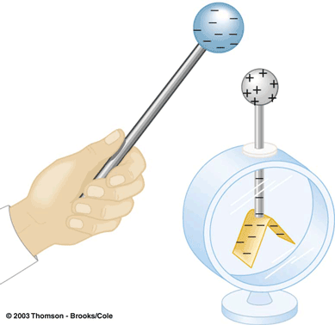
- In the figure below are shown schematics of two versions of an electroscope: a historic version on the left with gold foil leaves, and a more modern one with a pivoting metal arm on the right.
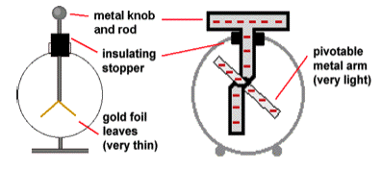
  - A charged object is touched to the metal knob of the electroscope and removed. The movable leaves of the electroscope, which hung straight down when the electroscope was uncharged, now stand apart as shown in the two figures. Explain why this happens.

  - A person touches the electroscope briefly. Now a charged object is brought near to the knob but doesn’t touch it. The leaves separate. Explain why.

  - While a charged object is near to the electroscope’s knob (but not touching) the knob of the electroscope is touched with a finger and then the charged object is taken away. The leaves stand out again. Explain why this happens, tell what sign of charge you think the electroscope has, and why you think so.

X
Y
- - - - - - - - - - -

- Two metal spheres that are initially uncharged are mounted on insulating stands, as shown above. A negatively charged rubber rod is brought close to, but does not make contact with, sphere X. Sphere Y is then brought close to X on the side opposite to the rubber rod. Y is allowed to touch X and then is removed some distance away. The rubber rod is then moved far away from X and Y. What are the final charges on the spheres?

Sphere X Sphere Y
  - Zero Zero
  - Negative Negative
  - Negative Positive
  - Positive Negative
  - Positive Positive

1
2
- - - - - - - - - - -

- Two initially uncharged conductors, 1 and 2, are mounted on insulating stands and are in contact, as shown above. A negatively charged rod is brought near but does not touch them. With the rod held in place, conductor 2 is moved to the right by pushing its stand, so that the conductors are separated. Which of the following is now true of conductor 2?
  - It is uncharged
  - It is positively charged
  - It is negatively charged
  - It is charged, but its sign cannot be predicted
  - It is at the same potential that it was before the charged rod was brought near.

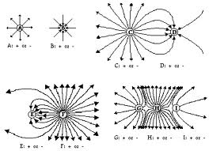
Can you Field these notes? They are electric!

- What is an electric field?

Definition
(units)

Rules for drawing
Force on a charge in an electric field

Electric field created by a point charge | 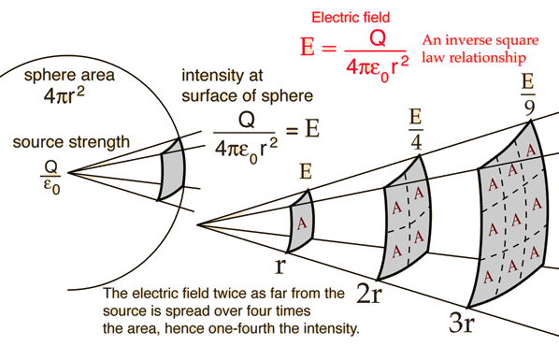

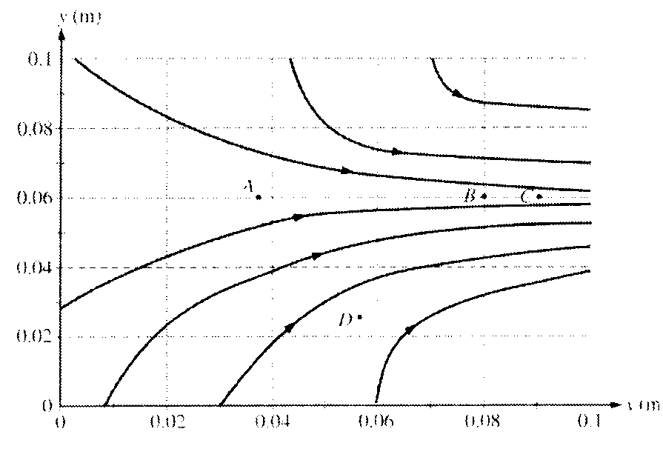
- Consider the electric field diagram.
a) Points A, B, and C are all located at y = 0.06 m . At which of these three points is the magnitude of the electric field the greatest? Justify your answer.

(b) An electron is released from rest at point B. Qualitatively describe the electron's motion in terms of direction, speed, and acceleration.

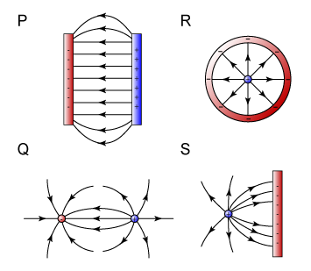
- From the electric field vector at a point, one can determine which of the following?
I The direction of the electrostatic force on a test charge of known sign at that point
II. The magnitude of the electrostatic force exerted per unit charge on a test charge at that point
III. The electrostatic charge at that point
a. I only
- III only
- I and II only
- II and III only
- I, II, and III

- A charge particle traveling with a velocity v in an electric field E experiences a force F that must be
- parallel to v
- perpendicular to v
- parallel to v x E
- parallel to E
- perpendicular to E

- If the only force acting on an electron is due to a uniform electric field, the electron moves with constant
- acceleration in a direction opposite to that of the field
- acceleration in the direction of the field
- acceleration in a direction perpendicular to that of the field
- speed in a direction opposite to that of the field
- speed in the direction of the field

-2Q

E

+Q

- A rigid insulated rod, with two unequal charges attached to its ends, is placed in a uniform electric field E as shown above. The rod experiences
- net force to the left and a clockwise rotation
- net force to the left and a counterclockwise rotation
- net force to the right and a clockwise rotation
- net force to the right and a counterclockwise rotation
- rotation, but no net force
- An alpha particle (the nucleus of a Helium atom) has a mass of 6.64 x 10⁻²⁷ kg and a charge of +2 e. What is the direction and magnitude of the electric field that will balance the gravitational force on the particle?

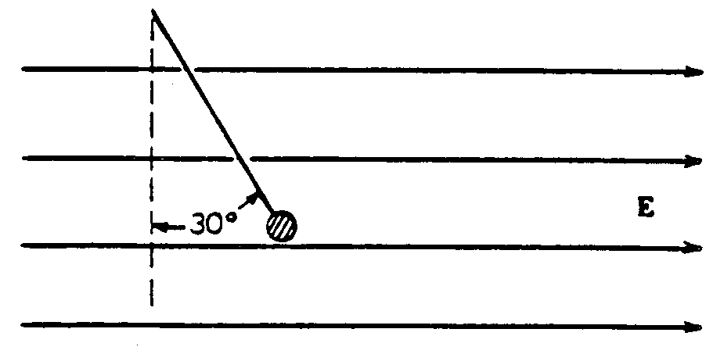
- A small conducting sphere of mass m, attached to a string of length L, is at rest in a uniform electric field E, directed horizontally to the right as shown above. There is a charge of Q on the sphere. The string makes an angle of 30° with the vertical.
a. In the space below, draw and label all the forces acting on the sphere.

b. Write Newton’s 2nd Law equations in terms of m, E, g and Q.

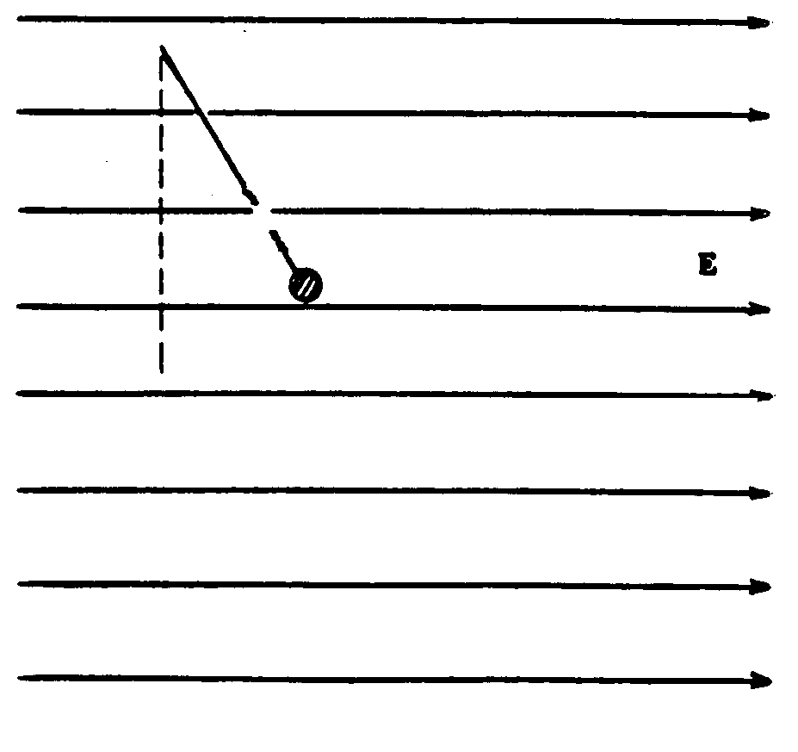
- The string now breaks. Describe the subsequent motion of the sphere and sketch the path of the sphere on the following diagram while in the electric field if the force of the electric field is equal to the force of gravity.
.

L

d
E
v_{o}
θ

L

- A uniform, upward-directed electric field E of magnitude 2.00 x 10³ N/C has been set up between two horizontal plates by charging the lower plate positively and the upper plate negatively. The plates have length L=10.0 cm and separation d=2.00cm. An electron is then shot between the plates from the left edge of the lower plate. The initial velocity v₀ of the electron makes an angle θ =45⁰ with the lower plate and has a magnitude of 6.00x 10⁶ m/s.
  - Will the electron strike one of the plates?

  - If so, which plate and how far horizontally from the left edge will the electron strike?

- A 10g block with a charge of +8.00 x 10⁻⁸ C is placed in an electric field E = (3000i – 600j) N/C.
- what is the magnitude of the electrostatic force on the block?

- what is the direction (relative to the positive direction of the x axis) of the electrostatic force on the block?

- If the block is now released from rest at the origin at time t = 0, what are its
x and y coordinates at t = 3.00 s?

- Draw an electric field for a positive charge. Why do we draw it as if it were the protons accelerating?

+

- Qualitatively sketch the electric field lines for both between and outside two concentric conducting spherical shells when a uniform positive charge q₁ is on the inner shell and a uniform negative charge –q₂ is on the outer. Consider the cases q₁>q₂, q₁=q₂, and q₁<q₂.
q₁>q₂
q₁=q₂
q₁<q₂

q₁
+
- q₂
q₁
+
- q₂
q₁
+
- q₂
- q₂

+
q₁

- A positive charge and a negative charge of the
+
-
same magnitude lie on a long straight line.

    - What is the direction of the electric field due to these charges between the charges?

    - What is the direction of the electric field due to these charges outside the charges on the side of the positive charge?

    - What is the direction of the electric field due to these charges outside the charges on the side of the negative charge?

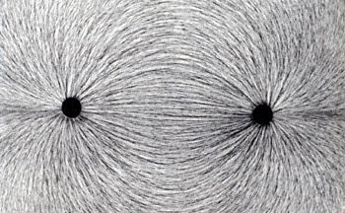
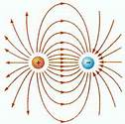

- The following configurations of electric charges located at the vertices of an equilateral triangle. Point P is equidistant from the charges.
a. b. c.
+q
+q
+q
P
+q
+q
-q
P
-q
-q
+q
P

d. e.
-q
+q
-2q
P
-q
+3q
-2q
P

    - In which configuration is the electric field at P equal to zero?

    - In which configuration is the electric field at P pointed at the midpoint between two of the charges?

- A thundercloud has the charge distribution illustrated above left. Treat this distribution as two point charges, a negative charge of -30 C at a height of 2 km above ground and a positive charge of +30 C at a height of 3 km. The presence of these charges induces charges on the ground. Assuming the ground is a conductor, it can be shown that the induced charges can be treated as a charge of +30 C at a depth of 2 km below ground and a charge of -30 C at a depth of 3 km, as shown above right. Consider point eP₁, which is just above the ground directly blow the thundercloud, and point P₂, which is 1 km horizontally away from P₁.
a. Determine the direction and magnitude of the electric field at point P₁.

b. On the diagram, clearly indicate the direction of the electric field at point P₂
c. How does the magnitude of the field at this point compare with the magnitude at point P₁? Justify your answer:

Greater Equal Less
- Two positive charges a distance a from the x axis. Two masses a distance a from the x axis. Find the electric field a point that is on the x axis and is a distance x from the charges. Find the gravitational force on m due to M and M.

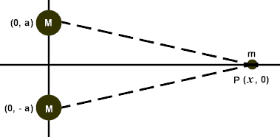
+
+
a
x
a

- Four charges, as shown below, are arranged in a square of 5 cm per side. In unit vector notation, what net electric field do the particles produce at the square’s center?
-20nC

5 cm cmcm
10nC nC
5 cm cmcm

-10nC
20nC

- What are the three uniform density equations?

- A charged nonconducting rod, with a length of 2 m and a cross-sectional area of 0.0004m² lies along the positive side of an x axis with one end at the origin.
    - The rod has a uniform volume charge density of -4x10⁻⁶C/m³. What is the charge of the rod?

    - The rod has a nonuniform volume charge density of ρ=-2x10⁻⁶ x². What is the charge of the rod?

- When do I need to integrate? What we have done so far….
Center of mass Rotational Inertia of a Force due to gravity
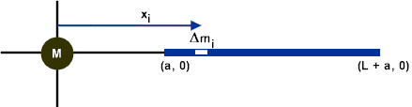
of an extended mass Rod about its center

- What is the electric field due to a line of charge with charge Q at point P (point P is empty space)?

d
P
+
+

+
L

60º
60 º ºo
R

R

Now a curved rod.
- A rod of uniform linear charge density λ = +1.5 x 10⁻⁵ C/m is bent into an arc of radius R = 0.10 m. The arc is placed with its center at the origin of the axes shown above.

- Determine the total charge on the rod.

- Write the equation that relates arc length to angular position

- Take the derivative of the arch length with respect to the angular position.

- Determine the magnitude and direction Determine the magnitude and direction of
of the electric field at the center O of the arc. Gravitational force on an object (mass m)
at the center of the arc (mass M)

- Two curved plastic rods, one of charge +q and the other of charge –q, form a circle of radius R in an xy plane. The x axis passes through their connecting points, and the charge is distributed uniformly on both rods. What are the magnitude and direction of the electric field E produced at P, the center of the circle?
x
y
+q
-q

P

- What are the magnitude and direction of the electric field E produced at P, located along the axis of a thin ring through its center.
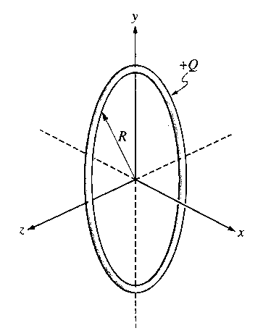
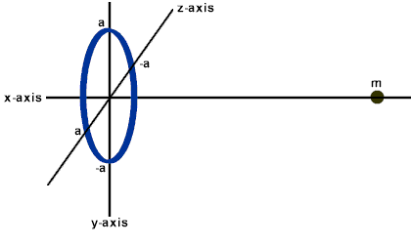

What is the electric field due to a What is the gravitational force due to a ring
charged ring along an axis through its center? of mass M along an axis through its center
  - At the center? a At the center?

  - At a point x away from the b. At a point x away from
center along the axis? the center along the axis?

c. At what distance along the central axis of a ring of radius R and uniform charge is the magnitude of the electric field due to the ring’s charge maximum?

- On the axes below, sketch E_{x} versus x for points on the x-axis from x = -2R to x = +2R.

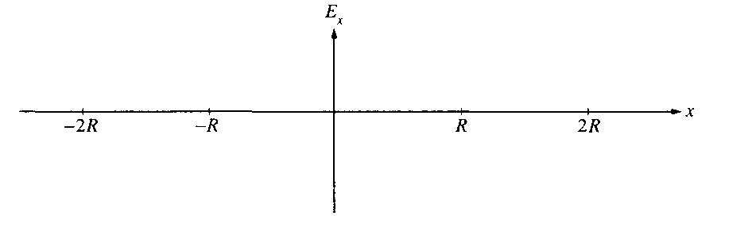

- An electron is placed at x = R/2 and released from rest. Qualitatively describe its subsequent motion.

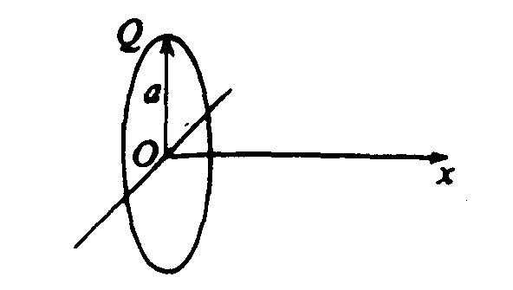
- Which of the following graphs best represents the electric field along the positive x-axis?

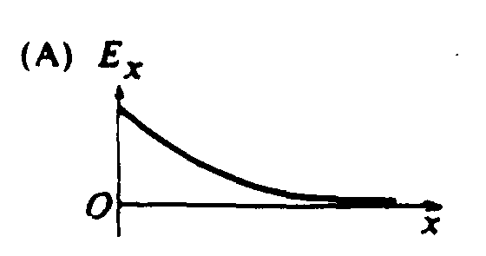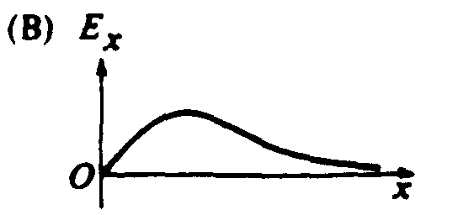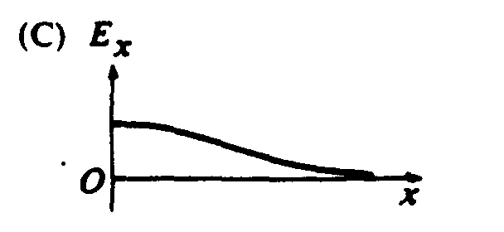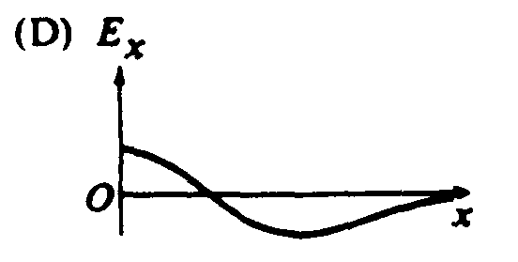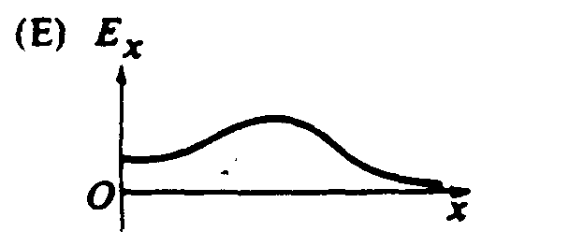

- What is the electric field due to a charged disk? Don’t worry… we will see how to do this with just power rule later but I want to show you the calculus necessary when summing up vectors if we don’t take advantage of energy as a scalar quantity. The reason this is difficult is because the electric field is a vector quantity.

  - Where do you start when trying to sum up the electric field due to point charges?

  - What do you substitute in for r?

  - A disk is a bunch of concentric rings with increasing radius. Let’s sum up the electric field due to these charged rings by putting it in terms of the radius.

  - What substitution do you do for cos?

  - To solve this expression what is the calculus called?

  - What is the answer to the summation of the electric field due to concentric charged rings that form a disk?

