Biology: Chapter 6 & 7 Test Review Name: _________________________________

Ch. 6: Chemistry in Biology
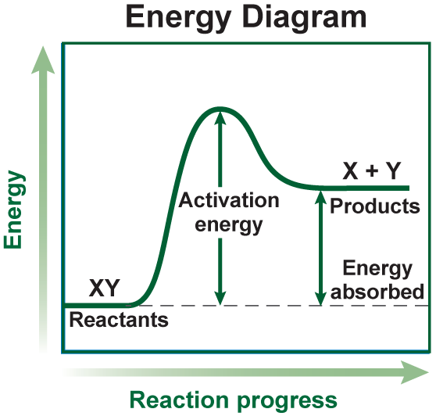
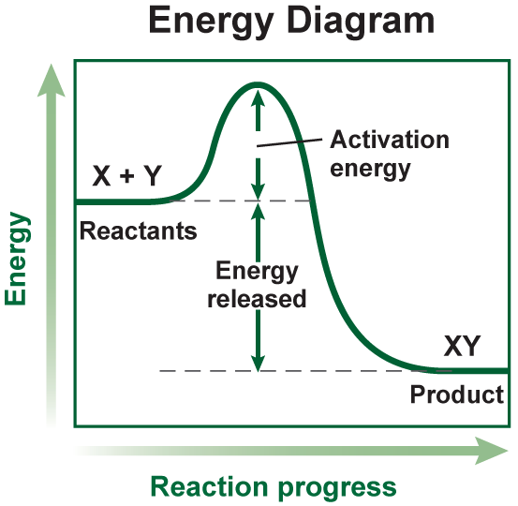
- a) Explain what is happening in an endothermic and exothermic energy diagram

b) What is the difference between endothermic and exothermic reaction?
c) Explain how the enzyme helped the chemical reaction in the above diagram
1) _________________________ 2) _____________________________
- Labeling enzyme, active site, enzyme-substrate complex, & substrate.
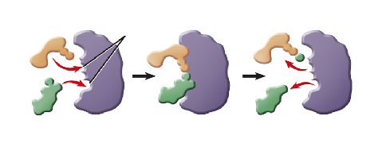
- How many and what kind of bonds does one water molecule have? _______________

- Do hydrogen and oxygen share the electrons equally in a single water molecule? _______
Explain why?

- If lots of hydrogen ions (H+) are found in a solution, is it an acid or base? ___________
- If lots of hydroxide ions (OH-) are found & very few hydrogen ions (H+), is it an acid or base? ____________
- Give TWO ways in which one could speed up a chemical reaction?
1) ____________________________ 2) ____________________________
- What is the difference between an enzyme and catalyst?
- a) Enzyme names usually end in what THREE letters? ____________
b) What is the enzyme that is useful in digesting starch (carbohydrate)? ______________
- Hydrogen bond occurs between “hydrogen” and what other THREE elements?
1) ____________________ 2) ____________________ 3) ______________________
- What is the key element for proteins that carbohydrates and lipids do NOT have? ________________
- Fill in the following table.
 | Definition | Examples
Proteins |  | - Hemoglobin
Carbohydrates |  | - Glycogen
Lipids
Nucleic Acids |  | - DNA

- What role does water play to maintain homeostasis in an organism?
- What lowers the activation energy for a chemical reaction? ________________________
- How is the protein shape determined?
1) ____________________ 2) _____________________ 3) __________________________
- How does temperature contribute to the rate of a chemical reaction?

Chapter 7: The Cell

- What are the three principles of the Cell Theory?
1)
2)
3)

- Draw a quick diagram of a phospholipid bilayer and be sure to label the following:
Protein phospholipid carbohydrate cholesterol

- a) What is a eukaryotic cell? ________________ b) Give an example: __________________
- a) What is a prokaryotic cell? ________________ b) Give an example: __________________
- What role does cholesterol play in the phosphobilayer?
- What is selective permeability? _______________________________________________________
- What is a membrane protein? ________________________________________________________
- What is a transport protein? __________________________________________________________
- What is the role of carbohydrates that are found in the vicinity of the plasma membrane?
- Compare & contrast animal and plant cells (be sure to give organelles that are in both & organelles that are specific to each cell type).

- What are THREE influences to the rate of diffusion
1) _________________________
2) _________________________
3) _________________________
- What is the difference between osmosis and diffusion?
- At what point in the process of diffusion will dynamic equilibrium be reached?

- Practice locating each of the following organelles in a diagram (use your book).
ORGANELLES | FUNCTION  (Explain how the organelles with ** are important for cell respiration & photosynthesis)
Vacuole
Golgi Apparatus
Cell Wall
Mitochondria**
Nucleus
Rough ER
Ribosomes
Nucleolus
Cytoplasm
Chloroplast **
Plasma Membrane
Smooth ER

- a) What is active transport? __________________________________________________________
b) Give TWO examples: 1) ____________________________ 2) _________________________
- a) What is passive transport? _________________________________________________________
b) Give TWO examples: 1) ____________________________ 2) _________________________
- What happens to a cell when placed in the following solutions
  - Hypertonic: ____________________________________________________________
  - Hypotonic: _____________________________________________________________
  - Isotonic: _______________________________________________________________
- Differentiate exocytosis and endocytosis? Provide examples of molecules that require these processes for movement.
- Label the phospholipid with the following labels: head, tails, polar end and non-polar end, hydrophilic and hydrophobic end. The phosphate-containing group is found in the _______________, while the lipids are found in the ______________.
