
LIVING ENVIRONMENT

September 7, 2018

Dear Parents,

My name is Mr. Allen Lee, and I will be your student’s science teacher this year. This is my third year teaching in Dryden, but my fifteenth year as an educator. I am also a parent and resident of the Dryden community. I have a Bachelor of Science degree in biology and a Master of Teaching in secondary education from the University of South Carolina. I am sending home a syllabus with your student that explains my expectations. This is going to be a great year, but I’m going to need your help.

Science can be difficult because it requires a new vocabulary. I will give various assessments, quizzes, and tests throughout the year. It’s very important that your student study and work hard outside of class for these assessments. Homework will be given almost daily for practice. In addition, your student will need to bring all materials to class including a 3-ringed binder that will hold all class notes, handouts, and labs. This binder will help your student as he or she prepares for the Living Environment Regents exam at the end of the year. Passing Regents exams are a requirement for graduation in NY State.

Another part of my job as a teacher is to teach not only science, but life skills. I place a big emphasis on responsibility. I expect my students to keep up with their assignments, as that is a skill that they will need as they continue to grow and mature into young adults. It is the student’s responsibility to complete assignments and remember to turn them in.

I encourage you to initiate communication by emailing me at alee1@dryden.k12.ny.us for updates on your student’s progress. I will always email you back in a timely fashion. That is the best and easiest way for me to communicate with you. If you do not have email, you can always call me at (607) 844-8694 x5357 and leave a message on my voicemail. As soon as I get the message, I promise to return your call. I also have information setup online at https://sites.google.com/site/drydenscience8/. Objectives, assignments, and other important information will be posted there with the intent on becoming a valuable tool even at home especially for make-up work. In addition, I have the capability of sending mobile phone text reminders about assignments/events in class. More information about that is on the back of this letter.

Please return the last page of this packet to me, front and back signed and dated. The front is so I can have your email and phone numbers and the back is all about lab safety that must be signed by you and your student. If you have any questions, please do not hesitate to contact me. It’s going to be a successful year, and I’m sure your student and I will both learn and grow together. Thank you for your support.

Sincerely,
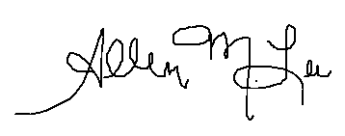



Allen M. Lee
Regents & Honors Living Environment
Dryden High School
607-844-8694 ext. 5357
Room G2
***Keep this for your records. ☺

REMIND 101

I would like to offer you and your students an additional opportunity to stay up to date with classroom announcements, assignments, and due dates. In an effort to better communicate school news and updates, I have signed up with Remind 101. This free web-based communications tool allows students and parents to receive text messages from me, in the form of real-time updates. There is also a free application that can be downloaded that allows you to see longer texts and receive attachments, but the free app isn’t necessary to receive the texts – it just makes the experience easier. ☺

During the enrollment process, you will be sending a text message to the phone number created by Remind101 (which is listed on the bottom of this letter). This is not my phone number. Remind101 will store the phone numbers, for communication purposes only, and I do not have access to these numbers. Specific instructions for enrolling in this program are at the bottom of this letter. It is my sincere desire that this tool will make it easier for you to do all the many things that are demanded of you as a parent and yet still keep you connected and up-to date. However, I will continue to update information on the school website too. It is recommended that BOTH parents and students sign up for this service. Please feel free to contact me with any questions or feedback.

Honors Living Environment  Text @drydenbioh to 81010  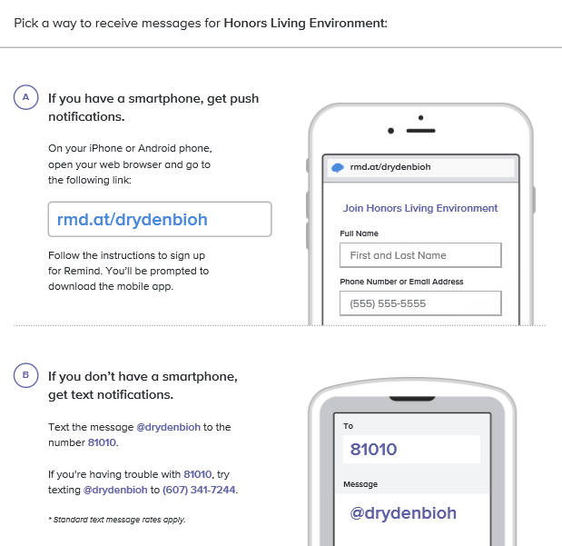 | Regents Living Environment  Text @drydenbior to 81010  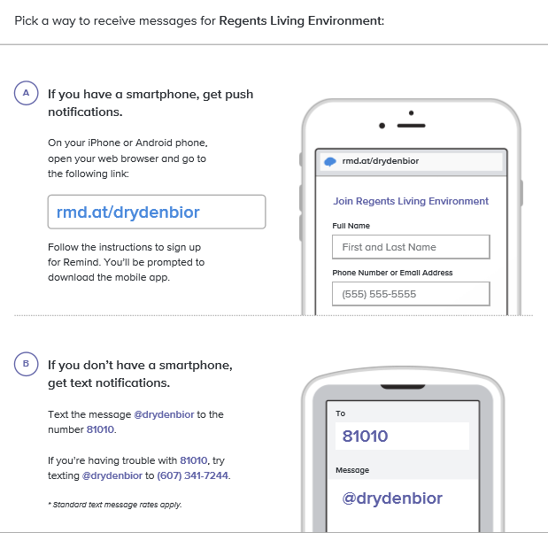
***Keep this for your records. ☺


Welcome to Living Environment (a.k.a Biology), where you learn what life is all about! This course covers a variety of topics from the DNA in our cells to how trees play a role in our ecosystem. Throughout this course the scientific process will be emphasized as students ask questions, hypothesize outcomes, design experiments, collect data and draw conclusions. We will meet every day, eighty minutes one day and forty minutes on the next. This schedule lends itself to a variety of hands-on experiences and laboratories where students will work in small groups promoting teamwork and encouraging individual responsibility.

Contact: alee1@dryden.k12.ny.us or (607) 844-8694 x5357
Website: https://sites.google.com/site/drydenscience8/
Curriculum Outline:
September | Scientific Process & What is life? | January - February | Genetics
October - November | Ecology | March | Evolution
December | Biochemistry & Cell Biology | April - May | Human Biology

Materials: Each student must bring to class everyday a 3-ringed binder, paper, and pen/pencil. Colored pencils/Highlighters and a calculator are strongly recommended.
Expectations:
- Show respect for the teacher and your peers.
- Do not walk or talk without permission.
- Bring ALL needed materials to class.
- Be in your seat and ready to begin when the bell rings.
- No food or drink in the classroom and/or lab at all times for safety reasons. Water only!

Grading:

Homework = 10% of your grade
Classwork (includes labs) = 40% of your grade
Assessments (includes tests, quizzes, & projects) = 50% of your grade

Midterm Exam/Final Exam = 20% of your FINAL grade

Regents Exam/Assessments: Tests consist of multiple choice, completion, short answer, and essay. Tests and quizzes will not be able to be revised for grade improvements. Please study in advance. You must pass a Regents Exam in Science to graduate high school in the state of New York.

Laboratory Work: NYS requires 1200 minutes of lab instruction prior to taking the Living Environment Regents. A folder of completed labs will be kept in the classroom. The Regents test contains a section, which asks questions pertaining to four NYS written labs that every student will have an opportunity to complete. It is very important for students to prioritize making up missed labs if they are absent. This improves students understanding of material. All labs must be completed and submitted 1 week prior to the scheduled Regents exam.
*Animal dissections are a component of the Living Environment curriculum. Students that are opposed to dissection may submit a written request for an alternative project at least one week prior to the lab. The request must state a valid reason as to why they are opposed to animal dissection.

Above & Beyond/“Conversation with a Scientist”: Students are expected to attend at least two “Conversation with a Scientist”, a lecture series that the Science Department organizes. Students, parents and community members are invited to join us. The presenters, representing many fields of science, will discuss their careers, research, and advice for students looking into a career of that sort. This is an excellent opportunity to meet some scientists and learn more potential career options. Extra credit is available for those students attending.
Cell Phones & Electronic Devices:
Research shows that off-task use of personal electronic devices, such as cell phones, tablets etc. significantly disrupts the transfer of information from short-term to long-term memory. This interruption of learning significantly impacts student focus and recall. As a result, Dryden High School has adopted the following procedure in order to promote student achievement and success.
We strongly recommend that students leave personal electronic devices in their lockers during class. If they choose to bring them to class, students will silence or turn off and stow personal electronic devices in classroom caddies, at their own risk. They will be retrieved upon teacher directive or at the end of class. There may be times during the class period when a lesson will utilize cell phone technology for instructional purposes. Teachers will determine these times and direct appropriate use.
Excessive cell phone use is problematic in higher education and the workplace. It is our responsibility, in conjunction with family support, to prepare students for this transition. This policy empowers students to develop personal accountability for their learning and success in future endeavors. Our goal is for students to be actively engaged in the classroom as well as within the school and wider social community.

Attendance/Makeup Work: Attendance is important. When you miss class, you miss out on your education. Making up work becomes more difficult than being in class. Research shows a correlation between attendance and school success. Late assignments will ONLY be accepted up until each unit test or end of the unit, so that you can always focus your attention on the current topic. After that, late assignments become a permanent zero. If you are absent from school, you are responsible for making up missed assignments one day after you return. It is the student’s responsibility to find the missing assignment and complete it. You will ALWAYS be expected to take a test and/or quiz on the given day even if you were absent the day before or even 2 days before. Make your plans accordingly. All makeup work can be found on my website to download and print. There are no excuses for not knowing what you need to do.
Assignments: Most assignments I give you will be graded, so take responsibility and make sure your work is turned in and your name is on your assignment. Any assignment with no name on it can’t receive a grade. All answers must be written in complete sentences. Do not copy homework and/or labs from anyone, or you all will receive a zero. Even though you work as a team doesn’t mean everybody has the same work!

Procedures in the Classroom:
Structure of the Period: As soon as you walk in everyday, you will have an assignment to complete. Also, check the white board for the objectives/homework for that day. I will take roll and check homework while you are completing your assignment. The remainder of class is instructional time (lecture, lab, activity, seatwork, etc). The last 5 minutes of class is for throwing away trash, cleaning around your desk or the lab, checking the board for assignments, and my chance to return graded assignments to you. Don’t forget to look at the board!
Seating Chart: You will be required to sit in assigned seats all year and your seat can change at any time. If you decide to sit somewhere else without my permission, you will be written up for not following directions. Seating accommodations will be made when necessary. In addition, do not get up from your seat without permission. This includes walking to the trash can and/or sharpening your pencil. Everything needs to be taken care of before the bell rings.
Tardy Policy: If you are not in your seat when the bell rings, you are tardy. If you drop your stuff off and then go to the bathroom and you’re not in class when the bell rings, you’re still tardy!
Bathroom/Water Policy: You must wait until I am finished talking whether it be a lecture or I’m going over an activity. You have plenty of time between classes and you are asked to use the bathroom/get water at this time. If you abuse the privilege, then your bathroom rights will be revoked. Leaving the room takes you out of the learning environment. Only 1 student is allowed to leave the room at a time.

AND PERHAPS THE MOST IMPORTANT THING…
In order for this to be an effective learning environment, we all must mutually respect one another. Swearing is not permitted at any time, and will not be tolerated. Anyone caught using profanity or disrespectful language towards anyone especially the teacher will automatically be referred to administration. This also includes substituting other words in place of inappropriate ones and teasing other classmates. School is a professional environment, and we must treat it as such. Bullying will not be tolerated.

STUDENT/PARENT COMMUNICATION FORM
(Please return this form completed front and back to Mr. Lee.) – First Easy 20 Point Assignment!!!

Student Name: _________________________________________ Period: _________

Instructions: Please review with your student the Living Environment document. After reviewing this document, please sign and return this form with your student to school by Monday, September 10, 2018. Please indicate the best method for contacting you below the signature line. Thanks for your time and continued support!

---------------------------------------------------------------------------------------------------------------------------------------------------

I have reviewed the Living Environment document and understand my basic responsibilities as a student in this course.

- ______ By initialing the line, I am aware of the late assignment policy - that missing assignments will not be accepted for a grade after each unit test. Once a unit test has occurred, missing assignments become a fixed “0” and credit cannot be earned.

- ______ By initialing the line, I am aware that there will not be an opportunity for test corrections or revisions. My responsibility is to study well for tests and quizzes.

Student Signature: ___________________________________________ Date: __________

---------------------------------------------------------------------------------------------------------------------------------------------------
Please have your parent(s) or guardian(s) complete the section below.

I have reviewed the Regents Living Environment document and understand my student’s basic responsibilities in the course. Please initial next to the following statements.

- ______ By initialing the line, I am aware of the late assignment policy - that missing assignments will not be accepted for a grade after each unit test. Once a unit test has occurred, missing assignments become a fixed “0” and credit cannot be earned.

- ______ By initialing the line, I am aware that there will not be an opportunity for test corrections or revisions, so my student should study well.

#1 Parent/Guardian Signature: _____________________________________ Date: _________
Check Preferred Contact Method: [ ] Email – My email address is __________________________
[ ] Telephone – My telephone number is ___________________
Best time(s) to call ____________________________
#2 Parent/Guardian Signature: _____________________________________ Date: _________
Check Preferred Contact Method: [ ] Email – My email address is __________________________
[ ] Telephone – My telephone number is ___________________
Best time(s) to call ____________________________

I am interested in knowing more about your child’s strengths and weaknesses as a student. What can you tell me that will help me know and work with your child better as a student and/or as a person?
(If you prefer you may email a response to this question to alee1@dryden.k12.ny.us)
LAB COMPLETION AGREEMENT

For entry into a State Regents examination, a student must complete a minimum of 1200 minutes of hands-on laboratory with satisfactory lab reports AS WELL AS complete each of the four New York State Mandated Labs that have been or will be conducted throughout the academic year. Questions on the Regents Examination given in June will be geared towards the State Mandated Labs – Making Connections, Relationships & Biodiversity, Diffusion through a Membrane, and Beaks of Finches. Therefore, students MUST complete those labs. The lab reports must be kept on file for at least six months after the State Regents examination as per Commissioner’s Regulation [100.5, (b)(7) (iv)(d)]. Therefore, it is CRUCIAL that the student make a concerted effort to get these lab assignments turned in for grading.

I hereby agree that I will:
- Satisfactorily complete a minimum of 1200 minutes of laboratory time and the requisite paper documentation (lab reports) for each to be turned in and filed by my teacher.

- I understand that if at any point during the year that I fall behind in labs or become delinquent in the documentation of those labs that I will be assigned mandatory activity period detentions with my instructor until such time that I am caught up to date. My progress will be monitored by the teacher and it is at his discretion that I will be required to attend activity period detentions.

- I understand it is the right of my parent or guardian to be kept updated on my laboratory performance.

- I understand that I must notify the teacher in writing ahead of time if there is a laboratory experiment that I cannot perform due to medical, social, religious, or philosophical condition or belief. I will also contact the principal ahead of time to discuss the matter and arrange for a mutually agreeable and comparable laboratory experience that reinforces the curriculum.

- In the event that I am going to be absent for a period of time, I agree to stay during activity period upon returning to complete any laboratory experiments that I have missed.

- I agree that it is my responsibility to turn in all laboratory experiments in a timely manner. If I fail to complete them in a timeframe prescribed by the teacher, it is not the teacher’s responsibility to run the laboratory at the end of the year for delinquent students.

Student Signature: ________________________________________________ Date_________

Parent/Guardian Signature: ________________________________________________ Date_________

Revised from Mr. Comet’s 2016- 2017 Lab Manual

