IB Biology Name ____________________ Period _______
Leaf Chromatography Introduction
The leaves of most plants are green because of a special pigment called chlorophyll which is contained in the leaf cells. This pigment captures light and turns it into energy. It is essential for plant growth.
There are several different types of pigments found in a leaf. Each has a characteristic color:
Chlorophyll a = bright-green
Chlorophyll b = dull or olive-green
Xanthophyll = yellow
Carotene = orange
The leaves in trees are typically green because of the high amounts of chlorophyll a and b. During the fall, the trees prepare for winter and stop making chlorophyll. When this happens, the other pigments in the leaves begin to show up. Depending on the tree, the leaves may turn yellow, red, or orange. These colors have always been present, but they have been overpowered by the green pigment in chlorophyll. In this lab, we will attempt to separate these pigments.
Paper chromatography works on the principle that different pigments, when dissolved in a solvent (such as water or ethyl alcohol), will move through a piece of paper at different rates. The rate is determined by (1) how soluble the pigment is in the solvent and (2) the degree of adhesion of the pigment to the surface of the paper.
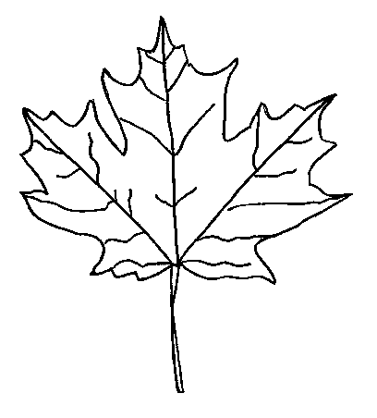
You will be preparing a chromatogram in this lab. This simple tool is used to separate different pigments. You will transfer leaf pigment onto a piece of chromatography paper. You will then dip the chromatography paper in chromatography solvent which will separate out the different pigments.
The key to identifying the different pigments in the leaf is measuring how far the pigment has traveled from its starting point. Be very precise in your measurements. You will calculate the R_{f} (retardation factor) value for each pigment. This factor is calculated by comparing the distance the solvent has moved with the distance the pigment has moved.

Materials: 250 mL flask, chromatography paper (13cm x 3cm), pencil, frozen spinach, sand, mortar and pestle, ethyl alcohol, chromatography solvent, stirring rod, graduated cylinder, tape, ruler

Procedure:
CAUTION: Chromatography solvents are flammable and toxic. Have no open flames; maintain good ventilation; avoid inhaling fumes.
- Make a pencil mark (do not use a pen!) across the chromatography paper 2cm from the bottom.
- Put a small amount of frozen spinach (about ½ tsp) into a mortar along with a pinch or two of sand (to help with grinding). Add 5 mL ethyl alcohol to the spinach. Crush leaves with the pestle, using a circular motion, until the mixture is finely ground. The liquid in the pestle is called the pigment extract.
- Use the edge of a glass rod to touch a drop of the pigment extract to the center of the pencil line on the paper strip. The goal is a small, dark dot! Let it dry. Repeat 10-20 times, to build up the pigment spot until you have a dark green dot. Each drop must dry before another drop is added. The drying keeps the pigment dot from spreading out too much.
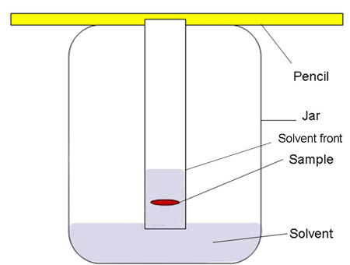
- Tape the chromatography paper to the middle of a pencil so that when the pencil rests across the top of the flask, the paper just touches the bottom (but not the sides) of the flask.
- The teacher will pour 10 ml chromatography solvent into the flask. The pigment dot must be above the level of the solvent.
- Watch the solvent rise up the paper, carrying and separating the pigments as it goes. Allow the paper to stay in the solvent for at least 15 minutes. When the solvent is near the top of the paper, remove the paper and let it dry.
- Use a pencil (do NOT use a pen!) to mark where the solvent stopped as it moved up the paper (should be colorless, but wet). Using a ruler, measure the distance (in cm) between the pigment origin (the line you drew on the bottom of the filter paper) and where the solvent stopped. This is called the solvent front. Record this data in a data chart of your own design.
- Use a pencil to mark the highest point of each pigment (color). Some discussion will likely take place regarding the different shades of the pigment. Using a ruler, measure the distance (in cm) between the pigment origin and the highest point of each pigment. These are called the pigment fronts. Record for each pigment.
- Using the formula provided, calculate the R_{f} value for each pigment and propagate the uncertainty. Record in your data chart and include a sample calculation.
- Label your chromatography paper with the four pigments.
R_{f} = distance moved by pigment from original spot
distance moved by solvent from original spot

Conclusions:
- What is paper chromatography?

Staple Filter Paper Here
Label the pigments

- Solubility and adhesion determine the rate at which the pigment will move. What set of properties would result in the fastest rate of movement?

- Why do chlorophyll a & b appear green? (Think about of the physics of light!)

- Why do leaves change colors in the fall?

- How could you use this method to predict the color a tree’s leaves will turn in the fall?

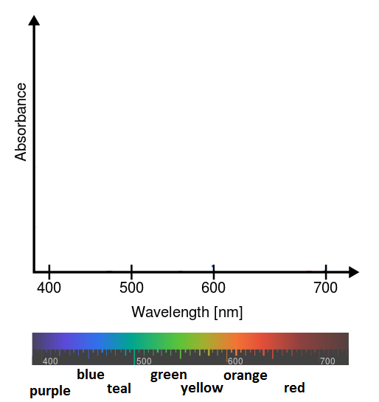
- Predict what the absorption spectrum might look like for Xanthophyll. Draw it on the spectrum below.

