Name __________________________________

Prob/Stat - Unit 2 Review Sheet

Directions: Make sure to also study your homework assignments and quiz to prepare you for the test. Don’t forget to put units, use the rounding rule for the mean and standard deviation, and label EVERYTHING!

1. Find the mean, median, and mode. 2. Find the mean, median, and mode.
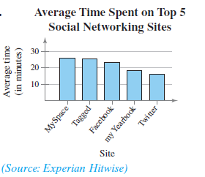
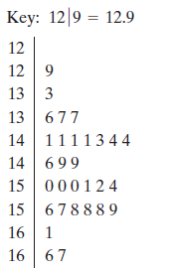

3. The data represent the scores of a biology class on a midterm exam.

a) Create a frequency distribution using 5 classes. Include the relative frequency and cumulative frequency.
b) Create a cumulative frequency histogram.
c) Create an ogive.

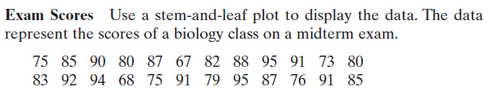

4. For the month of May, Dave’s checking account has a balance of $759 for 15 days, $1985 for 5 days, $1410 for 5 days, and $348 for 6 days. Dave’s bank will charge him a fee if his daily account balance is less than $1200. Calculate the weighted average. Did Dave get charged a fee for the month of May?

5. A student receives the following grades with an A worth 4 points, a B worth 3 points, a C worth 2 points, and a D worth 1 point. What is the student’s mean grade point score?

B in 2 three-credit classes D in 1 two-credit class
A in 1 four-credit class C is 1 three-credit class

6. Given the data set find the following:

a) the deviation for 5
b) the standard deviation (assume the data set is a population)

7. Given the data set find the following:

a) the deviation for 19
b) the standard deviation (assume the data set is a sample)

8. The graphs below both have a mean of 50. Which graph will have the larger standard deviation? Explain your reasoning.

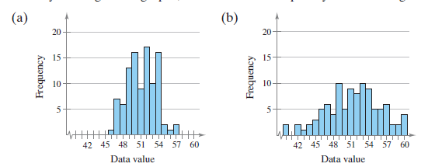

9. An Internet site compares the strokes per round for two professional golfers. Which golfer is more consistent? Explain your reasoning.

Player A with strokes and strokes
Player B with strokes and strokes

10. Which data set has the least standard deviation?

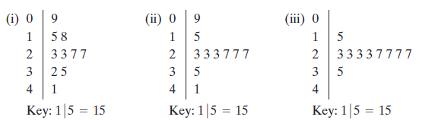

11. The data represent the scores of a biology class on a midterm exam. Create a boxplot.

12. a) Tell if the histogram is skewed left, skewed right, uniform, symmetrical, or none.
b) Tell which measure of central tendency should be used with the data.

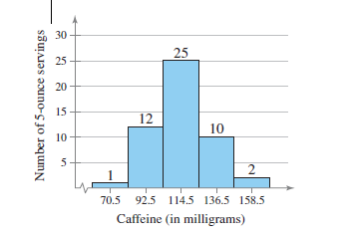
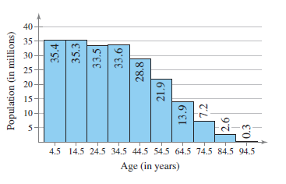
a) b)

- ____________________________ a) ___________________________

- ____________________________ b) ___________________________
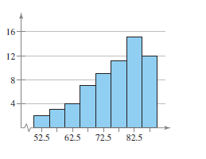
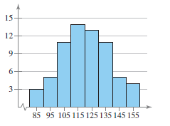
c) d)

- ____________________________ a) ___________________________

- ____________________________ b) ___________________________
13. Below is the number of nuclear power plants in the top 15 nuclear power producing countries. Create a boxplot.

