Enzymes

We've been talking about various biological molecules and that they are needed for reactions in the body (DNA, Protein synthesis, Cellular respiration etc.) and how molecules can change. You should know that it doesn't happen on its own. If you leave a blob of protein in a petri dish will it just break down to the amino acids? No. What will break down proteins? Enzymes! Enzymes are the biological substance (proteins) that act as CATALYSTS and help complex reactions occur everywhere in life.
A catalyst is a substance that increases the rate of a chemical reaction by reducing the amount of energy needed to start that reaction. This is called lowering the activation energy. ACTIVATION ENERGY can be thought of as a hill that must be gotten over. When a catalyst acts, it lowers the energy required to get over the HILL and the reaction can proceed. An enzyme is an organic catalyst meaning that it is a protein that catalyzes reactions in living organisms. Most reactions in the body require enzymes

LOCKS AND KEYS
A door that is locked needs a key that is just the right shape to fit in that lock. Otherwise you're stuck in the cold. Enzymes work in a similar way. Enzymes complete very specific jobs and do nothing else. They are very specific locks and the compounds they work with are the special keys.
Here's the deal... There are four steps in the process of an enzyme working.

(1) An enzyme and a SUBSTRATE are in the same area. The substrate is the biological molecule that the enzyme will work on.

(2) The enzyme grabs onto the substrate with a special area called the ACTIVE SITE. The active site is a specially shaped area of the enzyme that fits around the substrate. The active site is the keyhole of the lock.

(3) A process called CATALYSIS happens. Catalysis is when the substrate is changed. It could be broken down or combined with another molecule to make something new.

(4) The enzyme lets go. Big idea - When the enzyme lets go, it returns to normal, ready to do another reaction. The substrate is no longer the same. The substrate is now called the PRODUCT or products

ENZYME CONTROLS
Enzymes sometimes need to be controlled when done with their function. Other times they are controlled because of poisons. DENATURING occurs when the control changes the enzymes shape

(1) TEMPERATURE:
Proteins change shape (denature) as temperatures change. Because so much of an enzyme's activity is based on its shape, temperature changes can mess up the process and the enzyme won't work.
(2) ACTIVATORS:
Sometimes you need an enzyme to work faster and your body creates an activator. Other times you might eat something that acts as an activator. Activators make enzymes work harder and faster. Activators can help the enzyme bind to the substrate
(3) pH LEVELS:
In the same way that temperature can change the shape of proteins, the pH of the environment does the same thing. The proteins denature if too acid or too basic
(4) INHIBITORS:

Inhibitors either slow down or stop the activity of an enzyme. An inhibitor can be a COMPETETIVE INHIBITOR and block the active site or it can be an ALLOSTERIC INHIBITOR and bond to another spot causing the shape to change Remember - When the shape changes, the enzyme will not work the same way. A nasty example of an inhibitor is snake venom or cyanide.

Number: _______

Name ___________________________________________________ Period _____ Date ________________

Enzyme Worksheet
- What is a catalyst? ____________________________________________________________________
____________________________________________________________________________________

- What is an enzyme? ___________________________________________________________________
____________________________________________________________________________________

- What is the active site and what is its job? _________________________________________________
________________________________________________________________________________________________________________________________________________________________________

- What is a substrate? __________________________________________________________________
________________________________________________________________________________________________________________________________________________________________________

- What is the product? __________________________________________________________________
________________________________________________________________________________________________________________________________________________________________________

- Explain how an Enzyme works using the terms from 1 – 5 ____________________________________
________________________________________________________________________________________________________________________________________________________________________________________________________________________________________________________________________________________________________________________________________________

- What is denaturing and what causes it to occur? ____________________________________________
________________________________________________________________________________________________________________________________________________________________________

- What 4 things can affect the way enzymes work? Explain how each thing affects an enzyme. ________
________________________________________________________________________________________________________________________________________________________________________
________________________________________________________________________________________________________________________________________________________________________
________________________________________________________________________________________________________________________________________________________________________

- How can a lock and key be used to describe an enzyme? ______________________________________
________________________________________________________________________________________________________________________________________________________________________________________________________________________________________________________________________________________________________________________________________________

- Why do enzymes generally only bind to one type of substrate? _________________________________
________________________________________________________________________________________________________________________________________________________________________

- Label the following terms in the following picture
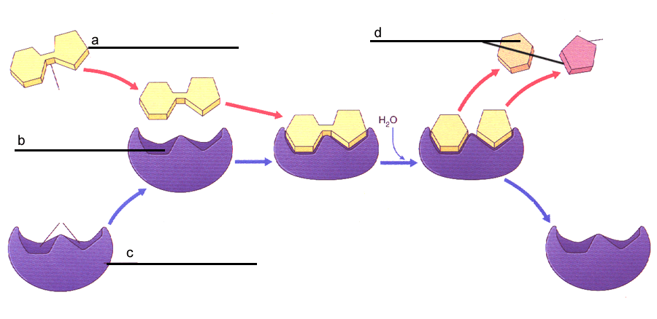
  - Enzyme___

  - Product(s)___

  - Substrate___

  - Active site___

Graph 1 Graph 2 Graph 3
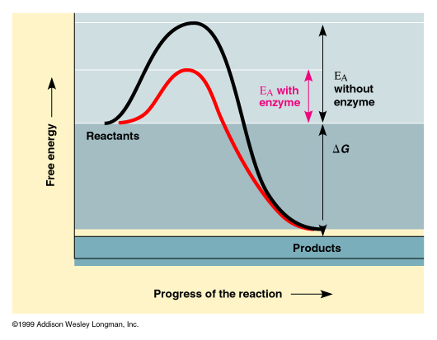
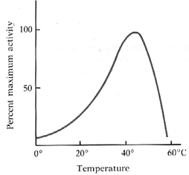
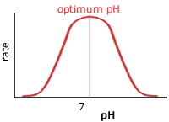

- Using graph 1, explain how enzymes work. Include the term activation energy and compare the two curves, explaining which is with the enzyme. _______________________________________________
________________________________________________________________________________________________________________________________________________________________________
________________________________________________________________________________________________________________________________________________________________________

- Using graph 2, explain how temperature affects enzyme activity. Use the word denature._____________
________________________________________________________________________________________________________________________________________________________________________
________________________________________________________________________________________________________________________________________________________________________

- Using graph 3, explain how pH affects enzyme activity. Relate to temperature effects.______________
________________________________________________________________________________________________________________________________________________________________________
________________________________________________________________________________________________________________________________________________________________________

