Genetic Crosses that Involve 2 Traits: Dihybrid Crosses
In rabbits, grey hair is dominant to white hair. Also in rabbits, black eyes are dominant to red eyes. These letters represent the genotypes of the rabbits:
GG = gray hair  Gg = gray hair  gg = white hair | BB = black eyes  Bb = black eyes  bb = red eyes
1. What are the phenotypes (descriptions) of rabbits that have the following genotypes:

Ggbb ___________________
ggBB ________________________
ggbb ___________________
GgBb ________________________

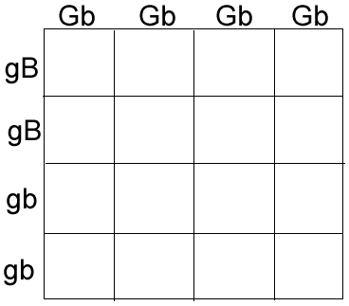
2. A male rabbit with the genotype GGbb is crossed with a female rabbit with the genotype ggBb The square is set up below. Fill it out and determine the phenotypes and proportions in the offspring.

How many have grey fur and black eyes? ________
How many have grey fur and red eyes? ________
How many have white fur and black eyes? ________
How many have white fur and red eyes? ________

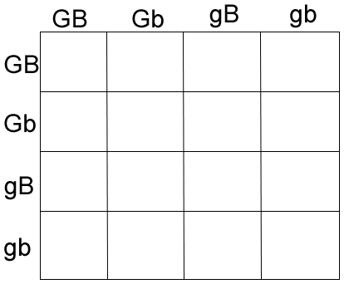
3. A male rabbit with the genotype GgBb is crossed with a female rabbit with the genotype GgBb The square is set up below. Fill it out and determine the phenotypes and proportions in the offspring.
How many out of 16 have grey fur and black eyes? ________
How many out of 16 have grey fur and red eyes? ________
How many out of 16 have white fur and black eyes? ________
How many out of 16 have white fur and red eyes? ________

4. Show the cross between a ggBb and a GGBb. You'll have to set the square up yourself!

5. In peas, yellow is dominant to green. Tall is dominant over short. Make a "key" to show all the possible genotypes (and phenotypes) for this. Use the rabbit key to help you if you're lost.

6. A pea plant that is green and short is crossed with one that is heterozygous for both traits.
Show the genotypes of the parents.
______________ x _______________
7. Set up a punnet square for the cross.

8. What are the phenotypes and ratios in the offspring?

