BIOLOGY REVIEW:
ORGANIC COMPOUNDS and ENZYMES

- What are the four organic molecules?
Carbohydrates, proteins, lipids, nucleic acids

- In a carbohydrate, what is the ratio of hydrogen atoms to oxygen atoms?
2:1 ex: MonoS = C₆H₁₂O₆ DiS = C₁₂H₁₀O₅

- What three elements are present in all four types of organic molecules?
Carbon, Hydrogen, Oxygen

- What is the molecular formula for a monosaccharide?
C₆H₁₂O₆
- What indicator and what color change are used to determine the following?
  - Starch iodine/blue-black
  - Carbohydrate Benedict’s solution & heat /brick red
  - Protein Biuret/purple
- Describe a positive test for lipids.
Translucent paper towel with oil drops

- Give an example of each type of carbohydrate:
  - Monosaccharide glucose, fructose, galactose
  - Disaccharide sucrose, maltose, lactose
  - Polysaccharide cellulose, glycogen, starch
(Cell wall) (animals) (plants)

- What are the building blocks of lipids?
Fatty acids and glycerol
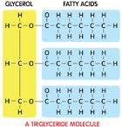 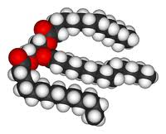 shaped like letter E

- What are the building blocks of protein?
Amino acids 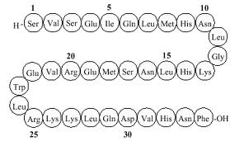

- What are the building blocks of nucleic acids?
Nucleotides
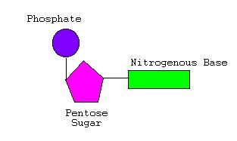
- What are the building blocks of carbohydrates?
Monosaccharides
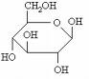

- What are the functions of each biological molecule?

Carbohydrates

1. preferred energy source

2. storage material –

3. structural material-

  - Proteins

1. growth and repair

2. enzymes – speed reactions

3. hormones –insulin, controls blood sugar

4. nails, hair, muscle, hemoglobin

5. last resort source of energy

  - Lipids

1. energy source

2. insulation

3. water proofing

4. plasma membrane

  - Nucleic acids

1. genetic blueprints

2. transferring information

- How are carbohydrates stored?
Plants: starch Animals: glycogen

- What do sugars and starches have in common?
Both a carbohydrates

- By looking at your notes on enzyme graphs, what is it meant by optimum temperature or pH?
The conditions that provide for the most effective rate of reaction.
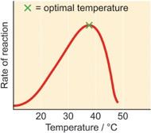
- How do you tell the difference between a chain of lipids and a chain of proteins?
Proteins have nitrogen in their chains. Lipids are in the shape of E
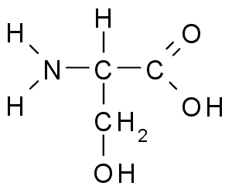Protein Lipid

- What is the purpose of an enzyme?
To change the rate of a chemical reaction

- What happens to an enzyme after if finishes changing the rate of a chemical reaction?
Reusable: It can be reused in another chemical reaction.

- What is the suffix (ending) in sugar names? In enzyme names?
ose ase
- What affects the rate of an enzyme?
Temperature and pH

- What does denatured mean?
When enzymes are destroyed after they have changed shape so much that they are no longer effective.

- Describe how an enzyme is specific.
Only one enzyme is made for a particular chemical reaction.

- Describe the lock and key hypothesis. Draw and label an example.

A certain enzyme acts like a lock and receives only one substrate that acts like a key to make a perfect fit at the active site on the enzyme. Once they fit form an enzyme substrate complex, the enzyme speeds up the chemical reaction of the substrate, and a new product is formed. The enzyme is unaffected and is ready for the next substrate (reusable)

- Why was it necessary to have the test tube of distilled water in each of our organic molecule experiments?
To serve as a control (without the independent variable)

- What type of bonds hold amino acids together?
Peptide bonds

- What are examples of each type of biological molecule?
Nucleic: DNA, RNA
Lipids: butter, fried foods, bacon fat
Protein: dairy products, peanuts, meat

Carbohydrates: Honey, candy, spaghetti, rice, potato, bread

- What are the properties of enzymes?

  - Proteins
  - Catalysts
  - Reusable
  - Substrate specific
  - Sensitive to temperature
  - Sensitive to pH

- Describe the enzyme lab

Enzyme: catalase
Source: liver, potato, apple etc
Substate: H₂O₂

Hydrogen peroxide is toxic in cells
2H₂O₂ +catalase à 2 H₂O + O₂

