FINAL EXAM review part A - key

- The common structure that makes up every living thing is a cell
- List the 3 parts of the cell theory (NOTE: this will be a short-answer question) All living things are made up of cells, cells are the basic unit of structure and function, cells come from pre-existing cells
- Name 2 characteristics that all cells have in common. Cell membrane, DNA (at some point), cytoplasm, ribosomes
- What is the difference between a prokaryote and a eukaryote? Prokaryotes are organisms without a nucleus and other membrane bound organelles in their cell; eukaryotes have a nucleus and membrane bound organelles
- For each of the following organisms, indicate if they are prokaryotes or eukaryotes:
  - Bacteria & Archaea prokaryote
  - Protista eukaryote
  - Fungi eukaryote
  - Plants eukaryote
  - Animals eukaryote
- Match the following terms with the description:
- cytoskeleton - chloroplast - mitochondrion
- nucleolus - nucleus - ribosome
- lysosome - vacuole - endoplasmic reticulum
- golgi apparatus
a) Contains almost all the DNA of the cell: nucleus
b) Site where ribosomes are made: nucleolus
c) Proteins are made here: ribosomes
d) This is where the lipid part of the cell membrane is made and it is involved in transporting materials: endoplasmic reticulum
e) This is where proteins are packaged: Golgi apparatus
f) Organelles filled with enzymes that help rid the cell of waste: lysosomes
g) Structure that can be used for storage:
h) Organelle that converts chemical energy of food into compounds that are easier for the cell to use: mitochondria
i) Organelles that capture energy from sunlight and convert it into chemical energy in a process called photosynthesis: chloroplasts
j) Network of protein filaments that gives the cell its shape and is involved in its movement: cytoskeleton
7. Which structure regulates what enters and leaves the cell? the cell memebrane
8. What is the cell membrane made of? Lipid bilayer (with embedded proteins)
9. List 3 types of organisms that have cell walls around their cells. Plants, algae, fungi, many prokaryotes
10. The net movement of particles from an area of high concentration to an area of low concentration is
called diffusion
11. Diffusion eventually leads to equilibrium
12. What does the statement “membranes are selectively permeable” mean? Membranes only allow certain substances to cross
13. The diffusion of water across a membrane is called osmosis

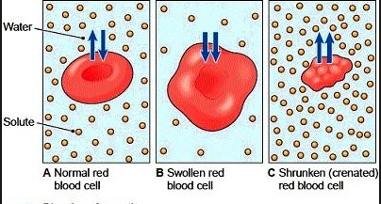

14. Observe the figure above. Indicate if the cell is in an isotonic, hypotonic, or hypertonic solution
A: isotonic
B: hypotonic
C: hypertonic
For each of the cells, indicate if the cell will increase in size, decrease in size, or stay the same.
A: stay the same
B: increase
C: decrease
15. In which type of solution may a red blood cell burst? hypotonic
- By which mechanism is glucose transported across the cell membrane? Facilitated diffusion
- Does this require energy? no
- Does active transport require energy? yes
- Put the following in order form smallest to largest: atom, molecule, organelle, cell, tissue, organ, organ system, organism

Chapter 8
- Organisms that can make their own food are called autotrophs (producers)
- How do heterotrophs, like yourself, obtain energy? By consuming (the products of) other organisms
- What is the chemical compound that cells use to store and release energy? ATP (adenosine triphosphate)
- How is the energy that is stored in ATP released? By breaking the bond between the second and third phosphate group (ATP → ADP + P + energy)
- 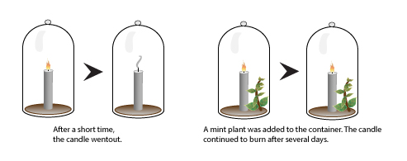
- The diagram above shows Priestley’s experiment. What did the mint plant release? oxygen
- Give the equation for photosynthesis. 6 CO₂ + 6 H₂O + light energy → C₆H₁₂O₆ + 6 O₂
- Which structures absorb the sun’s energy? Pigments (chlorophyll)
- Why do leaves look green? Chlorophyll reflects green light
- In which organelle does photosynthesis take place? The chloroplast
- Name the two parts of photosynthesis. The light (dependent) reactions and the light independent reactions (Calvin cycle)
- Where does each reaction take place? Light reactions in the thylakoid membranes of the chloroplast, light independent reactions in the stroma of the chloroplast
- Which molecule from the atmosphere enters the Calvin cycle? CO₂
- The diagrams below show the relationship between the rate of photosynthesis and temperature and light intensity. Which graph represents the effect of temperature on the rate of photosynthesis?

- 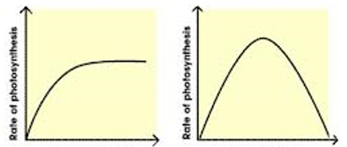

  - b)
Graph b; the rate of photosynthesis is low when the temperature is low due to slower movement of particles - it increases as the temperature increases – if the temperature is too high, enzymes will denature and the reaction rate will decrease and photosynthesis may stop
- Name the types of molecules that can enter or leave the plant when stomates are open. CO₂ enters, H₂O and O₂ leave
- Over time, a tiny sapling can grow into a large oak tree. A mature tree has a tremendous mass. Where did this mass come from? The mass mostly came from CO_{2,} which enters the Calvin cycle and is used to build sugars (the sugars give the tree its mass)

Chapter 9
- The process that releases energy by breaking down glucose in the presence of oxygen is cellular respiration
- Give the equation for cellular respiration. C₆H₁₂O₆ + 6 O₂ → 6 CO₂ + 6 H₂O + energy (36 ATP + heat)
- What are the 3 main parts of cellular respiration? Glycolysis, the Krebs (cictric acid) cycle and the electron transport chain
- What is the starting molecule for glycolysis? glucose
- If oxygen is not present, what process will take place? fermentation
- What type of fermentation may occur in your muscle cells? Lactic acid fermentation
- 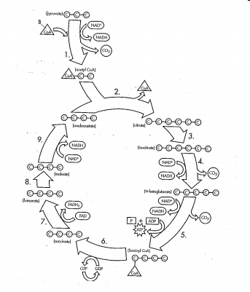
What is shown in the figure? The Krebs (citric acid) cycle
- What is the first molecule formed in the Krebs cycle? Citric acid
- Where will the high energy electrons, carried by NADH and FADH₂, be taken? The electron transport chain
- Where does this process take place? Inner membrane of the mitochondrion
- What happens to the electrons at the end of the electron transport chain? The electrons are accepted by oxygen (which combines with H⁺ to form H₂O)
- What is the function of ATP-synthase? It allows H⁺ ions to flow back into the mitochondrial matrix and it catalyzes the reaction that produces ATP
- After a longer race, why will you breathe heavily for a while? You are repaying an oxygen debt (the lactic acid that has built up needs to be broken down and this requires oxygen)
- Muscle cells store energy in the form of glycogen
- Complete the following table

Photosynthesis cellular respiration
Function store energy in sugars release energy from sugars
Location chloroplast mitochondria
Reactants CO₂ and H₂O C₆H₁₂O₆ and O₂
Products C₆H₁₂O₆ and O₂ CO₂ and H₂O

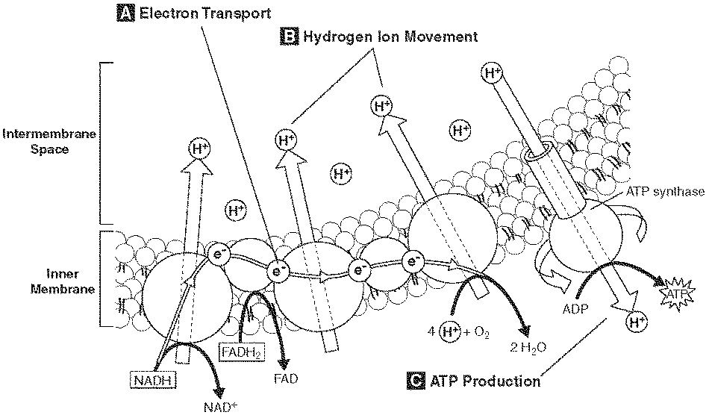
- What does the figure show? The electron transport chain (NADH and FADH₂ drop off high energy electrons, electrons are passed from molecule to molecule, electrons are accepted by oxygen, hydrogen is moved into the innermembrane space and when H flows back through ATP synthase, ATP is produced)
- Which molecule is the final electron acceptor? O₂

Chapter 10
- As a cell grows larger, does the ratio of surface area to volume increase or decrease? The ratio decreases
- The process by which a cell divides into 2 new daughter cells is called…cell division
- In eukaryotes, what are the two main stages of cell division? Mitosis and cytokinesis
- When chromosomes become visible at the beginning of cell division, what does each chromosome consist of? 2 sister chromatids
- Chromatids are attached at an area called the…centromere
- During the cell cycle, what is the period in between cell division called? interphase
- Complete the diagram of the cell cycle by writing the names of the 4 phases.

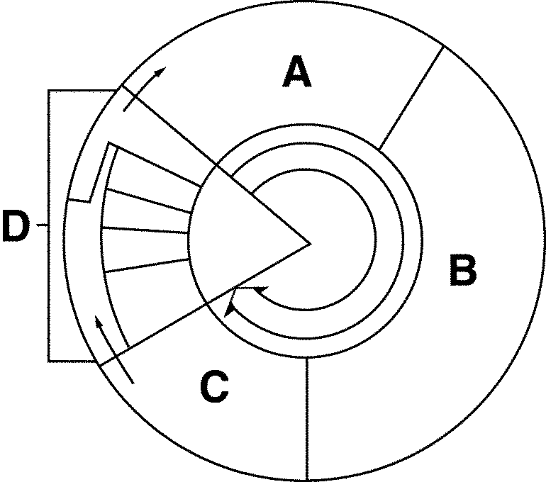A = G₁-phase, B = S-phase, C = G₂-phase, D = M-phase (mitosis + cytokinesis)

- The division of the cell nucleus is called…mitosis
- Name the three phases of interphase. G₁, S, and G₂
- What happens during the G₁ phase? Cell growth
- What happens during the S phase? DNA replication
- What happens during the G₂ phase? Preparation for cell division
- Name the 4 phases of mitosis in order. Prophase, metaphase, anaphase, telophase
- What is cytokinesis? Division of the cell’s cytoplasm (cell physically divides into 2 cells)

Chapter 11
- The scientific study of heredity is genetics
- What type of organism did Mendel work with? Pea plants
- Does genetics apply to all organisms? yes
- What is the difference between the P- , F₁, and F₂ generation? P is the parent generation, F1 is the offspring of the P generation, F2 is the offspring of the F1 generation
- What does the principle of dominance state? Certain traits are dominant while others are recessive
- What does a capital letter represent in a cross? A dominant allele
- What does a lowercase letter represent? A recessive allele
- The likelihood that an event will occur is called probability
- An individual that is GG is homozygous while an organism that is Gg is heterozygous.
- The outward appearance of an organism is its phenotype while the genetic makeup is its genotype?
- Cross two plants that are tall and heterozygous (show in a Punnett square) T t
T TT Tt
t Tt tt
- If heterozygotes have an intermediate phenotype (ex. pink in four o’ clock flowers), would it be considered incomplete dominance or codominance? Incomplete dominance
- If heterozygotes express both traits (ex. black and white speckled chickens), would it be considered incomplete dominance or codominance? codominance
- If the diploid number of a cell would be 66, the haploid number would be…33
- Are gametes diploid or haploid? haploid
- What is crossing over? The exchange of genetic information between homologous chromosomes (during prophase I of meiosis I)
- How many polar bodies are formed during meiosis in females? 3
- Explain the main difference between mitosis and meiosis (number of cells, haploid vs diploid, identical or non-identical) mitosis results in 2 diploid cells that are genetically identical to each other and to the parent cell; meiosis results in 4 haploid cells (in females 1 egg and 3 polar bodies) that are genetically different from each other and from the parent cell
19. 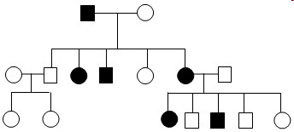
What is shown in the figure? A pedigree
20. How many individuals have the trait? 6
21. Assume this is a dominant trait. What can you conclude about the “shaded”
individuals? They are all heterozygous (you know this because one of the parents is homozygous
recessive and/or they have a child that is homozygous recessive)

Chapter 12
1. What stores and transmits genetic information from one generation to the next? DNA (deoxyribonucleic acid)
2. DNA is made of units called nucleotides
3. Name the 3 parts of a nucleotide. Sugar, phosphate group, and nitrogen-containing base
4. List the 4 types of nitrogenous bases. A, G, C, and T (for DNA; U for RNA)
5. What makes up the backbone of DNA? Alternating sugars and phosphate groups
6. Who developed the model that we still use today? Watson and Crick
- How are the two strands held together? By hydrogen bonds
- Write the complementary DNA strand for this section of DNA: CAGCTT GTCGAA
- Which type of RNA copies info from DNA and brings it to the site of protein production? Messenger RNA (mRNA)
- What is transcription? The process of copying the information from DNA to make mRNA
- Where does this take place? In the nucleus
- What is the process of transferring the information from mRNA to the making of proteins called? translation
- Where does this take place? On the ribosomes
- What is meant by a frameshift mutation? A mutation that results from the insertion or deletion on nucleotides (all codons will be mismatched from this point)
- Is every mutation harmful? No, many have no effect and some are beneficial

28. Given the following DNA sequence, determine the order of amino acids that will be formed and explain which of the two individuals has a mutation that will not be harmful.
Correct sequence: GGG ATA CGT GTT
CCC UAU GCA CAA
Pro Tyr Ala Gln

Individuals with a mutation:
Ted: GGG ATT CGT GTT
CCC UAA GCA CAA
Pro stop
Tim: GGT ATA CGT GTT
CCA UAU GCA CAA
Pro Tyr Ala Gln not harmful; it made the same protein

