AP BIOLOGY SUMMER ASSIGNMENT 2016

Welcome to the world of Advanced Placement Biology! The attached summer assignment is required for all AP Biology students for the 2016-2017 school year.

DO THESE THINGS FIRST!

- Sign up for my Remind.com AP Biology 2017 to receive messages about class
by sending a text to: 81010 with the message: @faec8a

- Join my google classroom – AP biology 2016-17.
Go to: www.classroom.google.com use code: eknylr4 to join class
It works best if you use a school google account, with your name, then @longbranch.k12.nj.us We will use google drive throughout year and you can submit your assignment to me here. I will be putting this assignment on google drive AND my teacher page on the High School web site

You are required to do 3 things before school starts in September:

Part 1 – Video Learning- Bozeman AP Biology – 30 pts
Part 2 – Biology Scavenger hunt – 50 pts
Part 3 – Root word investigation – 20 pts

You will get a 100 point Summative grade for this assignment

By completing the assignment you will get an understanding of The AP biology course and have some basics to succeed in class

The assignments are due NO LATER than the second day of class, if not submitted earlier. Note that the summer assignment will be your first summative grade for the class

1) If you do not do the summer assignment, you will start behind in the course.
2) Don’t get overwhelmed. Plan out when you will do it. Have your list of terms ready to take a quick picture when you see something

The AP Biology course.
The AP Biology course is rigorous. It is a college level course. Expect to do homework every night. You will get out what you put in to the course. You will be given the tools needed to get a 4 or 5 on the AP Biology exam by taking this course, but it will be up to you to use them and employ them.
The text we use is Raven-Johnson Biology 8th ed. 2008 in class, but most of your assignments will be using computers and other technology. During the year we will complete the 8 required AP labs as well as many additional labs and activities. You will gain practice in writing AP Free Response Questions, and in answering AP level multiple choice questions.

I STRONGLY SUGGEST that you invest in an AP Biology study guide (revised version) such as Cliff’s AP biology or Princeton review. Students who regularly use a study guide on their own beyond class work greatly increase their chances of getting a 5 on AP exam.

If you have questions about this assignment, or to send me completed sections, you may contact me via remind.com for a quick response or you can email me at dclark@longbranch.k12.nj.us if you are not in a hurry for the response. Don’t wait until the week before school to find out what you need to do!

Have a great summer!

Mr. D. Clark
Part I: Video learning Bozeman Science - 30 Pts total

You will learn about 3 key practices to succeed in AP biology by watching a video and answering questions about each. We will be using a lot of videos for Bozeman science this year as homework so this will give you a good introduction to the Host Mr. Anderson and the videos. Each video is about 10 minutes but allow yourself 30 minutes each to pause video and answer questions

Each video centers on the 4 Big Ideas of AP biology:

Big Idea 1: EVOLUTION
The process of evolution drives the diversity and unity of life.
Big Idea 2: Cellular Processes: ENERGY and Communication
Biological systems utilize free energy and molecular building blocks to grow, to reproduce, and to maintain dynamic homeostasis.
Big Idea 3: Genetics and INFORMATION Transfer
Living systems store, retrieve, transmit, and respond to information essential to life processes.
Big Idea 4: Interactions of SYSTEMS
Biological systems interact, and these systems and their interactions possess complex properties.

The 3 videos are as follows: Each work sheet has a specific link, but you can access them all if you google: < Bozeman AP biology> and choose first link. They will all be listed

- Video 1 – Using Models – 10 pts
- Video 2 – Using Mathematics – 10 pts
- Video 3 – Scientific Questioning – 10 pts

You must print out or obtain the 3 sheets following on next page. They can also be submitted on google drive. Note. There are 7 Intro AP practice videos by Bozeman science, You can do more for extra credit
Evolution
Free Energy and Cell Processes

Information
and Genetics

Systems and Interactions

AP Biology Practice 1 – Models and Representations Video Review – 10 pts

Video - www.bozemanscience.com/apb-practice-1-models-representations

- What is a model?.....A visual representation of _____________________________________

- A _____________________ of how it works is a “Conceptual Model”.

- What are the four Big Ideas we will be discussing in AP Biology? List below along with associated example:

- _______________________________ - example shows natural ________________

- _______________________________ - example:

- __________________________________ - genetics and cell

- ________________________________ - pyramid of

- What are the 5 things you will need to be able to do using models and visual representations? List below and then answer [Please keep in mind, some of the examples that he uses may be unknown to you at this time, focus on the “practice” not the content.]

  - _______________
    - Relating to beetles, draw/label the final graph he created below:

    - Why do you think there were fewer light colored beetles when the trees became darker?

  - _______________ What was is going to move in his example? ____________

  - _______________ They will give you a model and then ___________________ based on that. …

  - _______________ Means that you are __________________ your knowledge to a visual representation

  - _______________ Asking you to ___________ the knowledge that you have.

- Models allow us to make ___________ of a ______________ model.

- What is the most famous model of all? ______ That was created by __________________
AP Biology Practice 2 – Using Mathematics Video Review Sheet – 10 pts

www.bozemanscience.com/apb-practice-2-using-mathematics

- All sciences have what at their core? _____________________________

- What is “Mathematical Biology” driven by:

- _________________________: sequencing DNA – what is the trend? ______________

- ___________________ Theory: being used to predict ____________ Rule of ________

- Computing ____________________: computers are getting

- Laboratory experiments in silico:

- In vitro: __________________________________________________

- In vivo: __________________________________________________

- In silico: simulating _________________________________________

- Four equations in the four big ideas: You want to be familiar with these
  - Evolution: 3) Free energy:

  - Information: 4) Systems:

- Understandings in Using Mathematics:

  - _____________ the _______________ of a Mathematical Routine: Pause video, try and do it and then check it. If you can no do, just take notes (CALCULATOR REQUIRED)

  - Apply _________________________ Routines: Again, try this problem. You can do this one based on common sense! (CALCULATOR REQUIRED)

  - ________________________ quantities that ________________ natural phenomena.
    - Estimate which way water will go in each.

    - Potatoes: you can do this, just use graph. Potatoes have________M Sucrose
AP Biology Practice 3 – Scientific Questioning Video Review Sheet – 10 pts

www.bozemanscience.com/apb-practice-3-scientific-questioning

- I should be able to ask you, “How do we….

- Students should be able to answer, “This is how….

- What is a good example of how you ask questions all the time?

- What is the problem with:
  - Smallest bird question?

  - Universe question?

  - Genetically modified food question?

- Why is the plant growth question more scientific?....but what is a problem with it too?

- Why is the CO2 question a good scientific question?

- A good question is going to lead to: (2x)

- What are the three things you have to be able to do during the practice of “Scientific Questioning”?

- Write out one of the three questions he “posed” concerning the phylogenetic tree. (You are just asking, not answering.)

- When you “refine” a question, you are taking it to another _____________

- What is the third part of scientific questioning?

- What can you then do if you are good at scientific questioning?

Part II: Biology Term Scavenger Hunt - 50 pts

For this part of your summer assignment, you will be familiarizing yourself with science terms that we will be using at different points throughout the year and finding them in a practical situation

- Select and “collect” 25 words/terms from the list (On Next Page)
When I say “collect”, I mean you should collect that item by finding it and taking a photograph. You will make a digital “collection”, along with corresponding explanations. Use google drive to create a slide show or just make a google doc with pictures pasted in along with identification and description for each. If you do not have computer access, I will accept an actual photo album to physically turn in. You can have more than one item on a page.
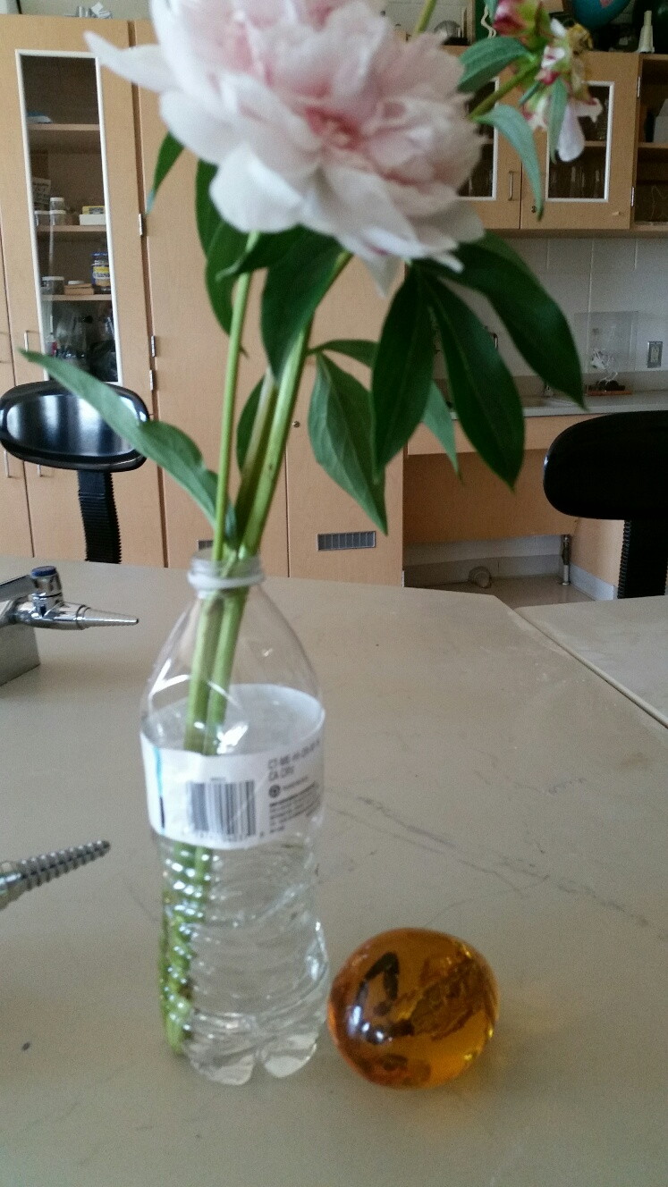
You do not need to find the exact item on the list, say for example, if it is an internal part to an organism, but you must apply the term to the specimen you find and explain in your finished project how this specimen represents the term.

- EXAMPLE: I chose the word “phloem”, I then took a picture of a flower and stem and would then write a description of phloem and where it is in my flower

- ORIGINAL PHOTOS ONLY:
You cannot use an image from any publication or the Web. You must have taken the photograph yourself. You MUST prove this by placing a small item (stuffed animal, a button, toy car, etc.) in all of your photographs that only you could have added each time. You could also make a small sign of your name that will be in each photo/drawing. You can even have yourself in the picture.

- EXAMPLE: In photo of flower I placed my scorpion egg

- NATURAL ITEMS ONLY:
Specimens may be used for only one item/word, and all must be from something that you have found in nature that is or once was alive. Ex. You can not use your little sister’s stuffed pony for a picture of a mammal. Take a walk around your yard, neighborhood, and town or even the beach. Go to a store that has living things, like home depot (plants) or PetSmart (animals) DON’T SPEND ANY MONEY! Research what the term means and in what organisms it can be found... and then go out and find one.

Be sure to include a description of the term and how it relates to the Photograph

Biology Scavenger Hunt list.

You must photograph at least 25 of the terms below as well as identify and describe each

Each photo and description is 2 pts for a total of 50 pts

1. adaptation of an animal
2. adaptation of a plant
3. abscisic acid
4. actin
5. amniotic egg
6. amylase
7. angiosperm
8. animal with segmented body
9. annelid
10. anther & filament of stamen
11. arthropod
12. archaebacteria
13. autotroph
14. auxin producing area of a plant
15. basidiomycete
16. Batesian mimicry
17. biological magnification
18. bryophyte
19. C 4 plant
20. Calvin cycle
21. carbohydrate -fibrous
22. cambium
23. cellulose
24. chitin
25. chlorophyta
26. cnidarian
27. coelomate
28. conifer leaf
29. commensalism
30. connective tissue
31. cuticle layer of a plant
32. deciduous leaf
33. deuterostome
34. dicot plant with flower & leaf
35. diploid chromosome number
36. echinoderm
37. ectotherm

38. endosperm
39. endotherm
40. enzyme
41. epithelial tissue
42. ethylene
43. eubacteria
44. eukaryote
45. exoskeleton
46. fermentation
47. flower ovary
48. frond
49. fruit – dry with seed
50. fruit – fleshy with seed
51. gametophyte
52. gastropod
53. genetically modified organism
54. gibberellins
55. glycogen
56. gymnosperm cone
57. haploid chromosome number
58. heartwood
59. hermaphrodite
60. insect
61. K-strategist
62. keratin
63. leaf – gymnosperm
64. lepidoptera
65. lichen
66. lignin
67. lipid used for energy storage
68. littoral zone organism
69. long-day plant
70. meristem
71. modified leaf of a plant
72. modified root of a plant
73. modified stem of a plant
74. monocot plant w/flower & leaf

75. muscle fiber – striated
76. mutualism
77. mycelium
78. mycorrhizae
79. myosin
80. nematode
81. niche
82. nymph stage of an insect
83. parasite
84. parenchyma cells
85. phloem
86. pine cone – female
87. platyhelminthes
88. pollen
89. pollinator
90. porifera
91. prokaryote
92. protein – fibrous
93. protein – globular
94. protostome
95. pteridophyte
96. r-strategist
97. radial symmetry
98. rhizome
99. two-chambered heart
100. spore
101. sporophyte
102. stem – herbaceous
103. stem – woody
104. stigma & style of carpel
105. tendril of a plant
106. thorn of a plant
107. unicellular organism
108. vascular plant tissue
109. xerophyte
110. xylem

Part III – Root word investigation – Research each root word write definition - 20 pts
The main reason students find it difficult to understand science is because of all the hard to write, spell and read words. Actually, scientific vocabulary is a mix of small words that are linked together to have different meanings. If you learn the meanings of the little words, you'll find scientific vocabulary much easier to understand. Find the mean to the following Greek/Latin root words.

Word | Meaning
a- / an-
meso-
leuco-
aero-
anti-
amphi-
aqua- / hydro-
arthro-
auto-
bi- / di-
bio-
cephal-
chloro-
chromo-
-cide
cyto-
derm-
haplo-
ecto- / exo-
endo-
epi-
gastro-
-genesis
herba-
hetero-
homo-
ov-
kary-
neuro-
soma-
saccharo-
primi-/ archea-
-phyll
Word | Meaning
hemo-
hyper-
hypo-
intra-
-itis
lateral
-logy
-lysis
-meter
mono-
morph-
micro-
macro-
multi- / poly-
-path / -pathy
-ped /-pod
phago-
-phobia
-philia
proto-
photo-
pseudo-
-stasis
sub-
sym- / -syn
-synthesis
-taxis
-troph
-tropism
-therm
tri-
zoo-, -zoa
zyg- / -zygous

Using Root words to define unknown words
Once you have completed the above root word table, use it to develop a SIMPLE definition, in your own words, for each of the following terms:
1. Hydrology ________________________________________________________________
2. Cytolysis ________________________________________________________________
3. Protozoa__________________________________________________________________
4. Epidermis _________________________________________________________________
5. Spermatogenesis __________________________________________________________
6. exoskeleton_______________________________________________________________
7. Abiotic ___________________________________________________________________
8. Pathogen ________________________________________________________________
9. pseudopod _______________________________________________________________
10. Hemophilia ______________________________________________________________
11. Endocytosis ____________________________________________________________
12. herbicide ________________________________________________________________
13. Anaerobic _______________________________________________________________
14. Bilateral _________________________________________________________________
15. autotroph _______________________________________________________________
16. Monosaccharide __________________________________________________________
17. Arthropod _______________________________________________________________
18. Polymorphic ______________________________________________________________
19. Hypothermia _____________________________________________________________
20. Biogenesis _______________________________________________________________

You will have a QUIZ on these words and the above root words on the first day of class and a TEST on them the second day of class

