Human Body
- What is the job of the circulatory system? 943
To Exchange oxygen and carbon dioxide, to deliver food, & pick up waster

- Define these terms:
  - Neuron 897 – Nerve Cell
  - Antibiotic 486 – A drug that kills bacteria
  - Homeostasis 16 – The process the body uses to stay in balance.

- Where in the body does chemical digestion take place? (Hint: more than 1 place) 980
Mouth, Stomach, Small Intestine

- What structures are found in the dermis? 934
Nerves, Sweat Glands, Hair follicles, Pillus muscles, fat

- Compare & contrast cells, tissues, organs & organ systems. 192
Cells make tissues,which make organs which make organ systems. They all work together.

- What does hemoglobin do? 952
Carries oxygen

- What do fats (lipids) and fatty acids do? 182
Make the phospholipid bilayer of cell membranes

Bacteria / Viruses

- Draw a bacterial cell below. Label parts of the cell with the following terms: DNA, Cell wall, Cell membrane, Ribosome, Cytoplasm, Flagella -472

- Describe the function of each bacteria part:
  - Flagella - 473 – Whip-like tail used for movement

  - Ribosome-177 – Small organelle on which proteins are assembled

  - Cell Wall-183 – For protection & support

- Describe Gram staining and what the results mean. 473
Gram Staining identifies bacteria with large amounts of peptidoglycan in their cells walls (Gram +)
Or small amounts of peptidoglycan in their cell walls (Gram -)
Gram negative bacteria are much more difficult to kill with antibotics

- What is the purpose of Nitrogen-fixing bacteria? 477
Nitrogen-fixing bacteria makes nitrogen from the air usable for plants.

- Why are bacterial decomposers helpful? 476
They cycle nutrients through the environment – breaking down dead organisms

- Define the following terms:
  - Pathogen 485 – A disease causing organisms

  - Prophage 480 – A small, circular piece of DNA on which bacteria can transfer genes to each other

  - Prokaryote 471 – Bacteria = no nucleus

  - Eukaryote 173 – has nucleus

  - Virus 478 – Acellular infectious particle

  - Lysis 480 – Bursting open of cell (happens in the lytic cycle)

- What are some characteristics of each phylum of bacteria? (and where do they live?) 472
  - Eubacteria - True bacteria – like warm, damp environments

  - Cyanobacteria – blue-gree, photosynthetic, live in ocean

  - Archaebacteria – ancient – can survive in harsh environments

- Draw each of the 3 bacterial shapes and label them with their proper names. 473

- Define the following 474-474
a. Photoautotroph – bacteria that uses light to make food

b. Chemoautotroph – bacteria that make organic molecules from carbon dioxide

c. Chemoheterotroph – bacteria that must take in organic molecules for both energy and a supply of carbon

d. Photoheterotroph – bacteria that are photosynthetic using sunlight energy, also need to take in organic compounds as a source of carbon

- What is botulism? How does it make you sick? 474
Clostridium botulinum – it is a paralytic type of food poisoning found in canned foods. It relaes a toxin that paralyzes the nervous ystem. ANAEROBIC!

- What are good growth conditions for bacteria? 474-474
Warm/Damp/Dark – Think Mouth

- Describe how bacteria obtain energy with respect to the following terms: 474
a. Obligate aerobes – must have a constant supply of oxygen

b. Obligate anaerobe – must live in the absence of oxygen

c. Facultative anaerobe – can survive with or without oxygen

- Describe three ways in which bacteria reproduce. 475
a. Binary fission – bacteria divides in half
b. Conjugation – hollow bridge forms between two bacterial cells and genetic information is exchanged
c. Spore formation – forms a thick inner wall enclosing the DNA and part of the cytoplams

- How can you keep food bacteria free? 486-7
Cook it, store it in a refridgerator

- Draw a virus below and label the parts. Include what each part does. 479

- Describe the 5 steps of the process in which a virus takes over a host cell. 481
  - Attachment
  - Injects DNA
  - Hijacks Cellular DNA to reproduce viruses
  - Assembly of Virions
  - Lysis of cell, release of viruses

- Are all viruses the same shape? Explain. 478-9
No, some are space ship shaped, star shaped, round with spikes…..

- Identify diseases causes by bacteria. 488
Lyme disease, tetanus, tuberculosis, etc.

- Identify diseases caused by viruses. 488
Common cold, Flu, AIDS, etc.

Classification
- Define each of the words below:
  - Autotrophic- 201 – Makes own food

  - Heterotrophic- 201 – Obtains good from another source besides self

  - Taxonomy- 447 – The science of classifying organims

- What are the three basic rules for writing scientific names? 448
  - Two part name
  - 1st word capitalized, 2nd word lowercase
  - Italics or underlined

- In what language are scientific names usually written? 448
Usually Latin, sometimes Greek

- Why are scientific names necessary? 448
So that ALL scientists speak the same language – because many common names apply to each organism.

- What information can the first word of a scientific name tell you? 448
Genus

- Write an example of a scientific name. 448
Homo sapien

- List the seven taxa in order from most general to most specific. 450
Kingdom, Phylum, Class, Order, Family, Genus, Species

- Which are more closely related: members of the same genus or members of the same order? Why? 449
Same genus, because as the taxa become more specific, the organisms are closer in relation

- Give at least 2 characteristics and 1 example from each kingdom. 457

  - Eubacteria – Unicellular, Auto & Heterotophs, cells walls with peptidoglycan Ex: E. coli
  - Archaebacteria – Unicellular, cells without peptidoglycan Ex: Methanogens
  - Protista – Unicellular & Multicellular, Auto & Heterotrophs, Ex: Paramecium
  - Plantae – Multicellular autotrophs, Ex: Trees
  - Fungi – Multicellular heterotrophs (except yeast!) Ex: Mushrooms
  - Animalia – Multicellular heterotrophs, Ex: Humans

- Which kingdoms have the most clear cut division? (The most different from each other?) 457
Plants & Animals

- What is a dichotomous key and how is it used? 462
It is a way to identify unknown organisms. It is used by answering a series of yes & no questions.

Evolution
- Define the following terms:
  - Evolution 369 – change over time

  - Relative Dating 419 – determines age of artifacts relative to other artifacts

  - Common ancestor 382 – The Progenitor

  - Natural selection 379 – A process by which the best fit survive to reproduce

  - Homologous structure 384-5 – structures that are similar in multiple species

  - Vestigial structure 384 – structures that are no longer evolutionarily useful

  - Survival of the fittest 381 – on the best fit organisms survive and pass the trait on to offspring

- Describe Lamarck’s Theory of Evolution. 376
Organisms traits become larger or smaller over time with use or disuses

- What are the 4 basic steps to the process of natural selection? 380-2 + notes
  - Variation in a population

  - Environmental pressue

  - Best fit survive & reproduce/ least fit die

  - Natural Selection

- Give an example of each step of natural selection: (Notes)
  - Long & short necked giraffes

  - Trees are taller, food is up high

  - Longer necks get food & live to reproduce, shorter necks starve

  - Population no all have longer necks

- In what type of rock are fossils most likely to be found? 418
Sedimentary

- Describe two ways to find the age of fossils. 419-420
Relative Dating
Radioactive Dating

- Explain what is meant by half-life.
The time needed for one half of the radioactive atoms in a sample to decay.

- Darwin’s finches are a great example of what? 404-410
Natural selection and / Adaptive radiation
- Compare population & species. 64
Populations are a species living in one specific area.

- Summarize the changes in brain capacity of hominids. 836
As time passes, brain capacity increases

- Define the following terms:
  - Mass extinction 431 – when many organisms dies at one time

  - Divergent/ Convergent evolution 437
Divergent – evolution that separates
Convergent – evolution that comes together

  - Adaptive radiation 436 – a type of natural selection that results in many species evolving from one original species

  - Speciation 404 – the process by which one species becomes two

  - Punctuated Equilibrium 439 – pattern of long, stable periods interrupted by brief period of rapid change

Lab Technique
- What are the uses for the following lab equipment? (from frog lab)
  - Probe – to poke/move things

  - Pins – to hold the body in thet ray

  - Scalpel – to make small, precise incisions

  - Scissors – to make longer, large incisions

  - Forceps – to pick things up

- Label the internal and external structures of the frog. 783-4 & from frog lab

External Nares

Mouth

Throat
Eye
Tympanic Membrane

Hind Limb
Foot
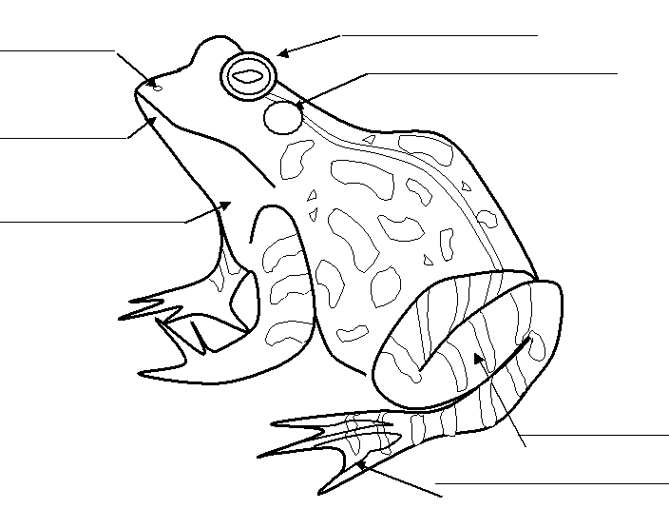

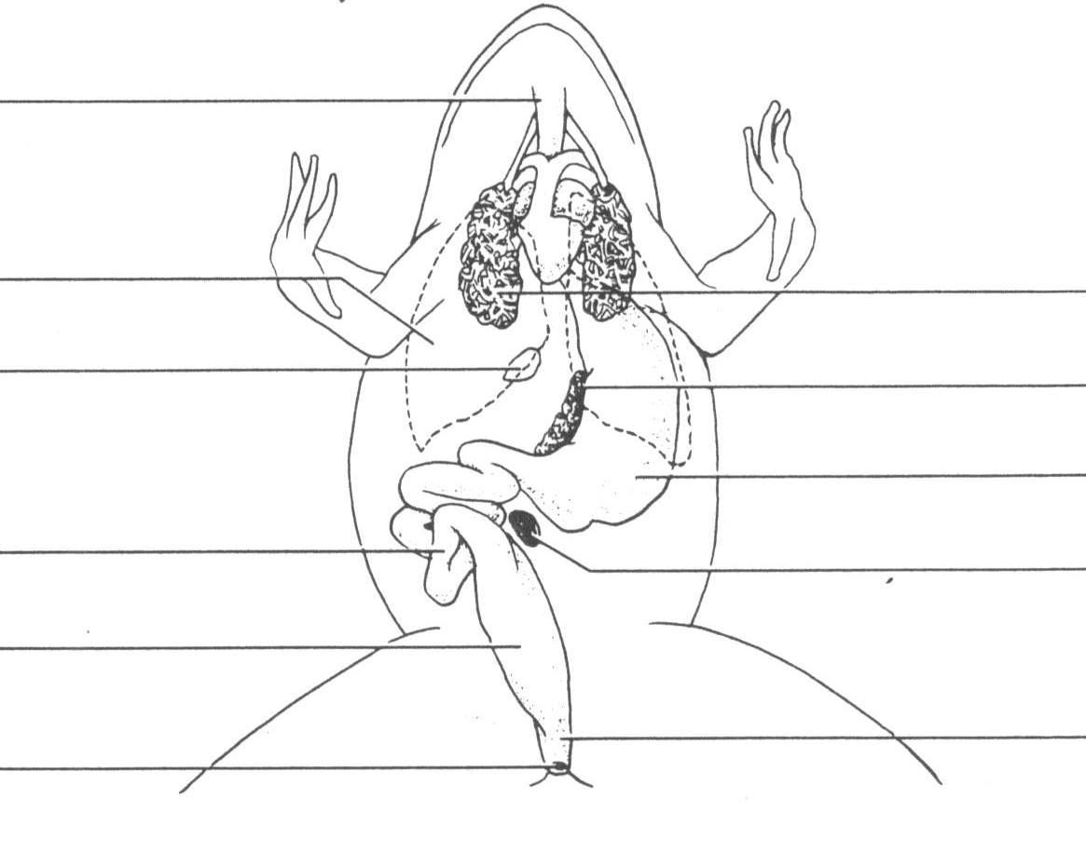
Esophogus

Liver

Gall Bladder

Small intestine

Large Intestine
Cloaca

Lung

Pancreas
Stomach

Urinary Bladder

Anus
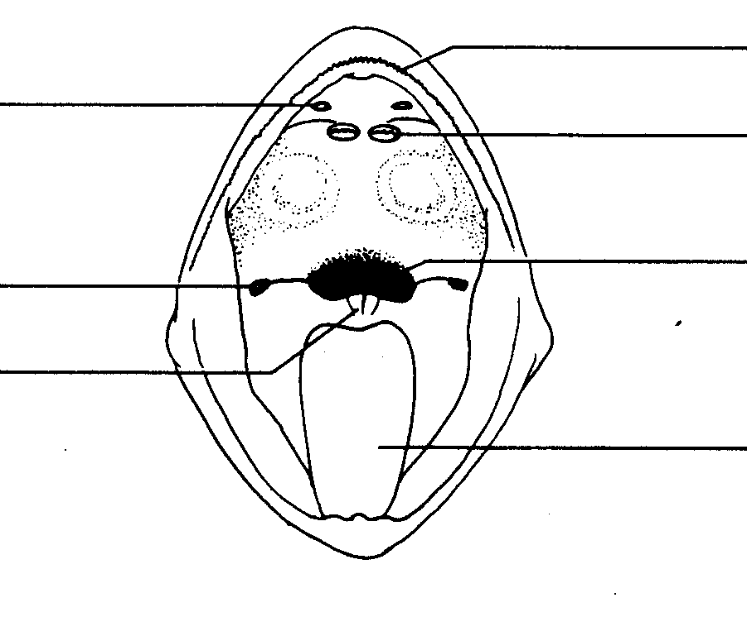
Internal Nares

Eustachian Tubes
Esophogus
Volmerine Teeth
Maxillary Teeth

Gullet

Tongue

Ecology
- Define the following & give an example where appropriate
  - Ecology 63 – The study of ecosystems and their environment

  - Abiotic factors 90 – non-living parts of an ecosystem

  - Biotic factors 90 – Living parts of an ecosystem

  - Eutrophication (example: algal bloom) notes - When a limiting nutrient becomes abundant & the algae in a pond/lake reproduce so rapidly that it covers the surface, and overloads the environment.

  - Commensalism 93 – a symbiotic relationship in which one organism benefits and one is not affected.

  - Mutualism 93 – a symbiotic relationship in which both organisms benefit

  - Parasitism 93 – a symbiotic relationship in which one organism benefits and one is harmed

  - Limiting Factors 124 – a resources in short supply that can slow/stop growth of a population

  - Producer 67 – autotroph – makes own food

  - Consumer 68-9 – Heterotroph; needs to obtain food to survive

  - Decomposer 69 – breaks down dead things for food

  - Primary Consumer 68 – eats producers

  - Secondary Consumer 68-9 – east primary consumers

  - Tertiary Consumer 69 – eats secondary consumers

  - Carrying Capacity 122 – the largest number of organisms an environment can support

  - Renewable Resource 144 – a resource that can be replenished

- Draw a food chain with at least 4 organisms in it below. Label which organism is the producer, consumer, secondary consumer, and tertiary consumer. 69

Grass ➔ Cow ➔ Human ➔ Cannibals (Hahaha)

- What are the land biomes? (10) 100-4
a. Tropical Savannah
b. Tropical rainforest
c. Tropical Dry forest
d. Desert
e. Temperate Grassland
f. Temperate Woodland
g. Temperate Forest
h. Coniferous forest
i. Boreal forest
j. Tundra

- What are the water biomes? (3) 106-11
Freshwater, Estuaries, Marine

- Contrast density dependant & density independent. 125-7
Density Dependent – the number of individuals determines survival (ex: food sources, space)
Density independent – affects all individuals the same way (Ex: hurricanes, earthquakes)

