Protein Synthesis: Transcription/Translation Notes

Khan Academy Video Title: DNA, Hot Pockets, and the Longest Word Ever

This sheet will serve as your notes for this section of content. Keep it in your binder so you can use this information as a reference for worksheets and to study from. DO NOT throw it away!

Link:https://www.khanacademy.org/science/biology/crash-course-biology-science/v/crash-course-biology-111

- Animals and food are made of salty water, ______________________, fats, and __________________combined in proportions.
- The DNA __________________ manual is copied by __________________ into RNA.
- Translation follows the instructions to assemble amino acids into __________________.
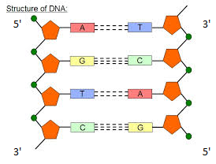
- Most polypeptides aren’t structural proteins, they are ______________that help reactions break or build things.
- The 4 nitrogenous bases of DNA are:
  - __________________ (A)
  - __________________ (T)
  - __________________ (C)
  - __________________ (G)
Transcription
- The promoter code T A T A A A A on one strand of DNA matches with
__ __ __ __ __ __ __ on the opposite strand
- DNA runs in the ___ to ___ direction or the 3’ to 5’ direction.
- The enzyme RNA __________________creates an mRNA strand from the DNA template.
- In RNA, Thymine (T) is not used, instead _____________(U) is used.
- This means that ____ matches with _____, not T, in RNA.
- The mRNA can now move out of the __________________.
Translation
- During translation, mRNA gets fed into the ___________________ like a dollar bill into a vending machine.
- tRNA _____________________ from the language of nucleotides into the language of amino acids and proteins.
- A __________________is any set of 3 nucleotide bases.
- The codon AUG has a tRNA anticodon of ____ ____ ____ .
- The codon UUA has a tRNA anticodon of ____ ____ ____ .
- This anticodon codes for __________________.
- The next amino acid gets connected onto the other amino acids to create a __________________chain.
- __________________structure is an amino acid covalently bonded to another, and then another.
- Secondary structures include helix and __________________.
- Tertiary structure occurs when proteins fold and the _____-______________bond.
- Quarternary structures form when __________________proteins bond together.
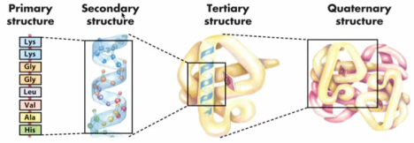

Practice:
Transcribe this DNA strand:
T A C G G C T A A T A G C T C G C G A A C A C T

Translate the mRNA strand:

Online Simulation:
http://learn.genetics.utah.edu/content/molecules/transcribe/
- What is the DNA template strand given on the simulation page?
_____________________________________________________________
- What is the mRNA strand you created from the DNA template?
_____________________________________________________________
- What is the start codon?
___________
- What amino acid does the start codon always code for?
____________________
- Write the chain of amino acids you created from the mRNA strand:
________________ – – – –___________________
- What is the “stop” codon you reached?
___________

