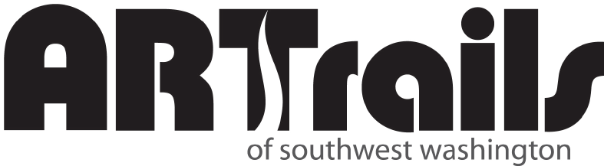
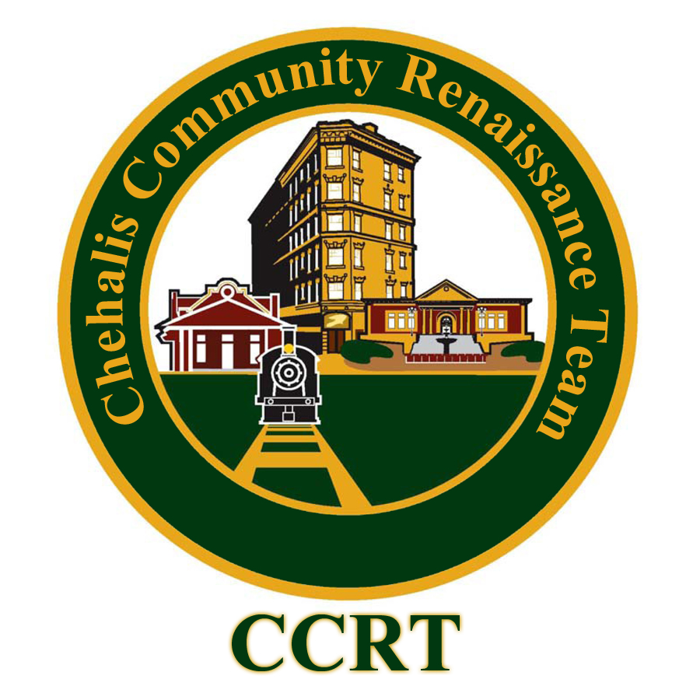

Chehalis Storefront Art Project
Mission Statement: To place artists and short- and long-term exhibits in empty Chehalis area storefronts to demonstrate Chehalis’ commitment to the arts, while beautifying downtown areas and allowing artists a unique canvas.

The Storefront Art Project is dedicated to connecting the Chehalis/Lewis County Art Community to Downtown property owners by way of Storefront Art and Exhibitions in vacant commercial spaces. The goal is to allow working artists, pop-up galleries and short-term window exhibits in empty downtown storefronts to demonstrate downtown’s commitment to the arts, while beautifying downtown areas and allowing artists a unique canvas.

Modeled after the successful Eugene Storefront Art Project and several other projects like it throughout the nation, the Chehalis Storefront Art Project seeks to use empty storefronts to display art. Additionally, working artists will set up their studios in empty buildings adding action and interest to the empty spots until they are rented. “Pop-Up” galleries will bring short-term art installations and galleries to the downtown district.

Our intention is to use art to help keep empty sites active and draw people to areas that are experiencing less foot traffic with the goal of assisting in revitalization and economic development. All art and artists will be juried by a committee from ARTrails with input from the store owner.

Current partners for the Chehalis Storefront Art Project are ARTrails of Southwest Washington and the Chehalis Community Renaissance Team.
Pop-up Galleries
Groups of two to ten artists set up a temporary art gallery using an empty storefront. These galleries are open to the public and stay up from one month to three months. Artists are responsible for the cleanliness and staffing of the gallery. Staffing is done using cooperative methods – each artist in the show is responsible for having the gallery open a specified number of hours per week. More than one gallery at a time may be open depending on available space and number of artists willing to show.

Needs from the property owner: Heat, electricity, toilet and water, insurance, public access
Benefit to the property owner: Space is open to the public, clean and set up in an eye-catching manner making the space more attractive to a potential buyer/renter. Occupied businesses are less likely to be the targets of graffiti, vandalism, or use by vagrants/homeless.

Disadvantage to the property owner: If the property should rent during the time the gallery is set up, the artists would need to remain until the end of the advertised show.

Working Artist
One to two artists set up their studio/s in an empty storefront. The studio/s would be semi-permanent and open to the public during any arts or community event, when the artist is working and/ or by appointment (depending on the artist). This is an on-going commitment by both the property owner and artist. Studios would be actual work space for the artist/s and may not be to the same aesthetic requirements as the galleries. In addition to the working studio space, artists will have small show/gallery space set up for sales which will be attractive and set up for people interested in seeing the outcome of the artist’s work. The arrangement between artist and business owner would remain in effect until the business sold/was rented or the two parties came to an agreement to end their partnership.

Needs from the property owner: Heat, electricity, toilet and water, insurance, public access

Benefit to the property owner: Space is open to the public during most arts or community event and other times at the artist’s discretion. The gallery/show area will be clean and set up in an eye-catching manner making the space more attractive to a potential buyer/renter. Studio area will be in regular use by the artist – including evenings/nights. Potential buyers/renters will be able to see the multi-use benefits of the space. Occupied businesses are less likely to be the targets of graffiti, vandalism, or use by vagrants/homeless.

Window Art
Artist will use the windows of an empty storefront as a display space for their art. These art displays will be on a rotating basis – four to eight weeks per artist in each window. Artists will work with the business owners and each other to keep the art rotating and fresh throughout the year. In addition to the artwork, each window will have a placard with contact information for the artist.

Needs from the property owner: minimal heat, electricity for window lighting

Benefit to the property owner: Increased foot traffic downtown, more people drawn to the storefront.

Disadvantage to the property owner: For sale/rent signs would have to be located in such a way that they do not cover the window art display
Chehalis Storefront Art – Application and Instructions

Use the following as a checklist to make sure that you have all required elements of the application included in your packet:

 Completed and signed application form.
- Five (different) photos and a completed application for each medium you would like to have juried. Minimum size 4x6, maximum size 8x10. (Slides, CDs, links to websites, portfolios, flyers used in advertising, etc., will not be considered). These photos will not be returned.
- Work must have been completed within the last two years and cannot be student work.
- A check/money order for the non-refundable application/jury fee of $25 per medium, per artist payable to ARTrails. Please do not send cash.
- A signed agreement to abide by the Chehalis Storefront Art Project guidelines (page two of the following application).

Mail completed jury packets to:
Chehalis Storefront Art Project
c/o Jan Nontell
1102 L Street
Centralia, WA 98531

Chehalis Storefront Art – Application
(Type or print legibly – use additional pages as necessary)

NAME:
ADDRESS:
CITY/STATE/ZIP: TELEPHONE:
E-MAIL:
WEBSITE:
Please check all that you are interested in:
- Window display with your art/contact information
- Studio space
- Participating in a cooperative gallery
- Art/Craft Festivals and/or Fairs
- Other (please describe)

ARTrails
Are you a participating member of ARTrails ____ Yes ____ No
Would you like information on how to become a member of ARTrails ____ Yes ____ No

Display: Briefly describe your proposed work and how it would be displayed. Describe if it needs to be hung, on stands, is an installation, etc., and a brief statement of your vision, including how long you'd like to display it and how much time it will take to set up. Each artist is responsible for hanging/displaying their work.

Studio Space: For artists requesting studio space - If you would like to use the participating storefronts as studio space, please describe what your requirements are (i.e., water, electrical outlets, any special needs). Include a brief description of your art process.

Description of Artwork: Mark each photo with your name (on the back) and corresponding photo number and the size of the piece on the front (i.e., Photo #1 – 2’x6’). The quality of your photo is important. While it is not essential to have professional photos done, it is essential that your photographs be clear, focused and well presented.

Description/Title Medium Size Price

Photo #1
Photo #2
Photo #3
Photo #4
Photo #5

I acknowledge that the photos submitted are of work I have done within the last two years and agree to the Chehalis Storefront Art Project Guidelines:

Signature Date

Mail applications and photos to:

Chehalis Storefront Art Project
c/o Jan Nontell
1102 L Street
Centralia, WA 98531
The Chehalis Storefront Art Project is an ongoing process and artists will be selected as the properties become available. You will not be notified until a property becomes available that is suited for your work. Please be patient and if any information changes within the next six months, please send us the updated information. The selection process is somewhat complex because we involve property owners in choosing work. Please be patient. If you are not selected it is not personal, it just wasn't a match for that location. We do our best to prioritize those who have been waiting the longest.

If you need more information or have questions email Jan Nontell at JRNontell@comcast.net.

