Algebra 2 Unit 5: Graphing Quadratics Exam Review Name:____________________

1. $y=−2{\left(x−1\right)}^{2}+8$

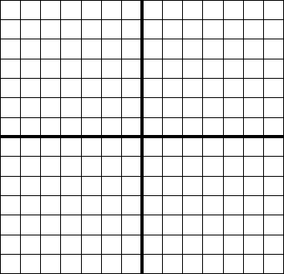
Vertex:

Axis of Symmetry:

Opens?

x-intercepts:

y-intercept:

Domain: Range:

Standard Form: ________________________ Intercept Form: _________________________

2. $y=\left(2x−5\right)\left(x+2\right)$

Vertex:

Axis of Symmetry:

Opens?

x-intercepts:

y-intercept:

Is the vertex a maximum or minimum? ___________

Standard Form: ________________________ Vertex Form: _________________________

3. $y=x^{2}+3x−\text{10}$

Vertex:

Axis of Symmetry:

Opens?

x-intercepts:

y-intercept:

Domain: Range:

Intercept Form: ________________________ Vertex Form: _________________________

4. $y=2x^{2}+\text{12}x−\text{14}$

Vertex:

Axis of Symmetry:

Opens?

x-intercepts:

y-intercept:

Domain: Range:

Is the vertex a maximum or minimum? ___________

Intercept Form: ________________________ Vertex Form: _________________________

5. What is the vertex of the function $y={\left(x+1\right)}^{2}+4$? ______________

If this graph were reflected across the y-axis, what would be the coordinates of the vertex after this reflection?

- (-1, -4) b) (-1, 4) c) (1, -4) d) (1, 4)

6. This is the equation of a parabola: $y=−2x^{2}−4x+3$
Determine the x-value for the vertex and whether this value is a maximum or a minimum.

- Maximum at x = 5 b) Maximum at x = -1
c) Minimum at x = 5 d) Minimum at x = -1

7. What are the zeros of the quadratic function $f(x)=2x^{2}+5x+1$

- $\frac{−5±\sqrt{\text{17}}}{4}$ b) $\frac{−5±\sqrt{\text{33}}}{4}$ c) $\frac{5±\sqrt{\text{17}}}{4}$ d) $\frac{5±\sqrt{\text{33}}}{4}$

8. Which function has the same range as $y={\left(x+2\right)}^{2}$ ?

- $y={\left(x+2\right)}^{2}−2$ b) $y=x^{2}+4$ c) $y=2{\left(x−1\right)}^{2}+1$ d) $y={\left(x−7\right)}^{2}$

9. Given $y=3x^{2}−\text{11}x+\text{14}$, find the discriminant and give the type and number of roots.
a) discriminant: -47; 2 imaginary roots c) discriminant: $i\sqrt{\text{47}}$; 2 imaginary roots
b) discriminant: -289; 2 imaginary roots d) discriminant: $\text{17}i$; 2 imaginary roots

10. What is the discriminant of ${\text{qx}}^{2}+\text{rx}+s=0$?
a) $\left|a+b\right|$ b) $q^{2}−4\text{rs}$ c) $r^{2}−4\text{qs}$ d) $s^{2}−4\text{qr}$

