Algebra 2 Intensified Name_________________________
Review for Final Exam Date_________________ Pd______

1. Solve the equation. 2. Solve and graph the inequality. $−3\left|2x−5\right|+5<−4$

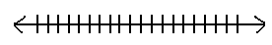

3. If , find g(-2).

A) –8.5 B) 9.5 C) D) 19.5

4. What is the slope-intercept form of the equation of a line that passes through (1, 4) and is perpendicular to a
line whose equation is ?

A) B) C) D)

5. Identify the graph of .

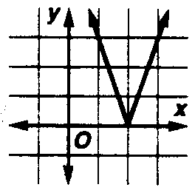
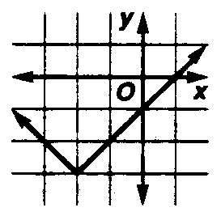
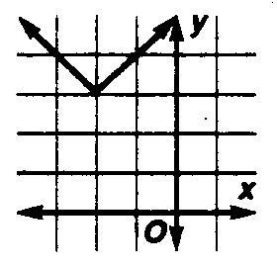
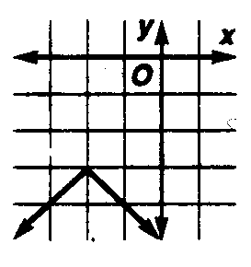
A) B) C) D)

6. Solve . Round to four decimal places.

7. Simplify

A) B) C) D)

8. Evaluate $2\sqrt{−\text{12}}⋅\sqrt{−6}$

A) $\text{12}\sqrt{2}$ B) $−\text{12}\sqrt{2}$ C) $\text{12}i\sqrt{2}$ D) $−2\sqrt{\text{72}}$

9. Multiply

A) B) C) D)

10. Factor completely.

A) B) C) D)

11. Simplify

A) B) C) D)

12. Factor completely $\text{81}x^{5}−3x^{2}$

A) $3x^{2}$ B) $3x^{2}$
C) $3x^{2}$ D) $3x^{2}$

13. Factor completely $7y^{2}−\text{32}y−\text{15}$.

A) $(7y−3)(y+5)$ B) $(7y+3)(y+5)$ C) $(7y+3)(y−5)$ D) $(7y−3)(y−5)$

14. Divide $(6x^{3}−\text{16}x^{2}+\text{11}x−5)÷(3x−2)$

A) $2x^{2}−4x+1−\frac{3}{3x−2}$ B) $6x^{3}−\text{12}x+3−\frac{9}{3x−2}$
C) $2x^{2}−4x+1−\frac{1}{3x−2}$ D) none of these

15. Solve $\sqrt[3]{y−3}−6=−4$.

A) -11 B) 11 C) 1000 D) -1000

16. Simplify $6\sqrt[3]{\text{36}a^{2}}⋅\sqrt[3]{6a^{2}}$ 17. Change to radical form. ${\text{27}}^{\frac{1}{2}}x^{\frac{4}{3}}y^{\frac{5}{6}}$

18. Solve $\sqrt{x+8}−\sqrt{x+2}=1$ 19. Solve ${\left(3x+1\right)}^{\frac{2}{3}}−\text{15}=5$

20. Solve by completing the square: $x^{2}+\text{11}=6x$ 21. Put in vertex form: $y=4x^{2}−8x−1$

22. Simplify $(5−3i)^{2}$.

A) $\text{16}−\text{30}i$ B) 34 C) $\text{34}−\text{30}i$ D) 16
23.
24.

25.

26. Solve . Round your answer to four decimal places.

27. From a group of 7 men and 6 women, five persons are to be selected to form a committee so that 3
men are on the committee. In how many ways can it be done?

28. Solve the system of equations .

A) (0, -2) and (0, 2) B) (0, -2) and (4, 0)
C) (0, -2) and (-4, 0) D) (0, 2) and (4, 0)

29. Out of 7 consonants and 4 vowels, how many words of 3 consonants and 2 vowels can be formed?

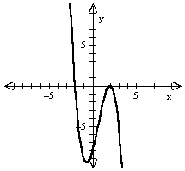30. Which of the following could be a function for the graph?

31. Find for the function.

32. One factor of $2x^{3}+x^{2}+8x+4$ is$x+2i$. What are the other two?

A) B) C) D)

33. If and , what is?

A) -1 B) 11 C) -7 D) 35

34. Find if and .

35. Find all rational zeros for the function .

A) B) C) D)

36. Find all the zeros of $y^{6}−8y^{3}=0$ .

37. Simplify

A) B) C) D)

38. Simplify

A) B) C) D)

39. Simplify

A) B) C) D)

40. Simplify

A) B) C) D)

41. Solve .

A) 2 B) 4 C) 16 D) 32

42. Evaluate .

A) 5 B) 7 C) 25 D) 49
43. Solve .

A) 2 B) 6 C) -2, 6 D) -6, 2

44. Simplify:

A) B) C) D)

45. What is the approximate solution of

A) B) C) 2 D) -2

46. Find the three geometric means between 42 and 672.

A) 84, 126, 168 B) 84, 168, 336 C) 210, 420, 630 D) 84, 336, 2688

47. What is S_{n} for the geometric series in which a₃ = 4, a₄ = -16, and n= 6?

A) 45.5 B) -45.5 C) D)

48. What is the sum of the infinite geometric series in which a₁ = 10 and r = ?

A) B) C) D)

49. Evaluate .

A) 89 B) 1365 C) 1350 D) 2730
50. is the expanded form of which expression?

A) (2x + 3)³ B) (2x + 3)² C) (3x + 2)³ D) (3x + 2)²

51. What is the 7th term of (x – y)¹⁰?

A) B) C) D)

52. What is the 20th term in the arithmetic sequence for which a₁=3 and d = 7?

A) 143 B) 136 C) 140 D) 133

53. The number 173 is what term in the arithmetic sequence ?

A) 35th B) 36th C) 37th D) 38th

54. Change 220° to radians.

A) B) C) D)

55. Change the radian measure to degrees. A) 20° B) C) 40° D)

56. What is the value of sec A to four decimal places? For #56-57

A) 2.1250 B) 1.8750 C) 1.1333 D) 0.5333

57. What is the value of tan B to four decimal places using the triangle above?

A) 2.1250 B) 1.8750 C) 1.1333 D) 0.5333

58. Find the measure of P to the nearest degree in the triangle at the right. For #58

A) 21° B) 23° C) 67° D) 69°

59. What is the value of ?

A) B) C) D)

60. Find the length to the nearest hundredth of the longest side of a triangle with A = 70°, B = 80°, and a = 9.

A) 4.79 B) 8.46 C) 9.00 D) 9.43

61. In ΔABC, a = 5, b = 7, and c = 11. What is B?

A) 19.7° B) 132.2° C) 28.1° D) 47.8°

62. Find the csc β if cot β = and .

A) B) C) D)

63. What is the period of y = ?
A) B) C) D)
64. If and θ is in the second quadrant, what is the value of ?

A) B) C) D)
65. If tan θ = and θ is in the fourth quadrant, what is the value of sec θ?

A) B) C) D)

66. What is the amplitude of ?
A) 3 B) C) 5 D) -5

67. What is the simplest form of ?

A) B) C) 1 D) 0

68. Molly, one of 20,000 students to take a national achievement test, earned a score of 940. The mean test
score was 850 with a standard deviation of 100. How many students had a higher score than Molly?
(Assume that test scores are normally distributed.)

69. Which of the following is not a solution of ?

A) 90° B) 180° C) 270° D) 1530°

70. Which of the following is not a solution for if .

A) B) C) D) 0

71. What is the simplest form of ?

72. Verify the following equation: (csc x)(sec x) = cot x + tan x

73. Solve for all values of x:

74. If y varies directly as z and inversely as x and and when , find z when
and .

75. Justine invested $2500 in an account earning her 2.4% annual interest compounded quarterly. How long will
it take for her to earn $500 in interest.

76. Find the area of the triangle. 77. Find the area of the triangle.

18
22
5
8
11

78. The half-life of Potassium-40 is about 1.25 billion years.

- Determine the value of k and the equation of decay for Potassium-40.

- A specimen currently contains 36 mg of Potassium-40. How long will it take the specimen to decay to only 15 mg?

- How many mg of Potassium-40 will be left after 300 million years?

33.
33.

