Waiver Day Session #41
Let’s Bring Patterns, Functions, and Algebra to Life!
1:25 – 2:40, Room 1107

- Data Review of Graphs and Concensogram

- Concensogram

- Concrete Strategies to Understand the Abstract!
  - PFA Resources and Strategies with Modeling
  - Writing Algebraic Equations, Model One Problem
  - “Get It Together” Number Shapes Activity with Small Group
  - Marcy Cook’s “Try-a-Tile”
  - Sharing of www.thinkingblocks.com

- Hands-on Equations & Math Readers
  - Overview
  - Word problem Mini Lesson
  - Math Readers

- Need for Extensions
  - Highest ability students, lowest Value Added growth
  - PFA is one of our standards areas with lowest number of students scoring above proficient
    - Function Lesson

- PFA Vocabulary

- Time for Closure and Sharing among Participants!

Patterns, Functions, and Algebra Vocabulary

pattern
number pattern
geometric pattern

relationship

computation

function

value

rule

variable

equation

expression

equality

inequality

increase

decrease

number sentence

construct

input-output table

solve

predict

prediction

open sentence

interpret

variable

inequality

greater than

less than

previous

order of operations

double

triple

input/output table

unknown

estimation

conclusion

Patterns, Functions, and Algebra
2011 OAA Grades 3-5
Percent of All Questions Above and Below Proficient

Grade Level

On Our Weakest PFA Questions
WCS Students Performed

_______________________________________________ Below Expected About Expected Above Expected

Standard  Grade 4  PFA | Question 27  Carl had $95. He bought 3 CDs for $15 each.  Which number sentence can be used to find how much money, m, Carl has left? | School | District  73% | State  64%

Standard  Grade 4  PFA | Question 18  Mike is thinking of a number n. He knows that ten times the number is less than 70.  Which inequality describes this situation?  - 10 × n < 70  - 10 × n > 70  - 10 × 70 < n  - 10 × 70 > n | School | District  72% | State  68%

Standard  Grade 4  PFA | Question 39  Each week, Jane puts two dollars ($2) into her bank account and her mother puts in an additional dollar ($1).  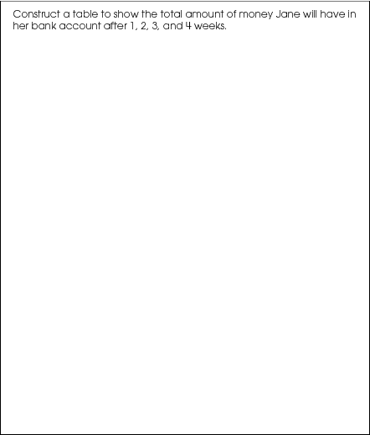 | School  Mean | District  Mean  1.25 | State  Mean  0.97
Standard  Grade 5  PFA | Question 8  On Sunday, Justin has 25 bottle caps in his collection. Starting on Monday, he will get 4 new bottle caps every day.  Which expression could be used to determine the number of bottle caps Justin will have after n days?  - 21n  - 29n  - 4n + 25  - 25n + 4 | School | District  68% | State  63%
Standard  Grade 5  PFA | Question 8  Which expression is the same as “five times a number n”?  - 5n  - 5 + n  - 5n + 5  - 5n + n | School | District  74% | State  72%

Standard  Grade 5  PFA | Question 46  John reads 20 pages of a book each night. The expression 20x can be used to find the total number of pages John has read.  What does x represent in this expression?  - number of pages in the book  - number of nights he has read  - total number of pages he has read  - number of pages he has read each night | School | District  47% | State  44%
Standard  Grade 5  PFA | Question 28  Bonnie used a rule to create the input-output table shown.  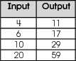  Which could be the rule Bonnie used?  - add 7 to the input  - add 11 to the input  - double the input and add 3  - triple the input and subtract 1 | School | District  72% | State  68%
Standard  Grade 5  PFA | Question 35  A library is having a reading contest. Students are awarded points for reading books. They receive prizes based on the number of points they earn. The table shows the number of points they earn after reading different numbers of books.  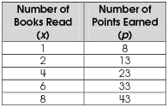  In your Answer Document, write the rule that the library uses to determine the number of points a student earns for reading x books.  Then, use the rule to determine the number of points a student would earn for reading 5 books.  Show or explain how you found the number of points. (2 points) | School  Mean | District  Mean  0.71pts | State  Mean  0.59pts

Grade 5, 2011 OAA District Data
Above or Below Expected by Performance Level

Performance Level

