AP Name ________________________________________hr 4
Worksheet
Chapter 7 Review Date ____/____/____ Score:________/ = ________%

In 1-4, the application involves the accumulation of small changes over an interval to give the net change over that entire interval. Set up an integral to model the accumulation and evaluate it to answer the question.

1. A toy car slides down a ramp and coasts to a stop after 5 sec. Its velocity from t = 0 to t = 5 is modeled by $v(t)=t^{2}−0\text{.}2t^{3}\text{ft}\text{/sec}$. How far does it travel?
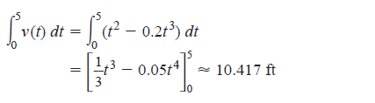

2. The fuel consumption of a diesel motor between weekly maintenance periods is modeled by the function $c(t)=4+0\text{.}\text{001}t^{4}$gal/day, $0≤t≤7$. How many gallons does it consume in a week?

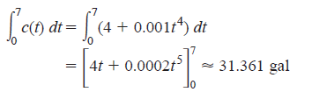

3. The number of billboards per mile along a 100-mile stretch of an interstate highway approaching a certain city is modeled by the function $B(x)=\text{21}−e^{0\text{.}\text{03}x}$, where x is the distance from the city in miles. About how many billboards are along that stretch of highway?
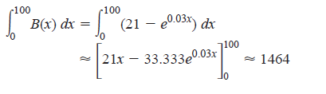
4. The electrical power consumption (measured in kilowatts) at a factory t hours after midnight during a typical day is modeled by $E(t)=\text{300}(2−\text{cos}({πt}/{\text{12}}))$. How many kilowatt-hours of electrical energy does the company consume in a typical day?

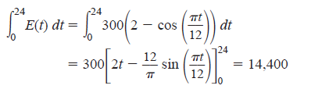

In 5-12, find the area of the region enclosed by the lines and curves.
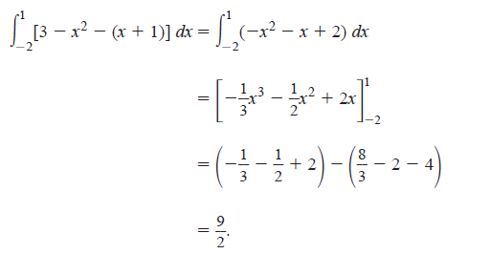
5. $y=x+1,y=3−x^{2}$

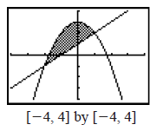

6. $x=2y^{2},x=0,y=3$
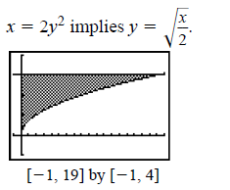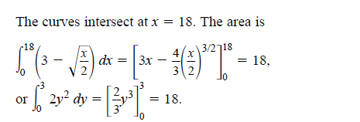

7. $y=\text{sin}x,y=x,x=π/4$

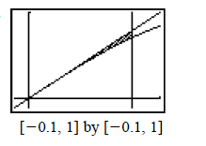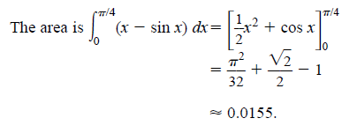

8.

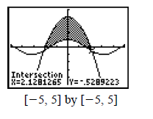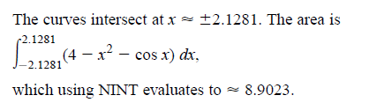
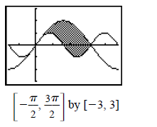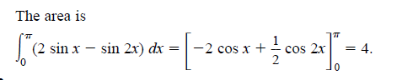
9. The Necklace one of the smaller bead-shaped regions enclosed by the graphs of $y=1+\text{cos}x$ and $y=2−\text{cos}x$.
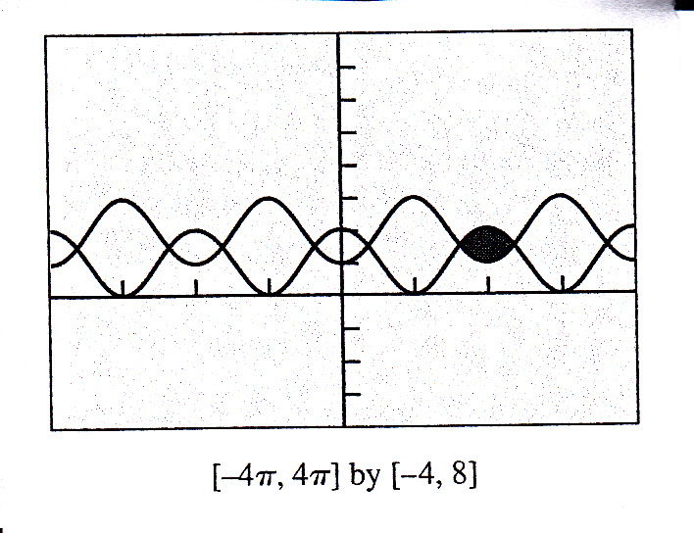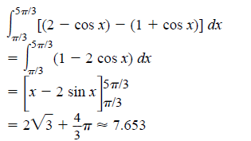

10. The Bow Tie the region enclosed by the graphs of $y=x^{3}−x$and $y=\frac{x}{x^{2}+1}$.
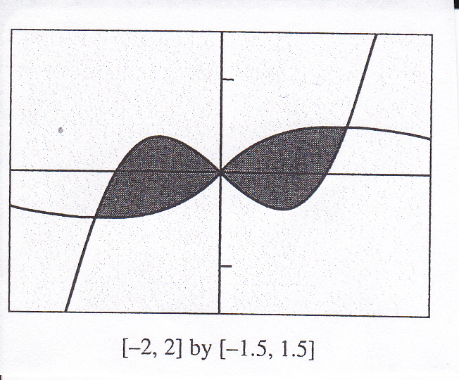
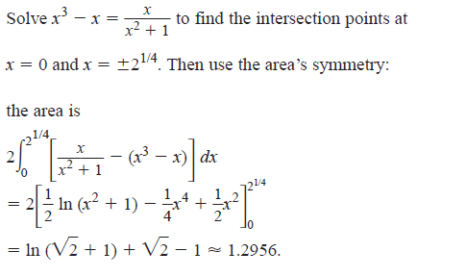

NEED ALTERNATE #11

ALTERNATE NUMBER *!!!!!!!!!!!!! #12 from red/blue book

12. The Kissing Fish the region enclosed between the graphs of $y=x\text{sin}x$and $y=−x\text{sin}x$over the interval $[−π,π]$
.
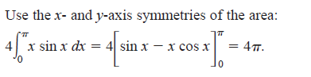
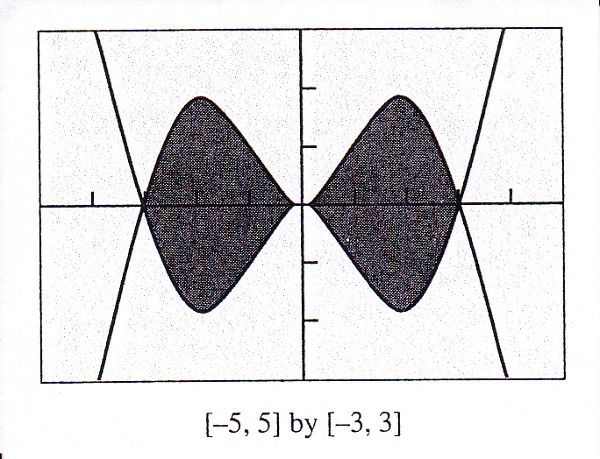

13. Find the volume of the solid generated by revolving the region enclosed by the parabola $y^{2}=4x$and the line $y=x$
about

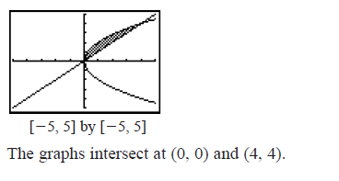
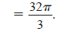
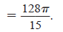
(a) the x-axis (b) the y-axis

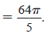
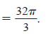
(c) the line x= 4 answer (d) the line y = 4 answer

14. The base of a solid is the region enclosed between the graphs of$y=\text{sin}x$and $y=−\text{sin}x$from $x=0$to $x=π$. Each cross section perpendicular to the x-axis is a semicircle with diameter connecting the two graphs. Find the volume of the solid.

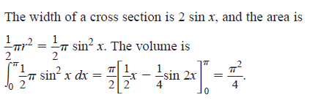 #24

15. The region enclosed by the graphs of $y=e^{x/2}$, $y=1$, and $x=\text{ln}3$is revolved about the x-axis. Find the volume of the solid generated.

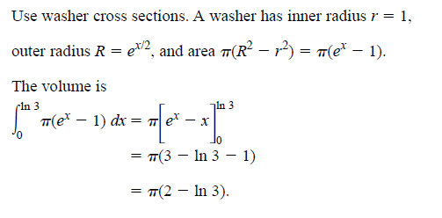
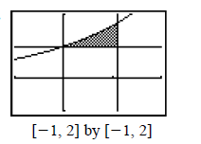

16. Fluid Force A standard olive oil can measures 5.75 in. by 3.5 in. by 10 in. Find the fluid force against the base and each side of the can when it is full. (Olive oil has a weight-density of 57 pounds per cubic foot.)
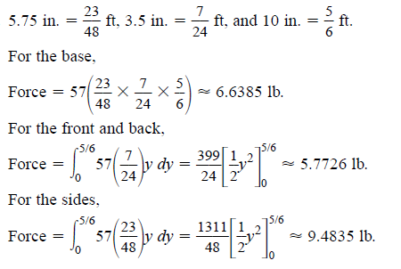

Need a new number 17.
TRY #37
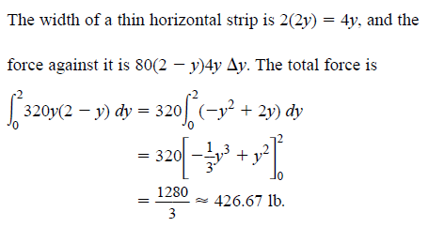

Or #36
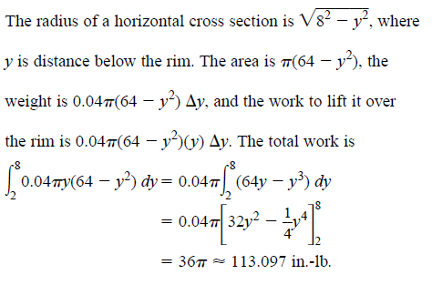

OR #34

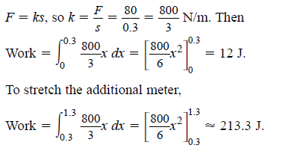

Or #33

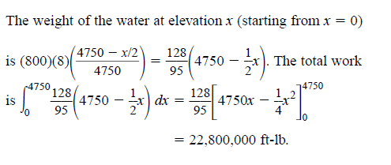
Or number 32

