Algebra 1 Review for Chapter 5 Test
Name _____________________________Date________ Period ____
Formulas you must know that will not be given to you on the exam:
b= y intercept Slope Intercept form of a line: y = mx + b
Point Slope form of a line that goes through a point :

Find the slope of the line that passes through each pair of points.

1. (2, 7) , (5, 2) 2. (-2 , -3) , (4 , 6)

3. (-4, -6) , (-3, - 5) 4. (2 , -8) , (2 , 5)

5. Find the slope of 6. Find the slope of

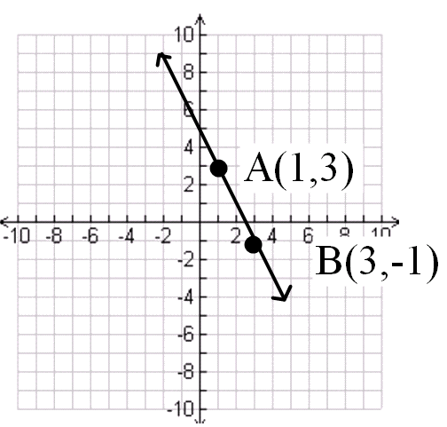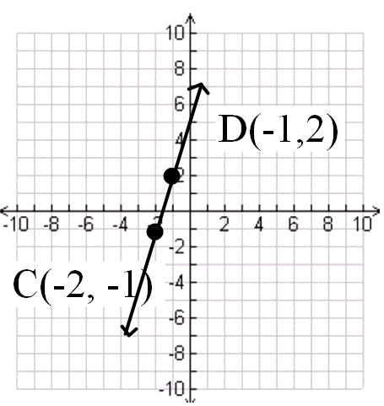

Graph each equation (first, solve for y if necessary):
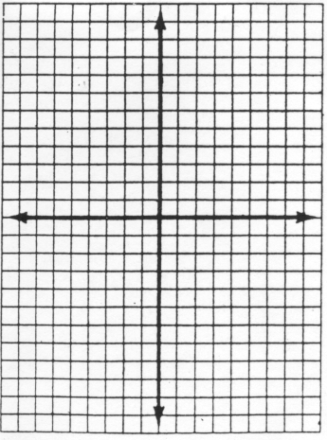
7. y = x 8. y = -x 9.
10.. 11. . 6x+3y = 9 12.
13.. 14. . x = 2
Write the equation of the line in slope-intercept form.
15. m = -3 , b = 2 16. m = -3 and passed through the point (-2, 3)

17. m = -1 and passes through the point (-4, -2) 18. A line passes through the point (5, -3) and (-1,-15)

19. A line passes through the point (2, 5) and (0,9) 20.
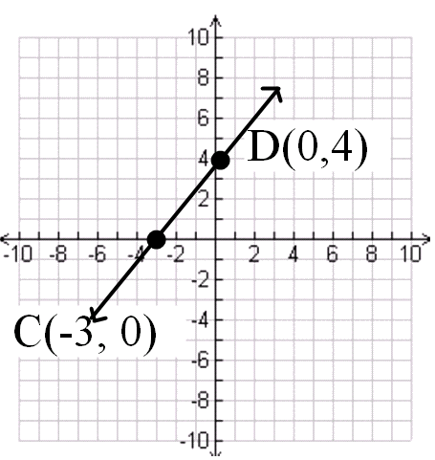
21. A line passes through point A (1, 2) and m = 3 22.A line passes through B(-4, -5) and m=-2
Point slope form of the line Point slope form of a line

________________________________________ ________________________________________

Slope intercept form of a line _________________ Slope intercept form of a line: _______________
______________________________________________________________________________________

23. Write the equation of the line in point slope form for a horizontal line that passes through (5, - 6)

24. Write the equation in slope intercept form.

25. Write the equation of the line in slope intercept form.

A line passes between the two points. Find the slope of the line, the slope of a line parallel to the line, and the slope of a line perpendicular to the line

26. (2, 7), (5, 2) 27. (-2, -3), (4, 6) 28. (-4, -6), (-3, -5)

Slope of the line: ________ Slope of the line ______ Slope of the Line ____

Slope of a Parallel Line: _____ Slope of a Parallel Line: ____ Slope of a Parallel Line ____

Slope of a Perpendicular Line ____ Slope of a Perpendicular Line ___ Slope of a Perpendicular Line: ___

29. (3, 7), (5, 6) 30. (-2, -3), (-4, -2) 31. (-8, -4), (-6, -12)

Slope of the line: ________ Slope of the line ______ Slope of the Line ____

Slope of a Parallel Line: _____ Slope of a Parallel Line: ____ Slope of a Parallel Line ____

Slope of a Perpendicular Line ____ Slope of a Perpendicular Line ___ Slope of a Perpendicular Line: ___

Write the slope-intercept form for an equation of the line that passes through the given point and is parallel to the graph of the given equation.

32. (-2, 3), y = 5x – 2 33. (1, 4), y = -3x + 2 34. (6, 0)

Write the slope-intercept form for an equation of the line that passes through the given point and is perpendicular to the graph of the given equation.

35. (3, 4), y = -x + 3 36. (-3, -2), y = 2x + 3 37. (4, 6)

Write a direct variation equation that relates x to y. Assume that y varies directly as x. Then solve.

38. If y = 9 when x = -3, find x when y = 6. 39. If y = 30 when x = 5, find y when x = 3.

A canoe company rents canoes for a daily rate plus $10 per hour. If you rent a canoe for 3 hours you will pay $45.
40. Write the point-slope form of an equation of find the total fee y for any number of
hours x.

41. Write the equation in slope-intercept form.

43. What is the daily fee for the uses of the canoe?

Write an Algebraic expression and solve.
44. The product of 4 and a number is 16. 45. The sum of 5 and a number is -12.

Evaluate.
46. 5 – 3(9 – 7) + 3 47. 5 • 3 + 2 – 6 ÷ 3

Solve.
48. 49. 3x + 4x – 7 = 12

50. 51.

If and , find each value.
52 f(-3) 53. g(-3) 54. f(4w) 55. g(2w)

56. a) What is the formula for slope?

b) 8 + 6 = 6 + 8 is an example of the ______________ property

c) What is the point slope form of a line?

d) What is the formula for direct variation?

e) What is the slope intercept form of a line?

f) Give an example of the distributive property.

57. y = 5x 58. 59
slope= ________ slope = ________ slope = ________

y intercept = ________ y intercept = ______ y intercept = __________

60. x = 5 61. 62
slope= ________ slope = ________ slope = ________

y intercept = ________ y intercept = ______ y intercept = __________

63. x = -4 64. 65
slope= ________ slope = ________ slope = ________

y intercept = ________ y intercept = ______ y intercept = __________

