Integrated Algebra B

Unit #3 Essential Skills (Number Theory)

Lesson 1: Real Number System, Properties, & PEMDAS

Objectives:
•Students will be able to identify rational and irrational numbers.
•Students will be able to decipher and apply the five properties of the Real number system.
•Students will understand and apply the rules of algebra (order of operations).

Vocabulary:

Rational Number
Irrational Number
Commutative Property
Associative Property
Distributive Property
Identity Property
Inverse Property
Order of Operations

Focus Questions:
What are the subset(s) of rational numbers?
Are non-perfect squares irrational?
Does every real number, except 0, have a reciprocal?
What is the difference between the additive identity vs. the multiplicative identity?
Using the order of operations, what is the 3rd step when simplifying the expression: 3(5 + 4²) $¸$ 7 -7 ?

Game Plan:
Do Now
Diagnostic Test (pre-test)
Real Number System
Real Number Properties
Order of Operations
Focus Questions
Homework: 3-1
The Real Number System
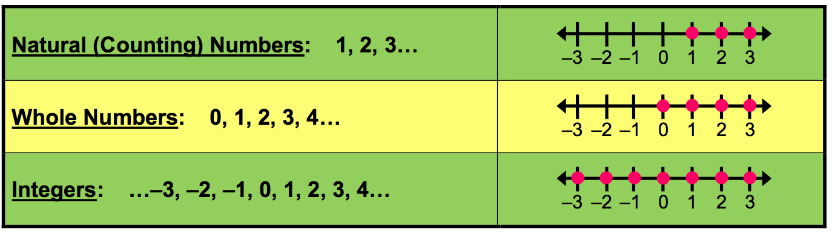
Rational vs. Irrational
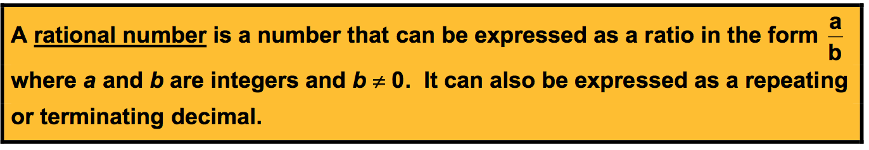
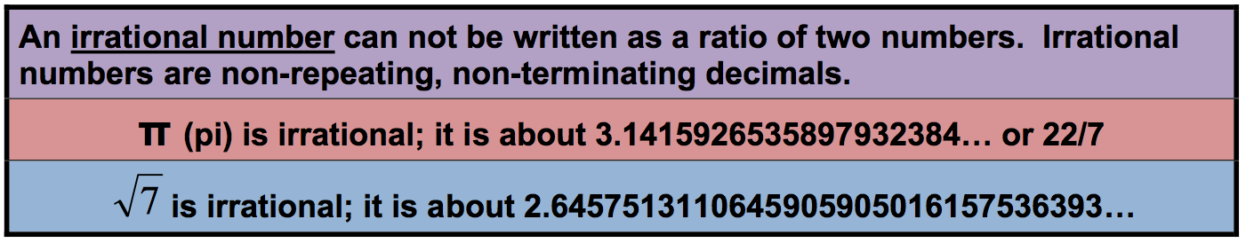
Any non-perfect square is irrational. ($\sqrt{5},\sqrt{7},\sqrt{\text{11}},\sqrt{\text{33}}$)

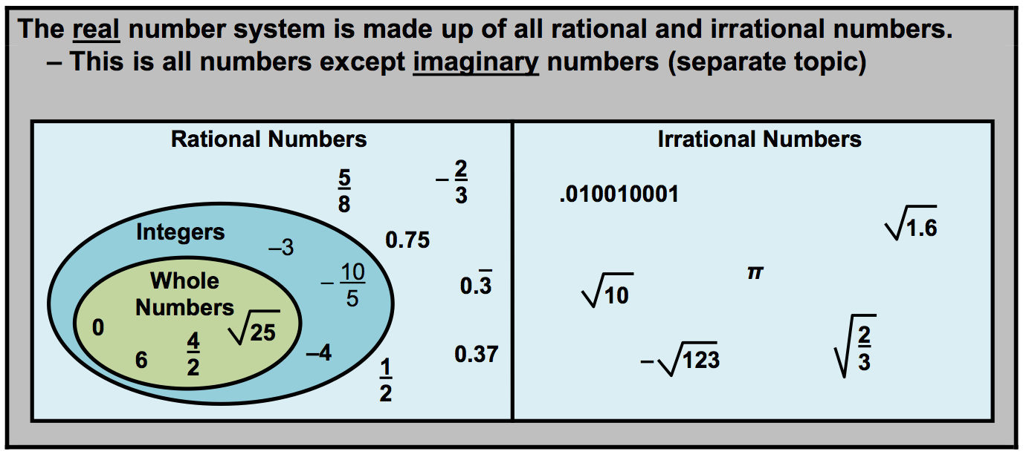
Practice:
True or False
-3 is a whole number. _______
$\sqrt{9}$ is an irrational number. _______
0 is a natural number (counting). _______
$\frac{1}{3}$ is a rational number. _______
All real numbers are either rational or irrational numbers. _____
Every whole number is a rational number. _______
All natural numbers are integers. _______

Sum it All Up:
For each item, choose the letter that defines the item.

A. can be written in the form a/b where a and b are integers and b ≠ 0
B. non-repeating and non-terminating decimals
C. has an integer as its square root
D. the set of counting numbers plus 0
E. consists of the rational and irrational numbers

______irrational numbers
______whole numbers
______rational numbers
______real numbers
______perfect square numbers

Properties of Real Numbers
Property | Addition | Multiplication
Commutative  “community” | a+b= b+a | (a)(b)= (b)(a)
Associative  “regroup” | (a+b) +c= a + (b + c) | (a•b) • c= a • (b•c)
Identity  “Back to itself” | a + 0= a | a(1)= a
Inverse  “Undo” | a + (-a) = 0 | a $(\frac{1}{a})$= 1
Distributive
“mail man”
a (b+c) = ab + ac
a (b -c) = ab – ac

Examples:
Name the property illustrated for each example below:
a] 3 • 1 = 3 ______________
b] 2 + 3 = 3 + 2 ______________
c] 2 + ( 3 + 4 ) = ( 2 + 3 ) + 4 ______________
d] 2 • ( 3 + 4 ) = 2 • 3 + 2 • 4 ______________
e] 3 + (-3) = 0 ______________
f] 5 • 1 = 5 ______________
g] 2 • ( 3 ) = 3 • ( 2 ) ______________
h] 17 $(\frac{1}{\text{17}})$= 1 ______________
Order of Operations
PEMDAS
The order of operations are the rules of algebra.
P
E
M
D
A
S
 Remember to perform multiplication/division & addition/subtraction from left to right.
U-Try Practice:
9 – 3 + 6= | (7+2)² | $\frac{2·\text{15}}{2}$ =
$\frac{\text{14}}{2^{2}(5+2)}$= | ⎜-8 ⎜ + -3 | 3⎜7 – 4 ⎜=
5! -3! = | 5⁰ + ⎜-7⎜ = | $\sqrt{\text{10}−6}+\sqrt{\text{64}}$ =
1.4³⁽²⁾ = | - ⎜-4⎜= | 2(2)² + 4(2) – 8 =
-2(-3)² + 4(-3) = | $\frac{2\text{! }·4!}{3!}$ = | -$\sqrt{\text{49}}$ =
(-2 + 6)² + [2³ -1] = | 2² • 3¹ • 5² • 11¹ = | -4 + 32 $¸$ 4 – 2 =

Name: _______________ Integrated Algebra B
3-1 Essential Skills Ms. Torok

1). State whether each number below is rational or irrational.
-2 | $$\sqrt{\text{16}}$$ | 0 | $$3\frac{1}{2}$$
-8 | Π | $$1\text{.}\overline{6}$$ | 4.627803
$$\sqrt{3}$$ | $$\frac{\sqrt{2}}{2}$$ | -$\sqrt{\text{25}}$ | $$\sqrt{2}·\sqrt{8}$$

2). State the property illustrated in each of the following:
a) 5 + (-6) = (-6) + 5 _________________
b) (-7· 3)4 = -7(3·4) _________________
c) 8.5 + 0 = 8.5 _________________
d) -11·1 = -11 _________________
e) $(\frac{5}{2})$ $(\frac{2}{5})$= 1 _________________

3). Does the commutative property hold for subtraction? Explain your answer and give an example to support it.

Back→
Evaluate each expression:
4). If r= 2 and s= -7, then find ⎜r⎜ - ⎜s⎜.

5). What is the value of (b – b⁰) ^{a + 1} when a= -4 and b= 3?

6). What is the value of the expression -4x² + 5x when x = -3?

7). What is the value of the expression $\sqrt{\text{80}+1}$ - ⎜a ⎜ + b² when a= -2 and b= -3?

8). What is the value of the expression $\frac{(x+1)!}{\sqrt{4}}$ when x = 4.

