
Algebra 1

Identifying and Classifying Numbers

1. Explain the difference between a rational and an irrational number.

Classify the following numbers as rational or irrational.

2. ½ 3. 8 4. 5. 6.

7. List the set of all natural numbers.

8. List the set of whole numbers less than 4.

9. List the set of integers such that –3 < x < 5.

Classify the following numbers as rational, irrational, natural, whole and/or integer. (A number may belong to more than one set)

10. –3 12. 13. 14. 0

15. Using the following set of numbers: , place each element in the appropriate subset. (Numbers may belong to more than one subset)

rational numbers_______________________ irrational numbers_____________________

natural numbers_______________________ whole numbers_______________________

integers_______________________

True or False?

16. All whole numbers are rational numbers.

17. All integers are irrational numbers.

18. All natural numbers are integers.

Identifying and Classifying Numbers

1. Explain the difference between a rational and an irrational number.
A rational number can be expressed as the ratio of two integers. An irrational number is any real number that is not rational

Classify the following numbers as rational or irrational.

2. ½ 3. 8 4. 5. 6.
rational rational irrational rational irrational
7. List the set of all natural numbers.
{1, 2, 3…}

8. List the set of whole numbers less than 4.
{0, 1, 2, 3}

9. List the set of integers such that –3 < x < 5.
{-2, -1, 0, 1, 2, 3, 4}

Classify the following numbers as rational, irrational, natural, whole and/or integer. (A number may belong to more than one set)
10. –3 rational 12. rational 13. irrational 14. 0 rational, integer
integer whole number
15. Using the following set of numbers: , place each element in the appropriate subset. (Numbers may belong to more than one subset)

rational numbersirrational numbers_3.63363336___

natural numbers_______________ whole numbers____0,____________

integers___-3, 0, ____________________

True or False?

16. All whole numbers are rational numbers. True

17. All integers are irrational numbers. False.

18. All natural numbers are integers. True
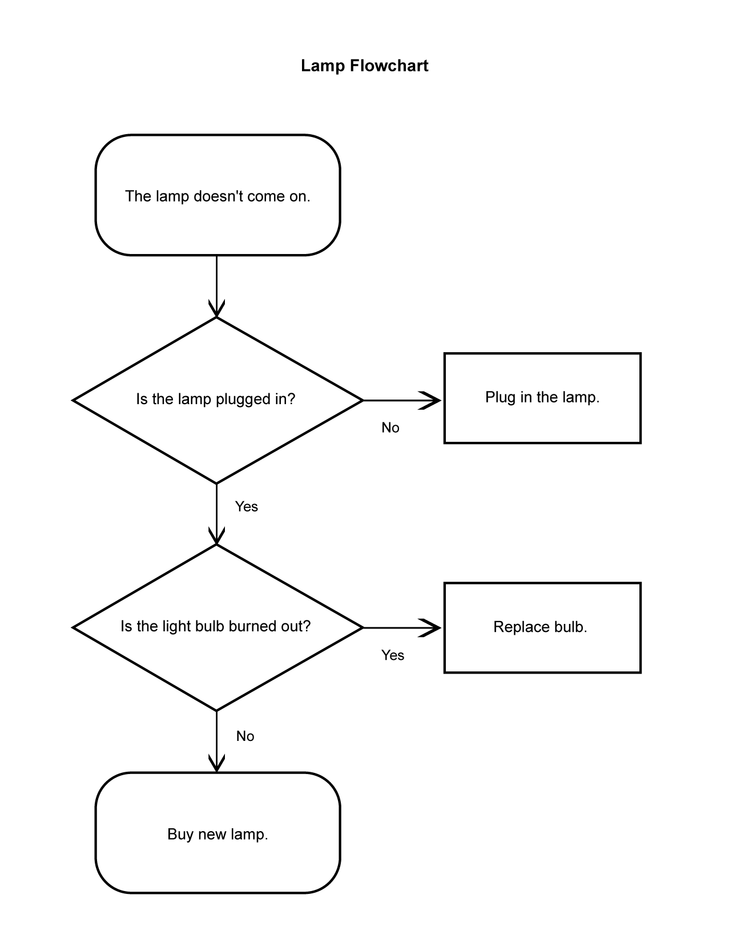

What is a Flowchart?

Flowchart Definitions and Objectives:
Flowcharts are maps or graphical representations of a process. Steps in a process are shown with symbolic shapes, and the flow of the process is indicated with arrows connecting the symbols. Computer programmers popularized flowcharts in the 1960s, using them to map the logic of programs. In quality improvement work, flowcharts are particularly useful for displaying how a process currently functions or could ideally function. Flowcharts can help you see whether the steps of a process are logical, uncover problems or miscommunications, define the boundaries of a process, and develop a common base of knowledge about a process. Flowcharting a process often brings to light redundancies, delays, dead ends, and indirect paths that would otherwise remain unnoticed or ignored. But flowcharts don't work if they aren't accurate.
A flowchart (also spelled flow-chart and flow chart) is a schematic representation of a process. It is commonly used in business/economic presentations to help the audience visualize the content better, or to find flaws in the process.

The flowchart is one of the seven basic tools of quality control, which include the histogram, Pareto chart, check sheet, control chart, cause-and-effect diagram, flowchart, and scatter diagram. Examples include instructions for a bicycle's assembly, an attorney who is outlining a case's timeline, diagram of an automobile plant's work flow, or the decisions to make on a tax form.

Generally the start point, end points, inputs, outputs, possible paths and the decisions that lead to these possible paths are included.

Flow-charts can be created by hand or manually in most office software, but lately specialized diagram drawing software has emerged that can also be used for the intended purpose. See below for examples.

Flowchart History:
Flowcharts were used historically in electronic data processing to represent the conditional logic of computer programs. With the emergence of structured programming and structured design in the 1980s, visual formalisms like data flow diagrams and structure charts began to supplant the use of flowcharts in database programming. With the widespread adoption of such ALGOL-like computer languages as Pascal, textual models have been used more and more often to represent algorithms. In the 1990s Unified Modeling Language began to synthesize and codify these modeling techniques.

Today, flowcharts are one of the main tools of business analysts and others who seek to describe the logic of a process in a graphical format. Flowcharts and cross-functional flowcharts can commonly be found as a key part of project documentation or as a part of a business process document. Flowcharts are widely used in education, clinical settings, service industries and other areas where graphical, logical depiction of a process is helpful.

When should flowcharts be used?
At the beginning of your process improvement efforts, an "as-is" flowchart helps your team and others involved in the process to understand how it currently works. The team may find it helpful to compare this "as-is flowchart" with a diagram of the way the process is supposed to work. Later, the team will develop a flowchart of the modified process again, to record how it actually functions. At some point, your team may want to create an ideal flowchart to show how you would ultimately like the process to be performed.

Among the benefits of using flowcharts are that they:
- Promote process understanding by explaining the steps pictorially. People may have differing ideas about how a process works. A flowchart can help you gain agreement about the sequence of steps. Flowcharts promote understanding in a way that written procedures cannot. One good flowchart can replace pages of words.
- Provide a tool for training employees. Because of the way they visually lay out the sequence of steps in a process, flowcharts can be very helpful in training employees to perform the process according to standardized procedures.
- Identify problem areas and opportunities for process improvement. Once you break down the process steps and diagram them, problem areas become more visible. It is easy to spot opportunities for simplifying and refining your process by analyzing decision points, redundant steps, and rework loops.
- Depict customer-supplier relationship, helping the process workers understand who their customers are, and how they may sometimes act as suppliers, and sometimes as customers in relation to other people.

What symbols are used in flowcharts?
The symbols that are commonly used in flowcharts have specific meanings and are connected by arrows indicating the flow from one step to another.
- Oval. An oval indicates both the starting point and the ending point of the process.
- Box. A box represents an individual step or activity in the process.
- Diamond. A diamond shows a decision point, such as yes/no or go/no-go. Each path emerging from the diamond must be labeled with one of the possible answers.
- Circle. A circle indicates that a particular step is connected within the page. A numerical value is placed in the circle to indicate the sequence continuation.
- Pentagon. A pentagon indicates that a particular step of the process is connected to another page or part of the flowchart. A letter placed in the circle clarifies the continuation.
- Flow line. This indicates the direction flow of the process.
Excerpt taken from: http://www.edrawsoft.com/Flowchart-tutorial.php

DL-TA for (title)______________________________________________________

Prediction question(s):______________________________________________________
________________________________________________________________________
________________________________________________________________________

Using the title, your own background knowledge, and any other contextual clues, make your predictions.

Before reading:
During reading:
During reading:
After reading:
Sample Flow chart
Classifying Real Numbers

Can the number be written as a fraction?
It is rational.
It is an integer.
Can the fraction be divided
evenly?

It is a whole number.
Is the number negative?
It is irrational.
It is a natural number.
yes
yes
yes
no
no
no
Is the number zero?
no
yes

Part I: Classify the real numbers below in all possible ways.

Number | Irrational | Rational | Integer | Whole | Natural
Example: 2 |  | X | X | X | X
A. -6
B.
C. 17.3
D. 3
E.
F. 8
G.
H. 5.0
I. -17.3
J.

Part II. Perform the indicated operations. Classify each sum or product as rational or irrational by circling the appropriate classification.

Example: A + C -6 + 17.3 = 11.3 rational irrational

1) B x G rational irrational

2) G + A rational irrational

3) E x C rational irrational

4) I x D rational irrational

5) G + B rational irrational

6) E x F rational irrational

7) I + J rational irrational

8) E + A rational irrational

9) F + J rational irrational

10) G x A rational irrational

Part III: Using your answers from Part II, answer the following questions with complete sentences. Justify your classification using appropriate algebraic language.

A. What is the classification of the sum of two rational numbers?

B. What is the classification of the product of two rational numbers?

C. What is the classification of the sum of a rational and an irrational number?

D. What is the classification of the product of a rational and an irrational number?

E. When is it possible for the product of a rational and an irrational number to result in a rational value?
Part I: Classify the real numbers below in all possible ways.

Number | Irrational | Rational | Integer | Whole | Natural
Example: 2 |  | X | X | X | X
A. -6 |  | X | X
B. | X
C. 17.3 |  | X
D. 3 | X
E. |  | X | X | X | X
F. 8 |  | X | X | X | X
G. |  | X
H. 5.0 |  | X | X | X | X
I. -17.3 |  | X
J. | X

Part II. Perform the indicated operations. Classify each sum or product as rational or irrational by circling the appropriate classification.

Example: A + C -6 + 17.3 = 11.3 rational irrational

1) B x G rational irrational
2) G + A rational irrational
3) E x C rational irrational

4) I x D rational irrational
5) G + B rational irrational
6) E x F rational irrational

7) I + J rational irrational

8) E + A rational irrational

9) F + J rational irrational

10) G x A rational irrational

Part III: Using your answers from Part II, answer the following questions with complete sentences. Justify your classification using appropriate algebraic language.

A. What is the classification of the sum of two rational numbers?
The sum of two rational numbers is rational because the sum can be written as a fraction.

B. What is the classification of the product of two rational numbers?
The product of two rational numbers is a rational number because the product can be written as a fraction.

C. What is the classification of the sum of a rational and an irrational number?
The sum of a rational and an irrational number is irrational since the sum cannot be written as a fraction in which the numerator and denominator are both integers.

D. What is the classification of the product of a rational and an irrational number?
The product of a rational and an irrational number is irrational because the product cannot be written as a fraction in which the numerator and denominator are both integers.

E.. When is it possible for the product of a rational and an irrational number to result in a rational value?
The product of rational and an irrational number can result in a rational value when one of the factors is the rational number 0.

Homework Assignment: Classification of Sums and Products

1. Find each sum or product. Determine its classification as rational or irrational.

a. 1000 + ( -288) = ___________________

b. 54.25 + = ____________________

c. 0.7 17 = _________________________

d. 4.1 x = ________________________

e. -36 x = _________________________

.

2. Write an example for each condition.
a. The product of two rational numbers:

b. The sum of two rational numbers:

c. The product of a rational and an irrational number:

d. The sum of a rational and an irrational number.

1. Find each sum or product. Determine its classification as rational or irrational.

a. 1000 + ( -288) = 712 rational

b. 54.25 + = 54.25 + irrational

c. 0.7 17 = 11.9 rational

d. 4.1 x = 28.7 rational

e. -36 x = -36 irrational

2. Write an example for each condition.
a. The product of two rational numbers:

Answers will vary.

b. The sum of two rational numbers:

Answers will vary.

c. The product of a rational and an irrational number:

Answers will vary.

d. The sum of a rational and an irrational number.

Answers will vary.

An Activity Comparing Foot Length and Shoe Size

Student Worksheet

Using the standard measuring edge of your ruler, measure and record the length of the student’s foot, in centimeters, and the student’s shoe size. Record 10 sets of data for girls and 10 sets for boys.
Length of Foot | Shoe Size | Ratio of Foot Length to Shoe Size

GIRLS BOYS
Length of Foot | Shoe Size | Ratio of Foot Length to Shoe Size
.

Answer these questions:

Which is the independent and which is the dependent variable? How do you know?

__________________________________________________________

Write ordered pairs on the line below, graph them, and look for a pattern.

__________________________________________________________

Does the data appear to be linear? Explain your reasoning. ________________________________________________________

Using your calculator, find the average ratio of foot length to shoe size. This is the constant of variation. What does this value mean in the context of the data you have collected? ____________________________________________________________

_____________________________________________________________

Write an equation that models the situation. __________________

List three other examples of positive relationships from real-life.

An Activity to Study Dimension of a Rectangle

Student Worksheet

Each group has 36 algebra unit tiles. Using all of the tiles you have been given, arrange the tiles in a rectangle and record the height and width. Continue to make rectangles until you think you have created all possible rectangles. Record the area for each rectangle.
Height (h) | Width (w) | Area

Answer these questions:

1. Does it matter which variable is independent and which variable is dependent? Explain. __________________________________________________________

2. Get together with other groups and decide which the entire class will use. Record the class decision below.
_________________________________________________________________

3. Using the table and the class decision about independent and dependent variables, write the ordered pairs below.
_________________________________________________________________

4. Graph these pairs on the paper provided and look for relationships in the graphed data.

5. Write an equation to model this situation._____________________________
Exponential Growth and Decay

In this activity, fold a piece of computer paper in half as many times as possible. After each fold, stop to fill in a row of the table. Continue folding and recording until the table is filled.

NUMBER OF FOLDS | NUMBER OF REGIONS | AREA OF SMALLEST REGION
0
1
2
3
4
5
6
7
N

Part I: Label the axes of the graph below before you plot your data. One axis is for Number of Folds and one axis is for Number of Regions. Think about the scale of your range and plan your markings before you begin.

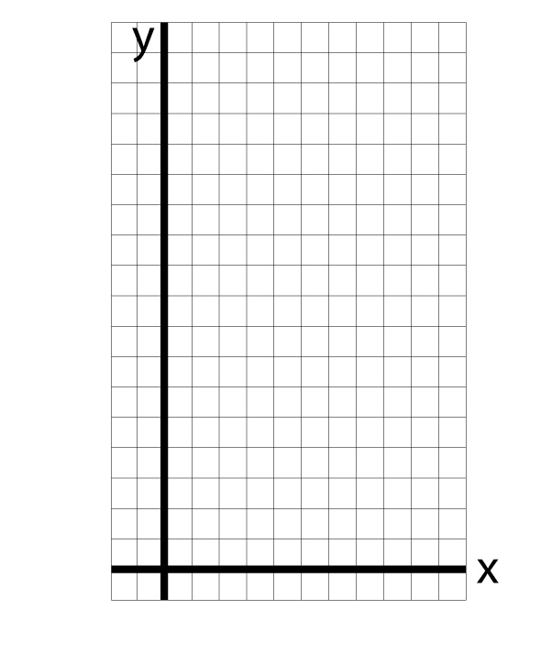

Answer the following questions with the class:
1. Identify the independent and the dependent variables.
The independent variable is ____________________________________
The dependent variable is ____________________________________

2. Is the graph linear? Explain your reasoning. _______________________________________
___________________________________________________________________________

3. Describe the pattern that occurs in the data. ________________________________________
___________________________________________________________________________

4. Write an equation to determine the number of regions if there are n folds.
_______________________________________

Part II: Label the axes of the graph below before you plot your data. One axis is for Number of Folds and one axis is Area of Smallest Region. Think about the scale of your range and plan your markings before you begin.

Answer the following questions with the class:

1. Identify the independent and the dependent variables.
The independent variable is ____________________________________
The dependent variable is ____________________________________
2. Is the graph linear? Explain your reasoning. _______________________________________
___________________________________________________________________________

3. Describe the pattern that occurs in the data. ________________________________________
___________________________________________________________________________

4. Write an equation to determine the number of regions if there are n folds.
_______________________________________
Exponential Growth and Decay

In this activity, fold a piece of computer paper in half as many times as possible. After each fold, stop to fill in a row of the table. Continue folding and recording until the table is filled

NUMBER OF FOLDS | NUMBER OF REGIONS | AREA OF SMALLEST REGION
0 | 1 | 1
1 | 2 | or $2^{−1}$
2 | 4 | or $2^{−2}$
3 | 8 | or $2^{−3}$
4 | 16 | or
5 | 32 | or
6 | 64 | or
7 | 128 | or
N |  | or $2^{−n}$

Part I: Label the axes of the graph below before you plot your data. One axis is for Number of Folds and one axis is for Number of Regions. Think about the scale of your range and plan your markings before you begin.
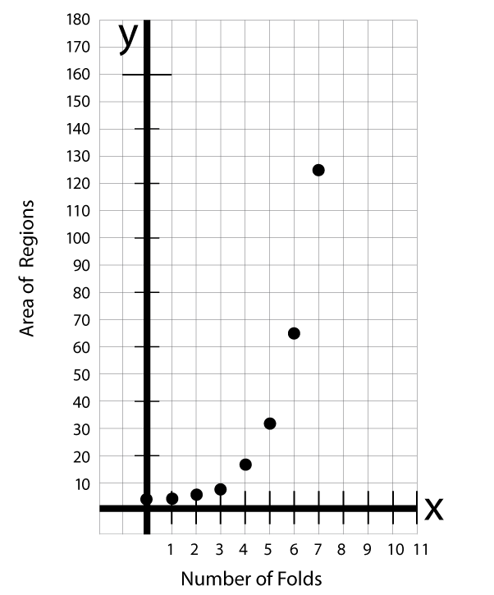

Answer the following questions with the class:
1. Identify the independent and the dependent variables.
The independent variable is ________number of folds____________________________
The dependent variable is ________number of regions____________________________

2. Is the graph linear? Explain your reasoning. The graph is not linear because the data points do not seem to form a line; there is not a constant rate of change.
3. Describe the pattern that occurs in the data. The number of regions increases by a power of two. The power is equal to the number of folds.
4. Write an equation to determine the number of regions if there are n folds.

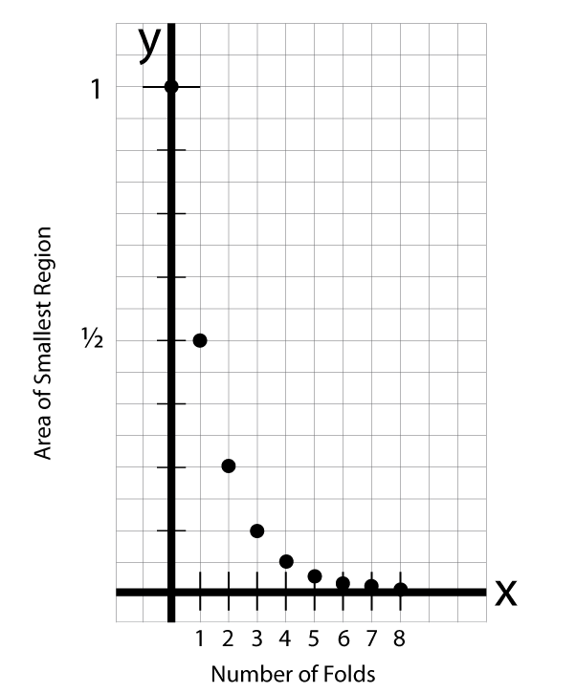
Part II: Label the axes of the graph below before you plot your data. One axis is for Number of Folds and one axis is Area of Smallest Region. Think about the scale of your range and plan your markings before you begin.

Answer the following questions with the class:

1. Identify the independent and the dependent variables.
The independent variable is ___number of folds_________________________________
The dependent variable is _______area of smallest region________________________
2. Is the graph linear? Explain your reasoning. The graph is not linear because the data points do not seem to form a line; there is not a constant rate of change.
3. Describe the pattern that occurs in the data. The area of the smallest region decreases by a negative power of two (or a power of ½). The power is equal to the number of folds.
4. Write an equation to determine the number of regions if there are n folds.
Pay Day!

In your math log, respond to the following question.

Part I:
Which of the following jobs would you choose? Give reasons to support your answer.
Job A: Salary of $1 for the first year, $2 for the second year, $4 for the third year, continuing for
25 years.
Job B: Salary of $1 Million a year for 25 years

Part II:
At the end of 25 years, which job would produce the largest amount in total salary?

NUMBER OF YEARS WORKED | YEARLY SALARY  JOB A | TOTAL SALARY  JOB A | YEARLY SALARY  JOB B | TOTAL SALARY  JOB B
1 | $1 | $1 | $1,000,000 | $1,000,000
2
3
4
5
6
N

1. Predict when the salaries will be equal. Explain your reasoning.
2. Does Job A represent linear or exponential growth? Explain your reasoning.
3. Does Job B represent linear or exponential growth? Explain your reasoning.
4. Write an equation to represent the salary for each job option.

Pay Day!

In your math log, respond to the following question.

Which of the following jobs would you choose?
Job A: Salary of $1 for the first year, $2 for the second year, $4 for the third year, continuing for
25 years.
Job B: Salary of $1 Million a year for 25 years
Give reasons to support your answer.

At the end of 25 years, which job would produce the largest amount in total salary?

NUMBER OF YEARS WORKED | YEARLY SALARY  JOB A | TOTAL SALARY  JOB A | YEARLY SALARY  JOB B | TOTAL SALARY  JOB B
1 | $1 | $1 | $1,000,000 | $1,000,000
2 | $2 | $3 | $1,000,000 | $2,000,000
3 | $4 | $7 | $1,000,000 | $3,000,000
4 | $8 | $15 | $1,000,000 | $4,000,000
5 | $16 | $31 | $1,000,000 | $5,000,000
6 | $32 | $63 | $1,000,000 | $6,000,000
N | 2^{n-1} | This cell would remain empty | $1,000,000 | $1,000,000N

1. Predict when the salaries will be equal. Explain your reasoning. In about 20 years; Explanations will vary
2. Does Job A represent linear or exponential growth? Explain your reasoning. Exponential; the salary is equal to some power of 2 with the power equal to the number of years.
3. Does Job B represent linear or exponential growth? Explain your reasoning. Linear; the rate of change is constant
4. Write an equation to represent the salary for each job option. Job A:
Job B:
Linear or Non-Linear?

In this activity, you will construct a scatter plot using the data set you were given and determine if the data represents a linear or non-linear relationship.

1. Identify the independent and dependent variables and write them on the top left corner of the poster.

2. Construct the scatter plot on your poster board.

3. Describe the relationship between the two variables on the top right corner of the poster, including a decision about whether your data is linear or non-linear.

4. Present your findings to the class. Include in your presentation three informative points about your data and a discussion about why the data is linear or non-linear.

Median House Prices
Year | Price
1990 | 85000
1991 | 88000
1992 | 92000
1993 | 100000
1994 | 106000
1995 | 115500
1996 | 125000
1997 | 135000
1998 | 151000
1999 | 160000
Average Temperature
Month | Temp
1. Jan | 50
2 Feb | 54
3 Mar | 60
4 Apr | 67
5 May | 74
6 June | 80
7 July | 82
8 Aug | 81
9 Sept | 78
10 Oct | 68
11 Nov | 59
Old Faithful geyser eruption
Length of  eruption (minutes) | Minutes between  eruptions
2 | 57
2.5 | 62
3 | 68
3.5 | 75
4 | 83
4.5 | 89
5 | 92
Household with Television Sets
(in millions)
Year | Television Sets
1986 | 158
1987 | 163
1988 | 168
1989 | 176
1990 | 193
1991 | 193
1992 | 192
1993 | 201

Length and Weight of Whales
Length | Weight
(feet) | (long tons)
40 | 25
42 | 29
45 | 34
46 | 35
50 | 43
52 | 45
55 | 51

Wind Chill
Wind Speed | Wind Chill
(mph) | Fahrenheit
0 | 35
5 | 32
10 | 22
15 | 16
20 | 11
25 | 8
30 | 6
35 | 4
World Oil Production
Year | Barrels
 | (millions)
1900 | 149
1910 | 328
1920 | 689
1930 | 1412
1940 | 2150
1950 | 3803
1960 | 7674
1970 | 16690
1980 | 21722
Presidential Physical Fitness
Awards
Mile – Run
Age | Time (seconds)
9 | 511
10 | 477
11 | 452
12 | 431
13 | 410
14 | 386

RUBRIC
Graphing: Linear or Non-linear?
Student Name: ________________________________________
CATEGORY | 4 | 3 | 2 | 1
GRAPH
Labeling of X axis | The X axis has a clear, neat label that describes the units used for the independent variable (e.g, days, months, participants' names). | The X axis has a clear label that describes the units used for the independent variable. | The X axis has a label. | The X axis is not labeled.
Labeling of Y axis | The Y axis has a clear, neat label that describes the units and the dependent variable (e.g, % of dog food eaten; degree of satisfaction). | The Y axis has a clear label that describes the units and the dependent variable (e.g, % of dog food eaten; degree of satisfaction). | The Y axis has a label. | The Y axis is not labeled.
Title | Title is creative and clearly relates to the problem being graphed (includes dependent and independent variable). It is printed at the top of the graph. | Title clearly relates to the problem being graphed (includes dependent and independent variable) and is printed at the top of the graph. | A title is present at the top of the graph. | A title is not present.
Accuracy of Plot | All points are plotted correctly and are easy to see. A ruler is used to neatly connect the points or make the bars, if not using a computerized graphing program. | All points are plotted correctly and are easy to see. | All points are plotted correctly. | Points are not plotted correctly OR extra points were included.
Linear or Non-linear? | Graph fits the data well and makes it easy to interpret. | Graph is adequate and does not distort the data, but interpretation of the data is somewhat difficult. | Graph distorts the data somewhat and interpretation of the data is somewhat difficult. | Graph seriously distorts the data making interpretation almost impossible.

PRESENTATION | 4 | 3 | 2 | 1
Clarity of presentation | Explanations of the project are presented in clear and detailed manner | Explanations of the project are presented in a clear manner | Explanation is a little difficult to understand, but includes critical components | Explanation is difficult to understand and includes little critical components
Accuracy of Information | All mathematical facts are reported accurately | Almost all mathematical facts are reported accurately | One fact is reported accurately | No facts were reported accurately or no facts were reported
POSTER | Exceptionally well designed, neat, and attractive. Colors that go well together are used to make the graph more readable. A ruler and graph paper (or graphing computer program) are used. | Neat and relatively attractive. A ruler and graph paper (or graphing computer program) are used to make the graph more readable. | Lines are neatly drawn, but the graph appears quite plain. | Appears messy and "thrown together" in a hurry. Lines are visibly crooked.

Creating a scatter plot with the TI-83 graphing calculator:

1) Enter data into lists:
STAT EDIT
Clear lists by highlighting L1 then pressing Clear, Enter
Highlight L2 press clear, enter
Enter independent variable (x) in L1
Enter dependent variable (y) in L2

2) Turn on scatter plot:
2nd y=

Enter 1: On Type: scatter plot Xlist: L${}_{1}$ Ylist: L${}_{2}$ Mark: (any)

3) Set window to fit your data:
WINDOW
Xmin and Xmax should be set to fit the data in L1
Ymin and Ymax should be set to fit the data in L2
All other entries can be set at whatever you wish

- Look at Graph
GRAPH

Understanding Data

The table below gives the box score for game three of the 2003 NBA Championship series.

SAN ANTONIO SPURS
 |  |  |  |  | REBOUNDS
PLAYER | POS | MIN | FGM-A | 3GM-A | FTM-A | OFF | DEF | TOT | AST | PF | PTS
TONY PARKER | G | 43 | 9-21 | 4-6 | 4-8 | 1 | 2 | 3 | 6 | 0 | 26
STEPHEN JACKSON | G | 36 | 2-7 | 1-2 | 2-4 | 0 | 6 | 6 | 2 | 3 | 7
TIM DUNCAN | F | 45 | 6-13 | 0-0 | 9-12 | 3 | 13 | 16 | 7 | 3 | 21
BRUCE BOWEN | F | 32 | 0-5 | 0-2 | 0-0 | 1 | 3 | 4 | 0 | 3 | 0
DAVID ROBINSON | C | 26 | 1-5 | 0-0 | 6-8 | 1 | 2 | 3 | 0 | 2 | 8
Emanuel Ginobili |  | 28 | 3-6 | 0-0 | 2-3 | 2 | 0 | 2 | 4 | 2 | 8
Malik Rose |  | 22 | 4-7 | 0-0 | 0-0 | 0 | 2 | 2 | 0 | 2 | 8
Speedy Claxton |  | 5 | 2-2 | 0-0 | 0-0 | 0 | 1 | 1 | 0 | 1 | 4
Kevin Willis |  | 3 | 1-1 | 0-0 | 0-0 | 1 | 0 | 1 | 0 | 1 | 2
Steve Kerr
Danny Ferry
Steve Smith
TOTAL |  | 240 | 28-67 | 5-10 | 23-35 | 9 | 29 | 38 | 19 | 17 | 84
 |  |  | 41.8% | 50.0% | 65.7% | Team Rebs: 15

NEW JERSEY NETS |  |  |  |  |  | REBOUNDS
PLAYER | POS | MIN | FGM-A | 3GM-A | FTM-A | OFF | DEF | TOT | AST | PF | PTS
JASON KIDD | G | 42 | 6-19 | 0-5 | 0-0 | 2 | 1 | 3 | 11 | 3 | 12
KERRY KITTLES | G | 43 | 8-16 | 3-5 | 2-3 | 1 | 3 | 4 | 1 | 2 | 21
KENYON MARTIN | F | 42 | 8-18 | 0-1 | 7-8 | 2 | 9 | 11 | 0 | 5 | 23
RICHARD JEFFERSON | F | 36 | 3-11 | 0-0 | 0-0 | 2 | 7 | 9 | 0 | 2 | 6
JASON COLLINS | C | 25 | 0-3 | 0-0 | 0-0 | 4 | 1 | 5 | 1 | 6 | 0
Lucious Harris |  | 22 | 1-6 | 1-2 | 4-4 | 1 | 0 | 1 | 3 | 2 | 7
Dikembe Mutombo |  | 18 | 1-1 | 0-0 | 0-0 | 1 | 2 | 3 | 0 | 3 | 2
Rodney Rogers |  | 11 | 0-3 | 0-0 | 2-2 | 0 | 2 | 2 | 0 | 2 | 2
Anthony Johnson |  | 6 | 2-2 | 0-0 | 0-0 | 0 | 1 | 1 | 0 | 0 | 4
Aaron Williams |  | 4 | 1-2 | 0-0 | 0-0 | 1 | 1 | 2 | 1 | 1 | 2
Tamar Slay
Brian Scalabrine
TOTAL |  | 240 | 30-81 | 4-13 | 15-17 | 14 | 27 | 41 | 17 | 26 | 79
 |  |  | 37.0% | 30.8% | 88.2% | Team Rebs: 10

Source: www.nba.com

Key for Table
Pos | Position | 3GM-A | 3 point goals made – 3 point goals attempted
Min. | Minutes Played | AST | Assists
FGM–A | Field goals made–field goals attempted | PF | Personal Fouls
FTM–A | Free throws made–free throws attempted | PTS | Total Points Scored
R | Rebounds

Use the table above to answer the following questions.

1. Which player played the most minutes of the game? _______________________

2. Who had the most assists? _________________________________

3. Which team made a larger percentage of free throws? _____________________

FGM/FGA FTM/FTA
JASON KIDD
KERRY KITTLES
KENYON MARTIN
RICHARD JEFFERSON
JASON COLLINS
Lucious Harris
Dikembe Mutombo
Rodney Rogers
Anthony Johnson
Aaron Williams
TONY PARKER
STEPHEN JACKSON
TIM DUNCAN
BRUCE BOWEN
DAVID ROBINSON
Emanuel Ginobili
Malik Rose
Speedy Claxton
Kevin Willis
4. Calculate the percentage of free throws made/free throws attempted and field goals made/field goals attempted for each player. (Use the chart above to write your answers)

5. Which player(s) have/has the highest percentage? ____________________
Why do you think this is so?

6. Do you think that the players who attempt the most field goals are generally the players who make the most field goals? ________________

7. Make a scatter plot showing field goals made and field goals attempted.
Identify the independent and dependent variables.
Use different colors for the Spurs and Nets.

8. Does the scatter plot show a negative or positive correlation?

9. Who were the four perfect shooters in the game? Circle the points on the scatter plot that represent these perfect shooters.

10. The data on the graph seems to cluster in two sections. Can you explain where they cluster and why?

11. Give three interesting facts that you notice about the scatter plot.

12. Do you think that players who get a lot of rebounds also make a lot of assists (i.e., does the number of rebounds depend on the number of assists?)

13. Construct a scatter plot of rebounds and assists.

14. Is there a relationship between the two?

Understanding Data

The table below gives the box score for game three of the 2003 NBA Championship series.

SAN ANTONIO SPURS
 |  |  |  |  | REBOUNDS
PLAYER | POS | MIN | FGM-A | 3GM-A | FTM-A | OFF | DEF | TOT | AST | PF | PTS
TONY PARKER | G | 43 | 9-21 | 4-6 | 4-8 | 1 | 2 | 3 | 6 | 0 | 26
STEPHEN JACKSON | G | 36 | 2-7 | 1-2 | 2-4 | 0 | 6 | 6 | 2 | 3 | 7
TIM DUNCAN | F | 45 | 6-13 | 0-0 | 9-12 | 3 | 13 | 16 | 7 | 3 | 21
BRUCE BOWEN | F | 32 | 0-5 | 0-2 | 0-0 | 1 | 3 | 4 | 0 | 3 | 0
DAVID ROBINSON | C | 26 | 1-5 | 0-0 | 6-8 | 1 | 2 | 3 | 0 | 2 | 8
Emanuel Ginobili |  | 28 | 3-6 | 0-0 | 2-3 | 2 | 0 | 2 | 4 | 2 | 8
Malik Rose |  | 22 | 4-7 | 0-0 | 0-0 | 0 | 2 | 2 | 0 | 2 | 8
Speedy Claxton |  | 5 | 2-2 | 0-0 | 0-0 | 0 | 1 | 1 | 0 | 1 | 4
Kevin Willis |  | 3 | 1-1 | 0-0 | 0-0 | 1 | 0 | 1 | 0 | 1 | 2
Steve Kerr
Danny Ferry
Steve Smith
TOTAL |  | 240 | 28-67 | 5-10 | 23-35 | 9 | 29 | 38 | 19 | 17 | 84
 |  |  | 41.8% | 50.0% | 65.7% | Team Rebs: 15

NEW JERSEY NETS |  |  |  |  |  | REBOUNDS
PLAYER | POS | MIN | FGM-A | 3GM-A | FTM-A | OFF | DEF | TOT | AST | PF | PTS
JASON KIDD | G | 42 | 6-19 | 0-5 | 0-0 | 2 | 1 | 3 | 11 | 3 | 12
KERRY KITTLES | G | 43 | 8-16 | 3-5 | 2-3 | 1 | 3 | 4 | 1 | 2 | 21
KENYON MARTIN | F | 42 | 8-18 | 0-1 | 7-8 | 2 | 9 | 11 | 0 | 5 | 23
RICHARD JEFFERSON | F | 36 | 3-11 | 0-0 | 0-0 | 2 | 7 | 9 | 0 | 2 | 6
JASON COLLINS | C | 25 | 0-3 | 0-0 | 0-0 | 4 | 1 | 5 | 1 | 6 | 0
Lucious Harris |  | 22 | 1-6 | 1-2 | 4-4 | 1 | 0 | 1 | 3 | 2 | 7
Dikembe Mutombo |  | 18 | 1-1 | 0-0 | 0-0 | 1 | 2 | 3 | 0 | 3 | 2
Rodney Rogers |  | 11 | 0-3 | 0-0 | 2-2 | 0 | 2 | 2 | 0 | 2 | 2
Anthony Johnson |  | 6 | 2-2 | 0-0 | 0-0 | 0 | 1 | 1 | 0 | 0 | 4
Aaron Williams |  | 4 | 1-2 | 0-0 | 0-0 | 1 | 1 | 2 | 1 | 1 | 2
Tamar Slay
Brian Scalabrine
TOTAL |  | 240 | 30-81 | 4-13 | 15-17 | 14 | 27 | 41 | 17 | 26 | 79
 |  |  | 37.0% | 30.8% | 88.2% | Team Rebs: 10

Source: www.nba.com

Key for Table
Pos | Position | 3GM-A | 3 point goals made – 3 point goals attempted
Min. | Minutes Played | AST | Assists
FGM–A | Field goals made–field goals attempted | PF | Personal Fouls
FTM–A | Free throws made–free throws attempted | PTS | Total Points Scored
R | Rebounds

Use the table above to answer the following questions.

1. Which player played the most minutes of the game? __Tim Duncan_____________________

2. Who had the most assists? __Jason Kidd_______________________________

3. Which team made a larger percentage of free throws? ____Nets_________________

 | FGM/FGA | FTM/FTA
JASON KIDD | 32% | --
KERRY KITTLES | 50% | 67%
KENYON MARTIN | 44% | 88%
RICHARD JEFFERSON | 27% | --
JASON COLLINS | 0% | --
Lucious Harris | 17% | 100%
Dikembe Mutombo | 100% | --
Rodney Rogers | 0% | 100%
Anthony Johnson | 100% | --
Aaron Williams | 50% | --
TONY PARKER | 43% | 50%
STEPHEN JACKSON | 29% | 50%
TIM DUNCAN | 46% | 75%
BRUCE BOWEN | 0% | --
DAVID ROBINSON | 20% | 75%
Emanuel Ginobili | 50% | 67%
Malik Rose | 57% | --
Speedy Claxton | 100% | --
Kevin Willis | 100% | --

4. Calculate the percentage of free throws made/free throws attempted and field goals made/field goals attempted for each player. (Use the chart above to write your answers)
5. Which player(s) have/has the highest percentage of field goals made?__Mutombo, A. Johnson, Claxton, Willis_
Why do you think this is so? They did not have as many attempts
6. Do you think that the players who attempt the most field goals are generally the players who make the most field goals?__You can’t make goals if you don’t attempt them.______________

7. Make a scatter plot showing field goals made and field goals attempted.
Identify the independent (attempted) and dependent variables.(made)
Use different colors for the Spurs and Nets.
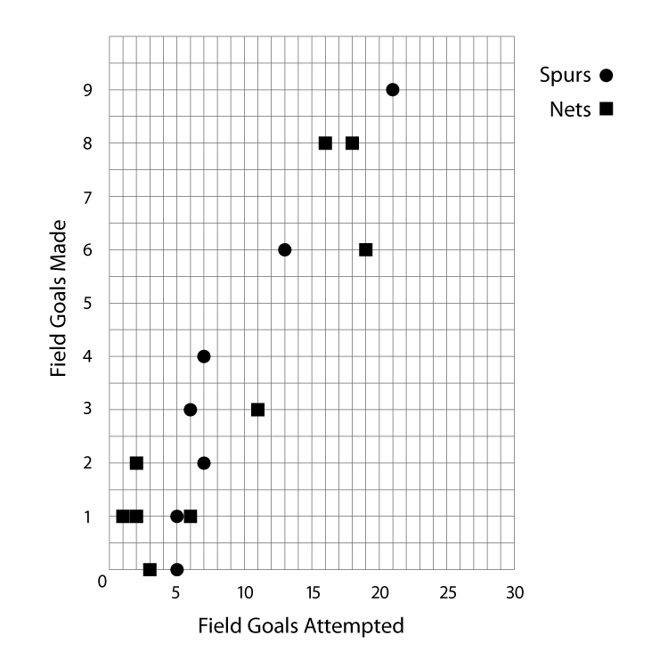

8. Does the scatter plot show a negative or positive correlation? positive

9. Who were the four perfect shooters in the game? Circle the points on the scatter plot that represent these perfect shooters. Mutombo, A. Johnson, Claxton, Willis_

10. The data on the graph seems to cluster in two sections. Can you explain where they cluster and why?
The cluster at the highest point represents the players who played more minutes. The lower cluster is the group that played fewer minutes.

11. Give three interesting facts that you notice about the scatter plot.
Answers will vary

12. Do you think that players who get a lot of rebounds also make a lot of assists (i.e. does the number of rebounds depend on the number of assists)? Students’ opinions will vary

13. Construct a scatter plot of rebounds and assists.

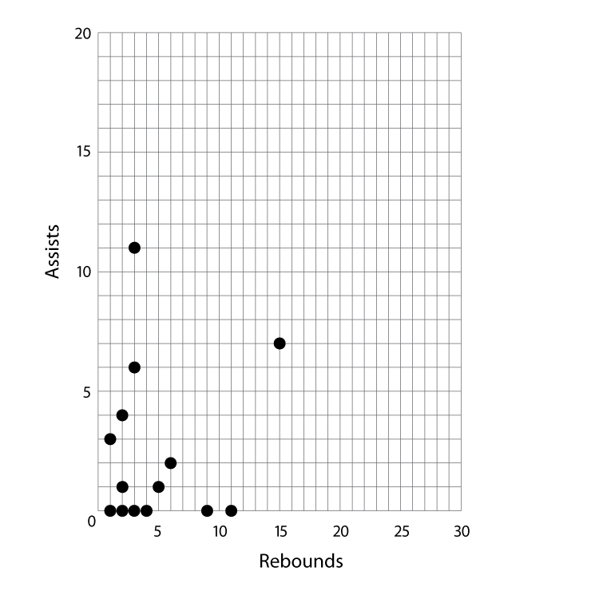

14. Is there a relationship between the two? no

