AIMS Review Packet
Scientific Method
- What is the difference between a hypothesis and a prediction?
- Why do scientists use a control group in experimental design?
- Susie wondered if the height of a hole punched in the side of a quart-size milk carton would affect how far from the container a liquid would spurt when the carton was full of the liquid. She used 4 identical cartons and punched the same size hole into each. Susie recorded her results in the chart below.

Height of hole  punched in container (cm) | Distance liquid spurts from the container (cm)
5 | 10
10 | 20
15 | 30
20 | 40

  - What is the independent variable?________
  - What is the dependent variable?__________
  - Write a hypothesis for this experiment, use proper format.
  - What would be an appropriate prediction if the height of the hole punched in the container was 25 cm (use numbers!)? Graph Susie’s results.

Distance spurt (DV)
(cm)

Height of the hole (IV)
(cm)

  - Describe the relationship between the height of the hole and the distance of the liquid
A group of college students were given a short course in speed-reading. The instructor was curious if a monetary incentive would influence performance on a reading test taken at the end of the course. Half the students were offered $5 for obtaining a certain level of performance on the test, the other half were not offered money.
Independent variable:
Dependent variable:
Experimental group:
Control group:

Cells
- Define each term and give an example.
Word | Definition | Example
Biotic
Abiotic

- Cell organelles – Complete the table.
Organelle Name | Where is it found? Label (P) plant, (A) animal, (B) bacteria, (E) All | Function: Write what the organelle does inside the cell and make a connection with how this helps a cell do its job. Remember, each type of cell has a different function. After you write your answer, ask yourself, “does this describe WHAT THE ORGANELLE DOES?” If not, fix it.
Nucleus
Nucleolus
Cell Membrane
Cell Wall
Mitochondria
Lysosome
Ribosome
Central Vacuole
Chloroplast
Cilia and Flagella
Cytoplasm
Cytoskeleton
Golgi Apparatus
Endoplasmic Reticulum

- Identify TWO major differences between prokaryotes and eukaryotes?

- What types of organisms are classified as the following:
  - Prokaryote:
  - Eukaryote:

- Levels of Organization: Put the following in order from smallest to largest.

- What are the three parts of the cell theory?

- What scientists helped with the development of the cell theory? What did they each contribute (research) to the cell theory?

- Identify the following cell types:
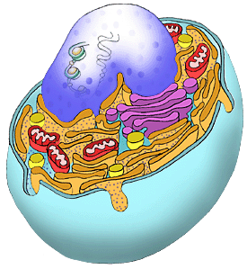
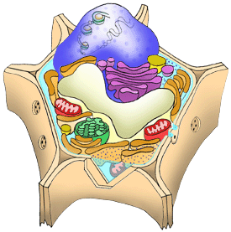
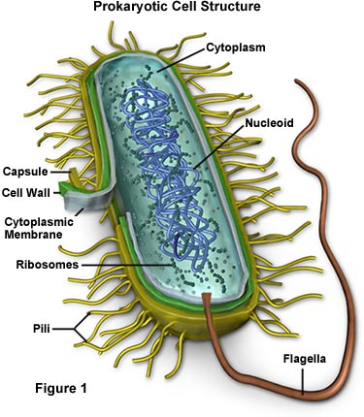

A b. c.

- The cell membrane is semi-permeable. What does this mean?

- Explain the difference between eubacteria and archaebacteria?

- Aside from nucleus, what other double membrane-bound organelle contains DNA?

Cellular Transport
- What is homeostasis?

- Define: hypertonic, hypotonic, isotonic.

- Complete the following table.
Type of solution | Where is solute concentration the highest (inside cell or outside cell) | Will water move in or out of cell? | Will the cell swell, shrink, or stay the same size?
Hypertonic
Hypotonic
Isotonic

- How are active transport and passive transport different?

- List and describe the types of passive transport.

- List and describe the types of active transport.

- What is the difference between osmosis and diffusion?

- Food coloring will diffuse through water until it reaches?

- What is cohesion?

- What is adhesion?

- What is specific heat?

- Water has a HIGH specific heat. Why is this property of water important to life?

- What is capillary action?

- How do plants use capillary action?

DNA / Mitosis
- What is the ultimate function of a DNA molecule?

- DNA molecules are made up of the following unit. What molecule is this?


- a. Label the three parts of this DNA subunit. Be specific on that sugar!!
b. Which two parts make up the backbone of the DNA strand?

- What are the complementary base pairing rules?

- What type of bond holds the bases of complementary DNA molecules together?

- What is the physical structure of DNA called and who discovered it?

- Using the base pairing rules, complete the other side of DNA.

- Consider the base-pairing rules. If a scientist determined that the genome of an organism contained 34% adenine, what is the percentage of the other bases?

PROKARYOTIC BACTERIA!!!!!!!!!!!!!!!!!!!
- Label each part of the cell cycle and describe a major event in each part:
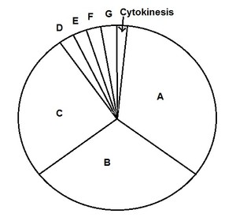
- G1: Cell growth, transcription + tranlsation

- S (DNA synthesis = Replication)

- G2: Cell growth

- Prophase of mitosis

- Metaphase

- Anaphase

- Telophase

INTERPHASE (Write the letters): A + B + C
- At what stage of the cell cycle do cells spend most of their time?

- What is the difference between DNA, chromatin, chromosomes, and sister chromatids? How are they all similar?

- What is a chromatid?

- What part of the DNA molecule splits during replication?

- What enzyme splits apart the two DNA strand during DNA replication?

- Diagram the process of DNA replication. Include the replication fork, helicase, ligase, DNA polymerase, and 3’and 5’ on both old and new strands.

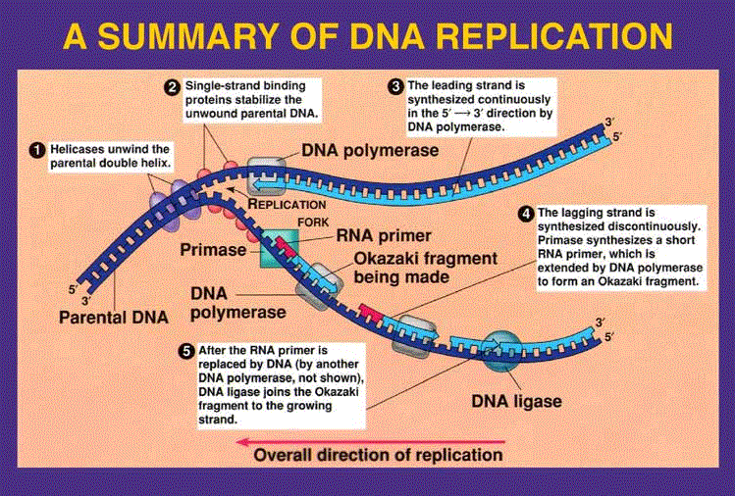

- Why is DNA replication important?

- What are 3 differences between DNA and RNA?

- Label the following structure at the arrows with the correct term.

- What are the four stages of Mitosis and what happens at each stage?

- What is the purpose of Mitosis?

- Why is it more accurate to call Mitosis nuclear division rather then cell division?

- Label each picture with the correct stage.
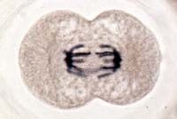
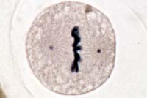
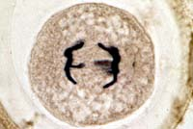
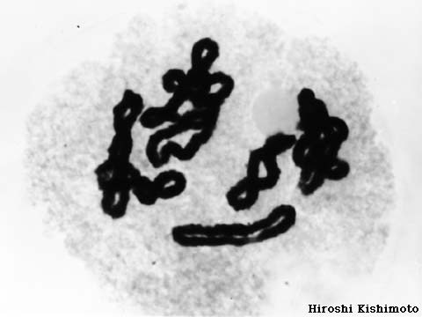

- What types of cells in your body undergo Mitosis?

- What is Cytokinesis?

- Explain the process of binary fission. What types of cells undergo this process?

Mitosis/ Meiosis
- How many cells are produced during mitosis? ___ cells

- DIPLOID =

- HAPLIOD =

- Are diploid or haploid cells produced in the process of mitosis? __________cells

- Are the resulting daughter cells genetically identical or different from the parent (original) cell?
- Why is process of meiosis important for an organism?
- How many times does the genetic information get split in meiosis?
- In which phase of meiosis does crossing-over occur?
- What is crossing over and why is it important?

Important: crossing over creates genetic variation
- How many cells are produced during meiosis? ___ cells

- Are the resulting daughter cells genetically identical or different to the parent (original) cell after meiosis?

- Are diploid or haploid cells produced in the process of meiosis? __________ cells

- If an organism has a haploid number of 8, how many chromosomes would it have in its body (somatic) cells?

- In humans, how many chromosomes does each of the daughter cells have after meiosis?

- What is the difference between Somatic Cells and Gamete Cells? Use correct biology terms.

- Explain the law of independent assortment.

- Identify the stage of meiosis for an organism (with a diploid number 2n = 4) in the pictures below:

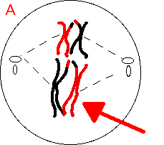
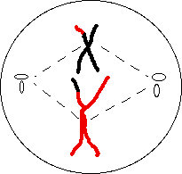
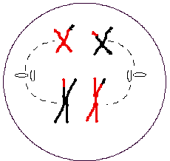
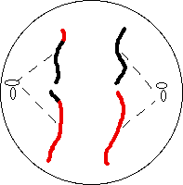

- What is a gene?

- What do genes code for?

- Compare and contrast DNA, genes, and chromosomes.

- What is the Central Dogma of biology?(flow of DNA to protein) (Fill in the blanks)

- Describe/draw the process of transcription.

- Why is transcription important? Why is it beneficial for the DNA? Be detailed.

- RNA uses the nitrogen base __ _____ instead of ________.

- Transcribe the mRNA from the following DNA:
3’ T-A-C-C-G-A-A-T-T-A-C-T-A-G-T-A-C-G 5’

- What are the 3 types of RNA found in the cell? What are their functions?

- Describe/draw the process of translation. The message in RNA, with the help of ribosomes, is converted into an amino acid chain, which will form a protein

- What types of RNA are involved with translation?

- What types of RNA are involved with transcription?

- What are the building blocks of protein?
- If an mRNA had 12 codons, how many amino acids would it code for?

- Where does transcription occur in the cell?

- Where does translation occur in the cell?

- The mRNA codon AUG codes for the amino acid
- The mRNA codon CCA codes for the amino acid
- Translate the mRNA that was produced in #78 into an amino acid chain.

3’ T-A-C-C-G-A-A-T-T-A-C-T-A-G-T-A-C-G 5’

- What determines the function of the finished protein?

- What is a mutation?

- What effects can mutations have?

Evolution
- Define the term evolution.

- What are 4 differences between Darwin and Lamarck?

- Describe/Define Darwin’s theory of natural selection (Include the four tenants)?

- What is the difference between adaptation and acclimation

- What is the difference between macroevolution and microevolution?

- Explain how the following pieces of evidence are used to support the Theory of Evolution: Fossils, Comparative Embryology, Comparative Anatomy, DNA, and Molecular Evidence.

- What is the difference between homologous structures and analogous structures?

- What is the difference between divergent and convergent evolution? Provide examples of each.

Dorsal Nerve cord + notochord
Paired appendage + spinal column
Paired legs
Amnion
Mammary glands
Placenta
Foramen magnum forward + short canine teeth
Lamprey
Human
Tuna
Bullfrog
Snapping Turtle
Kangaroo
Rhesus Monkey
Cladogram

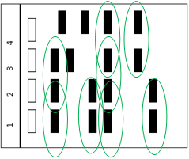
- Which organisms have paired legs?

- How does the Kangaroos Humans relationship compared to the lamprey Monkey relationship?

- Based upon the electrophoresis data; which organisms are the most closely related to each other? Remember, the bands in the gel represent proteins of similar size.

Genetics
- What is genetics?

- Who is considered to be the “father” of genetics?

- What is an allele?

- Define homozygous and heterozygous.

- Identify the following genotypes as homozygous recessive, homozygous dominant, or heterozygous:

- Define genotype and phenotype. Give an example of each.

- What is the difference between a dominant trait and a recessive trait?

- Can a heterozygous individual show the phenotype of the recessive trait? Explain.

- Explain the uses of a karyotype.

- If Sally has dimples and is heterozygous, what can you conclude about dimples?

- Everyone in Squidward’s family has blue skin, which is the dominant trait. Squidward is heterozygous for his blue skin. His wife has green skin.
  - Create a punnett square to show the possible genotypes of their children.
  - What are the possible genotypes? ________ _______
  - What are the possible phenotypes? _______ _______
  - What are the chances of a child with blue skin? _____
  - What are the chances of a child with green skin? _____
  - Phenotypic ratio: _________________
  - Genotypic ratio: __________________
- What is Incomplete dominance? Give an example

- What is Co dominance? Give an example.

- Sex linked genes tend to be carried on what sex chromosome?

- What sex chromosomes does a male carry? Female?

- If S= striped and s= solid, what are the phenotypes for each of the following: Ss: Striped

- If brown hair is dominant (B) to blonde hair (b), and two parents have a brown hair child, what are the possible genotypes of each parent?

- If the gene for tall plants was incompletely dominant over the gene for short plants, what are the possible genotypes and phenotypes of the offspring when a tall plant is crossed with a short plant? Complete the cross.

Tt | Tt
- In horses the coat color is controlled by co-dominant alleles. The alleles for a red coat or white coat are both expressed in a heterozygote. Horses that have a both a red and white coat are said to have a roan coat (both red and white hairs). Horses that have neither of the dominant alleles have a blonde coat. Cross two individuals with roan coats. Calculate the phenotypic and genotypic ratios.

- The gene for baldness is carried on the x-chromosome. What are the chances that a bald man and a carrier (heterozygous) woman would have a bald boy? A bald girl? Show the cross.

- Draw a pedigree and find the genotypes for the following situation tracking the instance of the recessive trait blonde hair: A blonde man marries a brown haired woman. They have two daughters who both have brown hair and a son with blonde hair. Their son has a son of his own with brown hair

Photosynthesis/Cellular Respiration
- What is an autotroph? Give examples
- What is a heterotroph? Give examples
- How are autotrophs and heterotroph linked?
- Why is chlorophyll green?
- What is photosynthesis?
- What is the equation for photosynthesis?
- Where does photosynthesis occur?
- Where does the light reaction occur? What goes into this reaction? What comes out?
- Where does the dark reaction (Calvin cycle) occur? What goes into this reaction? What comes out? Which pigment is directly involved with photosynthesis? (The primary pigment)
- Why are carotenoids and chlorophyll b important to photosynthesis?
- What three factors affect the rate of photosynthesis?
- Does photosynthesis occur in the roots, leaves or stems?
- Why does photosynthesis not occur in the other two places?
- What is an aerobic pathway? Give an example.
- When does aerobic respiration occur?
- What is an anaerobic pathway? Give 2 examples.
- What type of cellular respiration does yeast undergo?
- What is cellular respiration?
- Which is the equation for cellular respiration?
- Where does aerobic respiration occur in an eukaryotic cell? In a prokaryotic cell?
- Why do cells need energy?
- How much ATP can be produced from a complete breakdown on one glucose molecule?
- How does the amount of energy produced in cellular respiration compare with energy produced during fermentation?
- Glucose is broken down during glycoylsis to form what? What else is formed?
- Why are photosynthesis and cellular respiration reciprocal parts of a cycle? (How are they linked to each other?)

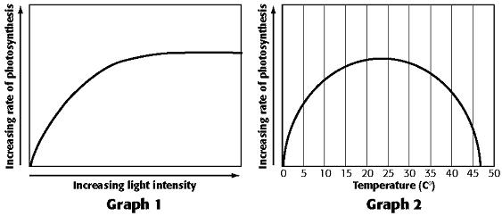
- Describe what is happening in graph 1. Explain why?
- Describe what is happening in graph 2. Explain why?

Ecology
- List the levels of organization from smallest to largest. Understand the differences.
- What is a biome?
- What defines different biomes?
- What is the difference between primary and secondary succession?
- In primary succession what is the first species to start to grow? Why?
- What is a symbiotic relationship?
- Compare and Contrast Mutualism, Commensalisms, and parasitism.
- What factors influence the growth of human population?
- What is the difference between density dependent factors and density independent factors?
- Compare and contrast exponential growth to logistical growth. Draw a graph to represent each.
- What happens if a population exceeds the carrying capacity?
- What is the relationship between population and resources?
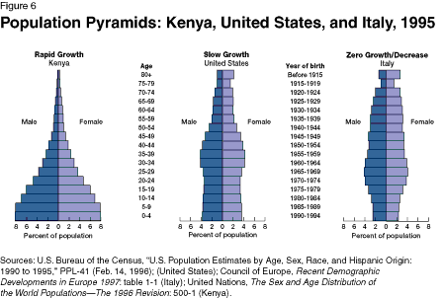

Above is a population pyramid. Spend some time and read the graph then answer the following question.
- Describe what is happening in each of the population pyramids.
- As a population gets older, what type of jobs will be in high demand?
- What is the relationship between predators and prey?
- What are the parts of the water cycle?

  - Carbon Cycle -

  - Nitrogen Cycle-

- How is a food web different from a food chain?

- What happens to the energy level as you go from one trophic level to the next?
- What is binomial nomenclature?
- What are the levels of naming?
- What are the six kingdoms?
- How are the kingdoms different?
- What are the characteristics that all animals have?

- What are the 9 phylum of animals and what does each phylum mean what is an example organism?
Name of Phylum | Meaning of the Name | Example organism
Porifera
Cnidaria
Platyhelminthes
Nematoda
Annelida
Mollusca
Echinodermata
Arthropoda
Chordata

