Parent/Guardian access to the South Panola School District’s gradebook program, Active Parent, will be available beginning August 22, 2016 and end May 12, 2017. All users will be required to create a new user account as none of the accounts from last year were brought forward.
Access to this exciting resource is available by typing the following address into your web browser http://grades.spsd.k12.ms.us . Click on Sign up for an Active Parent Account to immediately start the process. Simply provide the requested information and fill in the blanks. When you are satisfied with your responses please click on the Next button to fill out the student’s information. You may enter more than one student by completing one student’s information then click on add student to do the next student. If you have completed all the student information please click submit request. We will send a notification that your account has been successfully accepted. You may then go to http://grades.spsd.k12.ms.us to access the student(s) information.
In all cases the counselor is the appropriate first contact to set up conferences with teacher(s) for questions and concerns regarding assignments, grades, attendance, etc. In addition, district technology staff will provide email support at fmiles@spsd.k12.ms.us .

Active Parent Steps

Step 1 – After typing http://grades.spsd.k12.ms.us click on Sign up for an Active Parent Account

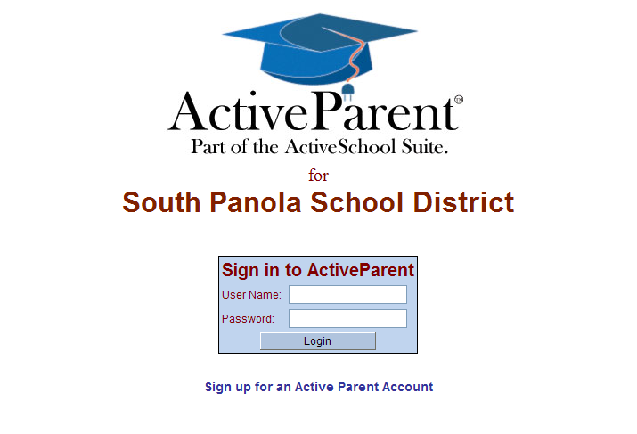
Step 2 – Fill in all information required to create the account. Click Next

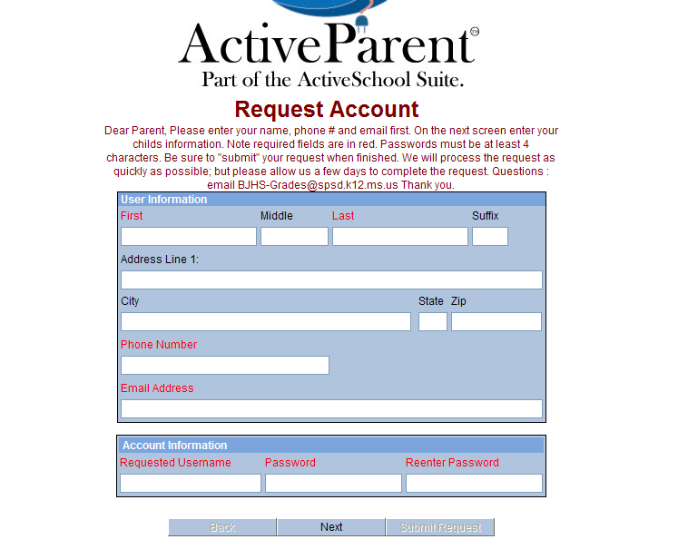

Step 3 – Fill out all the student information and click add student

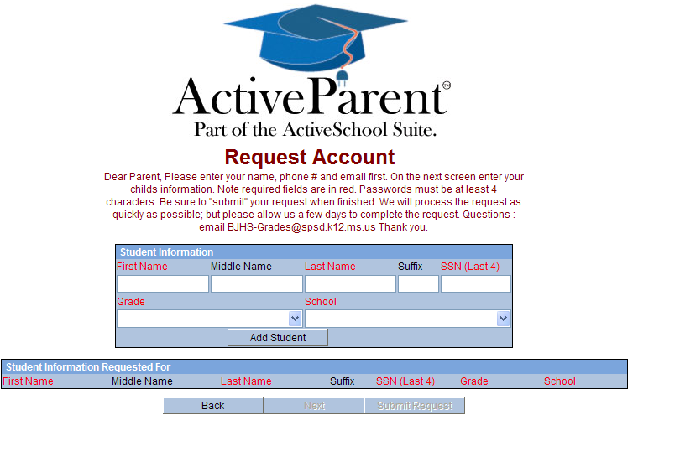
Step 4 – Process complete, an email will be sent to let you know when you can login.
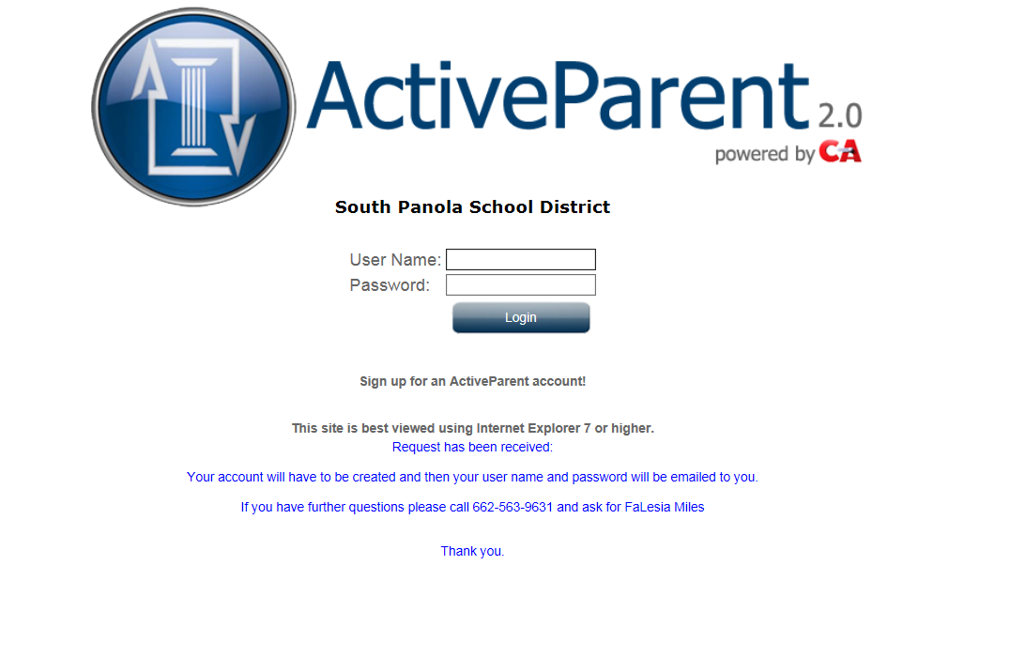
New for 2016-2017 School Year & iPhones Only

 | ActiveParent Central Access App is fully integrated into SAM and allows parents to view their student's class schedule, grades, discipline, attendance, and even AIM 2.0 (Active Instant Messenger) correspondence.

