Office of the Mayor
WILLIAM R. MARKS
Mayor

HOLLY HOLLMAN
Grant Coordinator/Communications Specialist

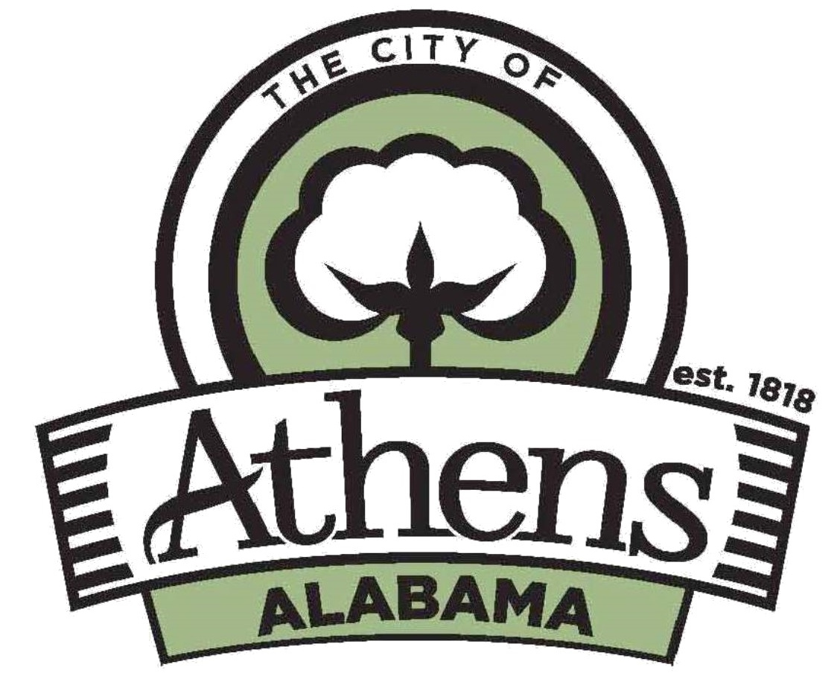

P.O. Box 1089
Athens, AL 35612
Phone (256) 262-1399
Email: hhollman@athensal.us

Dec. 4, 2020

Customer Accounts announces temporary closure

Athens Utilities Customer Accounts will be closed today (Dec. 4) at 11 a.m. to Tuesday, Dec. 8, at 8 a.m. due to COVID-19 protocols. This includes the drive-thru window. Utility disconnects will be suspended during the closure.
Customers can make payments in the following ways:
- Pay online at www.athens-utilities.com. The online company that provides this service does charge a one-time use fee.
- Mail bill stub with payment to City of Athens Utilities, P.O. Box 830200, Birmingham, AL, 35283-0200.
- Place bill stub with payment in the night box at the facility at 508 S. Jefferson Street.
- Pay by phone by calling toll free 1-855-760-0921. The company that provides this service does charge a one-time use fee.
- Pay by bank draft (no fee). Forms are available:
  - Online at www.athens-utilities.com

The office will undergo sanitization measures over the weekend and reopen on Dec. 8.

