Accounts Payable

Overview

A voucher is a record of a vendor invoice that contains information about the goods or services purchased and being paid for. Most often, vouchers are created online by copying a purchase order or receiver into the voucher. Vouchers are matched, approved, budget checked, and paid. Core-CT matches most vouchers using "3-way matching," a process that compares the amount, quantity, vendor and items on the purchase order, receiver. Budget checking the voucher entails checking the amount of the voucher against the available budget for payment. The use of non-PO vouchers must have prior approval of the OSC/APD Division.

Vouchers are approved online using Workflow, a system routing tool. The Office of the State Comptroller maintains the Pay Cycle and oversees the payment process. The Pay Cycle Manager initiates the automatic payment generation process which prints the checks, creates the ACH (Automated Clearinghouse) files, wires, and generates the remittance advice reports for the payments created. Payments are created daily.

It is the responsibility of the AP Manager to ensure that vouchers are 1) Matched, 2) Approved, and 3) Budget Checked.
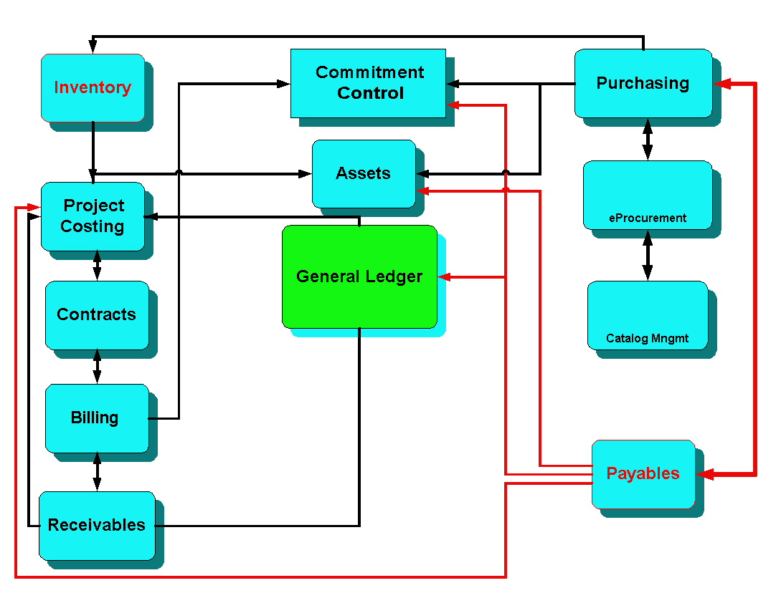
Accounts Payable integrates with other modules in Core-CT, and especially shares information with Purchasing.

It is important that all AP staff understand the integration points between Purchasing and Asset Management.

Asset Management information flows through Accounts Payable to Asset Management for item details identified earlier in Purchasing.

Figure 1 Accounts Payable integration with other financial modules. Note the strong connection to the Purchasing module.

Management/Supervisor Review Checklist

- Follow proper OSC Voucher procedures
  - Vouchers and Receivers must relate to a Core-CT purchase order
  - Non-PO voucher creation must have prior OSC approval
  - Ensure vouchers are being created and approved promptly to ensure no late payment penalties or finance charges
  - Ensure Interagency payments are being created promptly
- Update voucher review process to eliminate post audit violations
  - Duplicate vendor invoices: ensure consistency by voucher processors to fully utilize the duplicate vendor checking used in the system
  - Overpayments
  - Wrong payments: ensure voucher processors are selecting the right PO associated to the voucher for payment
  - Adjustment Vouchers correctly related to the original vouchers
- Check for Match Exceptions (Navigation: Accounts Payable > Review Accounts Payable Info > Vouchers > Match Workbench OR Accounts Payable > Reports > Vouchers > Match Exceptions (Report)) Ensure that Match Exceptions are resolved promptly
- Check for Budget Exceptions (Navigation: Commitment Control > Review Budget Check Exceptions > Accounts Payable > Voucher) Ensure that Budget Exceptions are resolved promptly
  - Verify adequate funds for payments (Navigation: Commitment Control > Budget Reports > Budget Status Report) especially at the beginning of a new fiscal year, budgets should be reviewed to ensure that vouchers will pass budget check and at the end of the year to ensure all funds are used appropriately
- Conduct periodic reviews with purchasing, asset management, and receiving staff to ensure business processes are followed and information is appropriately passed through all integrated modules
- Accounts Payable month end close: vouchers that are budget checked must be voucher posted. Vouchers that are not budget checked will be updated with an accounting date of the first day of the next open period.
- Accounts Payable year end close: any vouchers not processed through to payment at fiscal year end will be closed by OSC.
- An EPM Query is available for AP Managers: CT_CORE_FIN_AP_VCHR_CNT_USERID
  - Navigation: EPM Reporting Tools > Query > Query Manager (enter the query title or locate it in the AP folder).
  - This query will provide a count of vouchers entered during a specified time period by each AP staff member in your Business Unit. This query can be used as a performance measurement of your AP Unit. It can also be used find the number of vouchers entered during a specified time period.

Major Accounts Payable Reports from the Catalog of Online Financial Reports
Report Number | Report Name
aps8001j | Voucher Activity  (http://www.core-ct.state.ct.us/reports/docs/aps8001j.doc)  The report displays a detail listing of posted or unposted vouchers for specific date(s) or date range. The run control page allows the user to specify agency AP Business Unit, account and department. The user can obtain information on source documents by specified chartfields.
apy1010 | Voucher Register  (http://www.core-ct.state.ct.us/reports/docs/apy1010.doc)  This report presents a detail listing of vouchers by agency AP Business Unit, date entered, and voucher ID. The report is used to monitor and review vouchers.
apy1011 | Control Group Register  (http://www.core-ct.state.ct.us/reports/docs/apy1011.doc)  Control groups are not a required component of the Accounts Payable control hierarchy. They can, however, provide security options and determine workloads for Accounts Payable voucher processors. The report lists vouchers entered into Payables by Business Unit, control group ID, date entered, and voucher ID. For each Business Unit and Control Group ID combination, the report lists all the vouchers that meet these criteria by their Date Entered. For each Voucher, the report lists Voucher Header Information, Voucher Line Information, and Distribution Line Information.
apy1020 | Posted Voucher Listing  (http://www.core-ct.state.ct.us/reports/docs/apy1020.doc)  The report lists all posted vouchers for a given Business Unit and date range. For each Voucher ID, the report lists Document Type, Document Date, Document Sequence, Ledger, Accounting Date, Application Journal, Dist Type, Vchr Line, Dist Line, GL Unit, Account, Dept, Product, Project, Debit Amount, Credit Amount, Currency Code, and Unpost Seq#.
apy1090 | Match Exception  (http://www.core-ct.state.ct.us/reports/docs/apy1090.doc)  The report displays a detail listing of vouchers, by buyer, in match exception status. The run control page allows the user to specify agency AP Business Unit. For documents in match exception status, the report displays voucher data, purchase order data, receiver data, and match exception information. The last page of the report provides an explanation of each type of match rule broken. This report is used to investigate reasons why a voucher is not being paid.
apy2000 | Payment History by Vendor  (http://www.core-ct.state.ct.us/reports/docs/apy2000.doc)  This report presents a detail or summary listing for vendor(s) payment(s) made during an inclusive time period.
ctapr199 | Payment History  (http://www.core-ct.state.ct.us/reports/docs/ctapr199.doc)  The report displays a detail listing of payments by vendor. The run control page allows the user to select a vendor and specify a date range. Report output includes vendor ID, vendor name, Business Unit, voucher ID, check number, payment date, and gross amount. This report is used to investigate all statewide payments made to a particular vendor.

Frequently Used Job Aids
Month End / Year End Checklist
http://www.core-ct.state.ct.us/financials/ap/doc/ap_ye_chklst.doc
Common Match Exceptions
http://www.core-ct.state.ct.us/financials/ap/ppt/popular_match_exceptions.pps
(Also see the UPK)
Accounts Payable Navigation
http://www.core-ct.state.ct.us/financials/ap/doc/ap_nav.doc
Accounts Payable Job Aids
http://www.core-ct.state.ct.us/financials/ap/Default.htm
(Also see the UPK)
Voucher Life Cycle
http://www.core-ct.state.ct.us/financials/ap/doc/voucher_life_cycle.doc

Hierarchy of Voucher Creation (most common to least common)
- Voucher from Receiver
- Voucher from Purchase Order
- Approved non-PO voucher (see Statewide Memorandum 2004-26: http://www.osc.ct.gov/2008memos/numbered/200838.htm
- Interface for selected payments

The Typical Voucher Process
- Create (or build) the voucher
- Match the voucher (an automated process)
- Approve the voucher (using AP Workflow, a system routing tool)
- Budget Check the voucher (an automated process)
- Post the voucher (an automated process)
- Generate AP Journals (an automated process)
- Create and process the payment (initiated by OSC staff via the Pay Cycle process)
- Print the checks, generate ACH and WIR payments to vendors
- Post the payments (an automated process)

