Citibank Credit Card Program
Quick Reference Guide for Program Administrators

Program Setup Information and Checklist
Web Resource Guide
Setting Up Your Billing
Resource Guide
Contact Information
- Contract & Program Contacts
- Citibank Contacts
Helpful Hints
Credit Card Program Setup Checklist
The following checklist should be used by credit card program administrators to assure an orderly
transition to the new Citibank travel and purchasing credit card program. We suggest you follow the
checklist in order to assure a smooth implementation process.

Authorized User Entities without Internet access or those enrolling 20 or more cardholders for Purchase Cards and/or 20 or more cardholders for Travel Cards should contact OGS for additional assistance in completing step (7) below.

◻ ( 1 ) Attend Credit Card Training (via web cast if possible or view PowerPoint presentation available on the OGS web site.

◻ ( 2 ) Submit Risk Assessment documentation (Non-State Entities Only)

◻ ( 3 ) Contact OGS to obtain a copy of your agency’s hierarchy (State Agencies)
( 3 ) Contact Citibank to obtain a copy of your agency’s hierarchy (Non-State Entities)

◻ ( 4 ) Complete levels 5 – 7 of the hierarchy and e-mail to Citibank

◻ ( 5 ) Download the proper (State or Non-State) PA Setup form from the OGS website

◻ ( 6 ) Complete PA Setup forms and fax to OSC (State) or Citibank (Non-State)

◻ ( 7 ) Enroll cardholders on the CitiDirect Website

◻ ( 8 ) Receive cards from Citibank.

◻ ( 9 ) Each cardholder should fill out and sign a new Card Acknowledgement form. Collect the forms and keep on file at your agency. State Form

◻ (10) Distribute new Citibank cards to cardholders

Program Setup Information
(1) Attend or review training to obtain a general understanding of the program.
(2) Non-State entities only - Submit documentation for Risk Assessment.

Submit copies of your agency's financials for the past two year, a statement indicating your entity's legal name and a completed & signed copy of the ‘Non-State of New York Agency Authorized Users Program Request Form’ found on the second page of the ‘Risk Assessment’ file.
(3) State Agencies - E-mail OGS to obtain a copy of your agency’s hierarchy
Non-State Entities - Contact Citibank to obtain a copy of your agency’s hierarchy
State Agencies - Request a copy of your agency’s preliminary hierarchy via email at:
creditcard@ogs.state.ny.us
Please include the following information in your e-mail:
- Your Name and telephone number
- Your agency code
- Request a hierarchy set up form for procurement, travel or both
OGS will e-mail you an Excel file that includes some information about your hierarchy.
Non-State Entities - e-mail Michael Wilson at Michael1.Wilson@citi.com requesting a hierarchy form for your entity. Be sure to include whether you are looking for a Purchasing Card hierarchy, a Travel Card hierarchy or both.
Mr. Wilson will forward you an Excel file that includes information about your hierarchy for each of the types of cards you are requesting (Purchasing and/or Travel).
All Authorized Users: The program administrator/agency officials should complete the hierarchy form. The recipient name and address found in columns J – O should be the person who will receive the bulk shipped cards and any other Citibank mailings. Directions will be e-mailed with the hierarchy spreadsheet.
(4) Complete levels 5 – 7 of the hierarchy and e-mail to Citibank
You may customize your hierarchy by changing/adding additional levels 5, 6 and 7. You can choose how to break these levels down. Some options are to break down by division and bureau, program or cost center. Use the following example for guidance.
You may change the numbers beginning 5000x, 6000x and 7000x to any 5-digit number to match any existing organization codes, including cost centers. You may also choose to not use level 5, 6 or 7, but hierarchy numbers must be assigned. In this case, agencies should leave the numbers as created to speed up the enrollment process.
Agency Commissioner
Agency Code
Deputy Commissioner A
50001
Deputy Commissioner B
50002
Division F
60002
Division E
60001
Division D
60002
Division C
60001
Division G
60003

Bureau H
70001
Bureau I
70002
Bureau J
70001
Bureau K
70002
Bureau L
70003

The organizational chart above would be filled out as follows in the hierarchy spreadsheet:
Level 4 | Level 5 | Level 6 | Level 7 | UnitName
Agency Code |  |  |  | Agency Name
Agency Code | 50001 |  |  | Deputy Commissioner A
Agency Code | 50001 | 60001 |  | Division C
Agency Code | 50001 | 60001 | 70001 | Division C
Agency Code | 50001 | 60002 |  | Division D
Agency Code | 50001 | 60002 | 70001 | Bureau H
Agency Code | 50001 | 60002 | 70002 | Bureau I
Agency Code | 50002 |  |  | Deputy Commissioner B
Agency Code | 50002 | 60001 |  | Division E
Agency Code | 50002 | 60001 | 70001 | Division E
Agency Code | 50002 | 60002 |  | Division F
Agency Code | 50002 | 60002 | 70001 | Bureau J
Agency Code | 50002 | 60002 | 70002 | Bureau K
Agency Code | 50002 | 60002 | 70003 | Bureau L
Agency Code | 50002 | 60003 |  | Division G
Agency Code | 50002 | 60003 | 70001 | Division G

Once the hierarchy is complete, it should be e-mailed to Michael Wilson at Citibank at Michael1.Wilson@citi.com. Michael will build your hierarchy that you will see in CitiDirect®.
(5) Download the NYS PA Setup (State Agencies) or NYOAU PA Setup (Non-State Entities) form from the OGS website
The PA Setup form is used to:
- Add a new Program Administrator (PA) to the Citibank credit card program
- Change PA information
- Delete an existing PA
- Assign supervisors read-only PA access.
- Give PA’s access to CitiDirect® Card Management System
- Give PA’s access to Citibank® Electronic Reporting System (CERS)
- Give PA’s access to Citibank Custom Reporting System (Ad Hoc Reporting)
The forms are located at:
StateAgencies: http://www.ogs.state.ny.us/purchase/snt/awardnotes/7900802837NYS_PA_Setup.pdf.
Non-StateEntities:
http://www.ogs.state.ny.us/purchase/snt/awardnotes/7900802837OAU_PA_Setup.pdf

(6) Complete PA Setup forms and fax to the Comptroller’s Office at (518) 473-4392 (State Agencies) or to Citibank at (904) 954-7700 (Non-State Entities)
One PA Setup form must be completed for every program administrator at the agency. An authorized signor (someone at the agency authorized to sign vouchers) must sign the first PA Setup form. The Authorized Officer or an approved Program Administrator can sign additional PA setup forms.
All State agency forms should be faxed to the State Comptroller’s Office attn: Credit Card Unit at (518) 473-4392. Follow this process when changing PA information, deleting an existing PA or adding a new PA. State Agencies, throughout your program, please make sure the Comptroller’s office always has your most current PA information because they will be using this for disseminating important information about the card program.
(7) Enroll your cardholders on the CitiDirect Website
Once you have received your user name and password from Citibank for the CitiDirect website, you may begin enrolling cardholders online. This includes individual cardholders, Program Cards and Centralized Travel Accounts. If you are enrolling more than twenty (20) cardholders at a time or you do not have internet access, please contact OGS for further assistance.
Program Administrators should review current cardholders to determine if they should be issued a Citibank card.
Business address and phone number should be the Cardholder’s address and phone number. This is essential because Citibank uses this information to validate the cardholder if they call for customer service. If a cardholder can not verify this information and Citibank can not reach the Program Administrator, the cardholder may be declined service.
There are many spending and transaction limits that can be put on each cardholder. The mandatory limits are monthly dollar limits and single purchase limit. Currently the single purchase limit cannot be above an agency’s quick pay limit. The State Comptroller’s Office will work with any agency who has a business need for a limit above the quick pay limit. The monthly travel card limit is $10,000 for individuals and $9,999,9999 for CTA accounts and cannot be lowered.
The hierarchy levels are the number associated with where the cardholder should be placed in the hierarchy.
State Agencies: If you are applying for a Program Card, download the Acceptance of Risk form off the OGS Website, complete and fax to the Comptroller’s Office
A program card is a card in the name of the agency – not the name of an individual. To obtain a program card, agency management must first establish a need for a card that cannot be in an individual’s name. They then need to implement appropriate detection controls to mitigate the higher risks associated with a program card. You must certify to the Comptroller’s Office using the Program Card Acceptance of Risk form. The form is located at:
http://www.ogs.state.ny.us/purchase/snt/awardnotes/7900802837NYSProgramCardRisk.pdf.
The Authorizing Officer should complete this form and fax it to the Comptroller’s Office attn: Credit Card Unit at (518) 473-4392. The Comptroller’s Office will review this form.
(8) Receive cards from Citibank
Cards are bulk shipped to the Program Administrator
(9) Each cardholder must fill out and sign a new Card Acknowledgement form. Collect the forms and keep them on file at your agency.
The Card Acknowledgement forms (State & Other Authorized Users) can be found on the OGS web site. All Citibank cardholders must sign a cardholder acknowledgement form. A cardholder with a purchasing and travel card only needs to fill out one acknowledgement form. Forms should be kept on file at the agency and be available for the Comptroller’s Office to review.
(10) Distribute new cards to cardholders
You may choose to distribute your new Citibank cards all at once, or over time.
Web Tool Comparison
 | CitiDirect® Card Management System | Citibank® Online Statements | Citibank® Custom Reporting System (ADHOC) | Citibank® Electronic Reporting System  (CERS)
Web Address | http://www.cards.citidirect.com/welcome.asp | https://www.onlinestatements.cards.citidirect.com/nexd/ESLogin.jsp | https:\\www.customreporting.cards.citidirect.com | https://www.electrpts.cards.citidirect.com/cers/servlet/RevealServlet.RevealServlet
How do I get access? | Program Administrator Set Up Form | Register for access at the website listed above. | Program Administrator Set Up Form | Program Administrator Set Up Form
What is the tool used for if I am a PA? | Inbox  - Messages from Citibank  Card Management  - Add new cards  - Modify existing cards  - View an account  - View cardholder maintenance log  - Create/Modify a cardholder template for adding new cards  View Your Hierarchy  Connect to CERS  Inquiry  - View cardholder transactions  - View cardholder statements  - Dispute transactions  Assistance  - View guides  - Training tutorial  - Change password  - Change email | Download your statement Print your statement  Save your statement  View your statement | Create custom reports  Download monthly transactions  Run Queries for specific transactions | Total Business Reports  - See CERS Report Choices NY
What is the tool used for if I am a cardholder? | Inbox  - Messages from Citibank  Card Management  - View cardholder account  Inquiry  - View cardholder transactions  - View cardholder statements  - Dispute transactions  Assistance  - View guides  - Training tutorial  - Change password  - Change email | Download your statement Print your statement  Save your statement  View your statement | N/A | N/A
Number of Cycles Available | 36 months | 6 cycles | 18 cycles | 6 iterations for most reports  2 iterations if yearly report
Reference Material | PA  - Citidirect Program Administrator Quick Reference Card  Citidirect Program Administrator Reference Guide (107pages)  Cardholder  - Citidirect Cardholder Quick Reference Card | Citibank ®Online Statement Introductory Guide |  | - Electronic Reporting System Quick Reference Guide  - Total Business Report Listing

Setting Up Your Billing
You will not receive paper statements. Your agency’s program administrator must register at Citibank Online Statements to retrieve your agency’s monthly procurement and travel statements. While the agency program administrator is registering, he can designate alternate employees to register to retrieve the monthly statements. In order to register for your agency’s online statement, you must know your billing account number(s) and the account name and address. You can access this information using Citibank’s Custom Reporting System (Ad Hoc Reporting) or the Citibank Electronic Reporting System (CERS). Once you have the information you can enter it into the Online Billing Statement system and register yourself. Only the program administrator can designate additional employees as alternates to retrieve your bill. You will need the name and e-mail address of everyone you wish to designate.
You cannot register for online statements until your cardholders have made purchases and a billing statement is ready. Travel statements are ready on the 22nd of each month and are available online on the 24th and procurement statements are ready on the 6th of each month and are available online on the 8th.
The procedures below explain how to sign up for online statements. Once you register for either your procurement or travel account, you can “activate” the other (procurement or travel) account. This allows an employee to view both their travel and procurement accounts without the need for an additional userid and password. You should perform the procedures on the 8th of the month (procurement) and/or the 24th of the month (travel) after you hand out the cards for use.
Procedures:
1. Access your billing account number(s) and the account name and address from Citibank Custom Reporting System
Sign on to Citibank’s Custom Reporting System
Citibank will set up each agency program administrator with access to Citibank Custom Reporting System based on the information in your hierarchy forms. Once established, you will receive an email from Citidirect with your user ID followed by a second e-mail either giving you your temporary password or a message to call the helpdesk to get your temporary password.
Log on to the site
Using your Internet program, sign on to https://www.customreporting.cards.citidirect.com.
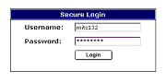Enter your logon user name and password, then click “Login.”

Open the State of New York’s shared reports folder

After you log in you will be brought to the following page:

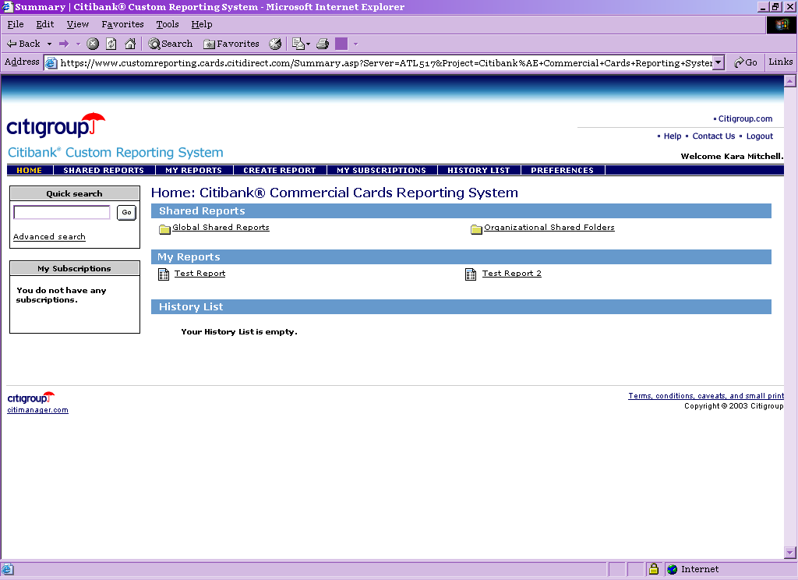

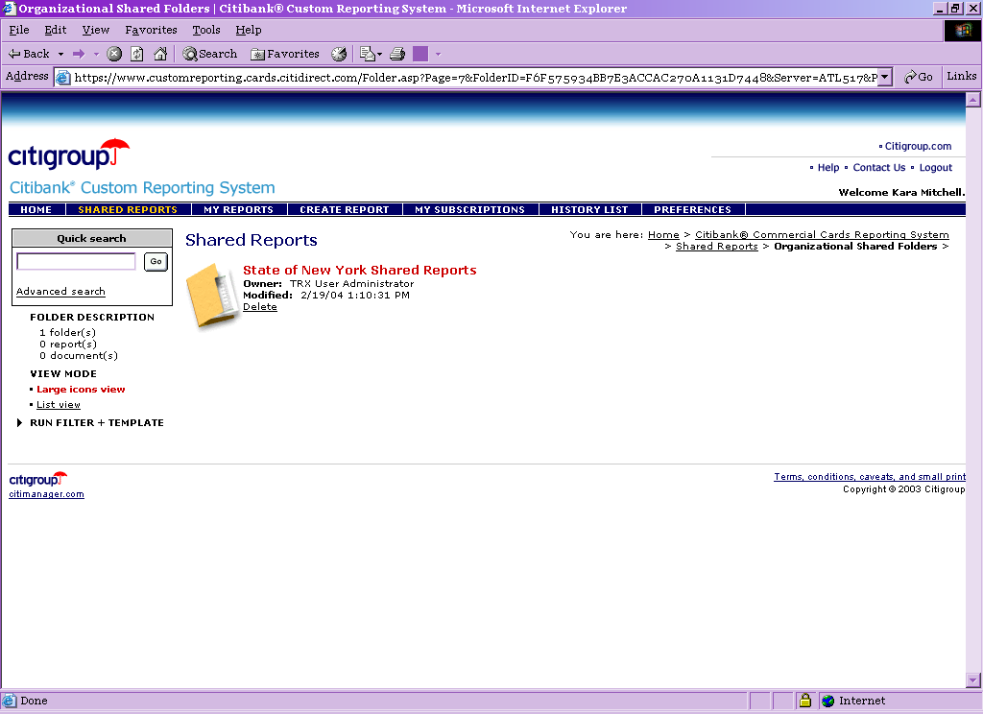
Click on the text that reads “Organizational Shared Folders. You will then be brought to the following screen:

Click on the text that reads, “State of New York Shared Reports.”
Run the report
Click on the words “Info to Register for Online Statements”
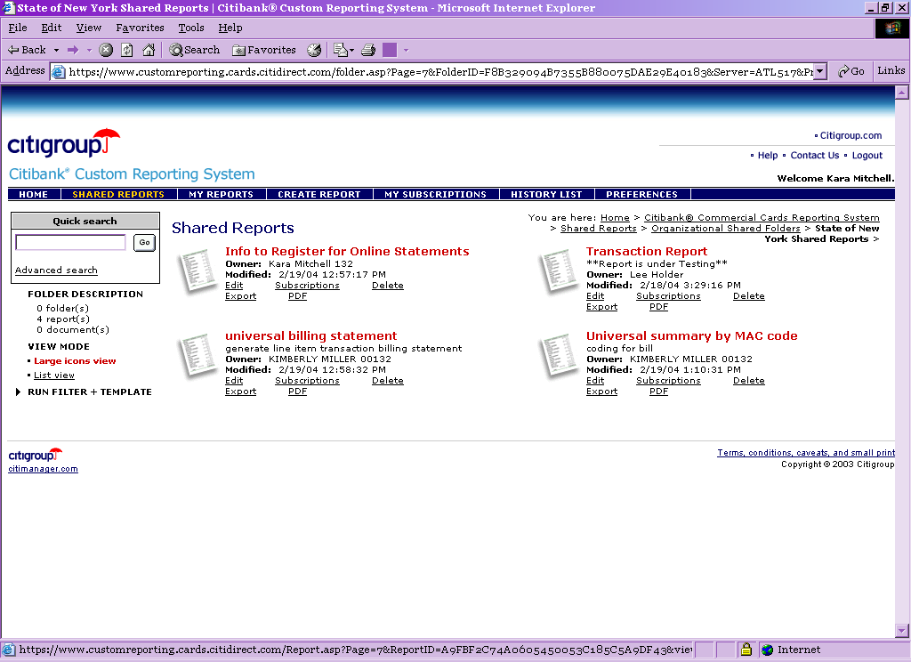

Choose to run the report on your corporate billing account. As pictured below, the reporting system should have already picked “C” for you. If not, click on “C” in the Available box and hit the right arrow to add it to the selected box. Click on Execute Report
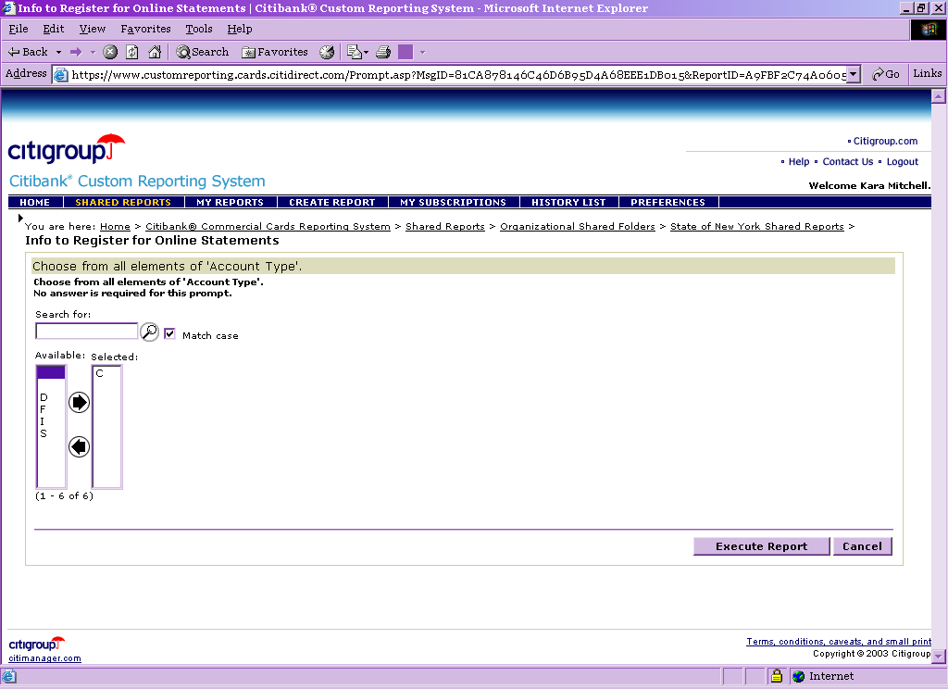

The below screen will pop up showing you are executing the report. The report should run within a few seconds.
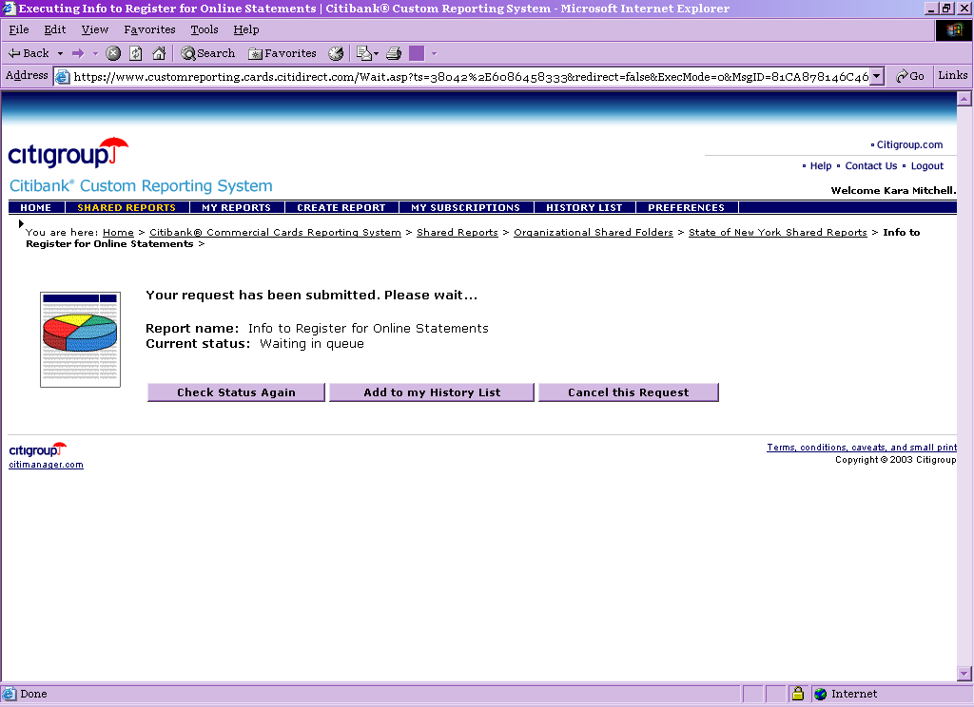

The report will generate the account name, number and address you need to register for online statements.
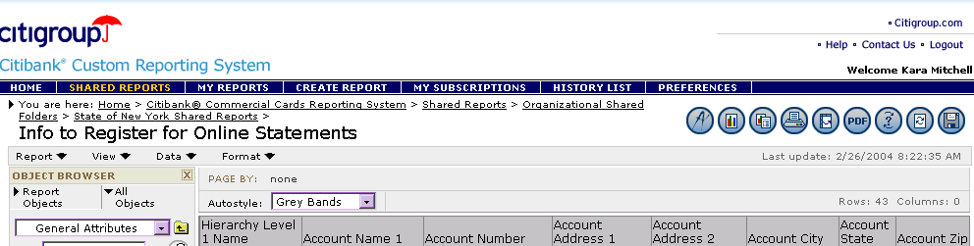
2. Register at Citibank® Online Statements to retrieve your agency’s monthly statements.
Log on to the site
Using your Internet program, sign on to https://www.onlinestatements.cards.citidirect.com.
Click on the Sign up link on the left side of the page.
Click “Continue” once you read the disclaimer that follows.

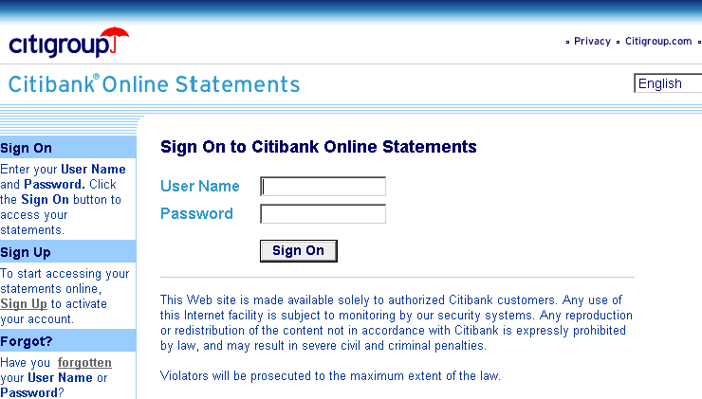

Enter Account Information
Key in your account information below exactly as is appears on the report you downloaded from the Citibank Custom Reporting System. Click “Continue” when finished.
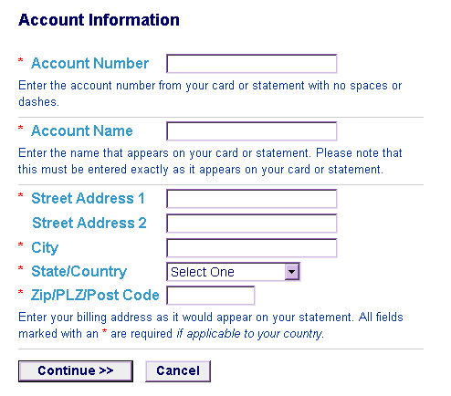

Choose User Name and Password
Enter your name in the “Name” field. Choose a user name and enter in the “User Name” field. Enter your e-mail address. Select a password hint from the list (the list includes mother’s maiden name, the city you were born in and your first pet’s name). Enter the answer to the hint in the “Answer” field. Once all fields are complete, click “Sign Up.”
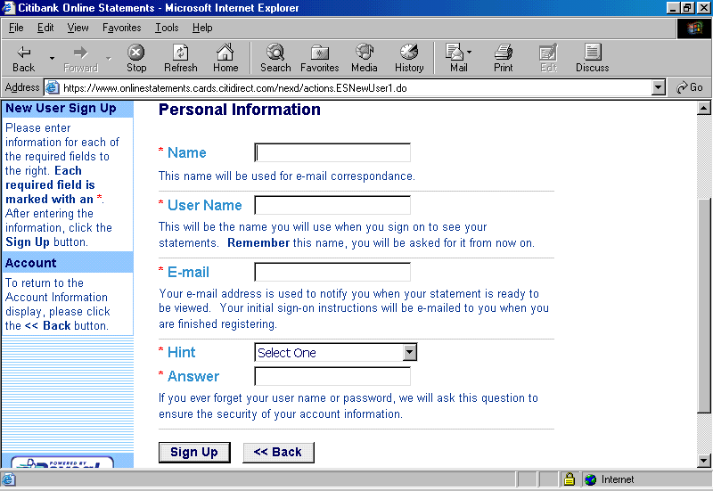

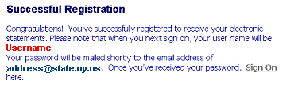You will receive the following message telling you you have successfully registered.

Sign in to System
Your temporary password will be e-mailed to you shortly. The e-mail you receive will include the following text:
Congratulations,

you have successfully registered for Citibank Online Statements.

Please visit https://www.onlinestatements.cards.citidirect.com to view your online statements. You will be asked for your user name and password
(12345678).

Once you sign on, you will be asked to provide a more permanent password of your choice.

Click on the link in the e-mail. At the Sign-on screen, enter the User Name you created and the temporary password from the e-mail (in this case, 12345678). When finished, click “Sign On.”
You will be prompted to choose a new password.
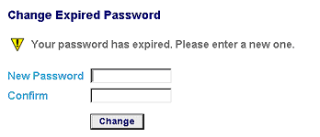

Passwords must meet the following criteria.
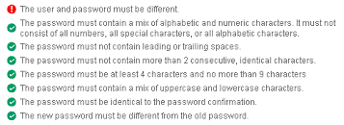

Enter the password of your choice in each field and click “Change.”
Add Alternates
You will want to add alternates to be able to access the Online Statements system. We suggest each agency register at least one additional program administrator and two accounts payable employees. Each alternate will receive an e-mail each month when the online statement is ready to view.
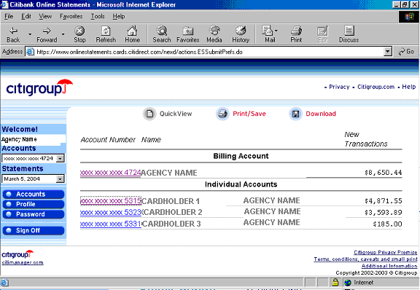Once you have successfully registered, you will be brought to a screen listing your current billing account amount due, as well as the amount due for each cardholder.

Click on the “Accounts” button on the left side of the page to begin the process of adding alternates. At the following screen, click “Add Alternate.”
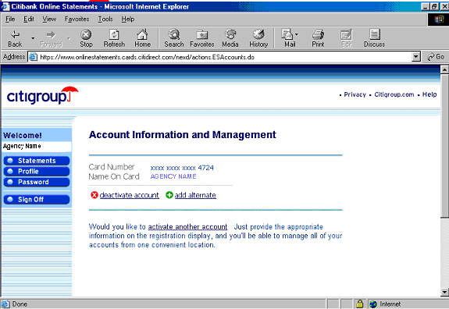

At the next screen, enter the alternate’s name and e-mail address. Leave the box checked to notify your new alternate by e-mail. When finished, click “Add Alternate.”
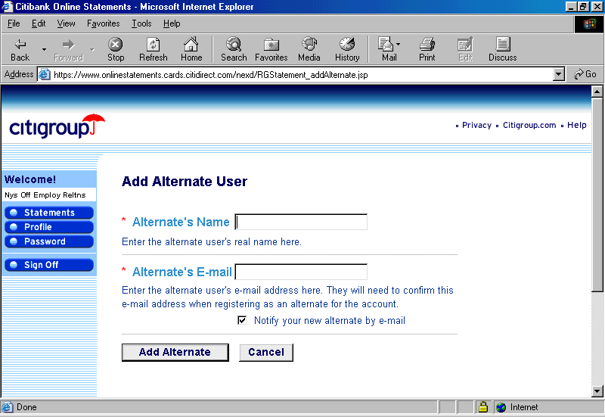
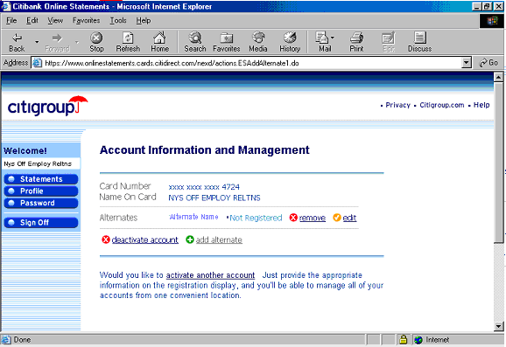You will be brought to the following screen:
From here you can add additional alternates by again clicking on “Add Alternate.”
Alternates should register
The alternate(s) will receive an email with the following message:
Greetings!

You have been assigned as an alternate viewer for account:

Name on card ..... AGENCY NAME
Account number ... XXXX-XXXX-XXXX-1234

Please register at https://www.onlinestatements.cards.citidirect.com.

The alternate should then register in the same manner as outlined above. Each alternate will need to be given the account number and address to enter into the system.
Activate Additional Accounts, if desired
From the Accounts Menu you can also activate additional accounts. This will allow you to manage all your accounts from one location (ex. procurement and travel).
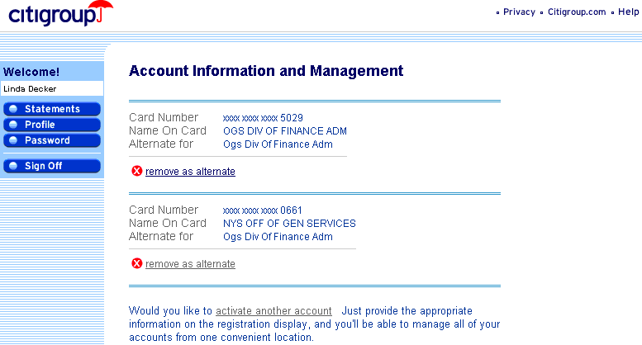
Resource Guide

Informational Websites
Citibank Resources
CitiManger (You can access all the web sites listed below from this site)
CitiBank® Customized Reporting
CitiBank® Electronic Reporting System
CitiBank® Online Statements
CitiDirect®

Disputes
Cardholders and Program Administrators may dispute a transaction using CitiDirect. After filling out an online form, CitiDirect will prompt the user to print a form and fax it to Citibank. They may also dispute a transaction by faxing a dispute form to Citibank. All forms should be faxed directly to (605) 357-2019. Please make sure to keep your fax confirmation to verify that transmission was successful.
Dispute forms can be filled out manually if the Cardholder is not using CitiDirect. A copy of the Citibank dispute form is available for review and downloaded from the OGS web site at: http://www.ogs.state.ny.us/purchase/snt/wordfiles/7900802837dispute_form.pdf.
Disputed items should be submitted within 60 days from the posting date of the charge. The cardholder or Program Administrator should follow up within this timeframe.
CONTACT INFORMATION

Contract & Program Contacts

Office of General Services
Master Contract Administration, NYS Purchasing Card Program & Non-State Entity Purchase & Travel Programs

Contract Issues & Procurement Card Administration
Non State Authorized Users
Nicholas C. Jacobia Linda Decker Rosalind Yezzi
Voice: (518) 473-4651 (518) 474-5999 (518) 402-5220
Fax: (518) 486-6867 Linda.Decker@ogs.state.ny.us Rosalind.Yeszzi@ogs.state.ny.us
nicholas.jacobia@ogs.state.ny.us

OGS Credit Card Unit
CreditCard@ogs.state.ny.us

Governor’s Office of Employee Relations
NYS Travel Card Administration

Craig Dickinson Sheila Brust
(518) 473-8317 (518) 473-1078
cdickinson@goer.state.ny.us sbrust@goer.state.ny.us

NYS Office of the State Comptroller

Credit Card Unit
Fax (518) 473-4392
CreditCard@osc.state.ny.us
110 State Street
10th Floor – Credit Card Unit
Albany, NY 12236

◊ Fax Program Administrator Set-up Forms ◊ Fax or e-mail Program Card Risk Assessment Forms
◊ Citibank Payment Instructions

Citibank Contacts

Client Account Manager
Michael Wilson
Michael1.Wilson@citi.com
Tel: 1-888-836-5011 ext 20044
Fax: 904-954-7700
Business Hours between 9:30 AM-6:00 PM,
Mon-Fri ET

◊ Hierarchy Inquiries / Additions/Revisions/ Moves ◊ Citidirect Card Management System / CERS / CCRS ID
◊ Rollout of Additional Divisions/Sites setup
◊ MCC Template Inquiries ◊ Payments / Payment Issues
◊ PA Setup/Change ◊ Security / Fraud Issues
◊ Reporting Options ◊ Collection Strategies
◊ Program Investigation

Help Desk Support
24 Hr. Help Desk: 1-800-790-7206 Option 0
Online System Helpdesk: 1-800-790-7206 Option 2, Opt 2

◊ Smart Data/Visa Information Manger/Entrust/ ◊ CitiDirect

CER/File Delivery • Password Resets
• Down Loading/Report Option Issues • New User ID Inquiries
• File Delivery Issues • General Inquiries
• Report Options
• Software Issues ◊ CitiDirect Website
• Software Installation/General Use/Issues • www.cards.citidirect.com

Cardholder and General Program Administrator Inquiries
Citibank Customer Service Tel: 800-248-4553
Collect Calls Tel: 904-954-7314
Applications Fax: 605-357-2092
Account Maintenance Fax: 605-330-6801
Dispute Fax: 605-357-2019
Attn: Corporate Cards
PO Box 6125
Sioux Falls, SD 57117
24 hours, 7 days a week

◊ Account Maintenance ◊ Payments:
• Name, Address, Phone Change, Account Closures, • Payment Inquiries
Credit/Cash Limit Changes, Etc. • Regular Payment Address:
◊ Account Status: Citibank Government/Corporate Card
• Balance, Credit, Cash, Billing Inquiries, Etc P.O. Box 6575
The Lakes, NV 88901-6575
◊ Authorizations: • Overnight Address:
• Authorizations Inquiry, Declines Citibank, NV
• Forced Authorizations Exception Payments
8725 W Sahara Ave
◊ Security Closures (Lost, Stolen, Not Received) The Lakes, NV 89117

Helpful Hints
Helpful Hints for Program Administrators (PA)
- Make sure hierarchies are set up before trying to enroll cardholders.
- Billing accounts will be created using information from hierarchy forms and need to be setup prior to cards being enrolled.
- Deleting a PA or Alternate PA will also lock them out of CitiDirect access.
- When deleting a supervisor, make sure there are not open cardholder accounts listed under the supervisor. (Procurement only)
- Procurement accounts cycle on the 6th of each month
- Travel accounts cycle on the 22nd of each month
- Credit limit for Travel cardholders is $10,000.00. PA’s and Alternate PA’s can increase the credit limits for cardholders with high travel usage.
- The PA for Purchase will determine single Purchase limit and Credit limit. The single purchase limit for any cardholder cannot exceed the agency’s quick pay limit. If there is a business need for a higher limit, the program administrator should contact the State Comptroller’s Office to discuss options.

Commonly Used Account Status (will show on reporting)

V9 = Closed Agency’s Request F1 = Lost Card
V8 = Closed Individual’s Request T2 = Returned Mail
T1 = Employee Terminated, Retired or left the Agency B9 = Deceased Cardholder
M9= Closed by Citibank/Duplicate Account
T4 = Never Received Card (NRI)
T5 = Stolen/ Unauthorized MO/TO
T6 = Fraud Early Warning block(FEW)

