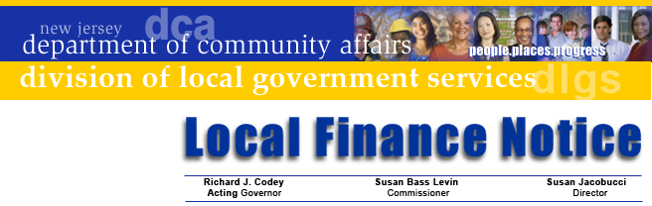

LFN 2005-2
January 12, 2005

UPDATE ON TAX COLLECTION
DATA SHARING STANDARDS

Over the past few years efforts by the Tax Collectors and Treasurers Association, data processing vendors, and members of the tax servicing and mortgage banking industry have resulted in changes to tax collection software that improves tax payment and receipting for properties who have their taxes escrowed.

The first phase of this effort was reached on a standard file format used by software vendors and tax payment services. That system, now in widespread use, involves collectors providing quarterly data billing files to tax servicers, who then return the files with payment data that permits automated postings to parcel accounts.

This system provides significant value to tax collectors. When using the standard a tax servicer making a payment of several or several hundred parcels, needs to provide a data file on disk or by e-mail along with a check or wire transfer (at the tax collector’s choice). Once received, compatible tax collection software import the data from the file and automatically post receipts to the appropriate accounts. This saves the tax collector time and effort during collection season and permits fast and reliable deposit of funds into interest bearing investment accounts.

Reliability of the process is assured by the billing file the tax collector provides servicers so that the servicers can properly match records of their active accounts with the amounts due. This ensures accurate payment amounts and permits the early identification of accounts that may have been sold or transferred to other servicers or processors.

The system is also secure. Security features built into the system provides the level of integrity needed to transfer files via e-mail; users can use this feature with confidence. Otherwise, the simple mailing of a disk is enough to take advantage of the system.

Contact Information

Director's Office
V. 609.292.6613
F. 609.292.9073
Local Government Research
V. 609.292.6110
F. 609.292.9073
Financial Regulation
and Assistance
V. 609.292.4806
F. 609.984.7388
Local Finance Board
V. 609.292.0479
F. 609.633.6243
Local Management Services
V. 609.292.7842
F. 609.633.6243
Authority Regulation
V. 609.984.0132
F. 609.984.7388
Mail and Delivery
101 South Broad St.
PO Box 803
Trenton, New Jersey
08625-0803
Web: www.nj.gov/dca/lgs
E-mail: dlgs@dca.state.nj.us

Distribution
Municipal Tax Collectors

2004 Improvements

Building on the success of the initial file standard, system developers have added new features. Missing from the original system was the capability to handle delinquent payments from escrow accounts that may have been transferred since the last tax payment. Not knowing when payments were made and handling interest calculations complicated this.

The new features:
- Creates a record for delinquent parcels and shows the delinquent principal amounts for the quarter. This permits tax payment organizations to know if the parcel is delinquent.
- Includes in the file any outstanding principal amount and interest calculated to the payment date (i.e., the first, or the 10th of the month for those with grace periods).
- Provides a single payment including current taxes, outstanding delinquency, and interest to the payment date in the payment file.

The impact of these changes will result in tax collectors being able to take advantage of improved collection practices. The key benefit is that quarterly payment files from tax servicers will include interest payments. The local system will automatically post the payments to taxpayer accounts.

Implementing the Changes

When implementing the new capabilities, tax collectors should consider sending their files via e-mail and permit tax servicers to send their files via e-mail in lieu of sending disks. Tax Collectors should also consider permitting wire or ACH payments directly into the bank account used for tax payments. These are now common business practices and can speed up the processing and handling of tax payments. Your software provider can assist you in implementing practices the software related changes and your bank representative can assist you with using wire or ACH deposits.

For its part, the Division will be assisting the mortgage and tax servicing industry by posting monthly updates of our tax code registry on our web site. We are also posting the data exchange file format on our site as well.

Finally, the team that developed this system will continue developing enhancements to address issues such as added and omitted taxes and using the new file format to assist the Division of Taxation provide delinquent revenues to municipalities through its state tax set-off program (SOILS).

The data file layouts and instructions can be obtained from participating software vendors, from the Division’s web site at www.state.nj.us/dca/lgs/taxes/taxmenu.shtml, or by calling the Division at 609.292.4656. Tax collectors desiring to use the system should contact their software vendor to find out if their system has been modified to accommodate it.

The Division thanks the many individuals who played a role in developing the model. We look forward to its routine use and its continued evolution.

Approved: Susan Jacobucci, Director

