FREDERICKSBURG REGIONAL GOVERNOR'S SCHOOL

FOR GIFTED STUDENTS

2023 SUMMER PROGRAM

GRADE 8 (rising 9th grade)

Application Forms and Information Packets

PARTICIPATING SCHOOL DIVISIONS: DATES & : June 5-9, 2023

King George TIME 9:00 a.m. - 3:00 p.m.
Caroline
Fredericksburg
Spotsylvania
Stafford

LOCATION: James Monroe High School, Fredericksburg, VA

OPEN HOUSE: Friday, June 9, 2023
2:15 p.m.
James Monroe High School
Fredericksburg, VA

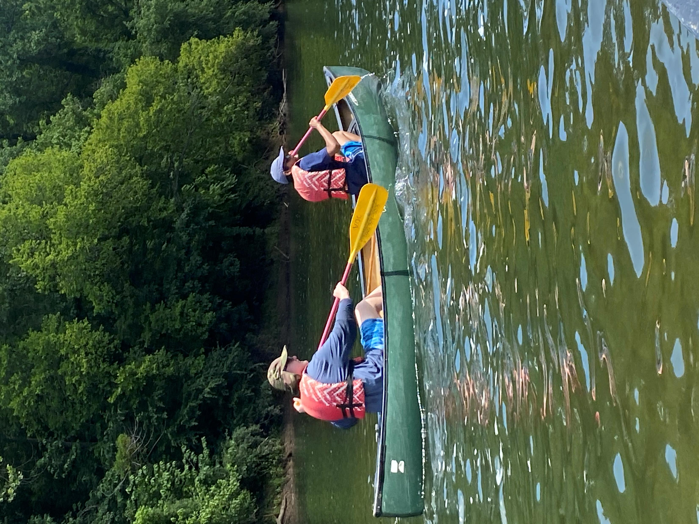
FREDERICKSBURG REGIONAL GOVERNOR’S SCHOOL
Grade 8
(rising 9th grade)
PROGRAM DESCRIPTION

COURSE TITLE: Environmental Technology– A Study of the Relationship Between Technology and Environmental Resources

DESCRIPTION: The goal of this course is to educate the student about the impact their lifestyle has on the world they live in. In a time of technology and convenience it is oftentimes easy to forget what has to happen to support our lifestyles. This course will expose the students to the many methods society has to employ in order to achieve our everyday living standard. It will further examine possible solutions to bridge a gap between what we have become accustomed to and the unsustainable ways we take to maintain our living standard. Students will understand their own “Ecofootprints” as well as emerging technologies that relate to better conservation and use of our limited natural resources. In the field experiences will be heavily relied on to expose students to conditions and technologies discussed and taught during the classroom portion of the course.

STUDENT
SELECTION: All students who will be completing eighth grade in 2023 and who are eligible to attend
school in Caroline, Fredericksburg, King George, Spotsylvania, and Stafford are eligible to
apply. Students must be identified as gifted within their school division and selected by their school division. Every effort will be made to accommodate your class preference. Your school cannot guarantee course selection. Please await confirmation from the Fredericksburg Regional Governor's School program.

LOCATION: JAMES MONROE HIGH SCHOOL will be the base school. However, as some field trips are planned for the class, a schedule will be sent to each participant prior to the beginning of the class.

DATE: June 5-9, 2023
TIME: 9:00 a.m. - 3:00 pm (Times may vary on field trip days).

COST: Tuition Free--The Fredericksburg Regional Governor's School is supported by our business community, the participating school divisions and a grant from the State Department of Education, Programs for the Gifted.

The Fredericksburg Regional Governor's School does not deny access to any program or activity on the basis of handicap, race, color, religion, national origin, or age. Where necessary, modification will be made to provide for the disabled. Specific questions on situations which may require alteration of current practices to accommodate disabled persons should be directed to Director, Fredericksburg Regional Governor's School at 1 Learning Lane, Fredericksburg, VA 22401 (Phone: 540-372-1120).

APPLICATIONS ARE TO BE COMPLETED AND RETURNED TO THE
GIFTED RESOURCE TEACHER AT YOUR SCHOOL BY _____________________
FREDERICKSBURG REGIONAL GOVERNOR’S SCHOOL
Summer 2023
GRADE 8 (rising grade 9)

APPLICATION FORM

School Division: Fredericksburg City Spotsylvania County
Stafford County King George County
Caroline County Private School

Student Name
Parent Name
Address
City |  |  | ZIP
Phone Numbers | Home - | Work -
Parent E-Mail
School Name

PARENTS PLEASE NOTE:
The Fredericksburg Regional Governor’s School is open only to students who have been identified by their school system as gifted. Classes are limited in size to provide individual attention and maximum access to equipment. It is expected that there will be far more applicants than can be accommodated. Experience has also shown that the program is most beneficial if the student really wants to participate. Please do not apply if you and your child are not prepared to make a commitment for the entire week of the program.

I agree to participate in this program if I am selected.

Date _________________________________ (Student's Signature)

I give permission for my child to participate in this program if selected and will provide transportation to and from the class meeting site.

Date _________________________________ (Parent's Signature)

RETURN COMPLETED APPLICATION TO THE GIFTED RESOURCE TEACHER
AT YOUR SCHOOL BY _____________________________
FREDERICKSBURG REGIONAL GOVERNOR’S SCHOOL
SUMMER PROGRAM 2023
GRADE 8 (rising grade 9
*Applicants should be current members of their division’s Gifted & Talented Program

I. ACADEMIC BACKGROUND:
Please list all math, science, and computer classes that you have had in middle school (6-8); include your present classes. Also list your grade (A,B,C, etc.) in each class.

Name of Class | Grade
Math:
Science:
CTE:
Overall GPA of all classes:

Have your participated in the Regional Summer Governor’s School before? Yes or No

II. STUDENT ACTIVITIES, INTERESTS, & HOBBIES.
In this section, please indicate how you currently spend your after school and summer times.
- List the five most significant hobbies in order of their interest to you (you are welcome to list more than 5). These should be activities you are passionate about participating in.
- Make sure to list any science, technology, or engineering activities or interests.
- In the space provided, describe your involvement in those activities, hobbies, passionate pursuits.

Activity | Approximate Time per week | Involvement

FREDERICKSBURG REGIONAL GOVERNOR’S SCHOOL

III. Personal Statement: Please use the space provided to give a personal statement on your desire to attend the Regional Governor’s School and your interest in learning in the areas of science and technology. You may use the back of the form or additional space if needed.

Please use this rubric to guide your personal statement writing prompt. | 2/2 | 1/2
Purpose & Content  Is the purpose of this personal statement clearly conveyed? | Addresses the prompt (personal statement/includes interest in STEM. Statement shows focus. Content offers significant information about the writer & provides concrete examples. | Marginally addresses the prompt, needs more specific focus. Content is somewhat weak & writer needs more specific information/examples. Content is off topic, vague or general.
Individuality  Does the personal statement effectively distinguish the author from other applicants? Is the author memorable & remarkable for the right reasons? | Writer has a clear voice/presence through detailed focus on experience, activities, background etc. Topics show originality/insights/personality. | Writer offers details but does not leave a strong impression.  Writer does no leave a dominant impression because the information is dull, vague, or lacking examples.
Mechanics  Is the piece grammatically sound? Are there any misspellings or typos? Are there errors in punctuation or structure? | Writer has less then 3 mechanical errors. | Writer has more than 3 mechanical errors that could include run-on sentences, fragments, verb problems, pronoun problems, spelling/diction, commas, sentence construction problems.

FREDERICKSBURG REGIONAL GOVERNOR’S SCHOOL

IV. TO BE COMPLETED BY MATH TEACHER: 1st recommendation
Please recommend any current students that you expect to be good candidates for the Regional Summer Governor's School for Technology and Science. They should be in the top 25% of their class, be enrolled in upper level math and/or science classes, and have high standardized test and class scores.

Student _______________________________ School _________________________ Grade ____________

Teacher ______________________________________ Subject _____________________________________

Directions: Please read the following statements carefully and place an X in the appropriate block according to the scale below:
1 - If you have seldom or never observed this characteristic.
2 - If you have observed this characteristic occasionally
3 - If you have observed this characteristic to a considerable degree
 | 3 | 2 | 1
Exhibits creativity and ingenuity through the production of originally designed and produced products.
Is adventurous, anxious to try new things within the areas of technical arts/science/math.
Is a keen observer; usually sees more in an assignment than other students.
Reasons things out; attempts to understand complicated material.
Is able to generate several alternatives to technical arts/science/math problems.
Attempts projects independently in class or at home.
Completed products are of superior quality.
Requires little external modification if an assignment is interesting to him/her.
Is proficient in the use of tools or equipment utilized in technical arts/science.
Can apply concepts learned to new situations or problems.
Add column total
Multiply by weight | 3 | 2 | 1
Weighted column total
Combined Total

FREDERICKSBURG REGIONAL GOVERNOR’S SCHOOL

IV. TO BE COMPLETED BY SCIENCE TEACHER: 2nd recommendation
Please recommend any current students that you expect to be good candidates for the Regional Summer Governor's School for Technology and Science. They should be in the top 25% of their class, be enrolled in upper level math and/or science classes, and have high standardized test and class scores.

Student _______________________________ School _________________________ Grade ____________

Teacher ______________________________________ Subject _____________________________________

Directions: Please read the following statements carefully and place an X in the appropriate block according to the scale below:
1 - If you have seldom or never observed this characteristic.
2 - If you have observed this characteristic occasionally
3 - If you have observed this characteristic to a considerable degree
 | 3 | 2 | 1
Exhibits creativity and ingenuity through the production of originally designed and produced products.
Is adventurous, anxious to try new things within the areas of technical arts/science/math.
Is a keen observer; usually sees more in an assignment than other students.
Reasons things out; attempts to understand complicated material.
Is able to generate several alternatives to technical arts/science/math problems.
Attempts projects independently in class or at home.
Completed products are of superior quality.
Requires little external modification if an assignment is interesting to him/her.
Is proficient in the use of tools or equipment utilized in technical arts/science.
Can apply concepts learned to new situations or problems.
Add column total
Multiply by weight | 3 | 2 | 1
Weighted column total
Combined Total

FREDERICKSBURG REGIONAL GOVERNOR’S SCHOOL

IV. TO BE COMPLETED BY ENGLISH TEACHER: 3nd recommendation
Please recommend any current students that you expect to be good candidates for the Regional Summer Governor's School for Technology and Science. They should be in the top 25% of their class, be enrolled in upper level math and/or science classes, and have high standardized test and class scores.

Student _______________________________ School _________________________ Grade ____________

Teacher ______________________________________ Subject _____________________________________

Directions: Please read the following statements carefully and place an X in the appropriate block according to the scale below:
1 - If you have seldom or never observed this characteristic.
2 - If you have observed this characteristic occasionally
3 - If you have observed this characteristic to a considerable degree
 | 3 | 2 | 1
Exhibits creativity and ingenuity through the production of originally designed and produced products.
Is adventurous, anxious to try new things within the areas of technical arts/science/math.
Is a keen observer; usually sees more in an assignment than other students.
Reasons things out; attempts to understand complicated material.
Is able to generate several alternatives to technical arts/science/math problems.
Attempts projects independently in class or at home.
Completed products are of superior quality.
Requires little external modification if an assignment is interesting to him/her.
Is proficient in the use of tools or equipment utilized in technical arts/science.
Can apply concepts learned to new situations or problems.
Add column total
Multiply by weight | 3 | 2 | 1
Weighted column total
Combined Total

FREDERICKSBURG REGIONAL GOVERNOR’S SCHOOL

IV. TO BE COMPLETED BY ADMINISTRATOR, MENTOR, OR OTHER
ADULT: 4th recommendation
Please recommend the following child that you expect to be good candidates for the Regional Summer Governor's School for Technology and Science. They should be in the top 25% of their class, be enrolled in upper level math and/or science classes, and have high standardized test and class scores.

Student _______________________________ School _________________________ Grade ____________

Your Name ______________________________________ Subject ___________________________________

Directions: Please read the following statements carefully and place an X in the appropriate block according to the scale below:
1 - If you have seldom or never observed this characteristic.
2 - If you have observed this characteristic occasionally
3 - If you have observed this characteristic to a considerable degree
 | 3 | 2 | 1
Exhibits creativity and ingenuity through the production of originally designed and produced products.
Is adventurous, anxious to try new things.
Is a keen observer; usually sees more in matters than other children.
Reasons things out; attempts to understand complicated material.
Is able to generate several alternatives to problems.
Attempts projects independently in school or at home.
Works well with other children and generally gets along well in social settings.
Requires little external modification if a task is interesting to him/her.
Is proficient in the use of tools or equipment utilized in today’s technical world.
Can apply concepts learned to new situations or problems.
Add column total
Multiply by weight | 3 | 2 | 1
Weighted column total
Combined Total

