7th Grade Science - Safety Poster Guidelines

Name:_______________________________Period:______Due Date:__________________________

Safety Rule I was Assigned:___________________________________________________________

You will make a poster that depicts a safety rule and the consequences of NOT following it. Keep in mind this is an individual assignment! You may get ideas and suggestions from your group members but you must complete the poster by yourself. This safety poster may have words written on it and must clearly depict the safety rule. These posters will be displayed around the room as reminders to students during future laboratory investigations of the safety rules. Please make sure they are easily seen. Be creative and colorful!

Students will use cardstock or poster board for their posters and include information to explain their safety rule on the poster.

It would be in your best interest to view the grading rubric prior to starting your safety poster. By doing so, you will have a better idea of how you will be graded on this portion.

Poster Guidelines:

USE COLOR! BE NEAT!

BE CREATIVE!!!

Students may draw, use magazine cutouts, or use computer generated clipart or drawings on their poster.

Create the poster so another person can understand the safety rule being shown without any other form of explanation.

Poster must be clearly seen from your desk when it is hung on the wall.

Poster must be neat and organized.
Grading Rubric for Poster:

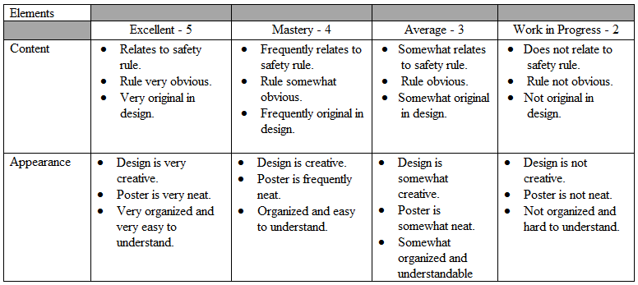

Grade for this poster is __________ /30.
(Mrs. Bumgardner will fill this out)

