Public Education Information Management System

PEIMS EDIT+
User Reference and
Training Guide



Texas Education Agency
FMY1112 Release
10/17/11.1

Note: Please contact EDIT+ Customer Support at editplus@tea.state.tx.us (or 512-463-9229)
with any questions you may have about this document.

The images in this document are provided for illustration purposes only and do not contain real data.
This document is the property of the Texas Education Agency. All rights reserved.

© Texas Education Agency–PEIMS Division
Enterprise Data Management Group
1701 North Congress Avenue
Austin, Texas 78701

1st Edition – 17th Edition September 2001 – April 2011
18th Edition October 2011
Table of Contents
Introduction 9
Overview 9
Prerequisite Knowledge and Skills 9
EDIT+ External Website 9
Customer Support 9
Chapter 1–The EDIT+ Environment 11
Overview 11
The Collection Process 11
PEIMS Collection Databases 12
Approved and Working Collections 12
Archive Policy 12
Chapter 2–The EDIT+ Hierarchy 13
Overview 13
Hierarchy Structure and Agent IDs 13
Working with Agent IDs 14
Alternate Agent IDs 14
AskTED 14
Campus Status Definitions in AskTED 15
Changes to AskTED Data 15
Chapter 3–Getting Started 17
Overview 17
System and Software Requirements 17
Accessing EDIT+ 18
TEASE Log On 18
EDIT+ Home Page 19
Home Page Functionality 19
Home Page Messages 19
Customer Support Services 20
Customer Support Resources 20
Customer Support Requests 21
Chapter 4–Email Notification 23
Overview 23
Automatic Email Notification 23
Selecting Automatic Email Notification 23
Examples of Automatic Email Notification Messages 24
User-Controlled Email Notification 25
Conditions for Sending User-Controlled Email Notification 25
Examples of User-Controlled Email Notification Messages 25
Chapter 5–PEIMS Data Submission 27
Overview 27
PEIMS Data Files: Sending the File 27
Selecting Files for Transfer/Upload and Validation 28
Validation Options 28
PEIMS Data Files: Managing File Processing 30
Progress Monitor 30
Logging Off During File Validation 30
User-Controlled Abort Button 30
File Not Found Message 30
Viewing Files in the Processing Queue 31
The Collection Status Page 32
Collection Status Page–Alternate Agents as a File List Option 32
Collection Status Page–Multi-Column Sort 32
Collection Status Page–File History 33
Collection Status Page–Version History 33
Collection Status Page–File Status Detail 34
Collection Status Page–View Edit Error Reports 34
PEIMS Data Files: Revalidating the Data 35
PEIMS Data Files: Retrieving the File 36
PEIMS Data Files: Understanding Valid Data 37
Aborted Status 37
Max Load Errors Exceeded 38
Maximum Validation Errors (Per Rule Error Limit) 38
Context Edits and Record Type Field Edits 39
PID Edit Record Requirements 39
Using Negative Numbers in EDIT+ 39
Knowledge and Skill 40
Exercise 5.1–Transferring a PEIMS Data File 40
Exercise 5.2–Sending a Partial File 40
Exercise 5.3–Choosing Record Groups 40
Exercise 5.4–Transferring a Fatal Free File 41
Exercise 5.5–Revalidating a File 41
Exercise 5.6–Retrieving Data 41
Chapter 6–PEIMS Data Acceptance 43
Overview 43
Campuses and the Data Acceptance Process 43
Campus Role–Completing the Campus File 43
Conditions for Completing a Campus File 43
Process for Completing a Campus File 44
Districts and the Data Acceptance Process 45
District Role–Accepting the Campus File 45
Process for Accepting a Campus File 45
District Role–Rejecting the Campus File 45
Conditions for Rejecting a Campus File 45
Process for Rejecting a Campus File 45
District Role–Completing the District File 46
Conditions for Completing the District File 47
Process for Completing the District File 47
ESCs and the Data Acceptance Process 48
ESC Role–Accepting the District File 48
Conditions for Accepting a District File 49
Process for Accepting a District File 49
ESC Role–Rejecting the District File 49
Process for Rejecting a District File 49
Knowledge and Skill Exercises 50
Exercise 6.1–Accepting a Campus File 50
Exercise 6.2–Completing a District File 50
Exercise 6.3–Accepting a District File 50
Chapter 7–EDIT+ Reports: Categories 51
Overview 51
The EDIT+ Report Hierarchy 51
General EDIT+ Report Categories 51
Standard Reports 51
Special Reports 52
Turnaround Reports 52
Edit Error Reports 53
Working with Errors 53
Other Categories of EDIT+ Reports 55
Collection Status Reports and Lookup Tables 55
Working with the Collection Status Report 55
Collection Status Report for Alternate Agents 56
Collection Error Summary 56
Working With Lookup Tables 57
PID Error Rate Reports 58
Student Leaver Record Submission Support Reports 58
Generating Student Leaver Reports from the EDIT+ Database 58
Generating Student Leaver Reports from a District File 60
Campus-Level Reports 60
Region-Wide Reports 61
Knowledge and Skill Exercises 62
Exercise 7.1–View Edit Error Report and View Edit Errors Online 62
Exercise 7.2–Collection Status Report and Look Up Tables 62
Chapter 8–EDIT+ Reports: Functionality 63
Overview 63
Reports that are Generated On Demand 63
Reports that are Auto-Generated 64
Selecting Auto-Generated Reports 64
Viewing Auto-Generated Reports 65
Auto-Generated Reports at Rollup of an EDIT+ Collection 65
Reports that are Bundled 66
Bundling Individual District-Level Reports (ESC Users) 66
Bundling District-Level Reports by Report Group (District Users) 67
Bundling Individual Campus-Level Reports (District Users) 68
Bundling All Reports for All Campuses–Super Campus Bundle (District Users) 69
Bundling District File Campus Reports (Campus Users) 69
Reports that are Parameter-Driven 70
Requesting a Report 70
Monitoring a Requested Report 72
Generating a Previously Requested Report Using Different Parameters 73
General Guidelines for Saving, Viewing, and Printing Reports 74
Required Software 74
Using the EDIT+ Download Page to Install the Required Software 74
Saving (Downloading) EDIT+ Reports 74
Extracting Zipped EDIT+ Reports 75
Viewing EDIT+ Reports 75
Printing EDIT+ Reports from PDF Files 75
Knowledge and Skill Exercises 76
Exercise 8.1–Generating EDIT+ Reports 76
Chapter 9–PID Search and PID Detail 77
Overview 77
PID Search 77
Conducting a PID Search 77
PID Detail 78
Manual Changes to PID (Campus 700) 79
Knowledge and Skill Exercises 80
Exercise 9.1–PID Search 80
Chapter 10–Roster Search 81
Overview 81
Accessing Roster Search 81
Using Roster Search 81
Knowledge and Skill Exercises 83
Exercise 10.1–Roster Search 83
Chapter 11–Data Search 85
Overview 85
Searching and Displaying Data 85
Knowledge and Skill Exercises 86
Exercise 11.1–Data Search 86
Chapter 12–Table Downloads 87
Overview 87
Downloading Table Data 87
Extracting Table Data from a Zip File 88
Knowledge and Skill Exercises 89
Exercise 12.1–Table Download 89

Table of Figures
Figure 1. PEIMS Data Collection and Acceptance Process 11
Figure 2. Relationship of Agent ID to Hierarchy Structure 13
Figure 3. Sample TEASE Login ID and Associated Record Types 13
Figure 4. TEASE Log On Page 18
Figure 5. Application List Page 18
Figure 6. EDIT+ Home Page 19
Figure 7. Customer Support Resources Page 20
Figure 8. Customer Support Request Page 21
Figure 9. CSR Address Book 21
Figure 10. Send Data–Select File 28
Figure 11. Select Validation Options–Single File 29
Figure 12. Select Validation Options–Multiple Files 29
Figure 13. Progress Monitor 30
Figure 14. PEIMS File Queue Page 31
Figure 15. Multi-Column Sort–Sort Menus 32
Figure 16. File History Page–Click Here Link 33
Figure 17. Version History–File Process History 33
Figure 18. District File Status Detail–Link from File History Page 34
Figure 19. District File Status Detail Page 34
Figure 20. District Collection Status Page–View Button for Edit Error Reports 34
Figure 21. Errors Reports Page 35
Figure 22. Revalidate Data 35
Figure 23. Revalidate File 36
Figure 24. Campus View–Collection Status Page and Complete Button 44
Figure 25. Campus View–Complete File Page with Confirmation Letter 44
Figure 26. District View–Collection Status Page and Reject Button 45
Figure 27. District View–File Reject Page with Rejection Letter 46
Figure 28. District View–Collection Status Page and Complete Button 47
Figure 29. District View–Complete File Page with Confirmation Letter 48
Figure 30. Online Error Listing–Search Fields 54
Figure 31. Online Error Listing–Search Results 54
Figure 32. Collection Status Report Page–ESC View 55
Figure 33. Collection Status Report for Alternate Agents Link 56
Figure 34. Collection Error Summary Page Detail 56
Figure 35. Collection Status and Lookup Tables Page 57
Figure 36. Student Leaver Record Submission Support Reports Page 58
Figure 37. Student Leaver Record Submission Support Reports–Statewide 59
Figure 38. Student Leaver Record Submission Support Reports–District 60
Figure 39. Select Approved Collection 61
Figure 40. View Reports–Campus Generated From District File 61
Figure 41. Standard Reports Page–On Demand Button 63
Figure 42. Reports By Campus Page 64
Figure 43. Select Validation Options Page–Select Reports Button 64
Figure 44. Select Auto-Generated Reports Page–Standard Reports Selection 65
Figure 45. Bundled District Reports Page–Select Report Drop-Down List 66
Figure 46. Bundled District Reports–Download Link 67
Figure 47. Standard Reports Page–Bundle Reports by Group 67
Figure 48. Bundle Reports by Campus 68
Figure 49. Super Campus Bundle Button for District Users 69
Figure 50. Bundled Reports for District File Campus Reports 69
Figure 51. My Report Request Page–Initial Launch 70
Figure 52. Create Report Request Page–Sample Report Parameters 71
Figure 53. My Report Requests–List of Requested Reports 73
Figure 54. My Report Requests–Edit Report Request 73
Figure 55. PID Search 77
Figure 56. PID Search–Results 78
Figure 57. PID Detail–Results 78
Figure 58. Prior Year Student Roster Search 81
Figure 59. Roster Search Results 82
Figure 60. PID Error Detail 82
Figure 61. Data Search–Select Record Type 85
Figure 62. Data Search Results 86
Figure 63. Table Downloads Page–Select Download 87
Figure 64. View Table Data in Notepad 88

Introduction

Overview
The PEIMS EDIT+ User Reference and Training Guide is designed to help the new EDIT+ user understand the features and functionality of the PEIMS EDIT+ web-based software application.

Prerequisite Knowledge and Skills
To gain the most from this Guide, you should have:
- basic knowledge of the PEIMS EDIT+ data collection process
- familiarity with the Windows® environment, Internet Explorer® and web navigation
For a general overview of PEIMS EDIT+ application, please review the Quick Start Guide found on the EDIT+ external website at www.tea.state.tx.us/index4.aspx?id=6553.

EDIT+ External Website
The EDIT+ external website (www.tea.state.tx.us/index4.aspx?id=3024) provides the following educational and instructional information about the EDIT+ software application:
- What is EDIT+?–Describes the EDIT+ application and operating procedures.
- User Setup–Provides a checklist for EDIT+ system requirements and user access forms.
- User Materials–Provides links to user reference manuals including the PEIMS EDIT+
User Reference and Training Guide, Administrator Reference and Training Guide, Quick Start Guide, and Table Downloads Reference.
- Tech Tips–Provides instructional technical documentation for the experienced EDIT+ user.
- Reports Reference–Informs the user about EDIT+ reports resources.
- Release Letters–Displays a list of recent EDIT+ Release Letters providing important information about new functionality, new reports, changes, and updates.
- FAQs (Frequently Asked Questions)–Questions and answers most commonly asked by users.
- Comments–Provides the user with a convenient method to contact EDIT+ Customer Support regarding questions, comments, and suggestions.
- PEIMS Collection Schedules–Displays current and prior year collection schedules.
- PEIMS Data Standards–Provides a convenient link to the PEIMS Data Standards.
- TEASE Log On–Displays the TEASE Log On page for direct access to the EDIT+ application.

Customer Support
Should you have any questions about this document or the features and functionality of EDIT+, please contact EDIT+ Customer Support at editplus@tea.state.tx.us or (512) 463-9229.

Notes:

Chapter 1–The EDIT+ Environment

Overview
PEIMS EDIT+ is a web-based application developed to provide a resource for Texas school regions, districts, and campuses to submit their PEIMS data to the TEA via the Internet. The application is used to transfer data files; validate data; generate reports; and query the Personal Identification Database (PID), a dynamic database of Texas student/staff demographic information. TEA uses PEIMS data to determine funding and accountability for each campus, along with providing data to TEA’s Public Education Information Resource Data Warehouse.
EDIT+ has two major software releases a year providing for four distinct data collections: early-to-mid October (Fall, Mid-Year) and early-to-mid April (Summer, Extended Year).

The Collection Process
PEIMS data goes through a series of steps as it travels from data collection at the campus level, through the district and ESC acceptance levels, and is finally submitted to TEA. The diagram below shows a flow chart of the data collection and acceptance process.
Figure 1. PEIMS Data Collection and Acceptance Process
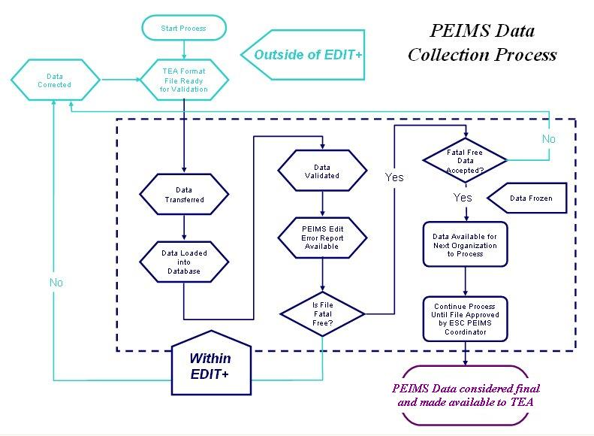

PEIMS Collection Databases
To ensure data integrity, EDIT+ defines a separate database environment for each collection (Fall, Mid-Year, Summer and Extended Year) and for the first and second submissions for those collections. This allows users to work on collections that have overlapping dates; and, provides the capability to access reports from previous collections.
The first time you access EDIT+ you are connected to the default collection. Subsequent log ins connect you to the last-accessed database. This means that once you’ve associated yourself with the first submission of the Fall Collection, your user profile remembers that until you change the association, using the Select Collection button.

Approved and Working Collections
At times, it is necessary to access prior year or historical collections in order to run edits, view reports, retrieve files, or conduct PID Searches and PID Edits. Once a database collection is closed (submission and re-submission), it is available in two forms:
Approved collections contain all the final PEIMS data and reports for every district for historical purposes. The data is frozen and sending files for validation against this database is not allowed. Approved collections are available in the Current Year Closed PEIMS Collection, the Prior Year Closed PEIMS Collection, and the Archived PEIMS Collection.
Working collections contain no data upon creation. The database is empty until you send a file. As always, the latest version of the file is available. This workspace allows authorized users to send partial files for validation and run reports if needed. This database also allows authorized users to submit PID verifies.

Archive Policy
The final submission of PEIMS data is readily accessible online for three years (current year and prior two years) and then archived to tape. Tapes can be retrieved by contacting EDIT+ Customer Support via email at editplus@tea.state.tx.us.
District-level reports generated through EDIT+ are readily accessible online for five years (current year and four prior years) and are not archived to tape. After five years, the bundled reports are no longer accessible.

Chapter 2–The EDIT+ Hierarchy

Overview
As discussed in the previous chapter, EDIT+ access is secured using multiple levels of system and application-design to protect the privacy of student and staff education records. PEIMS data is also protected within the EDIT+ application via the user-permissions hierarchy structure, associated record types, and file naming conventions.

Hierarchy Structure and Agent IDs
When a user’s TEASE Login ID is created, it is associated within a hierarchy structure and identified with an Agent ID, an Agent Type and an Agent Name. The Agent ID is the numeric identification of the campus, district, or ESC; the Agent Type is the role (campus, district, or ESC), and the Agent Name is the alpha name.
Figure 2. Relationship of Agent ID to Hierarchy Structure
User | TEASE Login ID | Agent ID | Agent Type | Agent Name
A | Assigned by TEA | 999950 | ESC/ESC Only | Education Service Center XCXI
B | Assigned by TEA | 999999 | District | Learning ISD
C | Assigned by TEA | 999999001 | Campus/Campus Only | Learning High School
Record Types
Additionally, the TEASE Login ID is associated with specific record types. Only certain users are able to work with certain record types. For example:
Figure 3. Sample TEASE Login ID and Associated Record Types
Sample TEASE Login ID | Associated Record Types
C999999001A_sample 1 | All
D999999A_sample 1 | Organization (010,011,020); Finance (030)
D999999B_sample 2 | Staff (040,043,050,055,060,090)
D999999C_sample 3 | Student (100,101,105,110,163,169,170,203)
R999950A_sample 1 | All
Note: C=campus; D=district; R=region (ESC)
File Naming Convention
The final element of data integrity is the file name. The first character of the name identifies the collection (F, M, S, E). Characters in positions 2-5 represent the 4-digit school year. Characters in positions 6-11 identify the district or region ID. Any characters in positions 12-14 identify the file as a campus file. If the there are any characters in positions 15-17, the system recognizes the file as a partial file (the term partial file indicates the file can be sent through EDIT+ but is not yet ready for submission to TEA). A file extension of .XML indicates the file is an .XML formatted PEIMS submission. Prior to 2009-2010, a single-digit school year identifier was used in the file naming convention.
Working with Agent IDs
PEIMS data tables are created with the hierarchy relationship of campus to district, and district to region. A user with the Agent Type of ESC can work with data for the region, for all districts within that region and for all campuses within each district. A user with the Agent Type of district can work with all campuses within the district. A user with the Agent Type of campus can only work with data for that campus. The Agent Name and Agent ID for the user in context display along the top banner of each webpage.
There may be times when a user from a higher-level of the hierarchy is authorized to work with a large number of files, view file processing status, or reports for Agent IDs within their hierarchy structure. This can be achieved by using a Change Agent ID button on the EDIT+ home page, thus applying an Agent ID filter.

Alternate Agent IDs
An Alternate Agent ID is an EDIT+ user from one Agent ID or hierarchy assisting a district or campus from a different Agent ID or hierarchy. Creating Alternate Agent IDs allows assignment of EDIT+ authority outside of the normal Agent ID or hierarchy.
Examples of an Alternate Agent ID relationship are:
- a large district may assist a smaller district
- a high school campus may work on the data submission for elementary schools
- a vendor working for an ESC may validate the data for multiple districts
- a charter school may assist another charter school
Requests for an Alternate Agent ID within the applicant’s region should be directed to the applicant's ESC PEIMS Coordinator. Requests outside the applicant's region must be established by completing and submitting the TEASE Request for Access form to the Enterprise Data Management group within the PEIMS Division for approval. A link to the form can be found on the User Setup page of the EDIT+ external website.
Note: ESCs and Alternate Agent IDs–ESC users who view only ESC data files and cannot have Alternate Agent IDs assigned.
Charter Schools and Alternate Agent IDs–If a charter school is considered a single district with one Superintendent, Alternate Agent IDs can be established without submitting the TEASE Request for Access form to TEA. However, the form must be submitted to set up Alternate Agent IDs between charter schools when each is considered an independent district.

AskTED
EDIT+ consistently updates hierarchical data from the organizational information submitted to the AskTED database. Therefore, it is always current on campus, district, and ESC relationships. The default security model prevents the sharing of data between peer Agents.
Note: The C901 table on EDIT+ is updated on a nightly basis from AskTED. This process stops running on April 1st and does not begin again until the Fall collection opens. During this interval, requests for adding campuses to the EDIT+ C901 table must go through the TEA AskTED Administrator.

Campus Status Definitions in AskTED
Campus Status definitions indicate the status of a campus in AskTED. This is not a campus type. A campus status is either Active, Deleted, or Under Construction.
- Active Campus–Indicates the campus is open.
- Deleted Campus–Indicates that the campus has closed.
- Under Construction Campus–Indicates the campus is active, but not open for instruction. When a campus is flagged Under Construction in AskTED, EDIT+ expects budget and possibly staff data to be submitted for the campus. If the campus submits student data, fatal errors occur.
See the PEIMS Data Standards for the definitions of campuses as defined by the Texas Education Agency.

Changes to AskTED Data
For changes, deletions, corrections to AskTED data, the District TED Administrator must contact the TEA TED Administrator at askted@tea.state.tx.us.

Notes:

Chapter 3–Getting Started

Overview
EDIT+ is secured using multiple levels of system and application-design to protect the privacy of student and staff education records. Before users can work within the application, sending files and generating reports, secure access must be established. Once access is established, the EDIT+ home page is central to navigating the application and its many features and functions.

System and Software Requirements
Minimum system requirements necessary to run the EDIT+ application and subapplications are listed below. Please contact the Technical Support staff at your region, district, or campus with questions you may have about your local computer or network.
- Minimum Processor / Memory:
- Intel® Pentium® processor (or equivalent) 90 MHz or faster as required by the Microsoft® Windows® operating system
- 96 MB or higher as required by the Windows operating system

- Minimum Operating System:
- Windows 98/Windows 98 Second Edition
- Windows Millennium Edition
- Windows NT 4.0 Workstation with Service Pack 6.0a or later
- Windows 2000
- Windows XP

- Minimum Free Disk Space:
- Sufficient local disk space must be provided for your PEIMS data files, the temporary compressed/encrypted files, and for the optional downloading of your PEIMS data file from EDIT+.

- Basic Software Requirements:
Note: Some software can be downloaded within EDIT+ by selecting the Click Here to Download Required Software link on the EDIT+ home page.
- Operating System: Windows
- Internet Browser: Microsoft Internet Explorer® 6.0 (or higher)
- Send Files: Microsoft .NET Framework® 2.0 (or higher)
- View Reports: Adobe® Reader 5.0 (or higher)
- Open Report Bundles/Zipped Files: WinZip® 8.0 (or higher)
Accessing EDIT+
Prior to accessing EDIT+, the following requirements must be:
- Access Form–TEASE Request for Access form prepared by the district and submitted to TEA.
- EDIT+ User Profile–Established by an EDIT+ Administrator and completed by TEA.
- TEASE Account–Established by TEA Security; TEASE Login ID and password sent through secure email to the new user.
Note: For detailed information about establishing EDIT+ user access including how to set up an EDIT+ user profile, see the chapter entitled, The EDIT+ User, in the EDIT+ Administrator Reference and Training Guide.

TEASE Log On
Once your EDIT+ user profile and TEASE Login ID are established, to log on to the EDIT+:
- Enter https://seguin.tea.state.tx.us/apps/logon.asp.
Figure 4. TEASE Log On Page
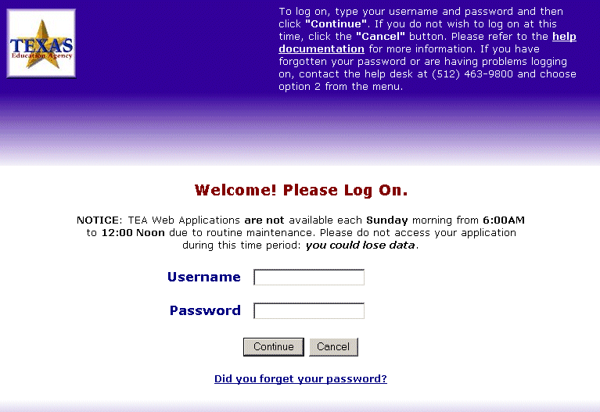
- Enter the assigned TEASE Login ID (username) and password (upper/lowercase sensitive).
- Select Continue to display the Application List. The TEA Application List page shows all applications your user name has the authority to access.
Figure 5. Application List Page
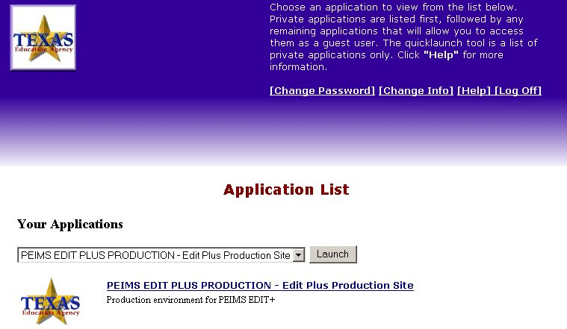
- To begin working, select EDIT+ Production from the drop down menu and click Launch, or you can select the EDIT+ Production hyperlink.
EDIT+ Home Page
When a user logs on to EDIT+, the first page visible is the home page. The page design of EDIT+ uses consistent colors and display areas to help you locate the information you need. The left side of the page displays a Contents list of EDIT+ feature links. A shaded link indicates the feature is not available to the user. The black bar across the top of the page provides links to log off EDIT+, the current PEIMS Collection Schedule, and UserHelp.
Figure 6. EDIT+ Home Page
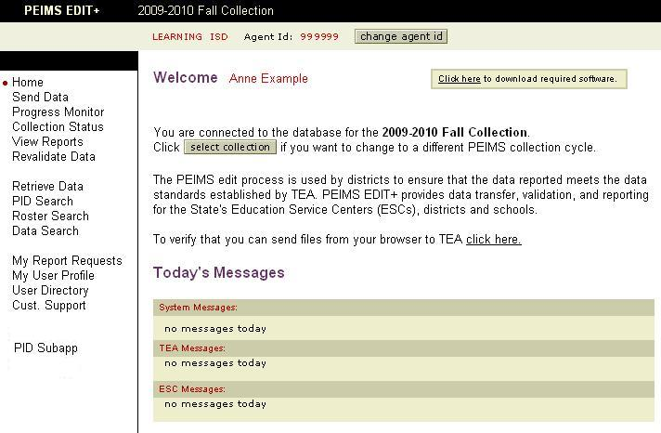

Home Page Functionality
The home page displays several functionality buttons and links:
- the Change Agent ID button gives authorized users the ability to filter to a deeper level in the EDIT+ user hierarchy.
- a Click Here To Download Required Software link directs users to a page where the software necessary for the EDIT+ file send and report retrieval process can be downloaded.
- a Select Collection button (located below the Welcome message) provides access to the Select PEIMS Collection page enabling users to select a specific PEIMS data collection period.
- a Click Here test link (located above Today’s Messages) directs users to a File Transfer Test page that allows users to test their access to the EDIT+ server.

Home Page Messages
The EDIT+ home page displays a section entitled Today’s Messages providing the EDIT+ user with system and reminder messages. There are three types of messages:
- System-This message is associated with system maintenance or support. For example, a message might be posted to announce the system will be unavailable during specific hours.
- TEA-This is an information message from TEA staff. For example, a message might be posted to announce a revision to a report.
- ESC-This is an information message from ESC staff that displays only for that ESC’s district and/or campus users. ESC users can also post messages that can be read by other ESCs.

Customer Support Services
The Customer Support link on the EDIT+ home page gives users the capability to troubleshoot the application by referencing readily available information via the Customer Support Resources page. Additionally, the page provides a link for submitting Customer Service Requests (CSRs) to the EDIT+ development team.

Customer Support Resources
To utilize EDIT+ Customer Support Resources:
- Select the Customer Support link on the EDIT+ home page. Selecting the link displays the Customer Support Resources page.
Figure 7. Customer Support Resources Page
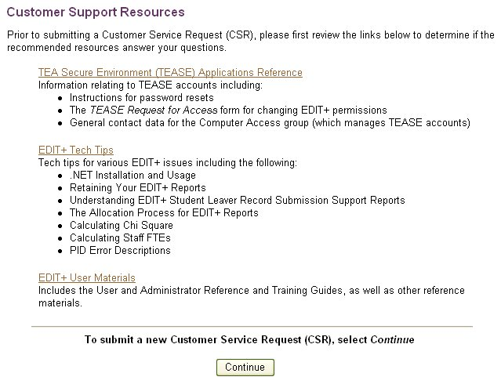
- Links on the Customer Support Resources page provide users with assistance for such as commonly asked questions as:
- TEASE (resetting password, obtaining a TEASE Request for Access form)
- Technical Tips (.NET Installation and Usage, Understanding EDIT+ Student Leaver Reports)
- Guidance for EDIT+ functions (user materials for topics ranging from how to set up a user profile to the details of SAF and PET)
- If questions are not answered by first using the available resources, a Continue button takes users to the Customer Support Request page where a Customer Support Request (CSR) can then be submitted to EDIT+ Customer Support.
Customer Support Requests
After first researching available resources via the Customer Support Resources, users can contact EDIT+ Customer Support for further assistance, by submitting a Customer Support Request (CSR).
To submit a CSR:
- From the CSR Category drop down list (‘This is a’) on the Customer Support Request page, choose Suggestion, Problem, or Question.
- From the Priority drop down list, choose Low, Medium, High, or Urgent.
Figure 8. Customer Support Request Page
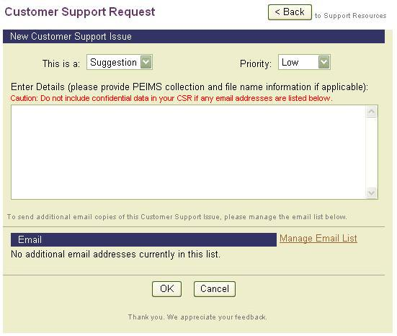
- In the Enter field, provide a concise but detailed explanation. If applicable, include references to a specific collection, file name, report name/number. Also include your name, ESC/district/campus, and contact information.
- To add or remove email addresses that you want copied on your CSR, select the Manage Email List link. The CSR Email Address Book displays.
Figure 9. CSR Address Book
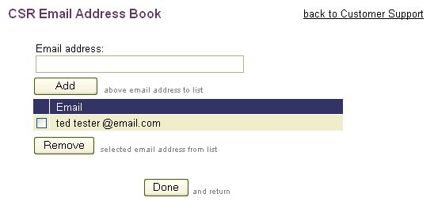
- Type an email address in the email address field and select the Add button to save. Any other email addresses you enter in the CSR Email Address book automatically receive a copy of the CSR you submit. It is recommended that you copy your ESC PEIMS Coordinator on all CSRs.
- To remove an email address from the CSR Address Book, select the checkbox next to the address and click the Remove button.
- To return to the Customer Support Request page, select the Back to Customer Support link at the top of the page or the Done button at the bottom of the page.
- After sending a CSR, a Customer Support Issue Confirmation page displays indicating that your request has been successfully posted. A unique tracking number is assigned to your request and your request is routed to EDIT+ Customer Support. Your comments are routed to the appropriate staff member and responses are sent to the email address that you specified in your user profile.
Note: Responses to CSRs are sent through TEA encrypted email. The encrypted email contains a secure link that the recipient selects to retrieve the CSR response.

Chapter 4–Email Notification

Overview
Email notification is a method used by EDIT+ to advise users about various EDIT+ processes, for example, information concerning PID edits, report availability status, and file processing status. EDIT+ users are required to have a valid email address at the time they request a TEASE Login ID.
There are two types of EDIT+ email notification:
- Automatic Email Notification
- User-Controlled Email Notification

Automatic Email Notification
Some EDIT+ email notification messages are sent automatically as a file’s status changes. Note that automatic email notification:
- lists default text; the user does not have the option to change the text of the email message.
- is always sent to the person who sent the file for processing.
- regarding Turnaround Reports, is sent to any user whose Agent ID matches the file name and has Turnaround Report notification selected in their EDIT+ user profile.
- regarding the Edit Complete and aborted file statuses, is optional and may be turned off in the EDIT+ user profile.

Selecting Automatic Email Notification
To set up Automatic Email Notification:
- On the My User Profile page, enter email address.
- Select check here to receive email notifications. This allows users to receive email notification when PEIMS and PID data validation has completed and reports have been generated.
- If the user is a new user, on the Add New User page, enter the email address. Select check here to receive email notifications.
- When the Turnaround Report notification box is checked, users receive an email when Turnaround Reports are ready for viewing.
Note: To set up a user who only views files and checks collection status, check Turnaround Report notification and leave the Send/Revalidate Data checkbox unchecked.

Examples of Automatic Email Notification Messages
Status | Message
PEIMS Edit Complete  (campus, district, or ESC)  Note: Users receive this email if the Check Here to Receive Email Notifications checkbox is selected in their user profile. | The PEIMS data file you submitted for edit processing has completed for the record groups you specified. Edit Error Reports are available from the EDIT+ Collection Status page for your review.  File name:  Date Sent:  # Records:  # Warnings:  # Specials:  # Fatals:
PEIMS Edit Aborted  (campus, district, or ESC)  Note: Users receive this email if the Check Here to Receive Email Notifications checkbox is selected in their user profile. | The PEIMS data file you submitted for edit processing was unable to complete and the status has changed to Aborted.  File name:  Date Sent:  Reason for Failure:
PID Edits Complete  PID Reports Requested | PID Reports have been requested for the PEIMS data file you submitted for PID edits.  File name:  Date Sent:
PID Error Rate Reports Available | The PID Error Rate Reports for the 20xx-20xx Summer Collection are ready for your review.
PID Error Rate Reports Available (Superintendents Only)  Note: Superintendent notifications are forwarded to Superintendents via a TEA Representative. This email is not sent directly from the EDIT+ system. | Your PID Error Rate Reports for the 20xx-20xx Summer Collection are ready for your review.
Turnaround Reports Available  Note: Any user whose default Agent ID matches the file name and has Turnaround Report Notification selected in their user profile will be automatically notified when Turnaround Reports are available. | The Turnaround Reports for the PEIMS data file you submitted are ready for your review.  File name:  Date Sent:
QA/Student Leaver Record Submission Support Reports Available | The QA Reports for the PEIMS data file you submitted are ready for your review.  File name:  Date Sent:  Procedure:  On the EDIT+ home page, click View Reports. Choose = Turnaround Reports. Pick the file name shown above from the drop-down list. Click the underlined report title in the QA Reports section.
User-Controlled Email Notification
User-controlled email notification is used in the Complete, Accept, or Reject processes which are detailed in the PEIMS Data Acceptance chapter. The following points are important to know about the EDIT+ User-Controlled Email Notification process:
- The ESC or District PEIMS Coordinator selects the email addresses of the persons to be notified during the file send process by using email selection buttons on the Complete File, Accept File, and File Reject pages.
- The ESC or District PEIMS Coordinator can add additional email addresses for other persons to be notified. Email recipients do not have to be EDIT+ users.
- The person who completes, rejects, or accepts the file can edit the email message text.
Conditions for Sending User-Controlled Email Notification
Condition | Who Should Be Notified | Notified
Campus File Completed by Campus | User-specified | When campus user completes file
Campus File Rejected by District | Campus user who completes file; also user-specified | When district rejects file
District File Completed by District | User-specified | When district completes file
District File Rejected by ESC | District user who completes file; also user-specified | When the ESC rejects file
District file Accepted by ESC | District user who completes file; also user-specified | When the ESC accepts file
ESC File Completed by ESC | User-specified | When the ESC completes file
ESC File Accepted | ESC user who completes the file; also user-specified | When the ESC accepts file
Examples of User-Controlled Email Notification Messages
Status | Message
Campus, District, or ESC Complete | The referenced file has completed the edit/validation process. Reports showing the remaining errors are available from the Collection Status page. Standard Reports are available through the EDIT+ View Reports page.  File name:  Date Sent:  # Records:  # Warnings:  # Specials:  # Fatals:
Campus File Rejected  Note: The reject reason is inserted by the EDIT+ user who initiates the email. | The referenced file has problems that should be resolved before it is accepted and merged into the district file. It has been rejected in the EDIT+ application to release it for resending. The specific items to be addressed are listed below.  File name:  Reject Reason:
(Table continues on next page)
(Table continued from previous page)
District or ESC Rejected  Note: The reject reason is inserted by the EDIT+ user who initiates the email. | The referenced file has problems that should be resolved before it is accepted and passed on for additional processing. It has been rejected in the EDIT+ application to release it for resending. The specific items to be addressed are listed below.  File name:  Reject Reason:
ESC Accepts District or ESC File | The referenced file has been accepted. Reports showing the remaining errors are available through EDIT+ View Reports page.  File name:  Date Sent:  # Records:  # Warnings:  # Specials:  # Fatals:

Chapter 5–PEIMS Data Submission

Overview
Whether campus, district, or ESC, one characteristic all PEIMS data files have in common is the submission process they go through when they are transformed from mere numbers input into a local computer to the end product of a functional report delivered to users.

File Transfer
Users connect to the EDIT+ application via the TEA Secure Environment (TEASE). Using this connection, their PEIMS data files are transferred from their local computer to TEA.

File Loading
Once the source data files are transferred from the user’s local computer, they are uploaded to an EDIT+ server at TEA and the EDIT+ validation process is initiated.

File Validation  The validation process within EDIT+ validates the PEIMS data file after it is transferred and uploaded. Validation rules are data guidelines and edit rules published every year in TEA’s PEIMS Data Standards. The process consists of the complex system validation of the PEIMS data file by applying these validation and edit rules. | 

Report Generation
When the process is complete, the EDIT+ user views a report of the processing errors (if any). After any errors are corrected, the validation process is repeated until the data is correct. EDIT+ reports are discussed in a separate chapter in this Guide.
PEIMS Data Files: Sending the File
EDIT+ employs a .NET component using the Hypertext Transfer Protocol (http) to process PEIMS data files. Using an Internet (http) connection, the EDIT+ user transfers their PEIMS data file to TEA where it uploads to an EDIT+ database server.
Beginning with the 2010-2011 PEIMS year, data may be sent to EDIT+ in an XML file format as defined in the PEIMS Data Standards. Files sent in the XML format will have an .XML file extension. XML files will be validated against the XML Schema Definition (XSD) and any resulting errors will appear in the edit error reports. XML files will then be transformed into 80 column format file for the rest of EDIT+ processing.
Note: All PEIMS data records are loaded into the EDIT+ server database each time a file is transferred so that users can revalidate data later without having to resend the file.

Selecting Files for Transfer/Upload and Validation
To begin the transfer/upload and validation of a PEIMS data file:
- From the EDIT+ home page, verify the collection (indicated in the black task bar at the top of the page) and your Agent ID. The file you select for the transfer/upload process must be associated with an Agent ID within your hierarchy and must reference the collection that matches the database to which you are connected.
- Select Send Data from the Contents list.
Note: If the Send Data option is shaded in the Contents list, you do not have Send/Validate permissions. Contact your EDIT+ Administrator to have those permissions added.
- Enter the full path location and file name in the selection field or select the Browse button to access the Choose File window to locate the file.
Figure 10. Send Data–Select File
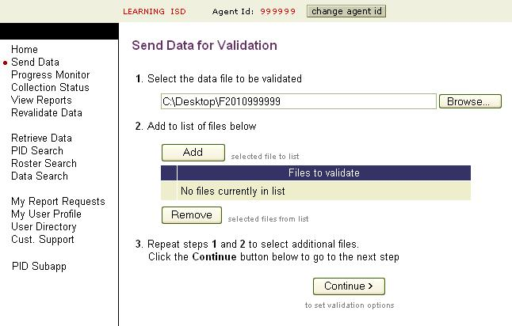
- Select the Add button to display the file in the Files to Validate list. Repeat the file select and add steps until all files you want to send are inserted into the Files to Validate list.
Note: If you change your mind about validating a file, select the checkbox next to the file name, then select the Remove button. This action removes the file from the list of files to validate but does not delete the file.
- Select Continue to proceed to the Select Validation Options page.

Validation Options
The Select Validation Options page lists possible record groups for validation. Record groups displayed are associated with user permissions and the collection in context. Exceptions are:
- ESC users do not see student record groups as an option
- Campuses ‘Under Construction’ see only Organization and Budget record groups
To select validation options:
- On the Select Validation Options page in the Validate column, click the checkbox next to Fatals Only if you wish to validate only fatal errors.
Note: The Complete/Accept button does not display when Fatals Only is selected, even if the file is fatal free. Special Warnings and Warnings are skipped during validation.
- In the Edit column, the PEIMS Edit (standard PEIMS file validation) checkbox is selected by default. If you only want to perform a PID Edit, deselect PEIMS Edit.
- In the Edit column, select the PID Edit checkbox to initiate PID validation. PID Validation is run against groups of demographic records for the purpose of validating PID data:
Student records | 100 | 101 | 105
Staff records | 040 | 043 | 045
Note: The PID Edit selection is not saved; therefore, you must reselect the PID Edit checkbox each time you send a file for which you want to run PID validation. PID Edit should always be checked if you want to run PID reports.
- In the Select Groups column, all record groups are selected by default. Deselect any you are not ready to validate. This must be done for each file you select for validation.
Figure 11. Select Validation Options–Single File
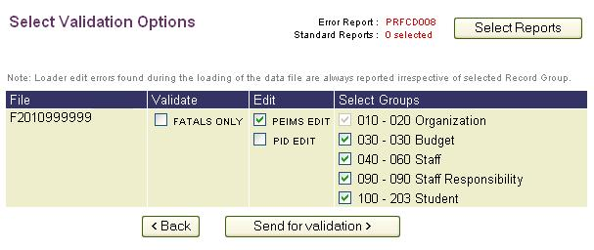
Figure 12. Select Validation Options–Multiple Files
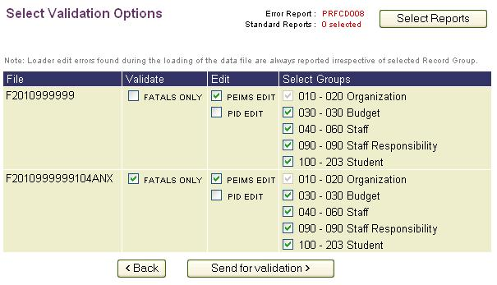
- The Select Reports button displays the Edit Error and Standard Reports eligible for auto-generation. Choose your reports then select Send for Validation to begin the file transfer.
- The Transferring Files page displays as the file is compressed, encrypted, and transferred to the EDIT+ server. DO NOT LOG OFF of EDIT+ until the Progress Monitor page displays; doing so will abort the transfer of your data file.
PEIMS Data Files: Managing File Processing
EDIT+ provides several features that enable users to manage the processing of their files.
Progress Monitor
When the transfer/upload phase is complete, EDIT+ automatically advances to the Progress Monitor page. This page displays the name and status of the uploaded file, the time the file transfer began, the elapsed time to complete the file transfer process, and the abort status of the file. If you transfer multiple files, all are tracked by the Progress Monitor.
Figure 13. Progress Monitor
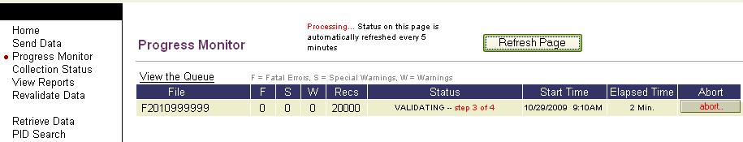
Notice that:
- File Status changes as the file progresses through transfer, loading, validation, and report generation.
- The number of errors found changes as the file goes through validation editing.
- Selecting the Refresh Page button manually displays updates from the database. The page refreshes automatically at regular intervals.
- A View the Queue link takes the user to a page that displays file queue status and file processing information.
Note: The .NET Applet logs the processing steps in a file named Applet.log. The file is small with usually about ten (10) lines of log information. The Applet.log file can be found in the My Documents folder on your hard drive.
Logging Off During File Validation
If you need to exit EDIT+ while your file is validating you can select Log off. The next time you log on, select the Progress Monitor link on the home page Contents list to view the status of the validation process.
User-Controlled Abort Button
Users can manually abort a processing EDIT+ file by selecting the file’s Abort button from the Progress Monitor page. When the Abort button is selected, a confirmation message displays with a Click Here option to return to the Collection Status page.
Note: A file can be manually aborted at any processing stage except report generation (i.e., files can be aborted during transfer, loading, and validation).
File Not Found Message
If the EDIT+ system cannot find the file you sent for processing, a File Not Found message displays. Should this message display, abort the file, then check the file name for accuracy and return to the Send Data page to resend the file.
Viewing Files in the Processing Queue
EDIT+ provides a feature for viewing files that are in a queue waiting to be processed and those that are currently processing.
To use the File Queue Status feature:
- From the Progress Monitor page, select the View the Queue link located directly above the file name. The PEIMS File Queue page displays.
Figure 14. PEIMS File Queue Page
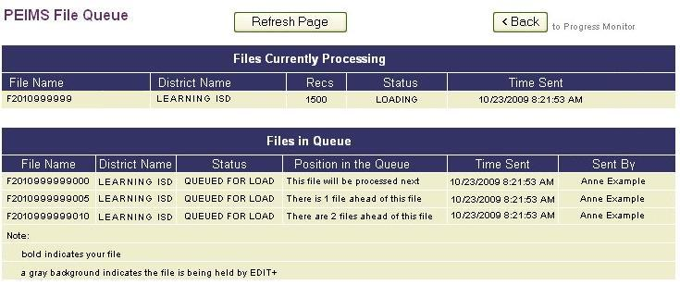
- The first section of the PEIMS File Queue page shows a list of Files Currently Processing. The second section of the page displays files that are in queue waiting to be processed. The Files in Queue provides the file name, district name, file processing status, position of the file in the queue, time sent, and who the file was sent by.
- All files are displayed in the order in which they will process. The file (or files) of the user who is checking the queue appear in bold.
- A shaded file name indicates the file is being held before processing. Files are occasionally placed on hold by EDIT+ Customer Support during peak processing periods. This is done to ensure that the maximum number of files from all submitters are processed efficiently by the system. If a file has been placed on hold, it displays at the end of the file queue until it is released back into the queue.
- As files are processed, they automatically move from Files in Queue to Files Currently Processing. This can be observed by selecting the Refresh Page button periodically. The Back button returns the user to the Progress Monitor page.
Note: The page can be refreshed manually every 30 seconds using the Refresh Page button. Attempting to refresh the page more frequently does not speed up the update since the scheduler refreshes only at 30 second intervals.
- By referring to the order of the files that are in the queue, as well as the district names, a user can have a general idea of the EDIT+ file processing time that may be ahead of their own file submission (based on an awareness of the size of the district).
- When your file has finished validating, the status table on the Progress Monitor page updates to a Complete status. The system displays a Click Here link to view the collection status of the files you have sent.

The Collection Status Page
In addition to current file status, information included on the Collection Status page includes:
- File version number (tracks number of times file has been transferred)
- Date and time file was sent along with record count
- Count of validation errors (Fatal, Special, and Warning)
- Link to file history (accessible via file name hyperlink)
- Option to view the Edit Error Report online (select View)
Note: If Fatals Only is chosen on the Select Validation Options page, a Fatals Run Only message displays in the Complete/Accept column and an N/A appears under the Special (S) and Warnings (W) columns.
Depending on your user role, the files seen in the list can be limited by using the change
Agent ID button. By default, EDIT+ displays the file status for all Agent IDs in the down flow path of your role’s hierarchy. A district can check the status of all campus submissions within that district; an ESC is able to check the status of all district submissions within that region.
Note: Charter schools display with a yellow highlight on the Collection Status page.

Collection Status Page–Alternate Agents as a File List Option
An Include Alternate Agents checkbox is available on the Collection Status page. This checkbox only displays if users have an Alternate Agent ID set up in their EDIT+ user profile. When checked, all files belonging to Alternate Agents are displayed in addition to the user’s normal list of files. The current state of the checkbox is saved across user sessions.

Collection Status Page–Multi-Column Sort
A multi-column sort option is available on the Collection Status page.
- Three fields allow users to select up to three sort criteria (Sort 1, Sort 2, Sort 3). The default sort is Date Sent (ascending); therefore, if no change is made to the Sort 1 field, information is sorted in ascending order by Date Sent.
- To change the sort, drop down menus displays a list of choices.
Figure 15. Multi-Column Sort–Sort Menus
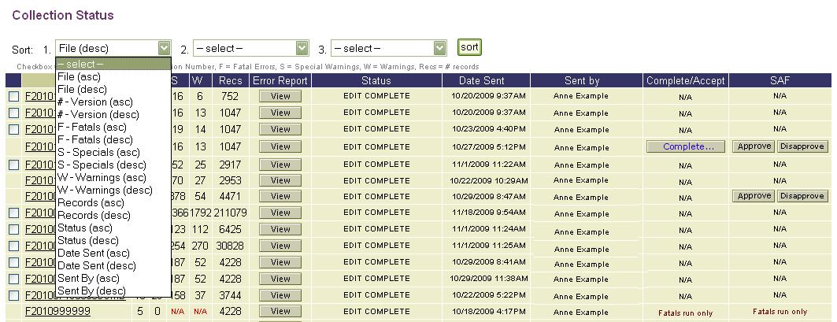
- Choose a second sort by selecting the down arrow in the Sort 2 field; select a third by selecting the down arrow in the Sort 3 field. Select the Sort button to display results.

Collection Status Page–File History
The File History page displays details regarding the number of attempts to send each file and a record of all errors, warnings, and special warnings encountered during the send attempt. This is an information only page.
To access the File History page:
- From the Collection Status page, select the file name link to display the File History page.
- Select the Click Here link to display the Record Groups Edited page.
Figure 16. File History Page–Click Here Link
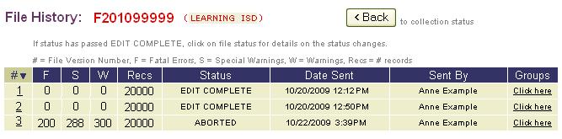
- The Record Groups Edited page lists which record groups were edited for each PEIMS file validation. Select Back to return to the File History page.

Collection Status Page–Version History
The Version History page gives EDIT+ users the ability to track all activities associated with a particular file (i.e., multiple PEIMS requests, requests for PID Edits and file retrievals).
- From the File History page, select a version number link from the first column.
- The Version History page displays the details for that version of the file including the date and time sent, who sent the file, and which EDIT+ machine processed the file.
Figure 17. Version History–File Process History
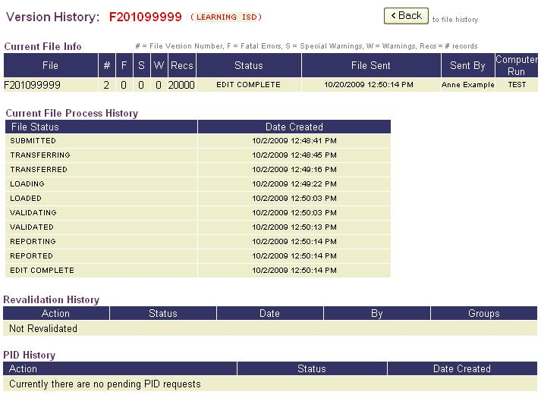
Note: The status of PID Edit processing is displayed in the PID History section.

Collection Status Page–File Status Detail
The File Status Detail provides a list of all status changes as a file moves through the PEIMS data file acceptance process.
To access the File Status Detail page:
- From the File History page, select an underlined link in the Status column.
Figure 18. District File Status Detail–Link from File History Page
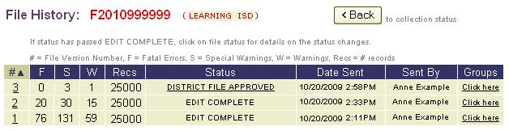
- The File Status Detail page displays each status through which the file progressed including date and time as well as who sent the file.
Figure 19. District File Status Detail Page
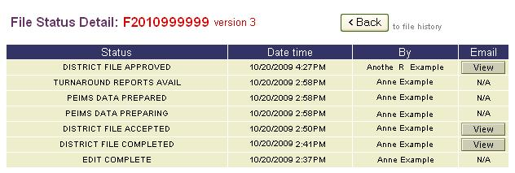
- Details of the email sent for the accepted or completed files can be viewed by selecting the View button under the Email column.

Collection Status Page–View Edit Error Reports
Edit Error Reports display a submission summary and all errors encountered during transfer.
- From the Collection Status page, the user can view Edit Error Reports by selecting the View button next to the report title.
Figure 20. District Collection Status Page–View Button for Edit Error Reports
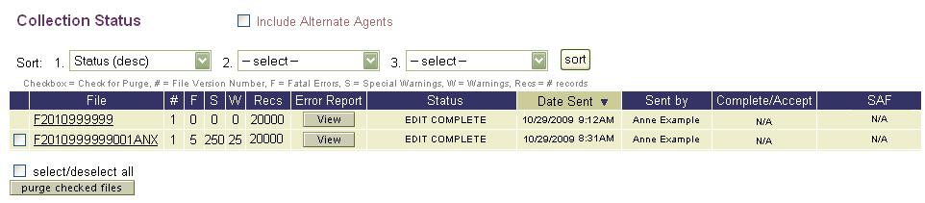
- The Error Reports page displays a list of Edit Error Reports.

Figure 21. Errors Reports Page
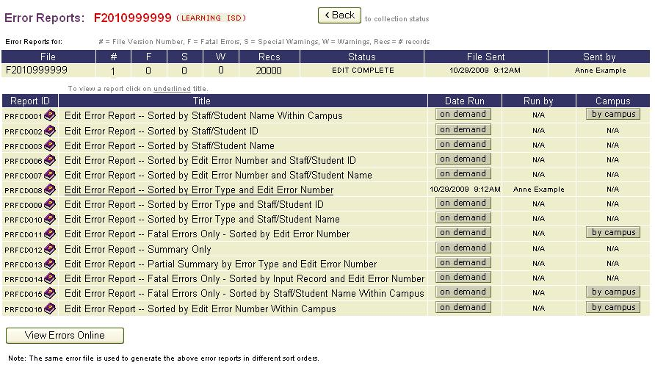
- Only one Edit Error Report can be generated during validation. Others can be run on demand after file transfer.
Note: Districts can generate Edit Error Reports by campus to isolate data for a specific campus and correct fatal errors more quickly.

PEIMS Data Files: Revalidating the Data
The Revalidate Data function allows users to generate Edit Error Reports for the same file over and over again without resending data. Edits are run against the file previously sent to the EDIT+ server.
Note: Choosing new record groups replaces any existing Edit Error Reports and may cause the summary of error counts to be incorrect. When processing a revalidate on PID Edit Only, Edit Error Reports are not overwritten. If you request a PID revalidate, only the appropriate PID reports are overwritten.

To revalidate data:
- From the Contents list, select Revalidate Data to display the Revalidate Data page.
- Files available for revalidation are displayed with a hyperlink.
Figure 22. Revalidate Data
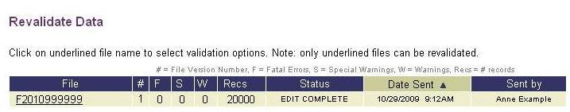
- Select the file name hyperlink to display the Revalidate File page.
- Select the checkbox to deselect the record groups you do not want to revalidate.
By default, only PEIMS Edit is selected. All record groups are selected.
Figure 23. Revalidate File
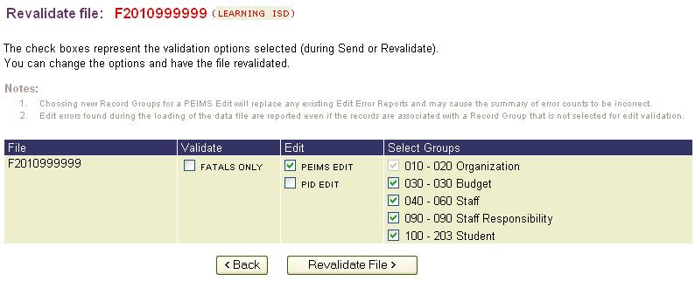
- Choose Fatals Only if you wish to skip Specials and Warnings during the revalidation.
- If the file contains PID data, select the checkbox for PID EDIT.
- Select the Revalidate File button to initiate. This process runs in the background.

PEIMS Data Files: Retrieving the File
Once a file has been sent to the EDIT+ server for validation, it is possible to retrieve the source file. Any file within a user’s Agent ID that has reached a minimum status of Edit Complete can be retrieved, including files containing fatal errors and files that have been accepted by the ESC. Files may be retrieved from the current collection or any prior collection.
Files are retrieved in an ASCII format and can be loaded into other applications such as Access® and Excel®. Retrieved files can be edited, saved (a different file name is recommended), and sent back through EDIT+ to run and generate reports.
To retrieve and save a data file:
- Select Retrieve Data from the Contents list on the EDIT+ home page. From the File list on the Retrieve Data page, select the hyperlink for the file you want to retrieve.
Note: Select Yes if a Security Warning page appears, allowing the file retrieval to continue.

- The Save As dialog box displays allowing you to specify a location on your hard drive to save the retrieved file.
- The Retrieving file dialog box displays the progress of the download. When the file retrieval is complete, you are returned to the Retrieve Data page.
- You can view the contents of the retrieved file by navigating to the save file location and double-clicking on the file.
- A dialog box displays asking how you would like to view the file. Choose the Select the program from a list radio button and select OK. Choose Notepad, WordPad, or any text editor to open the file.
PEIMS Data Files: Understanding Valid Data
The following table contains the various file status messages that display on the Progress Monitor and Collection Status pages as a data file moves through EDIT+.
Note: PID Edit goes through the same states as data file processing. For more information about PID Edit, see the Selecting Validation Options section of this chapter.
General File Status | Submitted  Transferring  Transferred  Queued for Load  Loading  Loaded  Validating  XML Validating  Validated  XML Validated  XML Validation Failed  XML Transforming  XML Transformed  XML Transformation Failed  Reporting  Reported  MAX Load Errors Exceeded  Aborted  Edit Complete
Campus File Status | Campus File Completed  Campus File Rejected
District File Status | District File Completed  District File Rejected  District File Accepted  SAF–District File Approved  SAF–District File Disapproved  SAF–District File Approved-Override  SAF–District File Disapproved-Override
District and ESC File Status | Turnaround Reports Available
ESC File Status | ESC File Completed  ESC File Accepted  ESC File Rejected  SAF–ESC File Approved  SAF–ESC File Disapproved  SAF–ESC File Approved-Override  SAF–ESC File Disapproved-Override

Aborted Status
An aborted status indicates that the file did not successfully transfer, load, or validate on the EDIT+ server. Aborted files do not appear in drop down lists on the Standard Reports, Special Reports, Turnaround Reports, or Table Download webpages.

Max Load Errors Exceeded
If the file contains more than 500 loader errors, processing stops. Loader errors are caused by:
- Invalid date format (20020514)
- Alpha vs. numeric (and vice versa)
- Duplicate record (matches on key field)
- Missing mandatory fields
The Max Load Errors Exceeded status indicates the file contains more than 500 load errors. Load errors occur due to data formatting problems or missing mandatory fields, and they prevent data from being loaded into the database. The first 500 errors are displayed in the Edit Error Report. When more than 500 loader errors occur, overall processing stops.
Note: Load errors cause other validation errors to occur, so they should always be corrected first. All load errors are fatal.
Error # | Error Description
9990 | Data Load Error: No records were loaded. File with record count = 0.
9993 | Data Load Error: Dist-ID in the 010 record does not match the DIST-ID part of the file name.
9994 | Data Load Error: Exceeded the maximum number of loader error limit.
9996 | Data Load Error: Unable to load record. Invalid data type or format for one or more fields.
9997 | Data Load Error: Unable to load record. Record length is greater than 80.
9998 | Data Load Error: Unable to load record. Invalid record type for collection or school type (Under Construction Campus, ESC, TYC, TSD/TSBVI).
9999 | Data Load Error: General Loader error; check your data. The record cannot be inserted into the database due to bad format.
90000 | Data Load Error: Please check your data or vendor software (invalid character in the file).
90027 | Data Load Error: Value should be numeric.
90030 | Data Load Error: Does not conform to pattern.
90032 | Data Load Error: Blanks not allowed.
99988 | Data Load Error: Unable to load record. Record group is excluded for user.
999998 | XML Validation Error
IMPORTANT! Note about Max Load Errors: You can request the Max Load error check be turned off for your Agent ID, allowing you to view all of your errors (this includes any campus files that may be sent during the time that it is turned off). The request should be made when the district file is close to fatal free. Contact EDIT+ Customer Support, via the Customer Support page, to make this request.

Maximum Validation Errors (Per Rule Error Limit)
A Maximum Validation Errors Exceeded error indicates that the file contains greater than a default number of validation errors on a specific edit. The default is variable; however, it usually ranges between 200-500 errors. When the per rule error limit is applied, the validation process stops for that particular edit and validation continues on to the next edit. The default listing of errors is displayed in the Edit Error Report.

Error Number | Error Description
9991 | Validation Error: Exceeded the maximum per rule error limit.

Context Edits and Record Type Field Edits
If certain record groups are deselected, those records are not validated; however, the following context edits are validated during the loading of data regardless of the excluded record groups:
- 04041, 04042, 04043, 04049, 04050, 04305, 04502, 0900C, 10005, 10008, 10009, 10010, 10015, 10016, 10017, 1010C, 1010D, 1010E, 10141, 10505, 42549, 43510
In addition to these context edits, all record type field edits (i.e., 1000A and 1000B) are checked during the loading process. For record type field edits see the PEIMS Data Standards.

PID Edit Record Requirements
Loader errors during PID Edit may impact your PID Discrepancy Reports (see the Special Reports section of the chapter entitled, EDIT+ Reports: Categories). Loader errors do not prevent PID Edit, but if records are missing, the validation is not accurate and PID Discrepancy Reports are not useful. Verify the file contains the following records before sending it for PID Edit. This applies when PID Edit is the only option selected on the Select Validation Options page.
Fall | Student | Enrollment: 100, 101
 | Staff | 040, 043
Summer | Student | 100, 101
 | Staff | NA
Extended Year | Student | 100, 101
 | Staff | NA
All Collections | Student | 105 is optional
 | Staff | 045 is optional

Using Negative Numbers in EDIT+
When reporting BUDGET-AMOUNT and ACTUAL-AMOUNT, all revenues, expenditures, and fund balances are shown as unsigned positive numbers. In rare cases, some accounts may need to appear as negative numbers, such as when a deficit fund balance occurs. In ASCII data, a negative number is represented by changing the last digit in the number to one of several character symbols. The symbols indicate the last digit of a negative number. For example, ASCII uses the dollar sign ($) to indicate that the last digit is an integer 4 and that the entire number is negative. Thus, the number -1234 is saved in ASCII as 123$. PEIMS converts these symbols to the correct negative numbers.
Last Digit Of Negative Number | Character Used In ASCII | Last Digit Of Negative Number | Character Used In ASCII
0 | Space | 5 | %
1 | ! | 6 | &
2 | " | 7 | '
3 | # | 8 | (
4 | $ | 9 | )

Knowledge and Skill
This section provides exercises to assess the knowledge and skill you have acquired from reading through the chapter.
Exercise 5.1–Transferring a PEIMS Data File
Complete the following steps:
- Log on to the EDIT+. From the Contents list, select Send Data.
- Select the Browse button and locate the file you want to send.
- Select Add to add the file to the list of selected files.
- Select Continue to display the Select Validation Options page.
- Select Back to return and select another file or select Send for Validation to continue transferring the files(s).
- Select Yes to continue past the Security Warning. EDIT+ displays the transfer completion bar showing percent complete, and then advances to the Progress Monitor page. After completion of the process, choose the Click Here link to continue to the Collection Status page. From the Collection Status page, you can view the status of the files you have sent.

Exercise 5.2–Sending a Partial File
Complete the following steps:
- Log on to the EDIT+ system if you are not currently signed on.
- Go to the Send Data page.
- Select the Browse button.
- Locate the file specified on your Training Data sheet.
- Add the file to the list of selected files, remove previously sent files, and select Continue.

Exercise 5.3–Choosing Record Groups
Complete the following steps:
- Select to validate only the budget records. Select Send for Validation.
- Follow the page instructions to complete the file transfer and validation. Be sure you understand what the Progress Monitor and Collection Status pages are used for. Check the history for the file you sent.

Exercise 5.4–Transferring a Fatal Free File
Complete the following steps:
- Validate a PEIMS data file.
- Review the status information. Follow the page instructions to complete the file transfer and validation.

Exercise 5.5–Revalidating a File
Complete the following steps:
- Select Revalidate Data from the EDIT+ Contents list.
- From the Revalidate Data page, select the fatal free file you have previously used.
(Tip: hyperlink). Select all record groups.
- From the Revalidate File page, select the Revalidate File button.
- View the Progress Monitor while the revalidation is progress. Notice the status of the file.

Exercise 5.6–Retrieving Data
Complete the following steps:
- Display the Collection Status page. Notice the files that you have already sent. The status should be Edit Complete.
- Select Retrieve Data from the EDIT+ Contents list.
- Retrieve one of the files. Save it to the Windows Desktop on your computer.
- View the file in Notepad, WordPad, or any text editor.

Notes:

Chapter 6–PEIMS Data Acceptance

Overview
Campuses, districts, and ESCs all contribute a vital role in the collection and submission of accurate PEIMS data to TEA.
- Campus–The campus prepares and submits its PEIMS data through EDIT+. When the file contains as few errors as possible, the campus flags the file for district review.
- District–When the campus file is received at the district, the district determines if the file is complete. If the campus data needs more work, it is rejected so the campus can continue editing the data. If the data is complete, the district merges the campus data into the district file. When the district file is complete and fatal free, the district flags the file for ESC review.
- ESC–When the district file is received at the ESC, ESC personnel review Edit Error Reports to verify the completeness and accuracy of each district’s data within their region. If the district data needs more work, it is rejected so that the district can continue to edit the data. If the ESC is satisfied with the results of the data validation, the district file is flagged as accepted by the ESC. The data is then considered final and made available to TEA.

Campuses and the Data Acceptance Process
The first participant in the PEIMS data acceptance process is the campus. When a campus has finished validating their data, they Complete the file.

Campus Role–Completing the Campus File
The Complete option is presented to the user on the Collection Status page each time a campus file is sent for validation.

Conditions for Completing a Campus File
Before a campus completes a file, the following conditions are assumed to be met:
- File must be sent after a submission opens and before the collection due date. If an extension is granted by TEA, the file must be sent before the extension due date.
- File should contain as few fatal errors as possible.
- File cannot be a partial file (i.e., named with a temporary file extension)
- File cannot be flagged as Complete if the Fatals Only option is selected on the Select Validation Options page even if the file contains no fatals.
- File must reach Edit Complete status (the Complete button is visible).

When a campus file is flagged as Complete, the following events occur:
- File is frozen; no other edits can be made unless the file is rejected by the district.
- Email notification process is activated with user-defined email addresses.
- District is notified that the file is ready for review.

Process for Completing a Campus File
To complete a campus file:
- From the Collection Status page, select the Complete button corresponding to the file you want to complete. The Complete File page displays.
Figure 24. Campus View–Collection Status Page and Complete Button
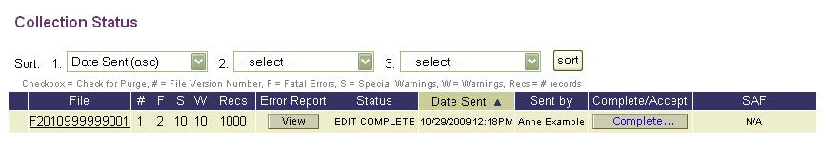
- An email notification section displays the name of the sending user in the From field as well as their email address in the Cc field, ensuring they receive a copy of the Complete File notice in their email inbox.
- A Confirmation Letter displays below the email notification section. You can customize the Confirmation Letter by entering your own text or use what is already typed.
Figure 25. Campus View–Complete File Page with Confirmation Letter
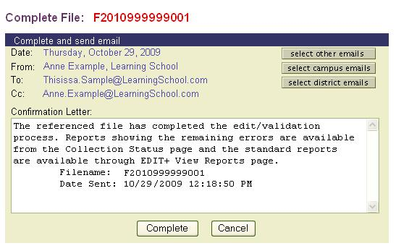
- Three email buttons also display on the page representing different groups of EDIT+ users who may be notified.
- Select Other Emails–This button displays a list of previously notified users. Select the Edit List button to add or remove listings. To add a person, enter the name in the Email Address field and select the Add button. To remove a person, place a check next to the name and select the Remove button. Select Done to return to the Complete File: [File Number] page. On this page, check the names of the users you want to notify, then click Done to save and return to the original Complete File page.
- Select Campus Emails and Select District Emails–These buttons display a list of campus and district users, respectively. Place a check by the names of the users you want to notify, then click Done to save the changes and return to the Complete File page.
- Click the Complete button to process email notification and complete the file. A confirmation message displays. The file is frozen unless it is rejected by the district.
Districts and the Data Acceptance Process
When the district receives notification that the campus file is complete, its participation in the PEIMS data acceptance process begins.
Districts have three distinct areas of responsibility in the data acceptance process:
- Accepting the campus file
- Rejecting the campus file
- Completing the district file

District Role–Accepting the Campus File
The district views Edit Error Reports for the campus and runs any other reports they may want to review to determine whether to accept or reject the campus file.
Process for Accepting a Campus File
If the campus file has reached Campus File Completed status and the district determines the file is ready to be merged with district date, the file is considered accepted and no online action is required in the EDIT+ system. Using third-party software, the district then merges the campus data into the district file and continues the edit process of the district file.

District Role–Rejecting the Campus File
If the district discovers errors that the campus should correct, the file is rejected and available again for campus changes. Notification is sent to the campus when the file is rejected. The campus data should be corrected using the vendor software and sent through EDIT+ again.

Conditions for Rejecting a Campus File
Before a district rejects a campus file, the following conditions are assumed to be met:
- Campus file sent for validation and flagged as Complete.
- District Collection Status page shows status of Campus File Completed.
- District has reviewed campus Edit Error Reports and determined file needs more work.

Process for Rejecting a Campus File
To reject a campus file:
- From the Collection Status page, select the Reject button corresponding to the file you want to reject. The File Reject page displays.
Figure 26. District View–Collection Status Page and Reject Button
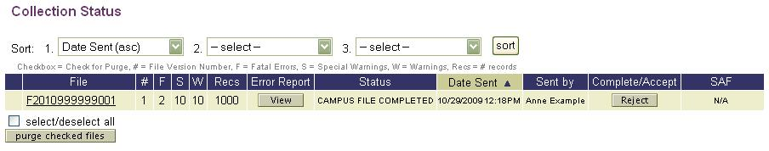
- An email notification section displays the name of the sending user in the From field as well as their email address in the Cc field, ensuring they receive a copy of the File Reject notice in their email inbox.
- A Confirmation Letter displays below the email notification section. You can customize the Reject Letter by entering your own text or use what is already typed.
Figure 27. District View–File Reject Page with Rejection Letter
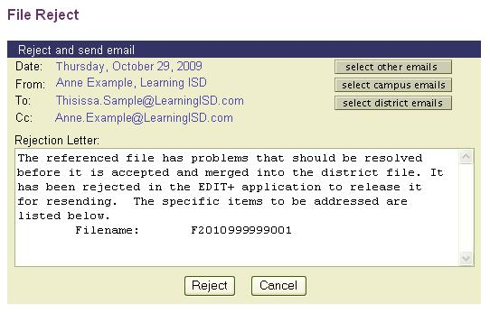
- Three email buttons also display on the page representing different groups of EDIT+ users who may be notified.
- Select Other Emails–This button displays a list of previously notified users. Select the Edit List button to add or remove listings. To add a person, enter the name in the Email Address field and select the Add button. To remove a person, place a check next to the name and select the Remove button. Select Done to return to the Reject File: [File Number] page. On this page, check the names of the users you want to notify, then click Done to save and return to the File Reject page.
- Select Campus Emails and Select District Emails–These buttons display a list of campus and district users, respectively. Place a check by the names of the users you want to notify, then click Done to save the changes and return to the File Reject page.
- Click the Reject button to process email notification and reject the file. A confirmation message displays and the file is available for the campus to resolve the issues addressed in the email.

District Role–Completing the District File
When all campus files are accepted and merged with district data into a single district file, the district validates the district file. Once the District PEIMS Coordinator has a district file that meets the conditions below, the file is ready to be completed.
Completing a file starts from the Collection Status page and only those actions that are appropriate for the specific file and user display as options.

Conditions for Completing the District File
When the district file meets the following conditions, the option to complete the file is presented on the Collection Status page:
- File must be sent after the opening date of submission and before the collection due date (unless an extension is granted). If an extension is granted, the file must be sent before the extension due date.
- File sent cannot be a partial file.
- File cannot be flagged as complete if the Fatals Only option was selected even if the file contains no fatals.
- All record groups for the collection must have been selected from the Validation Options page for the file to be eligible for completion.
- District files must have no fatal errors but can have any number of special warning or warning errors.
- File must reach the Edit Complete status and the district user must have the authority to Accept files in order to Complete a file.

When a district file is flagged as Complete, the following events occur:
- Data is frozen for district use and no other changes can be made unless the file is rejected by the ESC.
- Email notification process activates and sends emails to user-defined email addresses.
- ESC is notified the file is ready for the ESC to review and to Accept or Reject.
- If accepted, file status shows District File Completed on the Collection Status page.
- District can begin the resubmission process.
Note: To access the resubmission database, go to the EDIT+ home page and choose the Select Collection button. Change to the resubmission database for the current collection.

Process for Completing the District File
To complete a district file:
- From the Collection Status page, select the Complete button corresponding to the file you want to complete. The Complete File page displays.
Figure 28. District View–Collection Status Page and Complete Button
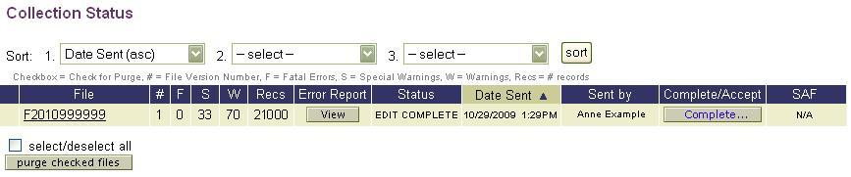
- An email notification section displays the name of the sending user in the From field as well as their email address in the Cc field, ensuring they receive a copy of the Complete File notice in their email inbox.
- A Confirmation Letter displays below the email notification section. You can customize the Confirmation Letter by entering your own text or use what is already typed.
Figure 29. District View–Complete File Page with Confirmation Letter
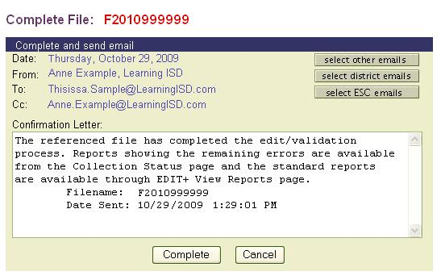
- Three email buttons also display on the page representing different groups of EDIT+ users who may be notified.
- Select Other Emails–This button displays a list of previously notified users. Select the Edit List button to add or remove listings. To add a person, enter the name in the Email Address field and select the Add button. To remove a person, place a check next to the name and select the Remove button. Select Done to return to the Complete File: [File Number] page. On this page, check the names of the users you want to notify, then click Done to save and return to the original Complete File page.
- Select District Emails and Select ESC Emails–These buttons display a list of district and ESC users, respectively. Place a check by the names of the users you want to notify, then click Done to save the changes and return to the Complete File page.
- Click the Complete button to process email notification and complete the file. A confirmation message displays. The file is frozen unless it is rejected by the ESC.

ESCs and the Data Acceptance Process
The ESC is the final participant in the PEIMS data acceptance process and has the responsibility of accepting or rejecting the district file. When the district file is received at the ESC, ESC personnel review Edit Error Reports to verify the completeness and accuracy of each district’s data within their region. If the district data needs more work, it is rejected so that the district can continue to edit the data. If the ESC is satisfied with the results of the data validation, the district file is flagged as accepted by the ESC. The data is then considered final and made available to TEA

ESC Role–Accepting the District File
When the district is satisfied that their file is ready for ESC level review, the district PEIMS Coordinator completes the file. This action notifies the ESC to review the district data and reports to either accept or reject the district file. The ESC views the Edit Error Reports and runs any other reports on demand that they may want to review.

Conditions for Accepting a District File
Before an ESC accepts a district file, the following conditions are assumed to be met:
- District file sent for validation and flagged as Complete.
- ESC Collection Status shows a status of District File Completed.
- District PEIMS Coordinator has reviewed the Edit Error Reports and has determined that the file is ready for ESC level review.

When a district file is accepted by the ESC, the following occurs:
- Email notification is sent to TEA automatically via EDIT+ and to the district user who completed the file.
- PID update process starts.
- PID reports are generated.
- File is sent to data tables for processing.
- Turnaround Reports are generated.
- Email notification is sent to the ESC, district, and Superintendent when Turnaround Reports are available for viewing.

Process for Accepting a District File
To accept a district file:
- From the Collection Status page, select the Accept button to display the Accept File page.
- Use the three email buttons to change the emails of people you wish to notify.
- Customize the contents of the Confirmation Letter by entering your own text, if desired.
- Click the Accept button to process the email notification and accept the district file.
- A confirmation message displays. To return to the Collection Status page, select the Click Here link. The new status of the file is District File Accepted.

ESC Role–Rejecting the District File
If the ESC discovers errors that need to be corrected by the district, the file is rejected. When the district has corrected the errors using the vendor software, the file is transferred and validated before the District PEIMS Coordinator flags the file as Complete once again.

Process for Rejecting a District File
To reject a district file:
- From the Collection Status page, select the Reject button to display the File Reject page.
- Use the three email buttons to change the emails of people you wish to notify.
- Customize the contents of the Rejection Letter by entering your own text, if desired.
- Click the Reject button to process the email notification and reject the district file.
- A confirmation message displays. To return to the Collection Status page, select the Click Here link. The new status of the file is District File Rejected.

Knowledge and Skill Exercises
This section provides exercises to assess the knowledge and skills you have acquired from reading through the chapter.
Exercise 6.1–Accepting a Campus File
Complete the following steps:
- As a district-level user with complete/accept authority in your EDIT+ user profile, send a campus file through EDIT+.
- When the file finishes processing, view the Collection Status page.
- Make a note of any fatal errors. Complete the campus file. Send the appropriate emails.
- Accept the campus file you flagged as completed in step three (only possible to do both when you have complete and accept authority in your EDIT+ user profile.)
- Send the appropriate emails and return to the Collection Status page. What is the status of the campus file now? What is the next step?

Exercise 6.2–Completing a District File
Complete the following steps:
- As a district-level user with complete/accept authority in your EDIT+ user profile, send a fatal free district file through EDIT+.
- When the file finishes processing, view the Collection Status page.
- Complete the district file you have just sent. Reminder: This file must be fatal free and must include all record groups before you are able to see the Complete button.
- Return to the Collection Status page. What is the status of the district file now?
Exercise 6.3–Accepting a District File
Complete the following steps:
- Who accepts a district file?
- As a user who is authorized to do so, accept a district file.
- Who receives notification that the file is accepted? What reports are now available?

Chapter 7–EDIT+ Reports: Categories

Overview
This chapter details categories of EDIT+ reports along with their unique features. For information about EDIT+ report functionality, see the chapter entitled, EDIT+ Reports: Functionality.
The EDIT+ Report Hierarchy
EDIT+ reports are developed for three hierarchy levels of users:
- ESC-level–ESC reports, generated by the ESC from an ESC file
- ESC-level by district–ESC reports, generated by the ESC from a district file
- District-level–District reports, generated by the district from a district file
- District-level by campus–District reports by campus, generated by the district from district file
- Campus-level–Campus reports, generated by the campus from a district file; only in an Approved collection and only available for viewing by the campus
- Campus-only–Campus reports, generated by the campus from a campus file
Note: Not all reports are available in all report categories. Please reference EDIT+ ReportsHelp for detailed information, including availability, report elements, and report samples. To access, select any purple book icon next to a report name within the EDIT+ application.

General EDIT+ Report Categories
EDIT+ provides several categories of reports. Listed below are typically the most commonly used categories of reports:
- Standard Reports
- Special Reports
- Turnaround Reports
- Edit Error Reports

Let’s take a look at these categories of reports in more detail.

Standard Reports
Standard Reports are auto-generated reports that are run as part of the PEIMS collection and submission process. They can also be run on demand as needed. Standard Reports are collection-specific and include such reports as:
- Fall–Budget, Budget Allocation, Staff, Student, Special Ed, CTE, TAKS, Student Leaver
- Mid-year–Actual Financial, Actual Allocation, Audit
- Summer–Attendance, Disciplinary Action, Title I, Special Ed Restraint
- Extended Year–Optional Extended Year Programs, Extended School Year Services
Special Reports
Special Reports include the Submission Summary, Principal Approval Letter, Superintendent Approval Form (SAF), District-Level QA Reports, and PID Discrepancy Reports (PID verify). Special Reports are associated with limited users and/or limited time periods. Some reports are available on demand only after certain events have occurred.
The Submission Summary displays the record types submitted and the type of edits performed on a data file. The Principal Approval Letter is emailed to the District PEIMS Coordinator by the campus when data files have processed with as few fatal errors as possible. The Superintendent Approval Form (SAF0A001) is a letter that is auto-generated during an EDIT+ process which enables Superintendents to electronically approve/disapprove a district file (or ESC Executive Directors for ESC files). For more information about SAF, see the chapter entitled, The SAF Process, in the PEIMS EDIT+ Administrator Reference and Training Guide.
District-Level QA (Quality Assurance) Reports compare current submission values to previous year values and identify differences between the years. PID Discrepancy Reports (PID Verify) are generated only when a user who has PID Edit permissions in their EDIT+ user profile selects PID Edit on the Select Validation Options page. The results of PID Discrepancy Reports (PID Verify) represent a dynamic snapshot of PID errors at the time the report is generated (results are overwritten each time PID Edit is run against the file). After a district file is accepted by the ESC, a final PID update is processed, the results are static, and the final version of the report (PID Update) is located in Turnaround Reports. Due to the nature of PID processing, PID Discrepancy Reports may not be immediately available for viewing. A twenty-four hour turnaround time may be necessary. Email notification is sent when the reports are available.
Note: PID and QA Reports are available for viewing and printing only after the file has been accepted by the ESC. The user name that displays in the Run By column on Turnaround Reports is the name of the ESC PEIMS Coordinator who accepted the file. The date/time in the Date Sent column is the date/time the file is accepted.
Turnaround Reports
Turnaround Reports include Data Validation Reports, District-Level QA Reports, PID Discrepancy Reports (PID Update), and Cover Letters. Turnaround Reports are available only after the district file has been accepted by the ESC.
Note: Cover Letters are TEA notices generated by the EDIT+ system. They acknowledge the timely submission of PEIMS data after a collection is complete and the data is reviewed by TEA; they also serve as notice that Turnaround Reports are available for the districts.
Some EDIT+ reports display on the Turnaround Reports page as well as other report pages. For example, some Student Disciplinary Action Reports display on the Standard Reports page and on the Turnaround Reports page. The Turnaround version of any report that is also listed in another report group has a prefix of PRT. For example, Student Disciplinary Action Summary, displays as PRF7D014 on the Standard Reports page, and PRT7D014 on the Turnaround Reports page. The format of the PRF version is the same as the format of the PRT version.

Edit Error Reports
Edit Error Reports (also known as Error Reports and Validation Reports) are used to explain errors in PEIMS data that have been flagged during validation. A single Edit Error Report is generated automatically when a file is transferred to the EDIT+ server with a request to validate the data. All other Edit Error Reports are available on demand after the file has been processed.
- Each validation process creates a new Edit Error Report and Submission Summary Report, overwriting any previously generated reports
- Edit Error Reports can be viewed and printed using Adobe Reader
- Edit Error Report data is available as a table download
Some Edit Error Reports are available for both districts and campuses; each campus report shows only the edit errors associated with that campus. To view a campus Edit Error Report, select the By Campus button on the Edit Error Reports page; a hyperlink associated with a campus indicates that there is an Edit Error Report available for that campus.
Note: Certain edits distinguish between campus, district, ESC, or charter school files. The file name indicates whether the file contains district or campus data. If you send a campus file, the campus-level edits run (this also applies to charter school campus-named files). If you send a district file, campus-level edits do not run. Check the PEIMS Data Standards to determine whether a particular edit is applicable to your campus.
Working with Errors
The View Errors Online and Data Search functions help streamline the data correction process. The detail is particularly helpful when working with errors that are triggered by rules involving two or more record types. Detailed record information is searchable and available dynamically via an HTML page, rather than a PDF. View the detail online or print using your Print button.
Record details are available in two places:
- Data Search (accessible via the EDIT+ Contents list) is especially helpful when working with Errors, allowing users to view relationships between records within their hierarchy. Data is displayed in the same format as the PEIMS Data Standards. For more information regarding data searches, see the chapter entitled, Data Search.
- View Errors Online button (accessible via the Edit Error Reports page) permits access to the error data associated with the files within your hierarchy. Data is displayed in a format that closely resembles the existing Edit Error Reports.

Viewing Edit Errors Online
Using the View Errors Online feature helps expedite the data correction process by providing error data associated with files within your hierarchy. It is especially helpful when working with edit errors that are triggered by rules involving two or more record types because it allows users to view relationships between records.
Data is displayed in an HTML page that closely matches the format of the Edit Error Reports. Your file must have reached Edit Complete status and an Edit Error Report auto-generated before errors can be viewed online.
Note: Student record errors are not searchable via Student ID or Student Name when a corresponding 100 record is either missing or not loaded due to a fatal error. These errors are viewable only by searching for a specific edit number.

To view errors online:
- From the Error Reports page, select the View Errors Online button located at the bottom of the page. The Online Error Listing page displays.

- Enter the search criteria in the appropriate field(s).
Figure 30. Online Error Listing–Search Fields
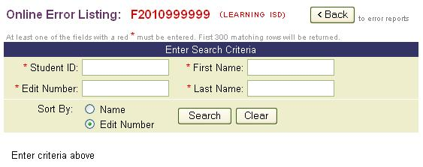
- To Search by Edit Number: Type in the edit number. Use the wildcard card character (*) to view all records of a certain type. Select the Search button to begin. The error listing displays the first 300 records. To constrain the search, use additional search criteria.
Figure 31. Online Error Listing–Search Results
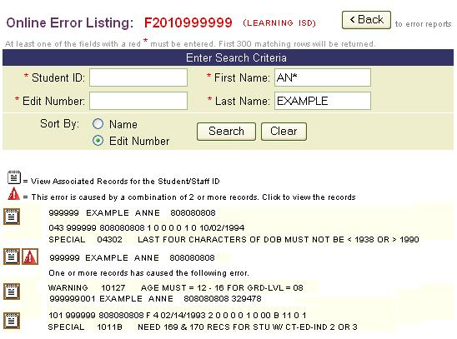
- To View Associated Records (for a specific student or staff ID) and Error Details: Select the Associated Records icon (resembles a notebook). The link displays records that are associated with the searched student or staff ID. Select the Error Details link (red triangle) to view the details of any records that were evaluated.
- To Search by SSN: Type in the Student ID. Click the Search button to display search results. Reminder: Wildcard card searches are not allowed in the SSN field.
- To Search by Name: Type the first and/or last name into the First Name and Last Name fields. The wildcard card character (*) can be used to search on a partial name. Select the Search button to begin. Search results are displayed.

Other Categories of EDIT+ Reports
EDIT+ provides several additional categories of reports:
- Collection Status and Lookup Tables (All collections)
- PID Error Rate Reports (Fall and Summer only, Approved collections)
- Student Leaver Record Submission Support Reports (Fall collection)
- Campus-Level Reports (campus users only, Approved collections)
- Region-Wide Reports (ESC users only, Fall and Summer)

Let’s take a look at each of these report categories in more detail.

Collection Status Reports and Lookup Tables
The Collection Status Reports and Lookup Tables page provides a method to quickly look up information without the need to generate reports.

Working with the Collection Status Report
Collection Status Reports give ESCs and districts a glimpse of activity within their hierarchy, including file send details, file error details, and student and staff PID error counts. ESC PEIMS Coordinators can monitor the progress of their districts; District PEIMS Coordinators can monitor the status of their campuses. The page does not display details for the current active Agent ID.
To view the Collection Status Report page:
- From the EDIT+ home page, select View Reports. Select the Collection Status Report link on the Collection Status and Lookup Tables page.
- The Collection Status Report page displays. All Agent IDs within the hierarchy are listed regardless of whether files have been sent. Use the column headers to change the sort order of the columns.
Figure 32. Collection Status Report Page–ESC View
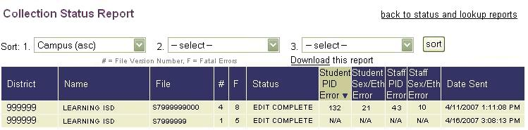
- The information in the Student and Staff columns is extracted from generated Student and Staff PID Discrepancy Reports. If a file has been sent but the reports are not yet generated, N/A displays in these columns.

- To print the Collection Status Report page using the browser, select the Print. To download, select the Download this report link above the column headers.
Note: Information displayed in the Collection Status Report is updated on a regular basis by AskTED. If a campus ID is missing a description, it is probably a new campus and the description is updated the next time AskTED and EDIT+ are synchronized.

Collection Status Report for Alternate Agents
For EDIT+ users with Alternate Agents established in their user profile, a Collection Status Report for Alternate Agents link is available on the Collection Status and Lookup Tables page.
Figure 33. Collection Status Report for Alternate Agents Link
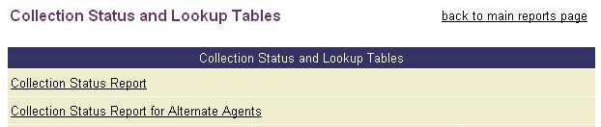

Collection Error Summary
The Collection Error Summary Lookup is a table located on the View Reports page. The table contains the total count for each error number received by a district during a collection. The count represents all files sent by an ESC, district, or campus.
Note: Districts are able to view data only for their district; ESCs are able to view data for all of their districts.

To view the data:
- From View Reports, select the Collection Status and Lookup Tables link.
- The Collection Status and Lookup Tables page displays.
- Corresponding to the Collection Error Summary Lookup listing, enter a District ID (or Campus ID, as applicable). Select the View button.
- The Collection Error Summary page displays for the District ID listing the edit number, severity, error description, and number of occurrences of a specific edit for all files submitted by a district for a collection. The information can be downloaded in a comma-separated file by going to the Table Downloads link on the View Reports page.
Figure 34. Collection Error Summary Page Detail
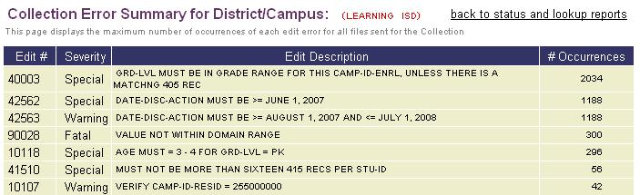

Working With Lookup Tables
Lookup tables search the EDIT+ database tables for information. The results are available during all collections. Printing the tables may require a great deal of paper depending on the size of the table therefore it is recommended that you use the browser's Print Preview feature to view the size of the lookup table results before printing.
Following are Lookup Tables available in all collections:
- Collection Error Summary Lookup Table–A summary list of edit error details for all files submitted by a district or campus during a collection. A statewide lookup is also available.
- Lookup Table C900 Districts–A master list of the county/district numbers for all districts in the state of Texas.
- Lookup Table C901 Campuses–A master list of the county/district/campus numbers for all campuses within a district.
- Lookup Table P900 Prior Year Districts–A master list of the county/district numbers used in the prior year.
- Lookup Table P901 Prior Year Campuses-A master list of the county/district/campus numbers used in the prior year.
Note: Tables available for viewing are dependent upon the collection.

To access the Lookup Tables page:
- Select View Reports from the Contents list on the EDIT+ home page, then select the Collection Status and Lookup Tables link.
Figure 35. Collection Status and Lookup Tables Page
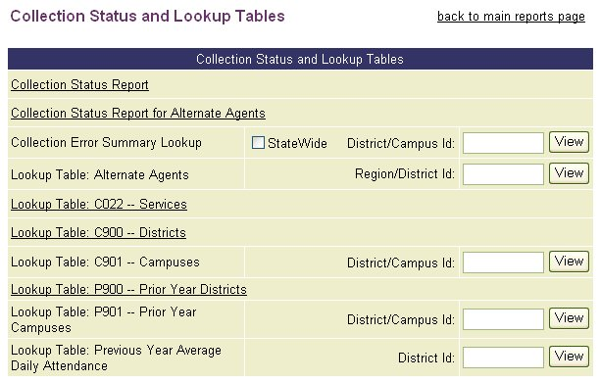
- To generate a C901 listing, enter an Agent ID in the District ID/Campus ID field next to C901 Campuses.
Note: You may enter a six-digit district (to view all campuses in a district) or a nine-digit campus Agent ID (to view only that campus information).
- Select View to display Lookup Table C901. You can select the browser’s Print button to print the entire table.
PID Error Rate Reports
PEIMS data submitted for the Fall and Summer collection must meet a PID Error Rate Standard for the school year as defined by the State of Texas. PID Error Rate Reports use the statewide collection of this data to determine if a region or district meets or does not meet the standard. Setting a standard for PID data quality encourages data quality practices within the districts. Regions and districts are notified whether the PID Error Rate Standard is met via the PID Error Rate Notification Letter (PIDFT001).
Note: PID Error Rate Reports are collection-specific and are generated after Fall and Summer Approved collections are created. They should not be confused with: (1) PID Discrepancy Reports (see the Special Reports section within this chapter) which districts can generate at any time during a Fall, Summer, or Extended Year collection to monitor their PID errors, or (2) Edit Error Reports (see the Special Reports section within this chapter) which districts can generate during all collections and are used to explain errors in PEIMS data that have been flagged during validation.
TEA’s PID Error Rate Standard policy and District Self-Evaluation document are available on the PID Error Rate Reports page in an Approved Fall or Summer collection. To access these links, from the EDIT+ home page, select View Reports and then select PID Error Rate Reports.
Student Leaver Record Submission Support Reports
Student Leaver Record Submission Support Reports assist districts with identifying students who may need to be reported in the Fall collection. The reports are available only for district users. All Student Leaver Record Submission Support Reports are generated on demand based upon criteria selected by the user on a report parameter page.
There are two result types for Student Leaver Record Submission Support Reports:
- Reports run against the EDIT+ database – provide statewide results
- Reports run against a district file – provide district-specific results

Generating Student Leaver Reports from the EDIT+ Database
To generate a Student Leaver Record Submission Support Report providing statewide results:
- From the EDIT+ Contents list, select View Reports, then select the Student Leaver Record Submission Support Reports link. The Student Leaver Record Submission Support Reports page displays.
Figure 36. Student Leaver Record Submission Support Reports Page
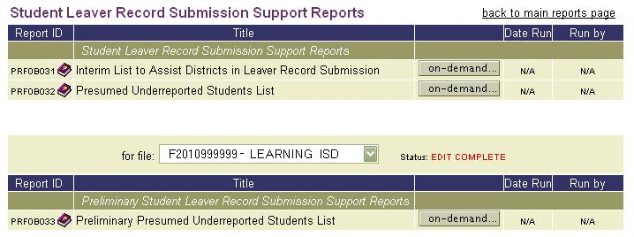
Note: For detailed information specific to each report, including information about Reported Type (see Step 3 below), select the purple book icon to the right of the Report ID.
- Select the On Demand button next to the report you want to generate. A report parameter page displays that is specific to the report you selected.
Figure 37. Student Leaver Record Submission Support Reports–Statewide
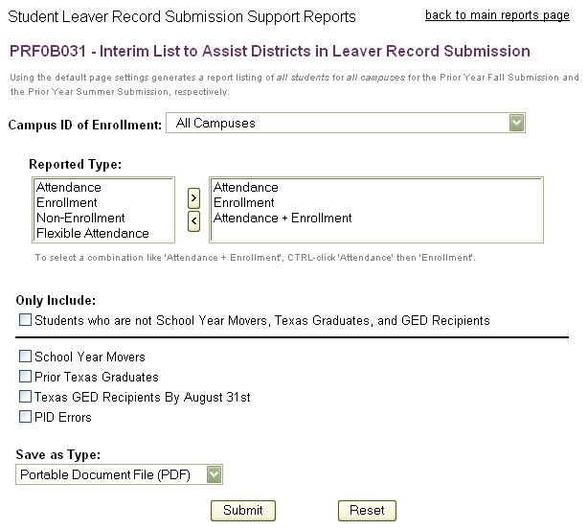
Note: Using the default page settings generates a report listing of all students for all campuses for the prior year Fall submission and prior year Summer submission, respectively.
- On the report parameter page, choose among the following:
- Campus ID of Enrollment–From the drop-down list, select the specific campus for which you want to run the report. To include all students in the report, select All Campuses.
- Reported Type–Choose a reported type and then click the right arrow button to move your selection to the parameter selection box. Each reported type (e.g., Attendance, Enrollment, Non-Enrollment, Flexible Attendance) generates a separate report. To remove a reported type from the parameter selection box, select the reported type you want to remove, then click on the left arrow button.
Note: Multiple Reported Types–A parameter selection can also contain combinations of reported types (e.g., Attendance + Enrollment). To generate a report with multiple reported types, select your first reported type, hold down the Ctrl key, select another reported type (or types), and then select the right arrow button. To remove multiple reported types, apply the same functionality in reverse, using the left arrow button.
- Only Include–To further filter report criteria, select a checkbox next to the applicable student subset.
- Save As Type–Choose to save the results of the report as a PDF file, an Excel spreadsheet, or a plain text comma-separated file.
Note: The Reset button removes all criteria chosen and resets the parameter page to its default settings.
- Click Submit. Periodically refreshing the Student Leaver Record Submission Support Reports page displays the progress of your report. When report processing is complete, the report name displays as a link. Notice the On Demand button immediately redisplays indicating the report is available to run again.

Generating Student Leaver Reports from a District File
To generate a Student Leaver Record Submission Support Report from a district file:
- From the View Reports page, select Student Leaver Record Submission Support Reports.
- The Student Leaver Record Submission Support Reports page displays. From the For File drop-down list, select the file you want to use to generate the report. The file must be at EDIT COMPLETE status.
- Select the On Demand button next to the report name. A report parameter page displays. Notice the parameter page displays the file name you selected on the Student Leaver Record Submission Support Reports page.
Figure 38. Student Leaver Record Submission Support Reports–District
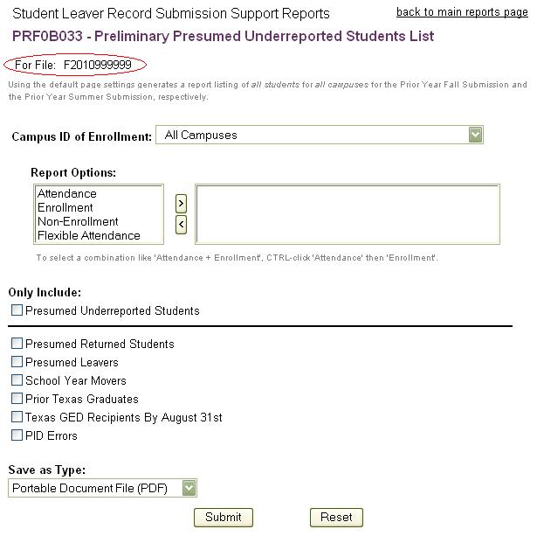
Note: Using the default page settings generates a report listing of all students for all campuses for the prior year Fall submission and prior year Summer submission, respectively.
- The remaining steps for generating the report are identical to Steps 3 and 4 of the Generating Student Leaver Reports from the EDIT+ Database section of this chapter.

Campus-Level Reports
Campus-level reports are campus reports run from a district file; available for viewing and generating by campus-only users in an Approved collection.
Note: District and ESC-level users do not see the campus-level reports option on their View Reports page.
In addition to generating campus-level reports, campus-only users can:
- view district-level by campus reports for their own campus previously generated during the collection by their district.
- generate campus-only reports (campus versions of a report; run from a campus file).

To view or generate a campus-level report as a campus-only user:
- Select the Approved collection from the Select PEIMS Collection page.
Figure 39. Select Approved Collection
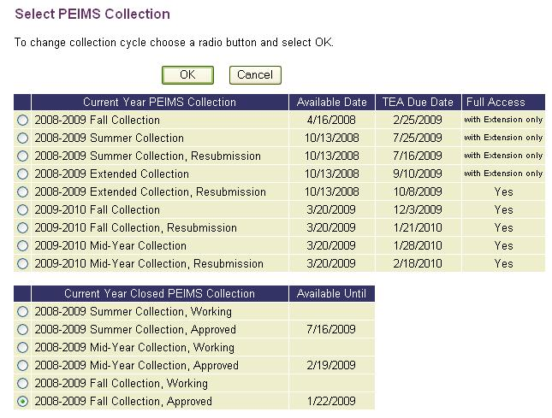
- Select Campus Reports Generated from District from the View Reports page.
Figure 40. View Reports–Campus Generated From District File
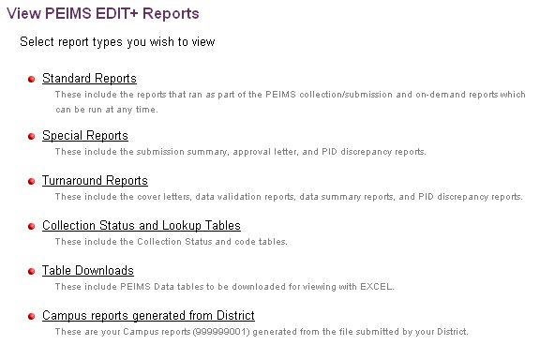
- Generate a report by selecting the On Demand button next to the report name. View a previously generated report by selecting the underlined report name.
Region-Wide Reports
Region-Wide Reports provide ESC users with the ability to generate certain reports using the data from all districts within their region (for example, PRF7D056-Disaggregation of PEIMS Summer Attendance Data). See the chapter entitled, Region-Wide Reports and Table Downloads, in the PEIMS EDIT+ Administrator Reference and Training Guide for details.

Knowledge and Skill Exercises
This section provides exercises to assess the knowledge and skills you have acquired from reading through the chapter.
Exercise 7.1–View Edit Error Report and View Edit Errors Online
After a file has been sent through validation, complete the following steps:
- View the Edit Error Report generated by default when validation is complete. How many special warnings are in this file? How many warnings? What is the sort order of this report?
- Generate two additional Edit Error Reports. Compare these reports with the one generated in the previous step. Familiarize yourself with how Edit Error Reports can help with data validation.
- Using an error from one of the above error reports, view the edit error online.

Exercise 7.2–Collection Status Report and Look Up Tables
From the Collection Status and Lookup Tables page, complete the following steps:
- View the C022 (Services) table. What is the description for Service code 02560050?
- View the Collection Status Report page for your Agent ID. What is the current status for most of your campuses?
- Locate the C901 (Campuses) table. Type your Agent ID in the for file field. View the list of campuses for your Agent ID. How many AEP schools are listed?
- Determine the student PID Error count and Staff PID Error count for your Agent ID.

Chapter 8–EDIT+ Reports: Functionality

Overview
EDIT+ reports can be generated using different methods. Some methods are specific to the report and are discussed in the previous chapter. However, general report functionality is achieved through the following methods:
- On Demand
- Auto-Generated
- Bundled
- Parameter-Driven

Reports that are Generated On Demand
EDIT+ users can manually generate many EDIT+ reports on demand. The reports are created from the PEIMS data files that you have transferred. Standard, Special, and some Turnaround Reports can be generated on demand.
- The reports can be saved to your hard drive and printed as needed.
- The reports are available for viewing until the file is transferred again (which overwrites previous report results).
Note: Individual reports run on demand receive higher priority in report scheduling than bundled reports.

To generate a report on demand:
- Select the View Reports link on the EDIT+ home page. From the View Reports page, select Standard, Special, or Turnaround (categories available for generating reports on demand).
- The applicable report page displays, listing the reports available for generating on demand.
- From the For File drop down list, select the file against which you want to run the reports.
Figure 41. Standard Reports Page–On Demand Button
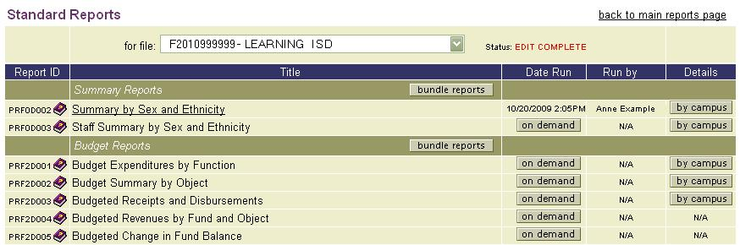
- Select the On Demand button in the Date Run column to initiate report generation. A reports processing window opens that confirms the report is running.
Note: Some reports may take longer to process than others. While the report is processing, you may use the Click Here link to close the reports processing window or you may use the browser’s Refresh button to refresh the page and follow the progress of the report.
- When processing is complete, the report name displays as a hyperlink. Selecting the link opens a PDF file which can be viewed or saved. It is recommended that you save the report. When another file is transferred, any previous report results are overwritten.
Note: District reports at the campus level are generated on demand by selecting the By Campus button that corresponds to the district report name. From the Reports By Campus page, select the corresponding On Demand button to generate the report.
Figure 42. Reports By Campus Page
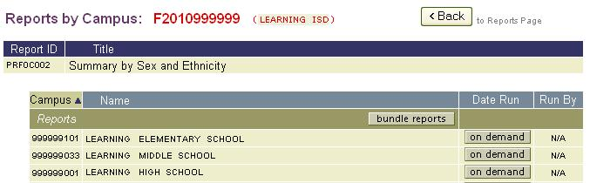

Reports that are Auto-Generated
Auto-generating reports is a convenient way to have reports immediately available following file validation. The selected reports can also be run on demand at anytime. Reports selected to auto-generate are retained as part of the user’s profile. Reports are auto-generated when a file reaches EDIT COMPLETE status.

Selecting Auto-Generated Reports
Users select the reports they want to auto-generate during the Data Send process. The selected reports are created at the end of the file validation process.
To select auto-generated reports:
- Click the Send Data link from the Contents list and load a file to send for validation.
- Click Continue. The Select Validation Options page displays. Choose the Select Reports button in the upper right corner of the page.
Figure 43. Select Validation Options Page–Select Reports Button
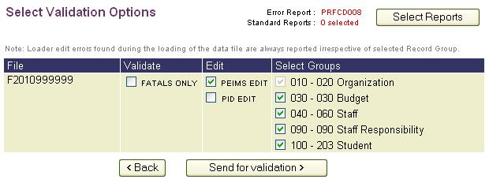
- The Select Auto-Generated Reports page displays a list of Edit Error Reports and a list of Standard Reports that can be selected for auto-generation.
Figure 44. Select Auto-Generated Reports Page–Standard Reports Selection
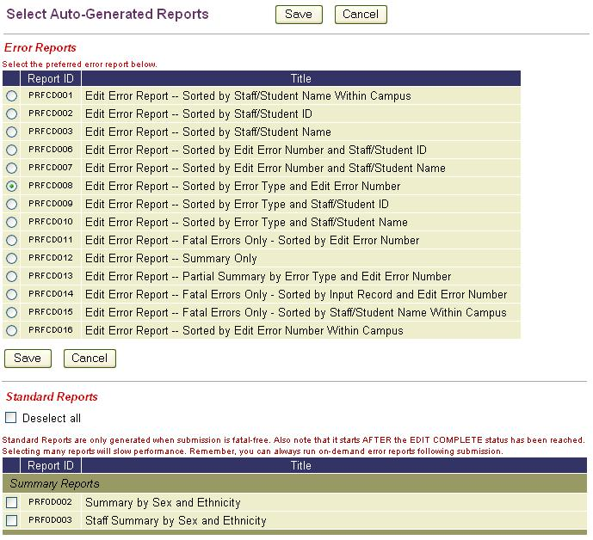
- Select the checkbox(es) that correspond to the reports you want to auto-generate. Clicking the Deselect All button removes all checks and refreshes the page.
- When all reports are selected, click a Save button to the Select Validation Options page.
- The report selections are saved as part of your user profile and pre-selected the next time you send the file. Note that selecting many reports to auto-generate can have an impact on processing time.

Viewing Auto-Generated Reports
To view auto-generated reports:
- If you are viewing the progress of a file from the Progress Monitor page, select Click Here to View Collection Status to view reports listed on the Collection Status page.
- Otherwise, select the View Reports link from the Contents list on the EDIT+ home page. Select Standard Reports and click on the underlined report name link to display the report.

Auto-Generated Reports at Rollup of an EDIT+ Collection
Prior to collection rollup, any district-level reports not run during the collection are automatically generated by the system for purposes of archiving. Note that, for these reports, EditPlus Admin (TEA) displays in the Run By column on the report category page.

Reports that are Bundled
ESC, district, and campus users have the ability to bundle certain individual reports and report groups as a convenient method for generating and printing the reports.
Note: Individual reports generated on demand receive higher priority in report scheduling than bundled reports.
Bundling Individual District-Level Reports (ESC Users)
ESC users can bundle a single selected district report for all their districts. Files must have reached a status of DISTRICT FILE COMPLETED and only districts submitted to date are included in the bundle.
Note: The bundle provides a snapshot of the report based on the date the district last submitted its file not on the day you bundle the report.
To bundle individual district-level reports:
- Select the Region-Wide Reports and Table Downloads link on the View Reports page (see the Region-Wide Reports and Tables Downloads chapter for more information).
- On the Region-Wide Reports and Table Downloads page, notice there are two links for district bundles: Bundled District Standard Reports and Bundled District Turnaround Reports. For illustration, we use the Bundled District Standards Reports link.
- On the Bundled District Standard Reports page, choose the individual report you want to bundle by selecting the Select Report drop down arrow. The page refreshes after the report is selected and may take a few moments.
Figure 45. Bundled District Reports Page–Select Report Drop-Down List
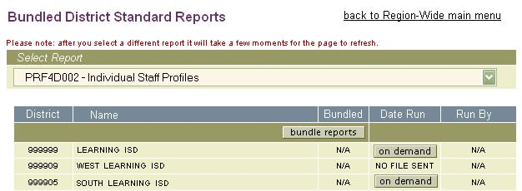
- Select the Bundle Reports button. After the button is selected, a confirmation message displays. To return to the Bundled District Reports page, select the Click Here link.
- When you return to the Bundled District Standard Reports page, if reports are running on demand for a district, the Bundle Reports button has changed to a Processing status. As each individual report completes processing, a district name with a hyperlink indicates the report can be viewed in PDF. Refresh the page by selecting the browser’s Refresh button.
- When the bundle finishes processing, the Bundle Reports button changes to a Download link. Selecting the Download link in the report group header saves the bundle.

Figure 46. Bundled District Reports–Download Link
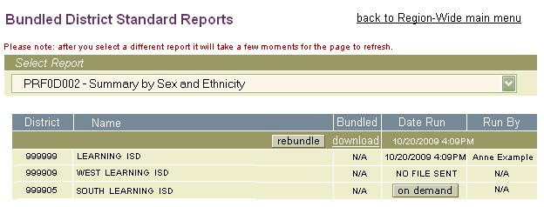
- To bundle another report, select the report from the Select Report drop down list and repeat the bundle process.
Note: After the initial bundling, ESC users can select the Rebundle button (located to the left of the Download link) to include newly submitted district files. EDIT+ does not prompt ESC users when new district files are submitted, however, if any district shows a Date Run that is later than the Date Run directly to the right of the Download link, that district report is not included in the bundle.

Bundling District-Level Reports by Report Group (District Users)
District users can bundle district-level reports by report group. To bundle these reports:
- From the Standard Reports page, select the Bundle Reports button in the banner header corresponding to the report group you want to bundle.
- This action initiates the generation of all reports in this report group. After selecting the Bundle Reports button, the Bundle Reports Request page displays to confirm your request. Use the Click Here link to return to the Standard Reports page.
- If the file and/or number of reports in the report group are large, it may take a few moments for all the reports to display as hyperlinks.
- Reports are generated when you see your name in the Run By column and a date and time stamp in the Date Run column. The report name is a hyperlink.
- When all reports have generated they are bundled into a single file that can be downloaded later. Notice that the Bundle Reports button has changed to a Download link. If reports do not generate within 24 hours, the Bundle Reports bundle button is displayed again.
Figure 47. Standard Reports Page–Bundle Reports by Group
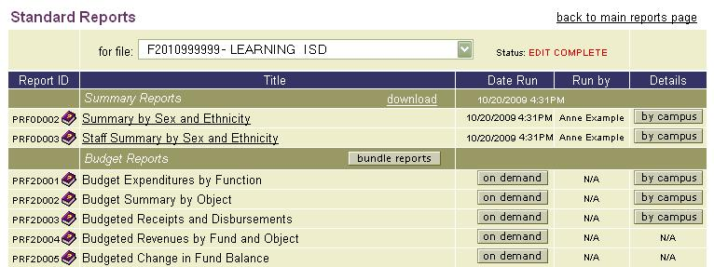
- To retrieve the bundled file containing the EDIT+ reports, select the Download link displayed in the report group header.
Note: Districts that bundle reports prior to the availability of Turnaround Reports will not have those reports in their bundle. For report groups that display on the Turnaround Reports page, bundles can be regenerated by selecting the Reset Bundle button. The button acts as a delete button. When selected, the Bundle Reports button replaces the Download link and date/time stamp of the previously generated bundle.

Bundling Individual Campus-Level Reports (District Users)
District users can also bundle campus-Level reports following a procedure similar to bundling district-level reports by report group.
To bundle individual campus-level reports:
- From the Standard Reports page, select the By Campus button corresponding to the report you want to bundle. The Reports by Campus page displays.
- From the Reports by Campus page, select the Bundle Reports button displayed in the Reports group header.
Figure 48. Bundle Reports by Campus
- The Campus Reports Request page confirms your request. Use the Click Here link to return to the Reports by Campus page.
- If the file is large, it may take a few moments for all the reports to display as hyperlinks. Use the browser’s Refresh button to make the display current.
- Reports are generated when you see your name in the Run By column and a date and time stamp in the Date Run column. The campus name is a hyperlink.
- All campus reports are generated and bundled into a single file that you can download later. Notice that the Bundle Reports button has changed to a Download link. If reports do not generate within 24 hours, the Reports Bundle button is displayed again.
- To download the bundled file containing the EDIT+ reports, select the Download link displayed in the report group header.

Bundling All Reports for All Campuses–Super Campus Bundle (District Users)
Districts interested in running a single bundle to generate all Standard Reports for all campuses within their district can do so using the Super Campus Bundle feature. The feature is available for files that have reached either District File Accepted or Turnaround Reports Available status.
Note: IMPORTANT! Because the Super Campus Bundle is run after hours (overnight), once the Super Campus Bundle button is selected and confirmed, no single report is available for generation until the processing of all reports is complete the following morning.
To use the Super Campus Bundle feature:
- Select Standard Reports from the View Reports page. Notice that a Super Campus Bundle button is located at the top of the reports list on the right side of the page.
Figure 49. Super Campus Bundle Button for District Users
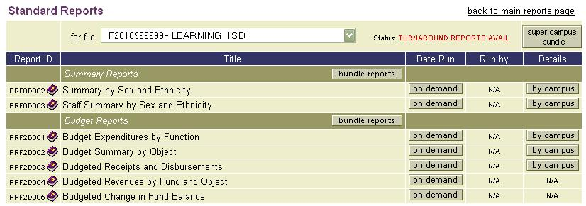
- When the Super Campus Bundle button is selected, a warning message displays prompting the user to confirm the request. Selecting OK confirms the bundle; selecting Cancel returns the user to the Standard Reports page.
- If the request is successful, a Download link replaces the Super Campus Bundle button.
Note: If any single report fails, the entire bundle fails and the Super Campus Bundle button redisplays on the Standard Reports page.

Bundling District File Campus Reports (Campus Users)
On the Standard Reports page, a Bundle Reports button located on the report header enables campus users to generate and bundle entire groups of reports against district files. The feature is available only in Approved collections for campus reports run against district data.
Figure 50. Bundled Reports for District File Campus Reports
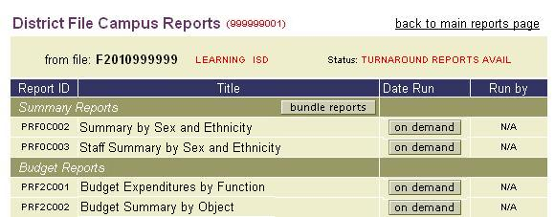
Reports that are Parameter-Driven
The My Report Requests feature enables users to create custom EDIT+ reports by selecting pre-determined parameters from various TEA pre-approved reports. Users can generate a specific report, then save (download) the report results to their local hard drive.
If a user has access to certain reports on the View Reports page (based on user hierarchy and permissions), those same reports are accessible using the My Report Requests. Reports are generated and saved based on TEASE Login ID, therefore visible only to the requestor.

Requesting a Report
To request, create, and generate a parameter-driven report:
- Determine you are in the collection for which you want to generate your report requests.
- Select My Report Requests from the from the EDIT+ home page.
- The My Report Requests page displays. This page is used to manage report requests. The first time a request is made during a collection period, the page displays with no reports listed (the only other time the page displays no reports is if the user deletes all requests).
Figure 51. My Report Request Page–Initial Launch
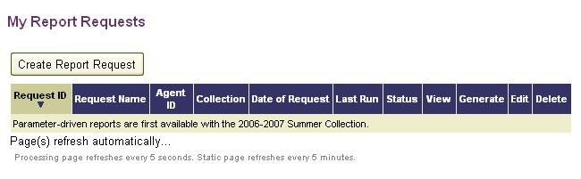
- Select the Create Report Request button. The Create Report Request page displays enabling you to create your first request.
- The Create Report Request page defaults to the first available category/group of reports. Selecting a different category/group from the available drop-down lists displays additional reports. Select the radio button next to the report name to request the report.
Note: Not all reports are parameter-driven therefore not every report category or group is listed. Only TEA pre-approved reports for current, Approved, and Working collections are available. No prior year collection reports are available for parameter-driven requests.

- Notice the selection criteria on the Create Report Request page. Review each of the selection criteria, completing the desired parameters for your request:
- Provide a name for this request–This name identifies the specific request. It should be descriptive enough to identify the report and its contents.
- Select the file to be used–The files available in this list are the same files available on the View Reports page for the Agent ID in context. To request a report, the Agent ID must match the file name (or be within the Agent ID hierarchy). Partial files can be used to generate parameter-driven reports.
- Select a category of reports–The categories available are the same categories available on the View Reports page for the Agent ID in context.
- Select a group of reports–The report group selection parallels the selection on the View Reports page for the Agent ID in context.
- Select a report–The reports displayed are based on individual report design and pre-approved by TEA.
- Parameter filters–Available parameters are based on individual report design and pre-approved by TEA. If the page displays a report with no filter or field sort selections, then the only parameter for the report is the export (Save As Type) option.
- Field sort–Available field sorts are based on individual report design and pre-approved by TEA. Fields can be sorted in ascending or descending order.
- Save as type–Select from three possible formats: Portable Document Format (.pdf), Excel® (.xls), or comma-separated value (.csv). Available formats are based on individual report design; therefore, not all formats are available for all parameter-driven reports.
Figure 52. Create Report Request Page–Sample Report Parameters
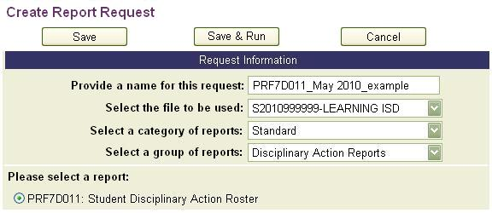
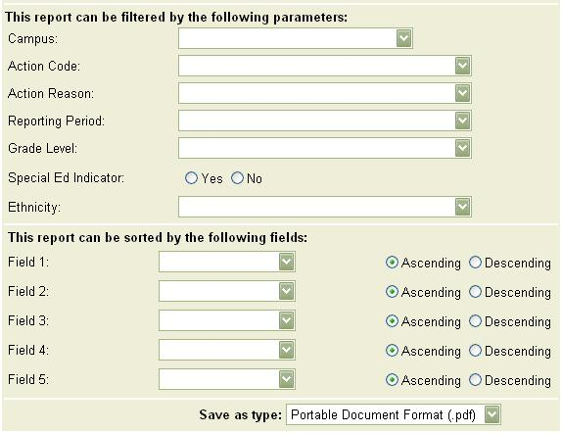
- Select the Save button to save your parameters and generate the report at a later time. A confirmation message displays. Select OK to return to the My Report Request page. Generate the report at any time by selecting the arrow button in the Generate column for the specific request.
- Select the Save & Run button to save your parameters and immediately generate the report. A confirmation message displays. Select OK to return to the My Report Request page where you can monitor report processing.
- If you select the Cancel button you are asked to confirm your request. Selecting OK returns you to the My Report Request page.
Monitoring a Requested Report
To monitor a report request:
- Once the report starts to process, details of the request display on the My Report Request page:
- Request ID–The Request ID is unique for each request and sequentially assigned based on requests generated system-wide. By default, the most recent request displays at the top of the list.
- Request Name–The Request Name is the unique name entered on the Create Report Request page.
- Agent ID–The Agent ID identifies the district associated with the file.
- Collection–The Collection column identifies against which collection the request is run. Possible values are:
First submission (e.g., F20071, M20071, S20071, E20071)
Second submission (e.g., F20072, M20072, S20072, E20072)
Approved collection (e.g., F2007A, M2007A, S2007A, E2007A)
Working collection (e.g., F2007W, M2007W, S2007W, E2007W)
- Date of Request–The Date of Request is a date and time stamp identifying when the original request is made.
- Last Run–The Last Run column displays a date and time stamp identifying when the request was last generated.
- Status–The Status column displays the processing status of the request. The most common values are: Submitted, Processing, and Completed. Once the status reaches Completed, the date and time stamp display in Last Run column.
- View–When the request successfully reaches Completed status, the View column displays an icon based on the type of file format selected on the Create Report Request.
- Generate–Once a request is created and the user selects the Save button, the Generate button displays on the My Report Requests page indicating the request is ready to generate. If the user leaves this page and returns at a later time, the Generate button remains until the request is generated. After a request is generated, the Generate button no longer displays.
- Edit–If the user wants to generate the same report with different parameters, the Edit button is used to select the new parameters.
- Delete–Select the Delete button to delete any request. A confirmation message displays asking the user to confirm the delete. If you are certain, select OK. Once deleted, the request cannot be restored.

- As a request is processing, the My Report Requests page automatically refreshes every 5 seconds. If no reports are processing, the page refreshes every 5 minutes. Each page displays up to 10 reports. If there is more than one page of requests, page number tabs at the bottom of each page enable you to toggle between pages.
- When report processing is complete, an icon representing the output format displays in the View column. Depending on the output format chosen, selecting the icon either opens a report for immediate viewing or provides an option to save the report to your hard drive.
Figure 53. My Report Requests–List of Requested Reports
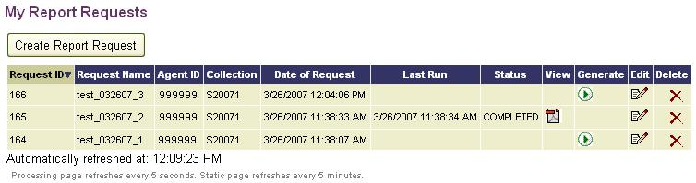
Note: Due to inherent limitations regarding the maximum quantity of rows in Excel®, if it is anticipated that an export will generate greater than 65,000 rows of information, users must: (1) select .csv as their output type, (2) save the report results to their local hard drive, and (3) open the file with a text editor such as WordPad® or Notepad®.

Generating a Previously Requested Report Using Different Parameters
Requests remain on the user’s My Report Requests page until deleted; therefore, a request can be regenerated by editing the original parameters. This process provides a quick and convenient method for easily regenerating a previously requested report using different parameter selections.
Note: Regenerating a report overwrites the results from a previously run report. To retain original parameters, create a new request with a new name for the different parameters.
To generate a previously requested report using different parameters:
- From the My Report Requests page, select the Edit button for the specific report.
Figure 54. My Report Requests–Edit Report Request
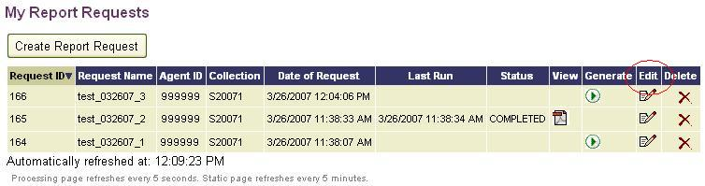
- The Edit Report Request page displays. Notice that the list boxes are populated with values from the previously saved request.
- Choose the new parameters with which you want to generate the report and select Save or Save & Run, as applicable.

General Guidelines for Saving, Viewing, and Printing Reports
After EDIT+ reports are generated, they are easily downloaded (saved), viewed, and printed. Specific guidelines for downloading parameter-driven reports are discussed in the Reports That are Parameter-Driven section of this chapter. General guidelines for saving, viewing, and printing EDIT+ reports generated from the View Reports page follow.

Required Software
Users must have WinZip®, Adobe Reader®, and Windows Internet Explorer® installed on their machines to download, view, and print EDIT+ reports.
- WinZip–Some EDIT+ reports are downloaded as zipped files. With WinZip, users can extract EDIT+ reports from a zipped file and save those reports to a folder on their network or local computer. WinZip is free can be downloaded either from WinZip’s website at www.winzip.com or from within EDIT+.
- Adobe Reader–To view and print EDIT+ reports, Adobe Reader also must be installed. Adobe Reader is free software that enables EDIT+ users to display and print EDIT+ reports as Portable Document Format (.PDF) files and can be downloaded from www.Adobe.com or from within EDIT+.
- Windows Internet Explorer–A current supported version of Internet Explorer is required.

Using the EDIT+ Download Page to Install the Required Software
To install any or all of the software needed to view, save, and print EDIT+ reports:
- Select the Click Here to Download link on the EDIT+ home page.
- The Download page displays.
- Select the WinZip icon to begin downloading a current version of WinZip.
- Select the Adobe Reader icon to begin downloading a current version of Adobe Reader.
- Select the Internet Explorer icon to begin downloading a current version of Internet Explorer (IE).

Saving (Downloading) EDIT+ Reports
When a report name displays a hyperlink, it is available for saving (downloading) to your hard drive.
To save a single report:
- Select the report name link to open the report in its own Adobe Reader window.
- Select the Save icon in the Adobe Reader toolbar. The Save a Copy dialog box displays.
- Choose the location for the file, then select OK to save the report file as a PDF.
To download a zipped bundle:
- Select the Download button from the Standard Reports page or the Reports by Campus page. The File Download dialog box displays.
Note: You may choose to Open this file in its current location; however, if you choose this option, the zipped file is not saved to your hard drive.
- Select OK to continue the download or select Cancel to cancel to the previous page.
- The Save As dialog box is displayed. The file name has an extension of .zip which indicates that WinZip has compressed the file.
Note: Windows defaults to the My Documents folder to save your file. You may choose another location to download and save your file by selecting the down arrow.
- Once the .zip file is saved, your next step is to extract the EDIT+ report(s).

Extracting Zipped EDIT+ Reports
To extract an EDIT+ report from a zipped file:
- Right-click on the zipped file. Select WinZip, then choose Extract to.
- The Extract dialog box opens displaying a default folder and location. If you prefer, you can choose a different location by selecting the Folders/drives scroll list. You can also create a new folder and location using the new folder icon.
- Select Extract. When the extraction is complete, the files are displayed in the saved location. Each PDF file name represents a separate EDIT+ report.

Viewing EDIT+ Reports
From within the EDIT+ application, reports that display a hyperlink can be viewed in Adobe Reader®. To print the report, select the Print button from the Adobe Reader tool bar or select
File >> Print from the menu.
To view a PDF file of an EDIT+ report that has been downloaded (saved) to your hard drive:
- Double-click the file name. Adobe Reader launches and displays the contents of the report.
- Use the arrow keys and scroll bars to navigate the report.
- To print the report, select the Print button from the Adobe Reader tool bar or select
File >> Print from the menu.

Printing EDIT+ Reports from PDF Files
When you have finished downloading and extracting your EDIT+ reports, you may decide you want to print the reports directly from your unopened PDF files.
To print an EDIT+ single report from a PDF file:
- From Windows Explorer, right-click the EDIT+ report PDF file name. Right-click your mouse, then select Print.
Note: If you know the contents of the report are accurate, you can print the report without opening the PDF file. Simply right-click on the PDF file name and select print.
To print a group of EDIT+ reports from PDF files:
- For an entire report group, from Windows Explorer, choose Actions >> Select All. All reports are selected. Right-click your mouse, then select Print.
- For a group of selected reports, from Windows Explorer, holding down your Ctrl button, select each report to be printed. Release the Ctrl button and right-click on any one of the selected PDF files, then select Print.

Knowledge and Skill Exercises
This section provides exercises to assess the knowledge and skills you have acquired from reading through the chapter.
Exercise 8.1–Generating EDIT+ Reports
Complete the following steps:
- From the Standard Reports page, generate a report on demand from a fatal free file.
- From the Special Reports page, generate report PRF0A001-Data Element Summary Report and PRF0A002-Submission Summary Report from a fatal free file. Which report provides a count of all the record types contained in your file?
- From the Standard Reports page, bundle the reports contained in the Budget Allocation Reports report group. Download the bundled reports to your computer desktop.
- As a campus user, bundle a group of campus reports run against district data (campus users as defined in user profile). As a district user, bundle district files using the Campus Bundles button.
- From the EDIT+ home page, select My Report Requests. Create and generate a parameter-driven Disciplinary Action campus report for your Agent ID, exporting the results to Excel® and using the following filters: Ethnicity (choose one), Action Code (choose one), Action Reason (choose one), for the 6th six-week period, for Grade 8, sort in descending order.
- Edit the report in the previous step with different parameters. Regenerate the report. On your My Report Requests page, notice that the report uses the same Request ID and Request Name.
- Create a new report request for the report you generated in the previous step using different parameters and a different request name. On your My Report Requests page, notice the report uses a different Request ID and Request Name.

Chapter 9–PID Search and PID Detail

Overview
PID is an acronym for Personal Identification [and System] Database, a statewide database of demographic student and staff data within the TEA system. EDIT+ offers functionality that allows the authorized EDIT+ user to search on the confidential data of staff and students within PID. Two of those research functions are PID Search and PID Detail.
Note: Only authorized users are granted access to PID. For more information regarding establishing PID access, see the chapter entitled, The EDIT+ User, in the EDIT+ Administrator Reference and Training Guide.

PID Search
The PID Search feature provides immediate response for student/staff lookup searches via the PID Search page. Searches can be conducted on 9-digit SSNs as well as student/staff IDs with a single leading alpha character plus 8 digits. Accepted alpha characters are: S (indicating a state-assigned ID), G (GED-assigned ID), or T (temporarily-assigned ID made by the Enterprise Data Management group within the PEIMS Division).
Note: If you do not have PID Search privileges in your user profile, PID Search is shaded in the EDIT+ Contents list. Access requires an approved TEASE access form on file with TEA.

Conducting a PID Search
To conduct a PID Search:
- From the EDIT+ home page, select PID Search. Enter data in at least one of the four required fields marked with a red asterisk (*).
Figure 55. PID Search
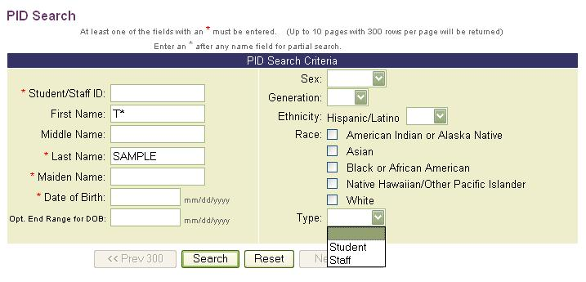
- Select the Reset button to clear any erroneous entries (or previous searches).
- Select the Search button to perform the search.
- The page refreshes, displaying the student/staff information in the lower portion of the page. Only the first 300 records display. Selecting the Next 300 >> button displays subsequent records.
Figure 56. PID Search–Results
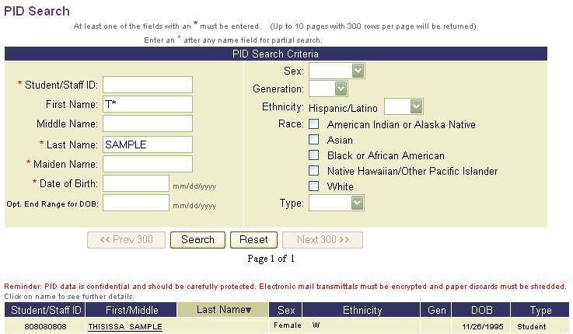
- Fields can be combined to narrow the search results:
- Partial Search using Name Fields–Partial name searches are done using a wildcard card character. Enter the first few characters of the name followed by an asterisk (*).
- Partials Search using Date Fields–Use the date fields to narrow your search on birthdates. For example, to locate all students born in 1992, use 01/01/1998 in the Date of Birth field combined with 12/31/1998 in the Optional End Range field.
- Partial Search using Drop-down Lists–Refine your search further by a drop-down list.

PID Detail
After conducting a PID Search, results can be viewed for specific individuals.
To view a PID Detail:
- Select a name link from the results listed on the lower half of the PID Search page. The person’s PID Detail page displays.
Figure 57. PID Detail–Results
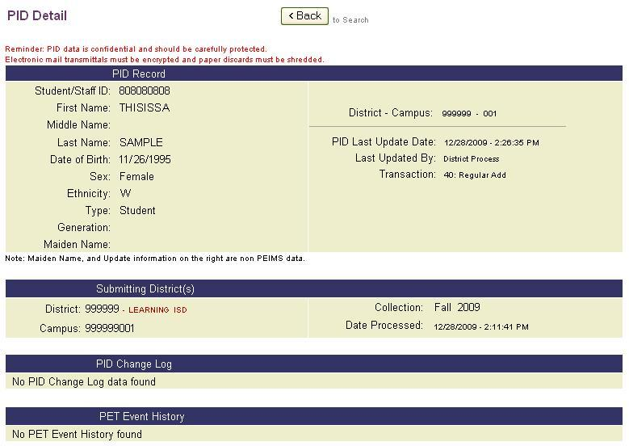
- The PID Detail page contains four categories of information:
- PID Record–This section displays personal data records for student or staff. The Last Updated By field displays the user who last updated the PID record either by submitting a PEIMS data file (batch) or manually (online) via PID Maintenance. If a user name does not display, TEA Online or District Process displays in the field.
Note: PID updates (batch and online) can only be made to a specific record every 14 days. The user must wait until 14 complete days have elapsed before making further update(s) to the record.
The following transaction codes display the process that was performed against PID in the most recent transaction:
10–Student/Staff ID data change only
11–Student/Staff ID and ethnicity/race change only (batch only)
15–Student/Staff ID and one major or minor demographic data change
20–One major or any minor demographic data change
21–Ethnicity/race change only (batch only; automatically applied when a data file submission changes ethnicity/race values)
Note: Although transaction code 21 does not lock PID records, if a record is locked prior to the code being applied, it remains locked until the 14-day restraint period has elapsed even though transaction code 21 displays in the PID record during that time.
25–Major demographic data change (First Name, Last Name, Date of Birth)
30–Verification that a person is in PID before any updates are made or verification that student/staff data is correct (batch only)
40–Regular add
45–Special demographic change; data changes to demographic fields made manually
50–Special add; person added manually to PID
60–Inquiry (batch only)
- Submitting District(s)–PID shows all districts that have processed a student or staff person, however, if an individual was not reported in the last collection cycle, there may not be information displayed in this section of the page results.
- PID Change Log–This section provides a change log of all updates to the individual’s record; sorted by the most recent update date.
- PET Event History–The final section provides a student’s PID Enrollment Tracking (PET) Event History. PET events are for EE-12 students only. Staff do not have PET events. To view a student’s PET Event History page, select the Click Here link.

Manual Changes to PID (Campus 700)
When the TEA PID Administrator applies a manual change to PID and the district does not provide the campus number, 700 is displayed in the campus field in the PID Record section. The actual campus number is recorded in the PID database and displayed in the campus field in the Submitting District(s) section of the PID Detail page.

Knowledge and Skill Exercises
This section provides exercises to assess the knowledge and skills you have acquired from reading through the chapter.
Exercise 9.1–PID Search
Complete the following steps:
- Search for the following students:
- Robert Smith with an ethnicity of African-American.
- All students named Smith born between April 1, 1995 and April 1, 2000.

- Narrow your search using the wildcard card character (*).
- Search for Martina Garcia.
- Add female as a search criterion.
- Add Hispanic as a search criterion.
- Add J as a Middle Name criterion.

- Using the wildcard, search for students with last name beginning with Joh. From the results set, look for a student with information listed under Submitting District(s) and PID History. What was the last district to process this record? Have any demographic changes been made to this record?

Chapter 10–Roster Search

Overview
The Roster Search process is interrelated with the QA Roster which is a list of all students
(7th grade and above) reported by a school district in the prior year, either the Fall or Summer collection. Certain EDIT+ reports, such as QA Reports and Student Leaver Record Submission Support Reports, check for status changes in student population from prior year to current year (e.g., enrollment, non-enrollment). To assist users in searching the QA Roster for a specific student record in their district or campus, EDIT+ provides the Roster Search feature.

Accessing Roster Search
Only users with PID Validation (PID Edit) permission are authorized to use this feature. Access is further restricted by the user’s hierarchy. TEA and ESCs have the ability to search on any district or campus ID. Districts and campuses are limited to searching only their own records.
The Roster Search link is located within the Contents list on the EDIT+ home page. The search parameters for Roster Search are similar to those for PID Search. Also similar to PID Search, the user can select any Student ID in the search results to display record details for that student.
Search results return two scenarios: student records with PID errors and records with no PID errors. If there is no asterisk next to the Student ID, a PID error has not been returned and selecting the Student ID displays the PID Detail page. If a record has a PID error, a red asterisk displays next to the Student ID and selecting the hyperlink displays a PID Error Detail page.
Using Roster Search
To conduct a Roster Search:
- Select Roster Search from the EDIT+ Contents list. The Roster Search page displays.
- Enter data in at least one of the fields marked with a red asterisk (*). Select the Reset button to clear your data entry. Partial searches can be conducted on name fields by typing the first few letters of the name followed by an asterisk (*).
Figure 58. Prior Year Student Roster Search
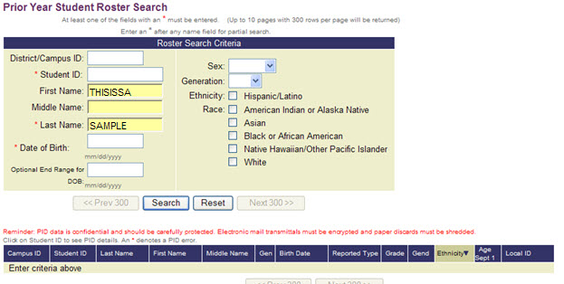
- Select the Search button. Results display directly below the search parameters. Up to 10 pages with 300 rows per page display for each search. You can navigate through multiple pages by selecting the <<Prev 300 and Next 300>> buttons.
Figure 59. Roster Search Results
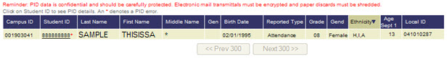
Note: The Reported Type column specifies the record type(s) for which the student is submitted. Possible values are: Attendance, Attend/Enroll, Attend Non-Enroll, Enrollment, Non-Enroll, and Enroll/Non-Enroll.
- If a red asterisk (*) appears next to a Student ID in the list of Roster Search results, selecting the Student ID displays the PID Error Detail page. This page displays the same information that appears on the Student PID Discrepancy Reports.
Figure 60. PID Error Detail
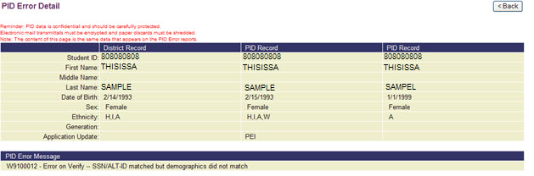
Note: Prior Student ID appears on the page only if a Student ID change is made.

Knowledge and Skill Exercises
This section provides exercises to assess the knowledge and skills you have acquired from reading through the chapter.
Exercise 10.1–Roster Search
Complete the following steps:
- Search for the following students:
- Jennifer Johnson with ethnicity of White, not of Hispanic Origin.
- All students named Johnson born between July 31, 1997 and July 31, 2000.

- Narrow your search using the wildcard card character (*).
- Search for Martina Garcia. Make a note of your results.
- Add female as a search criteria. Make a note of your results.
- Add Hispanic as search criteria. Make a note of your results.
- Add J as Middle Name criteria. Make a note of your results.

- Were you able to narrow the search results? How many results did you receive after adding gender, ethnicity and a middle initial to your search?
- What similarities does Roster Search have with PID Search? What differences?

Notes:

Chapter 11–Data Search

Overview
The Data Search feature allows users to search through all records contained in data files within their hierarchy. Any file can be searched once it has reached an Edit Complete status. Data is displayed in columnar format just as it appears in the database tables. Data Search is especially helpful when working with edit errors, allowing users to view relationships between records.
When using Data Search, the following tips are helpful:
- At least one of the fields marked with an asterisk (*) must be filled in.
- Combine fields to constrain the search.
- Fields are not case sensitive.
- Use the Reset button to clear all fields.

Searching and Displaying Data
To conduct a Data Search:
- Within the appropriate collection, select Data Search from the Contents list on the EDIT+ home page.
- The Data Search page displays. Select the file name you wish to search from the For File drop down menu. Only the files within your hierarchy display.
- Choose a record type by selecting the down arrow next to the Record Type field. The list of record types corresponds to the collection.
Note: Select the record type prior to typing in your search criteria. If a search field is not included in the record type you have selected, the search box is marked with n/a.
Figure 61. Data Search–Select Record Type
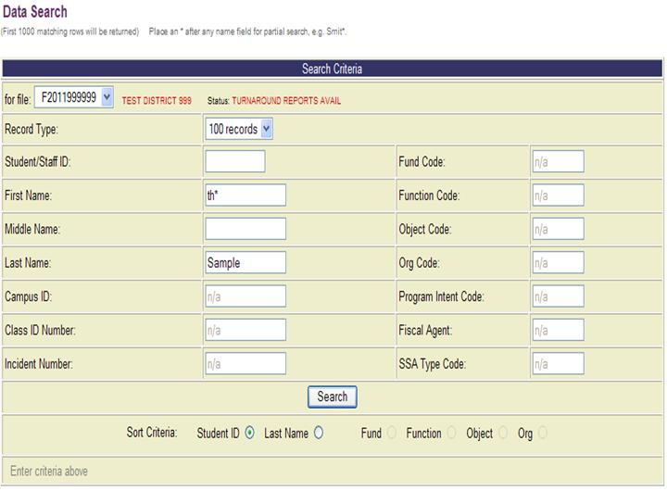
- In the Student/Staff ID field, you must enter a valid ID number consisting of a 9-digit Social Security Number or an ‘S’ and 8 digits. Do not include hyphens. Refer to the PEIMS Data Standards for details regarding valid Student/Staff IDs.
- In the name fields (First Name, Middle Name, Last Name), you can perform a partial search by typing the first few letters of the name followed by an asterisk (*). Fields are not case sensitive.
Note: With the 040 and 100 records, it is possible to enter a single asterisk (*) to return results.
- Choose sort order by selecting a radio button from the Sort Criteria displayed at the bottom of the page. If a sort option is not available, the radio button does not display.
- Select the Search button. The Data Search Results page displays. This information is especially helpful when working with edit errors, allowing users to view relationships among records. Use the browser’s Print button to print the information.
Figure 62. Data Search Results
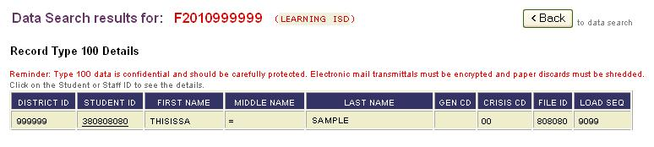

Knowledge and Skill Exercises
This section provides exercises to assess the knowledge and skills you have acquired from reading through the chapter.
Exercise 11.1–Data Search
Complete the following steps:

- Send a file through EDIT+.
- Go to Data Search. Select the file from the drop down menu.
- Search by record type 010. View the results.
- Search by record type 100 using a wildcard card search on the last name Jones. View the results.
- Search by record type 030. Search the 030 record again for all records with Fund Code 199 and Function Code 11. View the results.

Chapter 12–Table Downloads

Overview
Table Downloads are accessed from the EDIT+ View Reports page and downloaded in a comma-separated value (.csv) format. Once downloaded, data is imported to your computer with third party software applications.
Detailed information on each table download is available in the PEIMS EDIT+ Tables Reference. Information includes the data source for each of the EDIT+ tables, data relationships, and table organization.
Note: Table downloads do not run on demand. Downloads are scheduled to run after hours and prior to midnight on the same day they are requested.

Downloading Table Data
Table data is downloaded via zipped files. You must have a recent version of WinZip installed on your computer in order to download and extract the file. For directions on downloading WinZip to your hard drive, please refer to the chapter entitled, EDIT+ Reports: Functionality.
To download a table:
- Select View Reports from the Contents list on the EDIT+ home page, then select the Table Downloads link. The Table Downloads page displays.
Figure 63. Table Downloads Page–Select Download
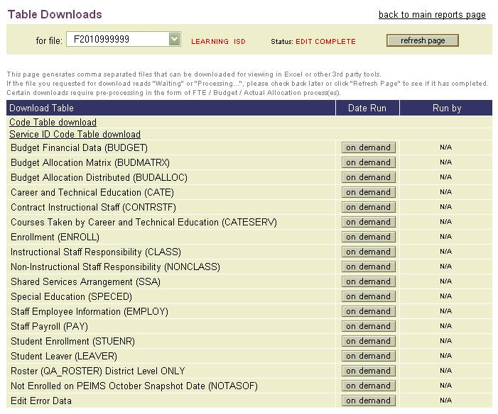
- Select the file name that you wish to work with from the For File drop-down list and highlighting the file you want. Only the files within your hierarchy display.
- Select the On Demand button next to the table name to begin the download of the table.
- The On Demand button changes to processing status, indicating that the download is in progress. Depending on the size of the table, it may take a few minutes for the file to complete processing.
Note: Certain downloads require pre-processing in the form of FTE/Budget/Actual Allocation process(es). If these processes are running, you are required to retry your download request by selecting the Retry link in the Date Run column.
- When processing is finished, the table name displays as a link indicating the file is ready for download to your hard drive. A date and time stamp display in the Date Run column. The user name displays in the Run By column.
- Select the table name link to begin the download. The file download dialog box displays giving an option to Open or Save the file. It is recommended that you save the file to your hard drive where it can be extracted with WinZip and viewed later.

Extracting Table Data from a Zip File
Extracting (decompressing) the zip file enables you to view and work with the data.
To extract the file:
- Use Windows Explorer to locate the zipped file (.zip) on your hard drive or network drive. Double-click on the file name to begin the extract process. You can extract multiple files by selecting more than one file name.
- The file that you selected in the previous step is displayed in the WinZip window. The file extension .txt indicates the file is saved as a text file.
- To view the data in Notepad, double-click on the file name.
- The table data file displays in Notepad.
Figure 64. View Table Data in Notepad
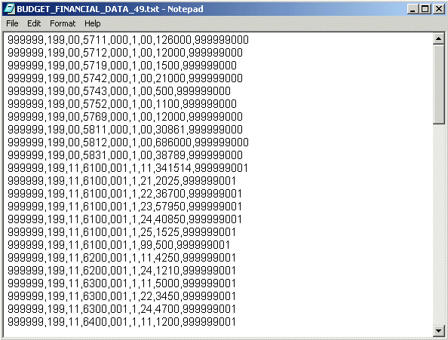
Knowledge and Skill Exercises
This section provides exercises to assess the knowledge and skills you have acquired from reading through the chapter.
Exercise 12.1–Table Download
Complete the following steps:
- Review the Collection Status page for your Agent ID. Make a note of the files listed.
- Go to View Reports. Go to Table Downloads.
- Select a file from the drop down list. Refer to the note you made in step one (only files in your hierarchy are available).
- Generate a download of a table. Save it to a location on your hard drive.
- When the download is complete, extract the data.
- View the data in Notepad or WordPad.

© Texas Education Agency–PEIMS Division
Enterprise Data Management Group
1701 North Congress Avenue
Austin, Texas 78701

