NYS 7th Grade Math Exam 2008 – Book 1 (Multiple Choice – No Calculators)

- What are the coordinates of point P?
A (2,3) B (3,2) C (-2,3) D (3,-2)

- What is 6,200 milliliters converted to liters?

1 liter = 1,000 milliliters

A 62 B 6.2 C 620 D 0.62

- What value of x makes the equation below true?

6x – 9 = 39

A 5 B 8 C 13 D 24

- A polygon is plotted on the coordinate plane below.
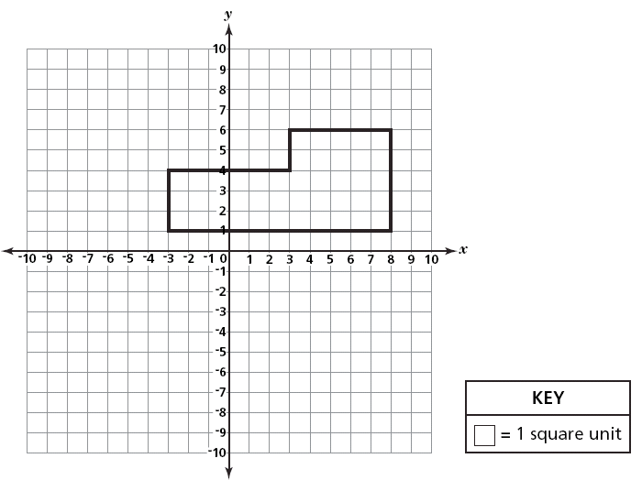

What is the area, in square units, of the polygon?

A 25 B 32 C 43 D 55

- Michael enters a 120-mile bicycle race. He bikes 24 miles an hour. What is Michael’s finishing time, in hours, for the race? d = rt

A 2 B 5 C 0.2 D 0.5

- Which of these is an irrational number?

A -2 B $\sqrt{\text{56}}$ C $\sqrt{\text{64}}$ D 3.14

- What is the least common multiple (LCM) of 8, 12 and 18?

A 24 B 36 C 48 D 72

- The number of fish sold at a fish market during a certain week is shown in the pictograph below.
What is the total number of fish sold on Tuesday and Wednesday?

A 10 B 25 C 45 D 50

- What is the value of the expression r²+s³ when r = 5 and s = 3?

A 19 B 34 C 52 D 85

- Veronica has a box that contains 24 pictures of her family, 6 pictures of her dog, and 12 pictures of her friends. Veronica randomly chooses one picture from the box. Which statement best describes what will likely occur?

A She will definitely pick a picture of her family.

B She will most likely pick a picture of her family.

C She is equally likely to pick a picture of her family or of her dog.

D She is equally likely to pick a picture of her family, of her dog, or of her friends.

- Simplify the expression below.

$$5+3⋅2−4^{2}⋅\left|−2\right|$$

A 43 B 48 C -16 D -21
- If the circumference of a circle is 16$π$, what is the radius? C = 2$π$r

A 4 B 8 C 16 D 32

- A butterfly weighs only about 5.0 x 10⁻⁵ of a kilogram. What is the number written in standard form?

A 0.00005 B 0.000005 C 50,000 D 500,000

- Every day at 7 a.m., Tamara recorded the outside temperature in degrees Fahrenheit (°F). She placed the data for one week in the table below.
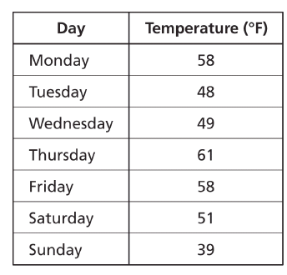
What is the range for the temperatures given in the table?

A 19°F B 22°F C 38°F D 61°F

- Hector spent $17 for a tube of paint and 5 brushes. The tube of paint cost $8. Which equation can be used to find b, the cost of each brush?

A 17 = 5b + 8 B 17 = 8b + 5 C 17b = 5 + 8 D 17 = b + 5 + 8

- A number cube is a cube with each side labeled with a number 1 through 6. Debbie rolled a number cube 60 times. The tally table below shows the number of times each number, 1 through 6, appeared.
Before her experiment, Debbie expected each number on the cube to appear an equal number of times. Which statement best compares the results of Debbie’s rolls with her expectations?

A Debbie rolled more 5s than expected C Debbie rolled more 3s than expected

B Debbie rolled fewer 4s than expected. D Debbie rolled fewer 2s than expected
- Between which two integers does $\sqrt{\text{29}}$ fall?

A 4 and 5 B 5 and 6 C 13 and 14 D 14 and 15

- Kasim’s Video Store has received a shipment of DVDs. The table below shows the number of each type of DVD in the shipment.

Kasim selects a DVD at random from the shipment. What is the probability that he chooses a western?
A $\frac{1}{4}$ B $\frac{1}{9}$ C $\frac{9}{\text{21}}$ D $\frac{9}{\text{30}}$

- The flower box in front of the main city library weighs 124 ounces. What does the flower
box weigh in pounds? 1 pound = 16 ounces

A $7\frac{1}{2}$ B $7\frac{3}{4}$ C 868 D 1984

- What is the greatest common factor (GCF) of 108 and 420?

A 6 B 9 C 12 D 18

- Alison is doing the laundry for her family and decides to count all the T-shirts. She creates the graph below to show how many T-shirts of each color her family has placed in the laundry.

What percent of the total number of T-shirts is red?

A 20% B 25% C 36% D 90%

- The graph below shows the type of instruments played by students in the school.

Janelle is chosen to perform a solo. What is the probability that she plays a stringed
instrument?

A $\frac{6}{\text{24}}$ B $\frac{8}{\text{24}}$ C $\frac{6}{\text{32}}$ D $\frac{8}{\text{32}}$

- What is the best estimation, in square centimeters, for the surface area of the rectangular prism shown below? Surface Area = 2wl + 2lh + 2wh

A 14 B 20 C 32 D 48

- A box contains 3 pens, 2 markers, and 1 highlighter. Tara selects one item at random and does not return it to the box. She then selects a second item at random. What is the probability that Tara selects 1 pen and then 1 marker?

A $\frac{5}{\text{36}}$ B $\frac{\text{27}}{\text{30}}$ C $\frac{6}{\text{30}}$ D $\frac{6}{\text{36}}$

- A school store’s expenses and sales for a three-month period are shown in the table below.
Based on the data in the table, what is the loss or profit for the store for the three-month period?

A $182.00 loss B $42.00 loss C $15.00 profit D $140.00 profit

- Which expression has the greatest value?

A 1.045 x 10² B 1.45 x 10² C 8.4 x 10⁻² D -8.4 x 10²

- Which tool is most appropriate for measuring the mass of a serving of cheese?

A ruler B thermometer C measuring cup D weighing scale

- There are 500 students in Andrew’s school. Andrew wants to survey a sample of students to determine the most popular school subject. Which sampling method is best to use to predict the most popular school subject?

A randomly select 50 students from the student list of 500

B randomly select 10 students having lunch in the cafeteria

C select the first 50 girls entering the auditorium for an assembly

D select the first 25 students leaving the building after school

- Carlos used 4 cubic yards of sand to fill his sandbox.
How many cubic feet of sand are in 4 cubic yards? 1 cubic yard = 27 cubic feet

A 9 B 12 C 64 D 108

- Which shape could be the base of a cone?

A circle B square C triangle D octagon

Math 7 Exam 2008 – Book 2 (Show All Work – Calculators Allowed)

31) The chart below displays the daytime high and the nighttime low temperatures for one Friday in Anchorage, Alaska.

Part A
How many degrees did the temperature drop from the daytime high to the nighttime low?

Answer ___________________ degrees

Part B
The warmest recorded temperature in Anchorage is 96 degrees higher than the Friday nighttime low temperature. What is the highest recorded temperature for Anchorage, Alaska?

Show your work.

Answer ______________________________ °F

32) The science teacher at Angela’s school is planning a field trip for all her classes. The number of accompanying adults must be proportional to the number of students. For example, if 30 students go on the field trip, there must be 5 adults.
Use the proportion below to determine the number of adults, a, that need to accompany 84 students on the field trip.
$\frac{\text{30}}{5}=\frac{\text{84}}{a}$
Show your work.

Answer _____________________ adults

33) Write “five less than four times a number” as an algebraic expression.

Expression_______________________________________

Evaluate the expression above when the value of the unknown number is 3.

Show your work.

Answer _______________________

34) Carlotta asks 30 campers which outdoor activity they enjoy. Of these campers, 13 enjoy swimming, 17 enjoy baseball, and 8 enjoy swimming and baseball.

Complete the Venn diagram using the information above.

Be sure to: title the diagram, label each circle, place a number in each section of the diagram.

How many campers did not select any outdoor activity?

Answer __________________________ campers

On the lines below, explain how you determined the number of campers who did not select any outdoor activity.

_______________________________________________________________________________

_______________________________________________________________________________

_______________________________________________________________________________

_______________________________________________________________________________

_______________________________________________________________________________

35) Tricia is choosing a container for her jewelry beads. The containers are shown below.
Find the volume of the prism. Round your answer to the nearest whole number.

Show your work.

Volume of prism _______________________ cubic centimeters

Find the volume of the cylinder. Round your answer to the nearest whole number.

Show your work.

Volume of cylinder ______________________ cubic centimeters

What is the difference in volume between the prism and the cylinder? Round your answer to the nearest whole number.

Answer ______________________ cubic centimeters

36) Write the prime factorization of 84 in exponential form.

Show your work.

Answer _______________________
- Dan’s classmates use different-color notebooks for different projects. Dan is creating a circle graph representing the number of different-color notebooks. Dan’s table shows the measure of each sector of his graph. Complete Dan’s table.

Using information from the table, create Dan’s circle graph. Be sure to label the sectors.
38) On the calendar below, Mindy recorded the daily high temperature in degrees Fahrenheit for the first fifteen days in May.

Part A
Use the information from the calendar to complete the temperature frequency table shown above.

Part B
Which temperature range occurs most frequently? Answer _____________________ °F

Part C
Which temperature range occurs least frequently? Answer _______________________ °F

