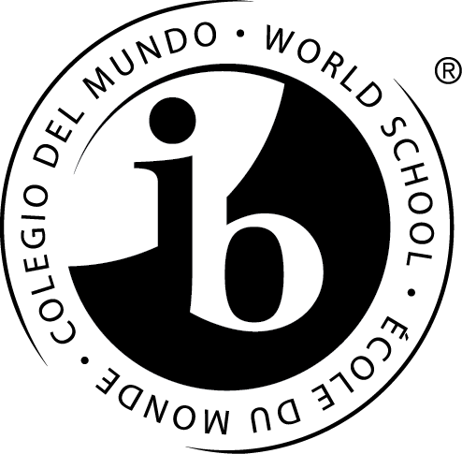

United States Civics, Economics, and History II
Thomas Jefferson Middle
An International Baccalaureate World School

Goal: Through our study of Social Studies, we will learn to be active citizens in our community who can apply our knowledge and understanding of different perspectives to benefit the world around us today and in the future.

Course Description: This year we will explore the history of the United States from the Civil War until modern day integrated with civics and economics. As an IB World School, we will explore these time periods using a global perspective. We will study documents, speeches, photographs, and archival footage to examine the everyday life of people at different times in our country’s history to recognize different perspectives and form our own arguments and opinions.

Resources:
Our textbook, America: History of Our Nation, is available digitally on Blackboard and as an IPad app. Hard copies are available as needed. We also use the History Alive! program and other fiction or primary source materials.

Units of Study:
Our Nation of Laws: Systems Protect our Rights
Reconstruction: Extending Citizenship to Freedmen
Expanding Nation: Expansion lead to Expansion of Citizenship
Progressives: How Citizens Influence Government
Industrialization: The Rise of Big Business and Governments Expanding Role In the Economy
WWI and Roaring Twenties: Challenges Abroad and Changes At Home
The Great Depression: The Role of Government Expands
World War II: Broadening the Role of the US In the World
Cold War: Economic and Political Differences
Civil Rights: Citizens Work for Justice
The Political Process: Political Parties, Mass Media and Elections
Modern America: Modern Challenges

Assessment: Students will have many opportunities to demonstrate their learning.

Assessment Type | Form and Weights
Formative (for practice) | Mini Quizzes (Not graded)  ATL Notebook (10%)  Document Study (10%)
Summative (to show mastery) | Unit Tests (50%)  IB Projects/IB Written Responses (30%)

Students will be evaluated using the APS Grading Scale and IB criteria. See the charts below for information. They are expected to complete all assignments and turn them in on time. If not, they will spend time with me to develop this good habit.

Students and parents may check grade updates and homework using the Parent Portal. Grades will reflect student achievement only, not behavior.

APS Grading Scale
Letter Grade | Percentages
A | 90 – 100
B+ | 87- 89
B | 80 – 86
C+ | 77 – 79
C | 70 – 76
D+ | 67 – 69
D | 60 – 66
E | 0 – 59
.5 and above will round up

IB Criteria Individuals and Society Assessment
Criterion A: Knowledge and Understanding Students develop factual and conceptual knowledge about individuals and societies. | 8
Criterion B: Investigating Students develop skills to organize, document and communicate their learning using a variety of media and presentation formats. | 8
Criterion C: Communicating Students develop skills to organize, document and communicate their learning using a variety of media and presentation formats. | 8
Criterion D: Thinking Critically Students use critical thinking skills to develop and apply their understanding of individuals and societies and the process of investigation. | 8

SOL Testing: Virginia has replaced the US I and US II SOLs with alternate assessments. Grade 6 and 7 Arlington students will now be assessed using performance assessment tasks. At Jefferson, these tasks are the same as our IB Tasks. Students will take the Civics and Economics SOL at the end of Grade 7. We will continue to prepare for that SOL this year.

Expectations:
ATL Notebooks and Document Studies(Class work and Homework): As they study America, students experience a variety of “Approaches to Learning”. These “ATL’s” are kept in their Social Studies section for review. ATL’s are collected for grading on the day of the Unit Test. ATL Daily Questions and tasks will be posted Google Classroom. Our class is primary source-based. Document Studies help us learn history through different lenses and are often assigned for homework.
Supplies: Students will come to class prepared with a pencil, colored pencils, an and organized binder.
Behavior: Students will be responsible for their learning and be respectful toward people and property. They will show what they know through participation and effort. Students will get two friendly warnings before completing an added behavior reflection signed by a parent or a disciplinary referral to the office.
Absences: Because this class is presented chronologically, students are discouraged from missing class. Students are responsible for making up work missed due to absences. Copies of all notes and worksheets are available in the classroom for absent students upon their return. If you know your student will be absent, please have him or her request assignments in advance.
Contact Me!
Ms. Maureen McMorrow E-mail: maureen.mcmorrow@apsva.us
Twitter: @TJMSMcmorrow

