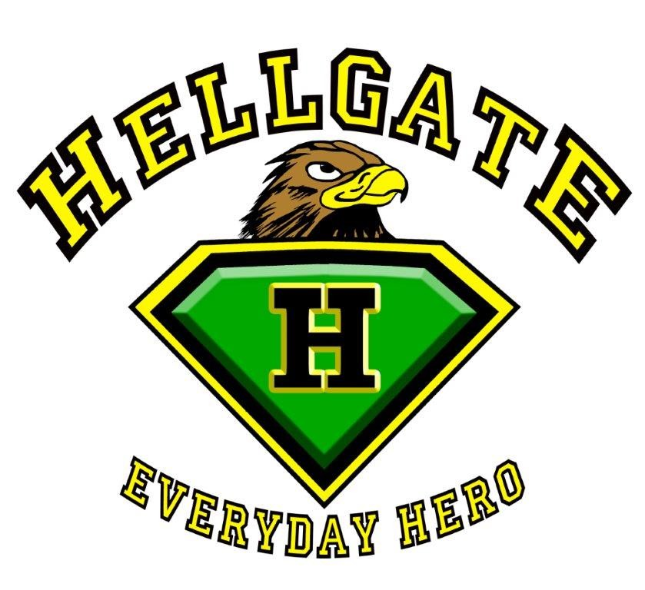
SUPPLIES FOR
HELLGATE MIDDLE SCHOOL

6th grade supplies

Pens
Pencils
Erasers
Markers
Colored Pencils
Ruler
Scissors
Protractor
Single Subject Spiral Notebooks (5)
Binder or Trapper Keeper
Glue Sticks (3)
Boxes of Kleenex (1-2)
Carpenter Pencil
Notebook for Practical Arts (1)
Graph Paper Notebook
Inexpensive Headphones or Earbuds

Expo Markers (2) Pack of lined index cards

*PE: t-shirt, shorts or sweats, gym shoes that are worn ONLY for PE, deodorant (stick or roll on) & Master Combination Lock for gym locker

7th & 8th grade supplies

Pens Pencils
Erasers Protractor
Ruler Colored Pencils
Scissors Markers
Single Subject Spiral Notebooks (5) Glue Sticks (3)
Binder Loose Leaf paper
Folders (3) Graph Paper Notebook
Boxes of Kleenex (3) 3 X 3 Sticky Notes (pack of 5)
Scientific Calculator (NOT graphing calculator)
Flash Drive Glue Stick (3)
Pack of lined Index cards Single Subject Spiral Notebook (5)

*PE: t-shirt, shorts or sweats, gym shoes that are worn ONLY for PE, deodorant (stick or roll-on) & Master Combination Lock for gym locker

All students will benefit from having supplies that will help keep their assignments and homework organized. Additional materials may be required once school starts.

