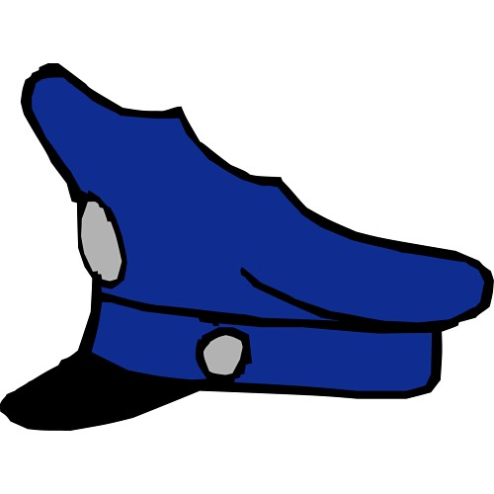
Kids Camp
Greenville Police Department

The Greenville Police Department along with the Greenville ISD Police Department is offering a summer camp for kids that have successfully completed the 5th grade and are going into the 6th grade. The program is Free and will be held June 6, 2022 thru June 10, 2022. Camp will be held at the Greenville ISD 6th Grade center located at 3201 Stanford St. and the hours will be from 8:00 a.m. to 4:00 p.m. The Greenville Police Department Kids Camp is designed to help kids get acquainted with police officers and other first responders and have fun with them. Activities will include dodge ball, basketball, flicka ball, music, getting hosed down by the fire trucks, meeting the K-9, and more. Kids will also learn about drugs and alcohol and their dangers, gang prevention, anti-bullying, internet safety, gun safety, first aid, and crime scene investigation (CSI). Kids will be divided into teams and will play the games and compete with one another while learning about teamwork.

The kids will be under the supervision of police officers and police volunteers at all times. Greenville Police Department Operations Division and Greenville ISD Police Department will be in charge of the camp and supervising all activities and classes. Lunch will be provided Monday through Thursday by GISD and on Friday we will have a pizza party. If your child would like to eat breakfast, GISD will start serving it at 7:30 a.m. and close at 8:00 a.m. While attending Kids Camp, your kids need to bring a hat, sunscreen, towel and it is recommended for them to wear shorts since it will be hot. A team shirt will be provided the first day and your kid will need to wear the shirt provided everyday since it identifies the kids group and identifies them as part of the camp. Please wash the shirt every day since we will be getting sweaty and dirty. We often have quite a few extra shirts that can be purchased for $5.00 each if you would like to buy a spare.

Once again, this camp is provided to you free of charge and we hope that everyone can attend so that they can become familiar with all of their peers. This program is also offered to the Greenville Christian School, Pioneer Technology & Arts Academy, and Home School students. Registration Deadline is May 6, 2022 so that we can ensure we have enough supplies for the kids attending. Please note that once your child is registered you will not receive a confirmation letter. Your child will just need to show up the first day of camp.

Thank you for your time and hope to see your kid there,

Lt. Gary Barrow Officer James Hamilton Chief Ramon Rodriguez
Greenville Police Department Greenville Police Department Greenville ISD Police Department
Operations Division Crime Prevention Officer School Resource Officer
gbarrow@ci.greenville.tx.us jhamilton@ci.greenville.tx.us rodriguezr@greenvilleisd.com

