6th Grade Study Guide Clefs and Notes

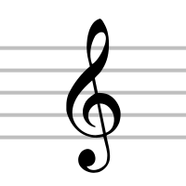
1.Treble Clef or G Clef- High notes are placed on the Treble Staff. Instruments with a high pitch read the Treble or G Clef.

2. The lines of the Treble Clef are- Every Good Boy Does Fine
3.The spaces of the Treble Clef are- F A C E

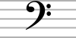

4. Bass Clef or F Clef-A staff with a Bass Clef sign is for low notes. Low pitched instruments use this clef.
The notes are different from the Treble Clef. You do not need to know the notes for this test.

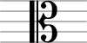

5. The Moveable C Clef in the ALTO position-this clef has a middle pitch range. It is used most commonly for the viola. It is so the Viola players would not have to read difficult Leger Lines. Their notes would be on a staff.
This clef can move to other positions. The center would become note C.

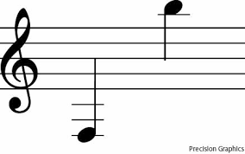
6. Leger Line Notes- notes written above or below a staff and it has it’s own line.

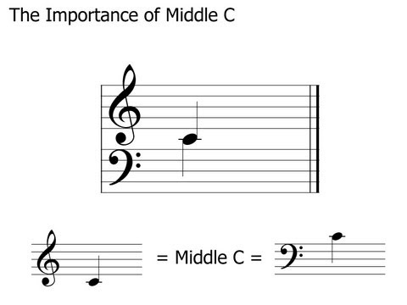

7. GRAND STAFF The Treble Clef and the Bass Clef together is called the Grand Staff. Keyboard instruments use the Grand Staff.

8. Middle C- the note in the center of the Grand Staff. In the early history of music, the Grand Staff had eleven lines. The middle line was later removed, in order to make reading easier. Now, when that middle line (middle C) is needed, a short piece of the middle line is drawn and called a leger line.

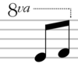
9. The Octave sign. Above a note it is meant to play the note one octave or eight notes higher. Below a note it means to play the note one octave or eight notes lower. It is much easier to read than reading Leger Lines.

